1. First the query to sum the total time in office of each of the prime minister.

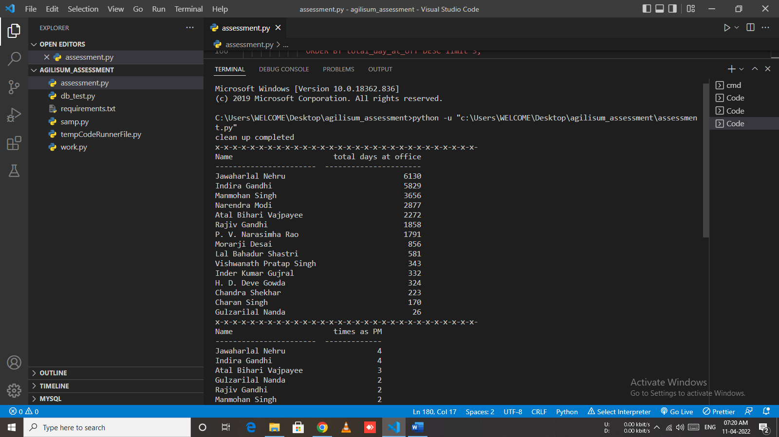

1. Second the Number of tenures each one resided in office.

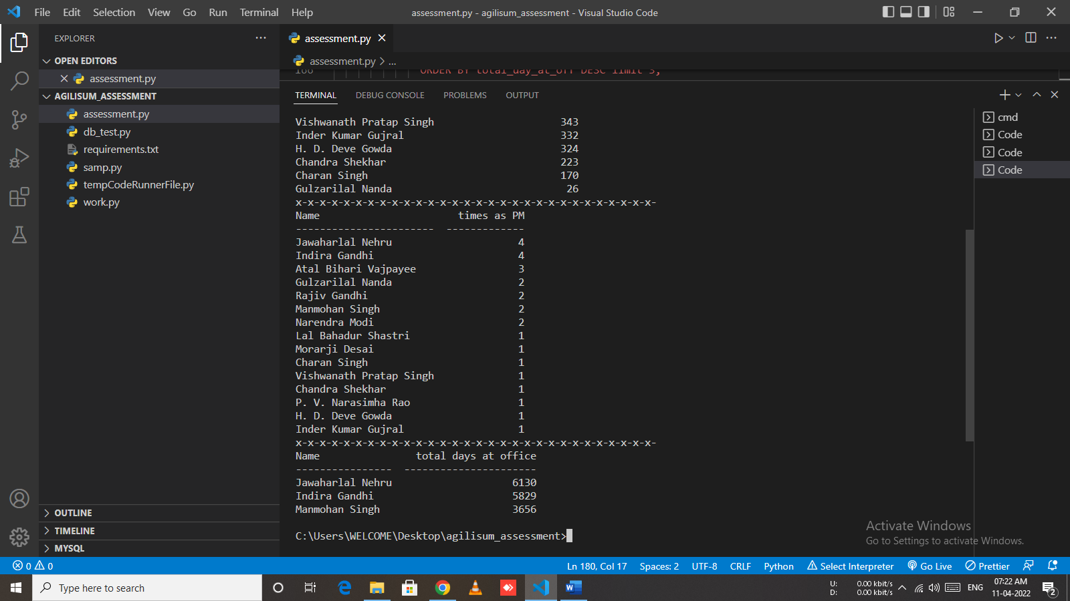

1. List the 3 rd highest tenure(total time in office) prime minister.

