WebDriver:-🡪

WebDriver is a user interface automation testing API (Application programming interface)

* WebDriver invented by Stewart Simmon
* To overcome IDE limitation we use WebDriver
* WebDriver allow user to conduct cross browser testing
* WebDriver allow user to conduct cross platform testing
* WebDriver allow user to write code on multiple languages
* WebDriver allow user to write code on multiple IDE’s (Work Benches)
* Eclipse, Net beans, Edit plus, Visual Studio ---etc

Selenium 1--🡪 Remote Control

Selenium 2-- 🡪 Remote Control+ WebDriver

|  |  |
| --- | --- |
| WebDriver | Remote Control |
| Dynamic handling on web application | Static Handling on web Application |
| Native browser support for WebDriver | Server in key event to contact browser |
| Mobile automation support | Do not support mobile automation |
| Support object oriented features to implement | Do not support many option of java oriented features |
| Full length support of Java script | Full length support of Java script |
| During WebDriver first target the element then we provide command | During Remote control first provide the command later target the element |
| By default synchronization available | Default synchronization not available in RC |
|  |  |

WebDriver Configuration:-🡪

To Configure WebDriver in your PC below Downloads are Required.

1. Download Java JDK 1.5 Above
2. Download Eclipse :-🡪Java Developer Version
3. Download Web driver API’s
4. Download java :-🡪

Before Download Java make sure java installed in your PC once

Cmd :🡪 java -version

Path to verify Java installation:-🡪

C:\Program Files\Java\jdk1.8.0_20

JDK is not install in your PC follow below path to Download and Install Java

URL:---> <http://www.oracle.com/technetwork/java/javase/downloads/index.html>

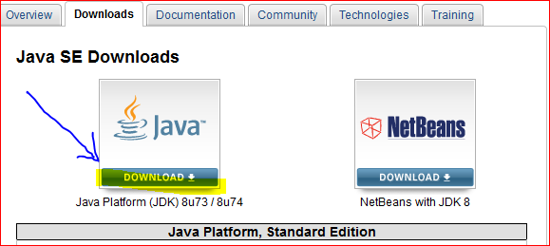

Click on Java Download

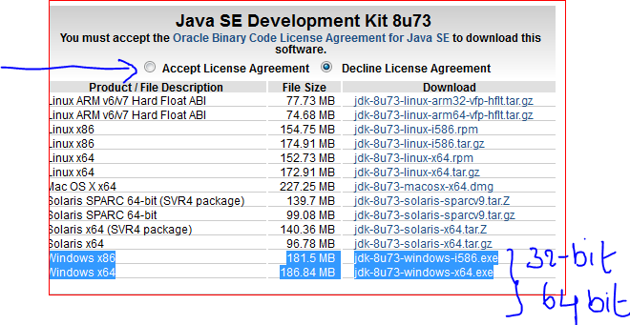

Click on Accept License agreement Radio button and Select download with respect to

Operating system (32 bit or 64 bit)

How to confirm Operating system Bit size:🡪

Start Menu-🡪 Do right click on computer --🡪Properties --🡪System Type

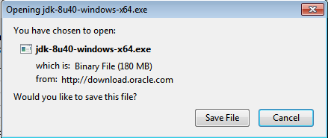

Save File into your drive

It is Executable jar file your can double click on file to install java into your PC

Click Next-🡪 Click Next--🡪 Click Next--🡪 Click Next---🡪 Close Window

🡪After Installation make sure java Installed

Eclipse Download:-🡪

URL🡪 <http://www.eclipse.org/downloads/packages/>

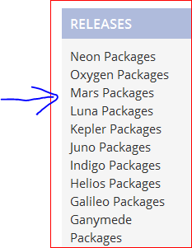

Select Eclipse release click on Link

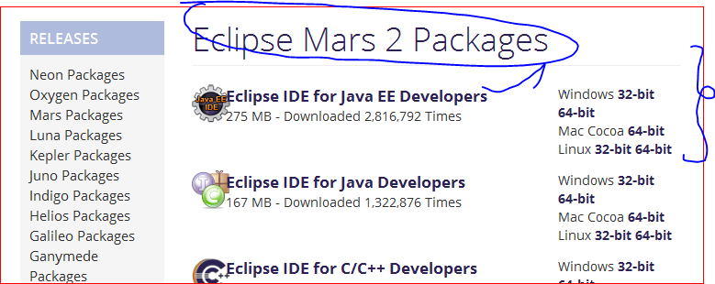

Select Operating system and Bit size to Download Eclipse

Click on available download at Eclipse mirror selection

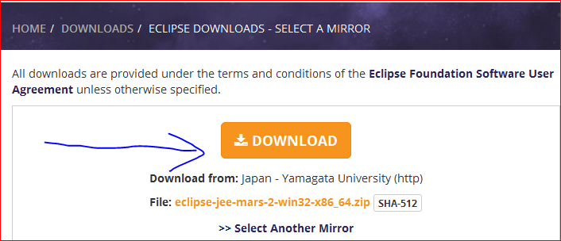

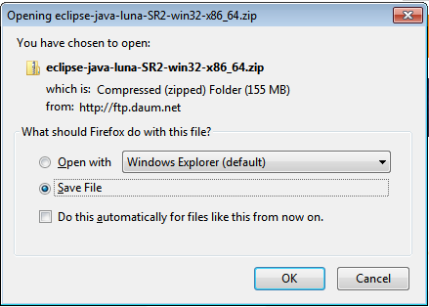

After selection mirror, it Ask Zip format file to Download

Save File into drive

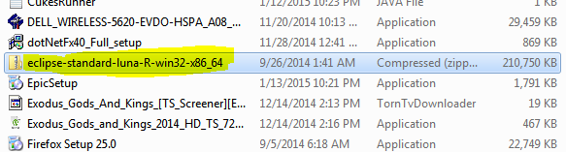

After Download Right click on Zip file Select Extract file -🡪 And specify Location to Un Zip file

After Extract completed under Eclipse folder you can see application in ball ICON



Double click on folder to open all eclipse properties

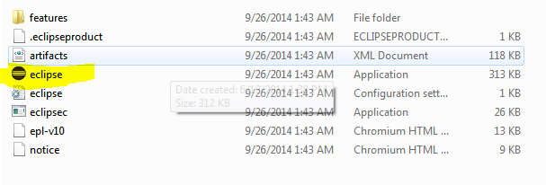

1. Download Web Driver jar file:---.

URL--🡪 <http://seleniumhq.org>

Click download tab

First API to Download:--. 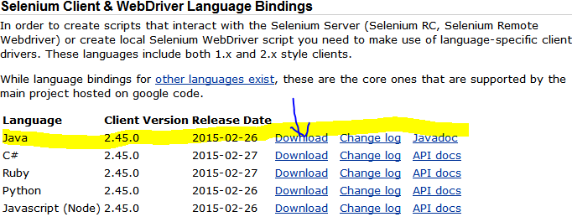

Select preferred language and click on download

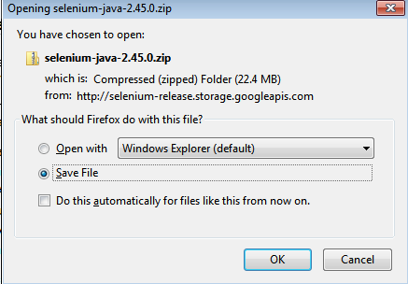

Click on ok to save Zip file into drive

Extract zip file to backup folder

----The above all downloads need to configure web Driver----🡪.

After completed all download set workbench first:-🡪

Create workspace:--🡪

1. In your drive create folder with any name “Workspace selenium”
2. Create Sub folder as library
3. Downloaded Selenium jar files copy to Library folder

**Double click on Eclipse Application to set Workspace**:🡪

Click on Run to launch Eclipse Application

Select workspace folder to create multiple projects in it

Creating java project in eclipse:-🡪

Open Eclipse-🡪 File Menu-🡪others-🡪Select java folder-🡪Select Java project

-🡪Enter Project name click on Finish-🡪click on Yes

Note:🡪 with above configuration we able to build and execute java programs only, we can’t

Execute and build selenium programs

To build selenium programs below configuration is required

Under package explorer--🡪 Right click on JRE system libraries -🡪

Use Build path option--🡪 Click configure Build path

In project properties window click on Add external jar files tab

And show download selenium jar files path to open

Note:-🡪 After you configure all jar files under project explorer it will reflect

With name referenced libraries