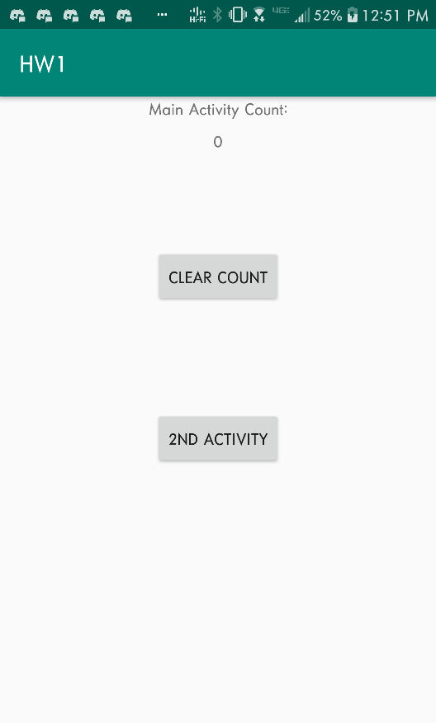

Figure 4 Counter Cleared

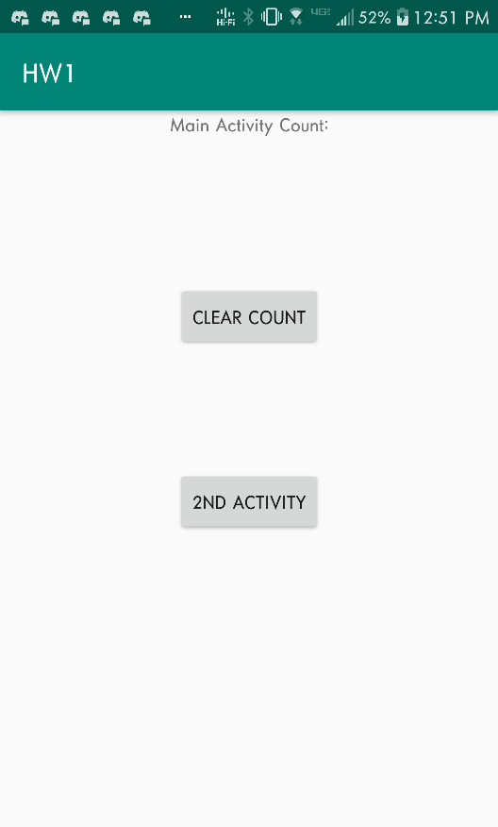

Figure Startup Screen

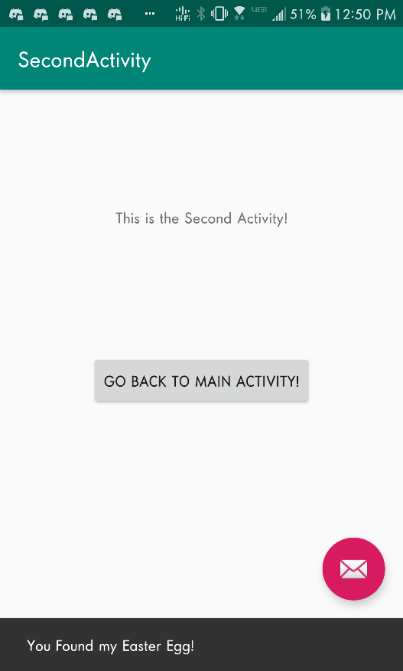

Figure 2 Second Activity

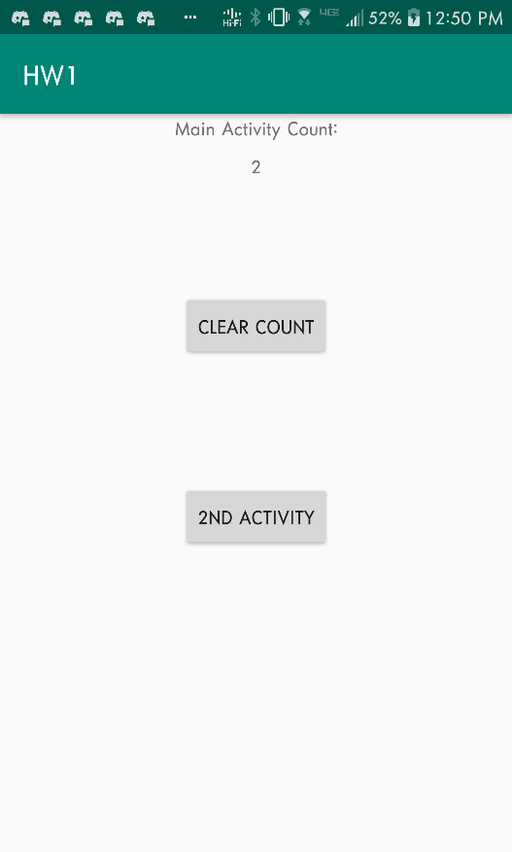

Figure 3 Main Screen Counted

Structure:

Main Activity:

1. Counts Amount of times it restarts since creation
2. Counter can be reset using a reset button
3. Counter is a protected class variable

Second Activity:

1. Contains a button that will bring it back to the main activity using the finish() command
2. Contains an Easter Egg in the lower right-hand corner that when clicked temporarily shows “You Found My Easter Egg”

Implementation Logic:

Simplistic. The goal was to make the code as minimalistic as possible. I simplified some of the methods mentioned in the slides, but provided the same functionality.

Figure 4 Cleared Counter

As this app is fairly simplistic, there’s not much to talk about here.