信號與系統Matlab hw1

系級：電機二 學號：b06901017 姓名：鐘民憲



$x_{1}[n] vs n$ $x_{2}[n] vs n$

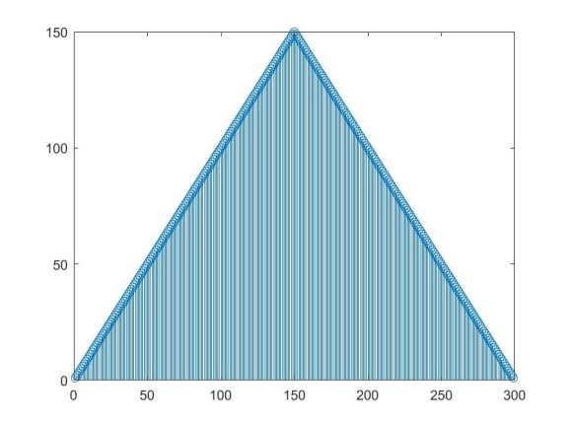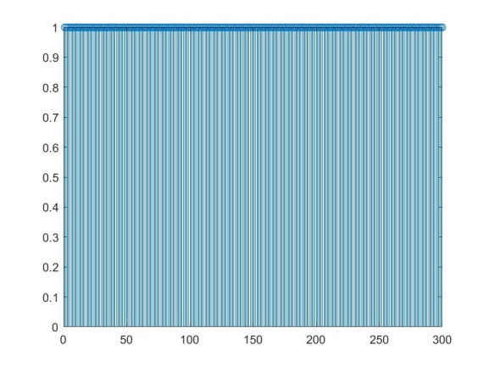

$x_{1}\left[n\right]=n,1≤n≤150$ $x_{2}\left[n\right]=1,1≤n≤300$

$x_{1}\left[n\right]=300-n,151≤n≤299$ $x_{2}\left[n\right]=0,elsewhere$

$x_{1}\left[n\right]=0,elsewhere$

1. Use **conv** to do convolution

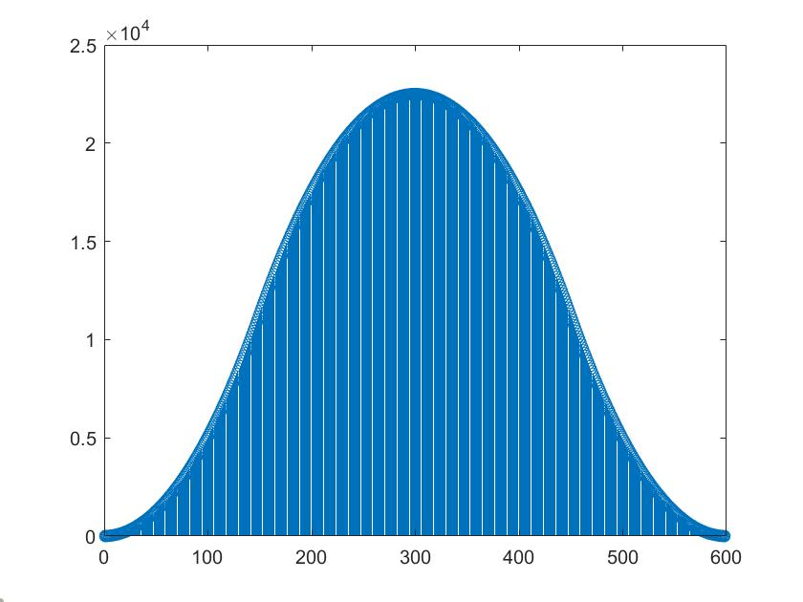

$$y\left[n\right]=x_{1}\left[n\right]＊x_{2}\left[n\right]=x_{2}\left[n\right]＊x_{1}\left[n\right]$$

$$=\sum_{k=-∞}^{k=∞}{x_{2}\left[k\right]x_{1}\left[n-k\right]}=\sum_{k=1}^{300}{x_{1}\left[n-k\right]} \\ =x_{1}\left[n-1\right]+x_{1}\left[n-2\right]+…+x_{1}\left[n-300\right] \\ When 2≤n≤300,y\left[n\right]=\sum_{k=1}^{n-1}{x_{1}\left[k\right]} \\ When 301≤n≤599,y\left[n\right]=\sum_{k=n-300}^{299}{x_{1}\left[k\right]}$$

1. Use matrix form to do convolution

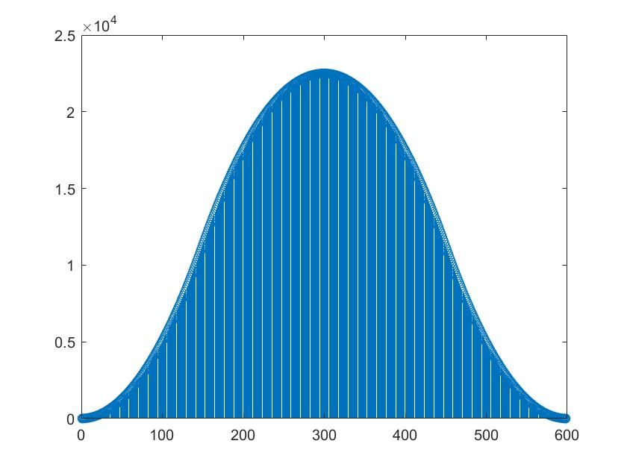

(Same as figure in b)

1. Repeat c but x1[n] changes to be the same as x2[n]

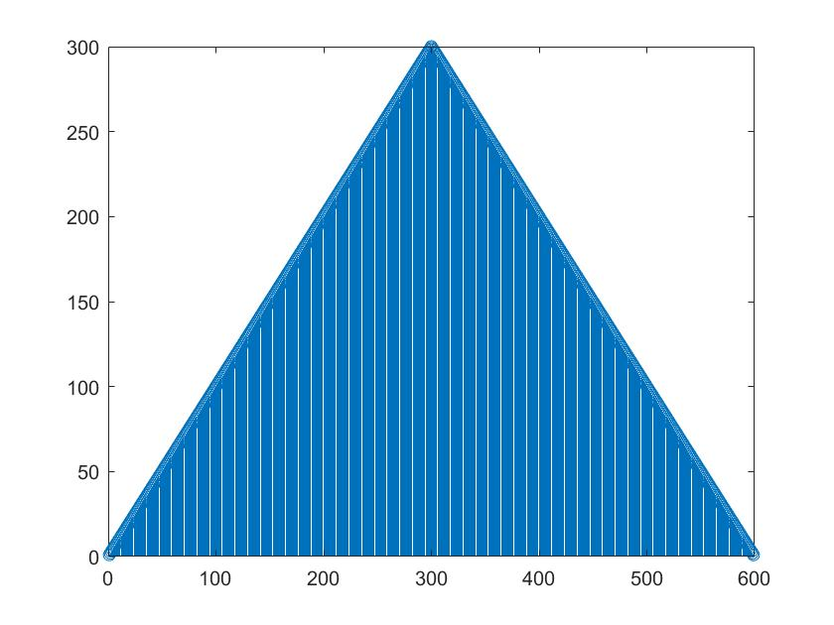

$$y\left[n\right]=x_{2}\left[n\right]＊x_{2}\left[n\right] \\ =\sum_{k=-∞}^{k=∞}{x_{2}\left[k\right]x_{2}\left[n-k\right]=\sum_{k=1}^{300}{x_{2}\left[n-k\right]}} \\ =x_{2}\left[n-1\right]+x_{2}\left[n-2\right]+…+x_{2}\left[n-300\right]$$

$$When 2≤n≤301,y\left[n\right]=n-1 \\ When 302≤n≤600,y\left[n\right]=601-n$$