信號與系統Matlab hw4

系級：電機二 學號：b06901017 姓名：鐘民憲

(a)

$$H\left(z\right)=\frac{0.0976{\left(z-1\right)}^{2}{\left(z+1\right)}^{2}}{\left(z-0.3575-0.5889i\right)\left(z-0.3575+0.5889i\right)\left(z-0.7686-0.3338i\right)\left(z-0.7686+0.3338i\right)}$$

$$=\frac{0.0976{\left(1-z^{-1}\right)}^{2}{\left(1+z^{-1}\right)}^{2}}{\left[1+\left(-0.3575-0.5889i\right)z^{-1}\right]\left[1+\left(-0.3575+0.5889i\right)z^{-1}\right]\left[1+\left(-0.7686-0.3338i\right)z^{-1}\right][1+(-0.7686+0.3338i)z^{-1}]}$$

$$=\frac{-0.1045-0.1596i}{1-(0.7686-0.3338i)z^{-1}}+\frac{-0.1045+0.1596i}{1-(0.7686+0.3338i)z^{-1}}+\frac{0.0068+0.4093i}{1-(0.3575-0.5889i)z^{-1}}+\frac{0.0068-0.4093i}{1-(0.3575+0.5889i)z^{-1}}+0.0976$$

∵h[n] is causal, $a^{n}u\left[n\right]\underset{↔}{z}\frac{1}{1-az^{-1}} for \left|z\right|>\left|a\right|$

$$∴h\left[n\right]=\left[\begin{aligned}\left(-0.1045-0.1596i\right)*{\left(0.7686-0.3338i\right)}^{n}+\left(-0.1045+0.1596i\right)*{\left(0.7686+0.3338i\right)}^{n} \\ +\left(0.0068+0.4093i\right)*{\left(0.3575-0.5889i\right)}^{n}+\left(0.0068-0.4093i\right)*{\left(0.3575+0.5889i\right)}^{n}\end{aligned}\right]u\left[n\right]+0.0976δ(t)$$

ROC: $\left|z\right|>\sqrt{{0.7686}^{2}+{0.3338}^{2}}≈0.838$

h[n] v.s n

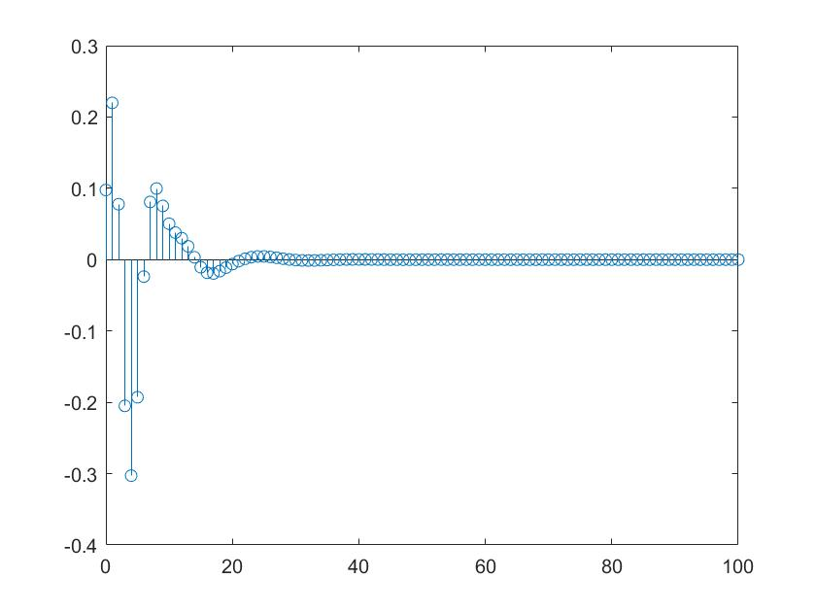

(b) pole-zero plot of H(Z)

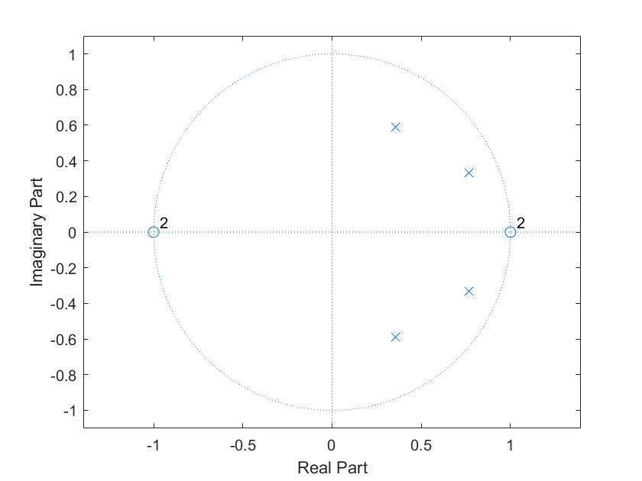

(c) |H(ejw)| v.s w ∠H(ejw) v.s w

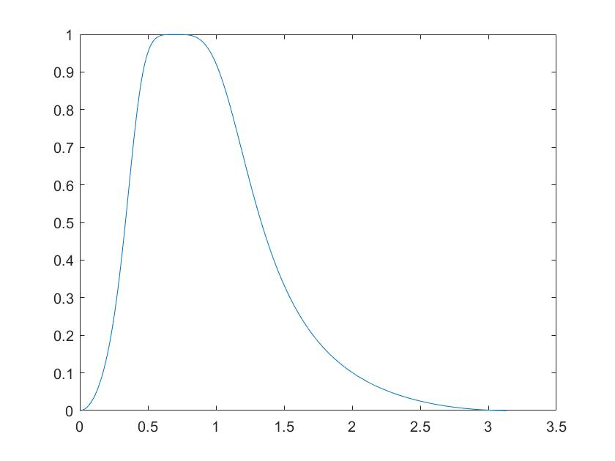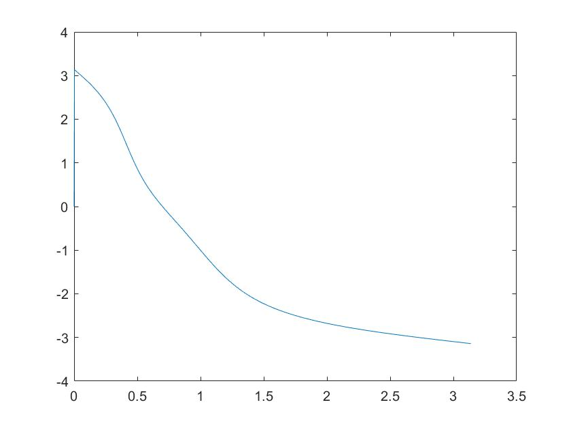

(d)

$$H\left(z\right)={0.0976H}_{1}\left(z\right)H_{2}(z)$$

By matlab function zp2sos, we can obtain and .

(e) |H1(ejw)| v.s w |H2(ejw)| v.s w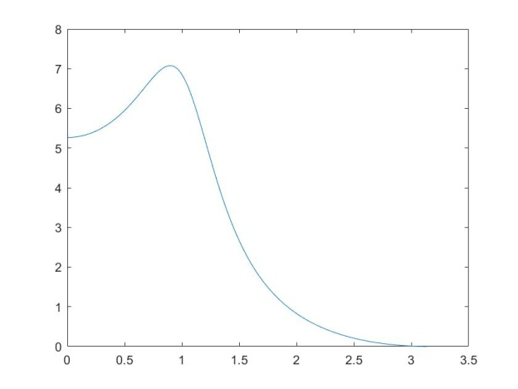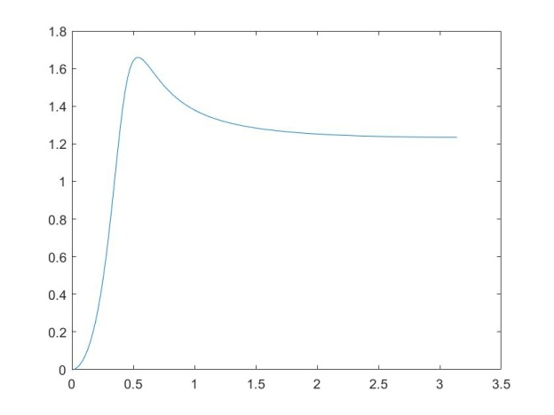

|H1(ejw)| |H2(ejw)| v.s w

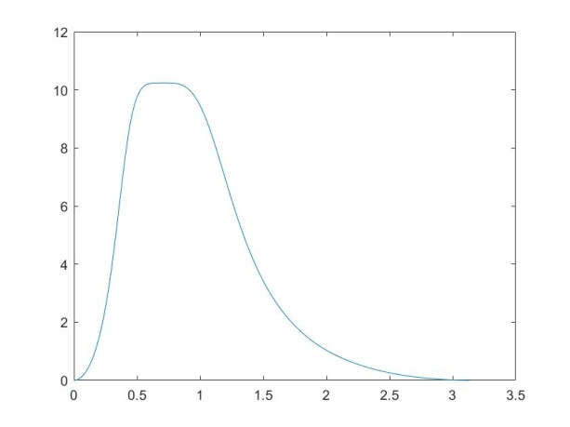

Almost same as figure in (c) only the magnitude is multiplied by $\frac{1}{0.0976}$.

(f) y[n] v.s. n where y[n] is the impulse response

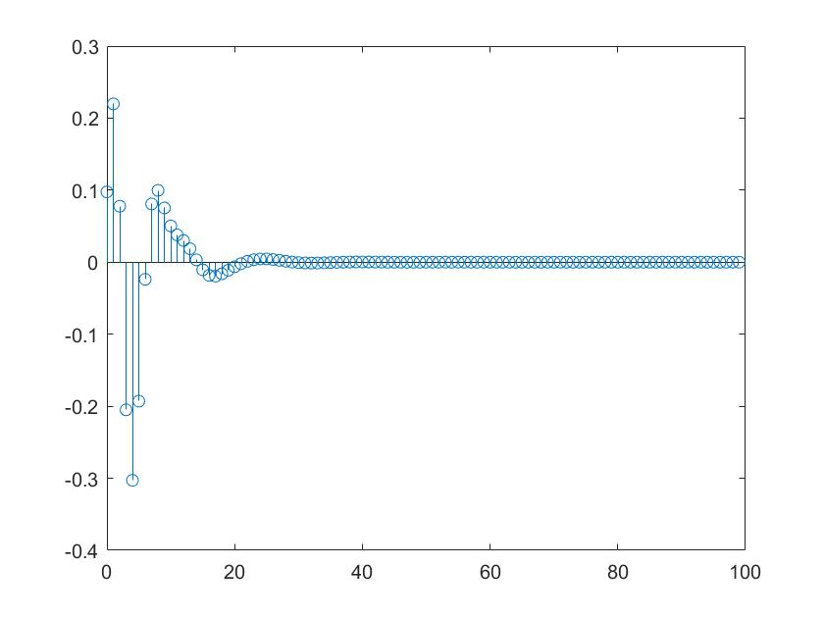

Exactly the same as the figure in (a).