Ensure you are logged in to the Global Protect VPN prior to starting E&E.
All the pop-up windows can be saved as PDF and dropped into the case file when we convert to PDF.

PERM ID:

Eligibility Determination
Case List

Cases will be displayed on the home screen. Identify target Case in the list. Capture Case List.

Program Eligibility
On the Case List, click on Open. Capture screen.
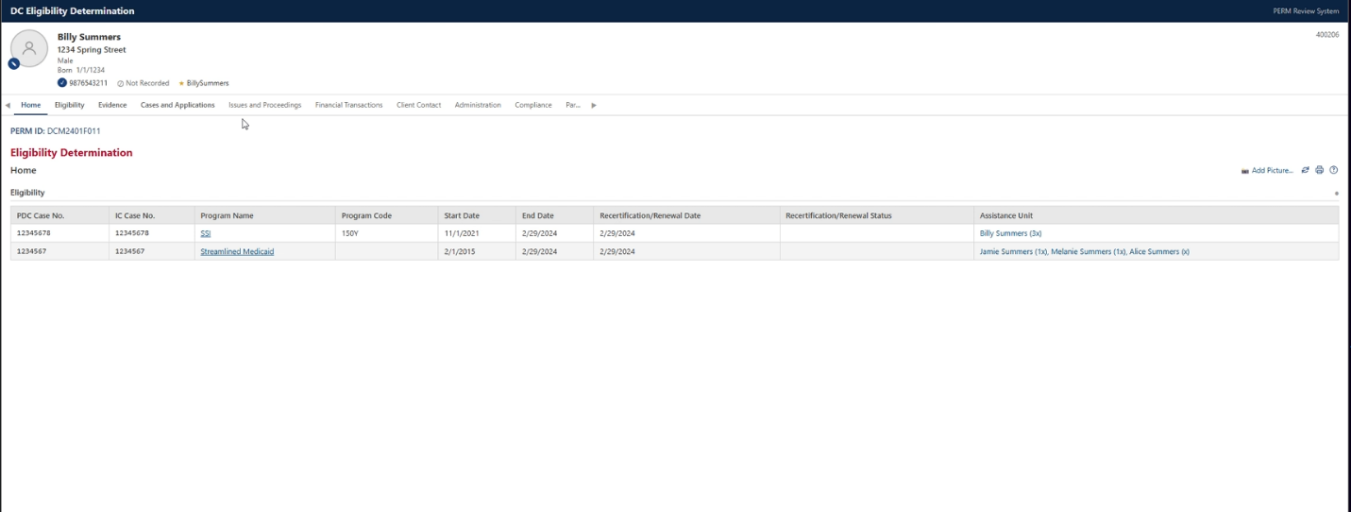

Program Eligibility
Click on the Eligibility tab. Capture information that covers the Date of Service.

Eligibility Evidence
Click on the Evidence tab. Scroll down to External System. Capture screen.
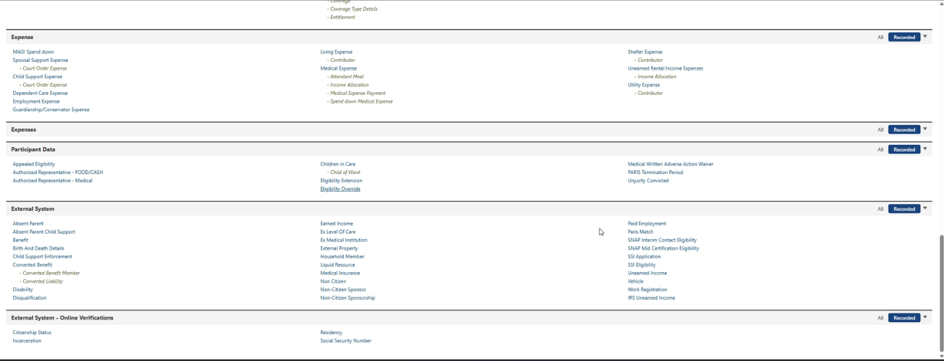

State Eligibility Determination
Click on the Certifications tab. In the Determination History section, capture information that covers the date of service.

