Advanced SQL Data Warehouse
& Business Analytics
Central Superstore — Mini-Project 2 Report
Field | Detail
Dataset | Central_Superstore.csv (2,323 order-line rows)
Tool | SQL Server (T-SQL) + Python / pandas + Tableau
Prepared by | AhmedTea
Scope | Data modeling, ETL pipeline, KPI reporting, business analytics, Tableau dashboards

Executive Summary
This project turns a flat, order-line-grain retail export (the Central region of the Superstore dataset) into a small but complete data warehouse: a four-layer medallion pipeline (staging → bronze → silver → gold), a star schema with one fact table and five dimensions, KPI views and stored procedures, a 16-query analytical catalog, a business-analytics write-up covering profitability, customer behavior, and sales trends, and four Tableau dashboards built on the gold layer.
Two genuine data-quality issues were found and fixed while building this against a live SQL Server instance rather than only in theory: a Jupyter notebook that referenced an undefined variable and assumed missing values that the actual extract does not have, and a delimiter-collision bug in the raw CSV that silently shifted sales, quantity, discount, and profit by one column for three rows. Both are documented in detail in Section 4.
Headline result: the business earned 39,706 in profit on 501,240 in sales (a 7.9% margin), but that figure hides a sharp split. Technology generates about 85% of profit, while two states, Texas and Illinois, receive nearly all of the deep discounts and lose 38,337 between them; the other eleven states are consistently profitable, with margins between 24.7% and 36.2%. The four Tableau dashboards in Section 10 make this visible.

1. Introduction & Business Scenario
A multinational retail company needs an automated analytical solution to monitor sales, profitability, customer behavior, and operational performance from its transactional data. This project builds that solution end-to-end for the company's Central sales region: from raw CSV ingestion, through cleaning and dimensional modeling, to reusable KPI views, stored procedures, and a documented set of analytical and business-insight queries.

2. Dataset Overview
The source file, Central_Superstore.csv, is a semicolon-delimited export at order-line grain (one row per Order ID + Product ID pair):
Metric | Value
Total order-line rows | 2,323
Unique orders | 1,175
Unique customers | 629
Unique products | 1,310
Distinct city / state / postal combinations | 195
Region covered | Central (single region)
Date range | 2013 – 2016 order dates (3 Jan 2013 – 30 Dec 2016)
Missing values | None — confirmed via pandas .isnull().sum() on every column

3. Data Architecture

3.1 Medallion Layers
The warehouse is built in four layers, all inside sql_dw_analytics/Datawarehouse_layers.sql:
Layer | Purpose | Tables
Staging | Raw text load straight from the CSV via BULK INSERT | staging.superstore
Bronze | Append-only, versioned copy of every staging load | bronze.superstore
Silver | Typed, cleaned, deduplicated business entities; bad values flagged, never dropped | customers, products, locations, order_lines
Gold | Star schema for reporting | fact_sales + 5 dimensions

3.2 Star Schema
gold.fact_sales sits at order-line grain and joins to five dimensions on surrogate integer keys:
- gold.dim_customer — customer_id, customer_name, segment
- gold.dim_product — product_id, product_name, category, sub_category
- gold.dim_location — city, state, postal_code, region, country
- gold.dim_date — a generated date spine (day, week, month, quarter, year, is_weekend)
- gold.dim_ship_mode — the four shipping methods used in the source data
Every foreign key on fact_sales is enforced with a REFERENCES constraint back to its dimension's primary key, and shipping_duration_days is stored (not computed) directly from silver's real order/ship dates at load time.

4. Data Quality Process

4.1 Notebook bugs (exploration phase)
Two real bugs were found and fixed in explore_with_py/exploring_cleaning_data.ipynb before it was usable end-to-end:
- df_cleaned was referenced from the duplicate-check cell onward but was never assigned anywhere — the notebook would raise NameError if run top to bottom. It is now created explicitly, as a defensive copy of df, once the missing-value check confirms there is nothing to impute.
- The missing-value section assumed Postal Code has gaps, which is true of the full multi-region Superstore dataset but not of this Central-region extract (zero missing values in any column). The text and the missing imputation step were rewritten to match what this file actually contains.
The notebook was executed end-to-end (jupyter nbconvert --execute) to confirm it now runs cleanly, and a final cell was added to persist the cleaned frame as both parquet and CSV for downstream use.

4.2 Delimiter collision (ETL phase)
Testing the ETL against a live SQL Server instance surfaced a second, more subtle issue: 3 of the 2,323 rows have a product name containing a literal semicolon inside double quotes — for example “Imation Secure+ Hardware Encrypted USB 2.0 Flash Drive; 16GB” (product TEC-AC-10004659). The original BULK INSERT used a plain FIELDTERMINATOR = ';' with no CSV-quoting awareness, so it split on that embedded semicolon too, shifting sales, quantity, discount, and profit left by one column for those 3 rows and leaving a stray semicolon inside the resulting profit value.
Fix: FORMAT = 'CSV' and FIELDQUOTE = '"' were added to the BULK INSERT options in staging.load_superstore (SQL Server 2017+), which makes the loader respect double-quote field enclosures and treat an embedded delimiter as literal text. All 2,323 rows load with correct column alignment as a result.
Every row that does fail a type conversion or falls outside an expected range is flagged — not dropped — via is_discount_out_of_range, is_loss_making, and has_cast_error columns on silver.order_lines, so a bad row is always visible and auditable rather than silently disappearing from the pipeline.

5. ETL Pipeline & Orchestration
Each layer's load logic is wrapped in its own stored procedure — bronze.usp_load_bronze, silver.usp_load_silver, gold.usp_load_gold — alongside the existing staging.load_superstore. A single entry point, etl.usp_run_full_pipeline, calls all four in dependency order inside TRY/CATCH blocks, sharing one run_id across the run.
Every step is logged to etl.load_log with its start time, finish time, status (RUNNING / SUCCESS / FAILED), row count, and error message where relevant. If a layer fails, that step is marked FAILED with the underlying error and the pipeline stops immediately rather than loading gold on top of a broken silver layer. This combination — reusable steps, one entry point, and a run history — is what makes this a pipeline rather than a script run by hand.
Running it end to end is one statement:
EXEC etl.usp_run_full_pipeline;

6. KPI Views & Stored Procedures
Object | Type | Purpose
gold.vw_monthly_sales_kpi | View | Orders, sales, profit, margin %, and average discount per calendar month
gold.vw_customer_profitability | View | Lifetime orders / sales / profit per customer, with a High Value / Standard / At Risk tier
gold.vw_product_performance | View | Units, sales, profit, and margin % per product, with a Loss Maker / Thin Margin / Healthy / High Margin label
gold.usp_get_sales_kpis_by_period | Procedure | Headline KPIs for an arbitrary date range, plus growth % vs. the immediately preceding period of equal length
gold.usp_top_n_products_by_profit | Procedure | Top-N products by profit, optionally scoped to one category

7. SQL Query Development
16 numbered, standalone queries (Q1–Q16 in Analytics.sql) exercise every required technique at or beyond its minimum:
Technique | Minimum required | Delivered
JOIN operations | 3 | 9+ (including a 4-way join)
CTEs | 2 | 6+
CASE statements | 1 | 6
Subqueries | 1 | 4 forms — WHERE, derived table (FROM), correlated, EXISTS
Window functions | not required | Used deliberately where they replace an inefficient correlated subquery (ranking, running totals, per-customer averages)

8. Business Analytics & Insights

8.1 Profitability
Profitability is concentrated in Technology: it earns 33,697 of the 39,706 total profit (19.8% margin), Office Supplies adds 8,880 (5.3%), and Furniture loses 2,871 (−1.8%). Seven of the 17 sub-categories lose money: Furnishings (−25.6% margin), Appliances (−11.2%), Tables (−9.1%), Bookcases (−8.3%), Supplies (−7.0%), Machines (−5.6%) and Binders (−1.8%). Tables is a structural problem rather than an occasional one: 49 of its 72 lines (68%) ship at a loss despite a high average sales price. The strongest margins are Labels (43.8%), Copiers (41.9%), Paper (39.9%) and Envelopes (38.3%), so Paper, not Binders, is the Office Supplies line that deserves additional marketing or discount budget. Discounting is the common driver: lines with no discount earn a 31.3% margin and 1–20% discounts still earn 12.4%, but 21–40% discounts lose 11.7% and the 456 lines discounted by more than 40% lose 135.3% of their sales (−40,793), a loss larger than the company's entire net profit. Those deep discounts are geographic: all 456 of them are in Texas and Illinois (average discount 37% and 39%), while ten of the other eleven states average under 0.1% and Michigan 0.7%.

8.2 Customer Behavior
Customer value is polarized. Of 629 customers, 34 (5.4%) are High Value (lifetime profit of 500 or more), 361 (57.4%) are Standard, and 234 (37.2%) are At Risk because their lifetime profit is negative; their order lines lose 44,999 in total. These customers are not rare outliers: their lines carry an average discount of 38.8% against 24.0% for the dataset as a whole, and 61% of their lines are Office Supplies (27% Furniture), so the driver is deep discounting across categories rather than Furniture alone. The Consumer segment has the largest customer base (328 customers) but the lowest average profit per customer (26), while Corporate (180 customers, 104) and Home Office (121 customers, 103) are roughly four times more profitable per customer.

8.3 Sales Trends
The data covers four years, January 2013 to December 2016. Annual sales were 103,838 (2013), 102,874 (2014), 147,429 (2015) and 147,098 (2016): a step up in 2015 followed by a plateau, not continuous growth. Profit followed a different path (540, 11,717, 19,899 and 7,551), so the margin rose from 0.5% in 2013 to 13.5% in 2015 and then fell to 5.1% in 2016 even though sales held steady. Seasonality is clear: February is the weakest month in every year (1,116 to 3,335 in sales), and November and December are above the 10,442 monthly average in all four years. In aggregate September is the single largest month (76,855), but that is driven mainly by September 2013 (34,409, including two order lines above 8,000); January is not a reliable trough (January 2016 reached 21,691).

9. Query Optimization & Performance
SQL Server does not automatically index foreign keys the way it indexes a primary key, so every FK column on gold.fact_sales (customer_key, product_key, location_key, ship_mode_key) has its own nonclustered index — without these, every dimension join would force a full table scan.
Two covering indexes go further: one on order_date_key (including sales, profit, quantity, discount, customer_key, product_key) for date-range KPI rollups, and one on product_key (including sales, profit, quantity, order_date_key, customer_key) for category rollups. Both let SQL Server answer the corresponding KPI queries from the index alone, without a key lookup back to the base table. A further index on silver.order_lines(order_id, product_id) speeds up the duplicate-check performed on every ETL re-run.
Verified in SSMS with Include Actual Execution Plan (Ctrl+M): querying gold.vw_monthly_sales_kpi resolves to an Index Seek on the covering index rather than a Clustered Index Scan.

10. Tableau Visualization
Tableau was used to visualize the gold layer. The workbook (dashboards/Executive_Overview.twb) connects to the superstore_dw database on SQL Server and reads gold.fact_sales joined to its five dimensions on the surrogate keys. It contains 22 worksheets arranged into four dashboards, one per business question, and a PNG export of each dashboard is stored in the same folder. Derived measures such as Profit Margin %, Loss Lines %, Avg Order Value, Profit Health, Discount Band, Customer Tier, RFM Segment and SLA Check are defined as Tableau calculated fields so the dashboards stay consistent with the SQL definitions.
Dashboard | Business question | SQL source
D1 – Executive Overview | How are sales and profit trending, and when is demand strongest? | Q6, Q16 and vw_monthly_sales_kpi
D2 – Profitability | Where are we losing money, and what role does discounting play? | Q3, Q8, Q11, Q14 and vw_product_performance
D3 – Customer Analysis | Who are the most and least valuable customers? | Q4, Q7 and vw_customer_profitability
D4 – Operations & Geography | Which states are profitable, and does shipping meet its promise? | Q12, Q13

10.1 Dashboard 1 – Executive Overview
The KPI strip reports 501,240 in sales, 39,706 in profit (a 7.9% margin), 1,175 orders, an average order value of 427 and a loss-line rate of 31.9% (741 of 2,323 order lines are sold at a loss). The monthly trend and seasonality views show the 2015 step-up in sales, the September 2013 spike and the consistent February trough described in Section 8.3. The month-over-month chart is dominated by two extreme bounces, about +1,040% in September 2013 and +1,080% in March 2015, which are recoveries from very weak prior months rather than structural growth. Weekend orders carry a slightly higher average order value (about 445) than weekday orders (about 420).
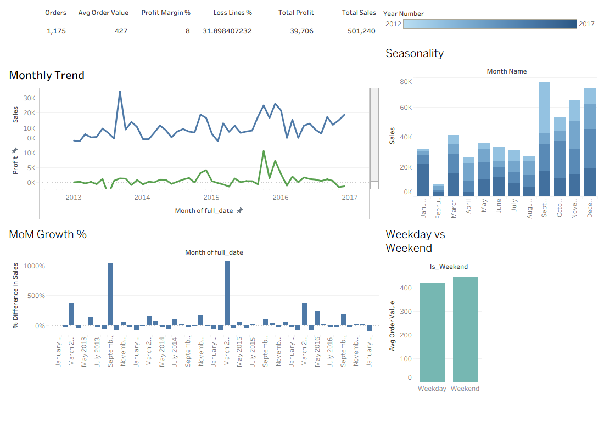
Figure 1. Dashboard 1 – Executive Overview

10.2 Dashboard 2 – Profitability
Seven sub-categories have negative margins, led by Furnishings (−25.6%), and the Furniture category as a whole loses 2,871 while Technology earns 33,697. The Canon imageCLASS 2200 Advanced Copier is the most profitable single product (8,400), while the GBC DocuBind P400 Electric Binding System is the largest loss maker (−3,049). The profit-health split shows 31.9% of lines at a loss, 9.9% at thin margin and 58.2% healthy. The clearest result is the discount curve: margin falls from 31.3% with no discount to 12.4% at 1–20%, −11.7% at 21–40% and −135.3% above 40%.
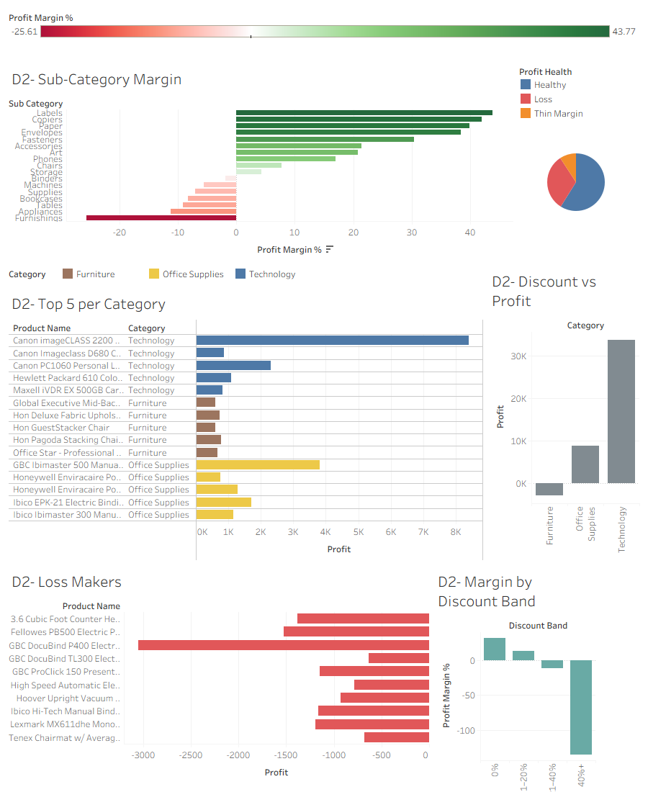
Figure 2. Dashboard 2 – Profitability

10.3 Dashboard 3 – Customer Analysis
The 629 customers split into 34 High Value, 361 Standard and 234 At Risk (Net Loss) customers; the At Risk share of 37% is the KPI that most deserves management attention. Average profit per customer is 26 for Consumer against 104 for Corporate and 103 for Home Office. The largest customer, Tamara Chand, generated 18,437 in sales and 8,745 in profit, while several large accounts (for example Becky Martin, with 10,540 in sales) are net-loss customers, so sales volume alone does not identify valuable customers. The RFM view classifies customers into Champions, Cooling Down, Lost and loyal-but-inactive groups for retention targeting.
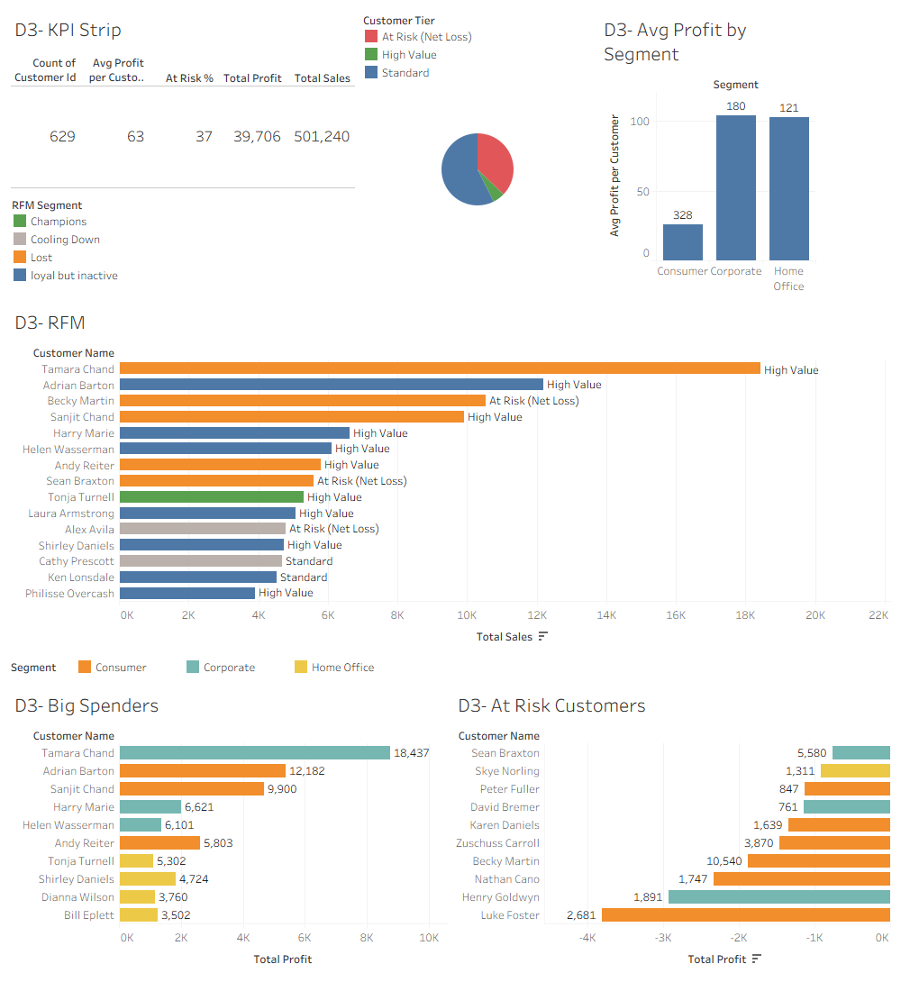
Figure 3. Dashboard 3 – Customer Analysis

10.4 Dashboard 4 – Operations & Geography
Geography explains most of the profit problem. Texas (sales 170,188, profit −25,729, margin −15.1%) and Illinois (sales 80,166, profit −12,608, margin −15.7%) together lose 38,337, while the other eleven states are all profitable with margins between 24.7% and 36.2%; Michigan is the largest contributor at 24,463. The cause is discounting: all 456 lines discounted by more than 40% sit in these two states, whose average discount is 37% and 39%, against under 0.1% in ten of the other states. On shipping, average delivery time is 0.03 days for Same Day, 2.32 for First Class, 3.33 for Second Class and 4.99 for Standard Class, so every ship mode meets the thresholds tested in Q12. Standard Class carries 61% of orders and 64% of sales, and margin by ship mode ranges only from 6.3% (First Class) to 8.8% (Second Class).
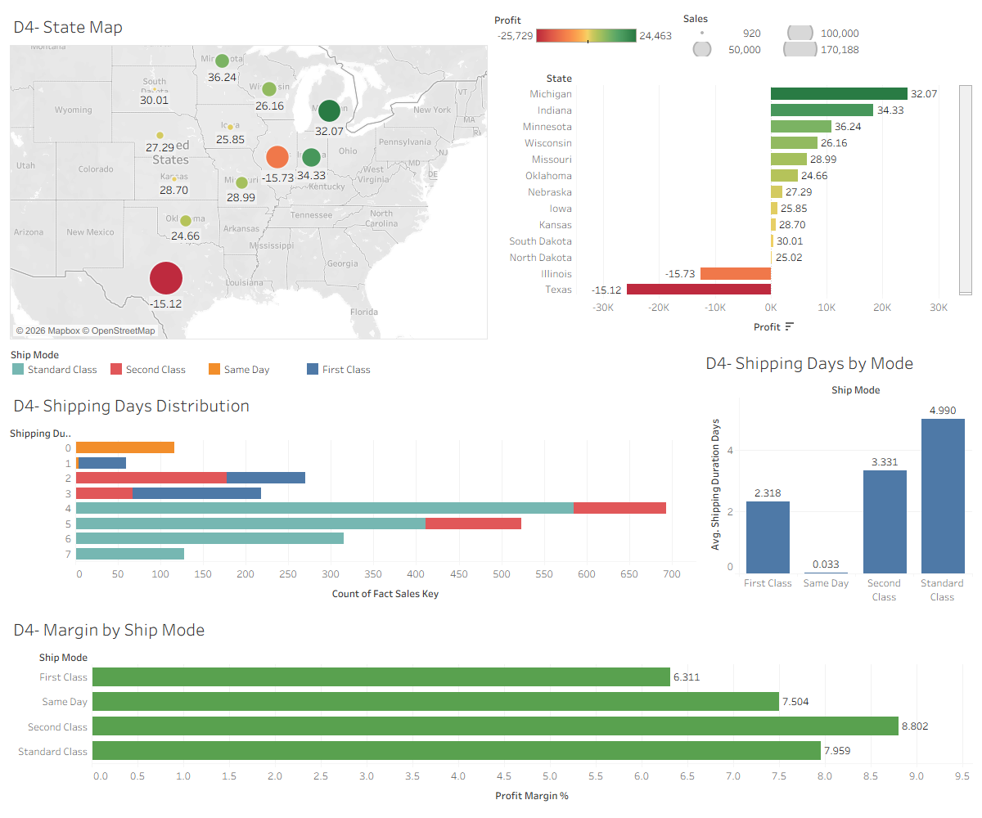
Figure 4. Dashboard 4 – Operations & Geography

10.5 Validation
Every headline figure on the dashboards was recomputed independently from Central_Superstore.csv with pandas and matches: 501,240 total sales, 39,706 total profit (7.92% margin), 1,175 orders, 629 customers, an average order value of 427, 31.9% loss lines, 234 At Risk customers (37.2%), Texas profit of −25,729 and Illinois profit of −12,608. The Section 8 narrative above was re-checked against the same recomputation.

11. Conclusion
The result is a small data warehouse that goes beyond the minimum technical checklist in every rubric category: 11 relational tables across all four layers, a proper star schema, 16 documented analytical queries, 3 KPI views, 2 parameterized stored procedures, a real orchestrated pipeline with run logging, a four-dashboard Tableau workbook, and a business-analytics narrative grounded in what the data actually shows rather than generic templated observations.

