Task 02

Smart Schematic

1. [Github project](https://github.com/MidooSalama/smart_shcematic)
2. Snapshots of working examples:

Figure 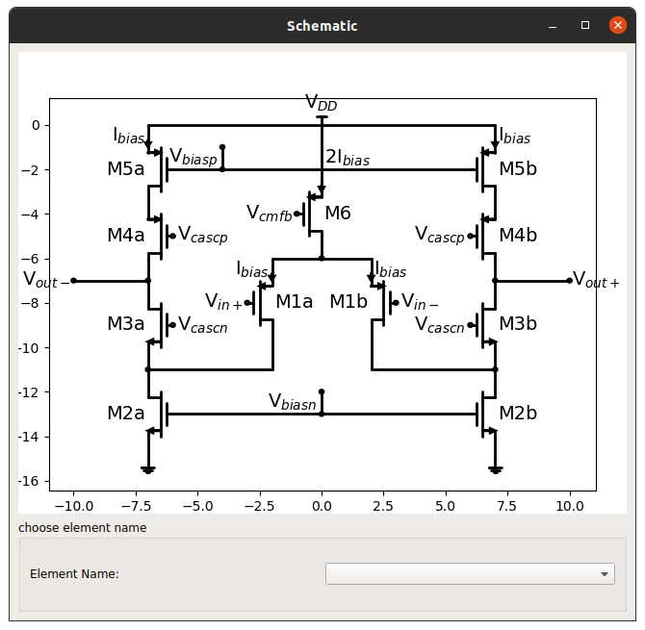1: the schematic

Figure 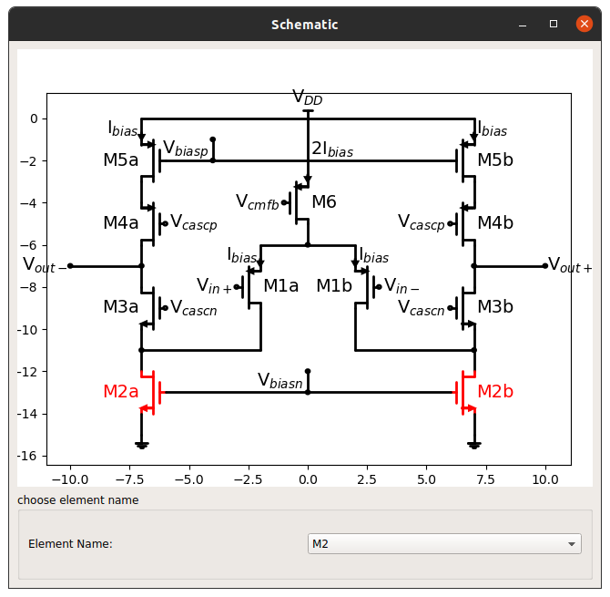2: the schematic with element M2 highlighted

Figure 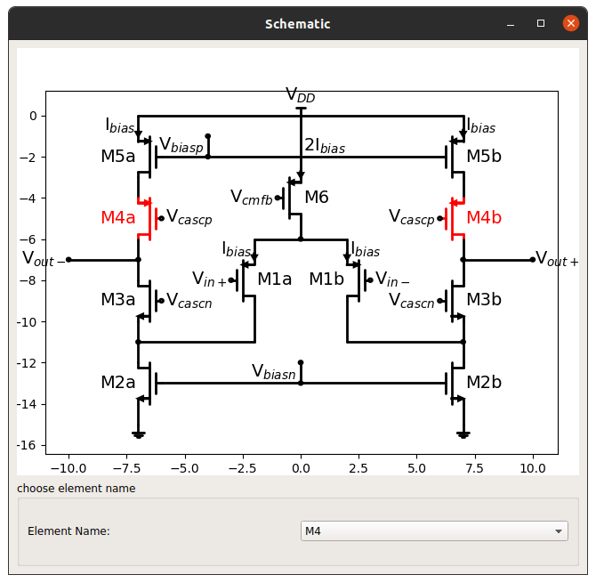3: the schematic with element M4 highlighted