Task 02
Smart Schematic

- Github project
- Snapshots of working examples:

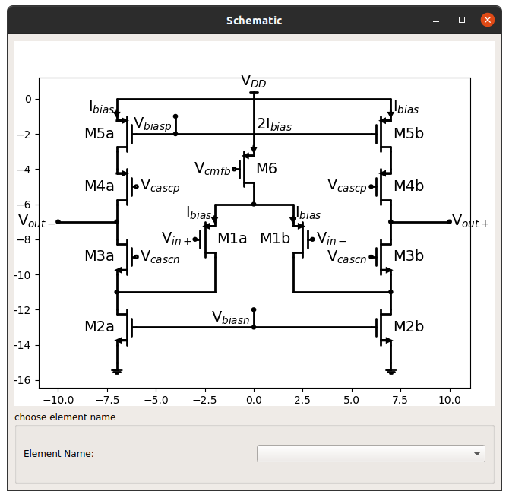Figure 1: the schematic

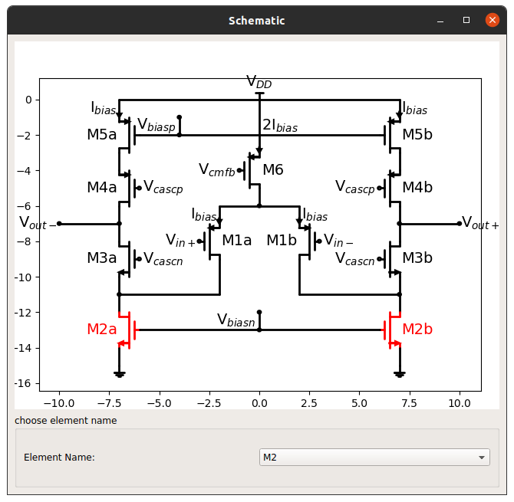Figure 2: the schematic with element M2 highlighted

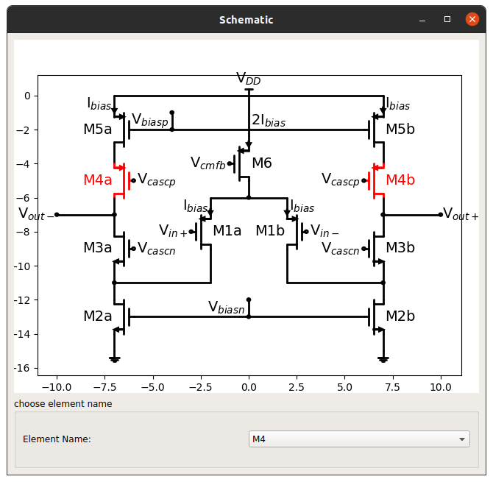Figure 3: the schematic with element M4 highlighted

