G-Synth: Small Sequence Design and Extended Sequence Design for auditable synthesis-ready DNA and post-sequencing validation
Software implementation and experimental validation with PCR-free insulin glargine A/B-chain constructs
Mohamed Merzougᵃ,* · Zohra Yasmine Zaterᵃ,ᵇ · Yasmine Saidiᵃ · Amaria Ilhem Hammadiᵃ · Marwa Airecheᵃ · Keltoum Bendidaᵃ · Hadjer Soumia Bouderbalaᵃ · Soheir Bouzidiᵃ · Djamal Saidiᵃ
ᵃ Higher School of Biological Sciences of Oran, BP 1042 Saim Mohamed, Cité Emir Abdelkader, 31000 Oran, Algeria
ᵇ Oran 1 University Ahmed Ben Bella, BP 1524 El M'Naouer, 31000 Oran, Algeria
* Corresponding author: Mohamed Merzoug; merzoug.mohamed@essb-oran.edu.dz

Abstract
Nucleic-acid design for synthesis is often fragmented across codon tools, restriction maps, plasmid editors and sequencing viewers, complicating proof that an ordered molecule is the one later cloned and assessed. We developed G-Synth, an open-source application and Python engine implementing host-selected codon optimization and two synthesis-centred workflows: Small Sequence Design (SSD) for one complementary oligonucleotide pair and Extended Sequence Design (ESD) for tiled, directional pairs. Both derive strand-specific restriction products and block release unless in-silico annealing and ordered ligation reconstruct both intended strands exactly. A staged Design→Hybridization→Restriction-cloning workflow exposes unpaired bases as cohesive ends in compact and nucleotide-level double-strand views, verifies complementarity with a digested vector and requires explicit ligation before product analysis. The same record supports editable annotation, PCR/digest/gel simulation and quality-aware Sanger validation. The separated engine, API and interface passed 1,098, 262 and 89 tests, respectively. In an experimentally grounded case study, SSD regenerated insulin glargine A- and B-chain constructs; all four oligonucleotides exactly matched archived synthesis records. NdeI/XhoI cloning into pET-21a(+) preserved the intended open reading frames and generated 5,490-bp and 5,523-bp recombinant plasmids. G-Synth assembled the four author-designated chromatograms into 100%-covered, 100%-identical consensus sequences. Bidirectional overlap was 56.1% for A and 71.2% for B, with 100% F/R agreement; independent Biopython analysis reproduced complete coverage and identity. The exact SSD/ESD release-gate combination was not identified in prior design-automation literature and is, to our knowledge, first automated and disclosed here. Protein expression, folding and bioactivity were not tested.
Keywords: synthetic biology; gene synthesis; restriction cloning; Sanger sequencing; software validation; insulin glargine.
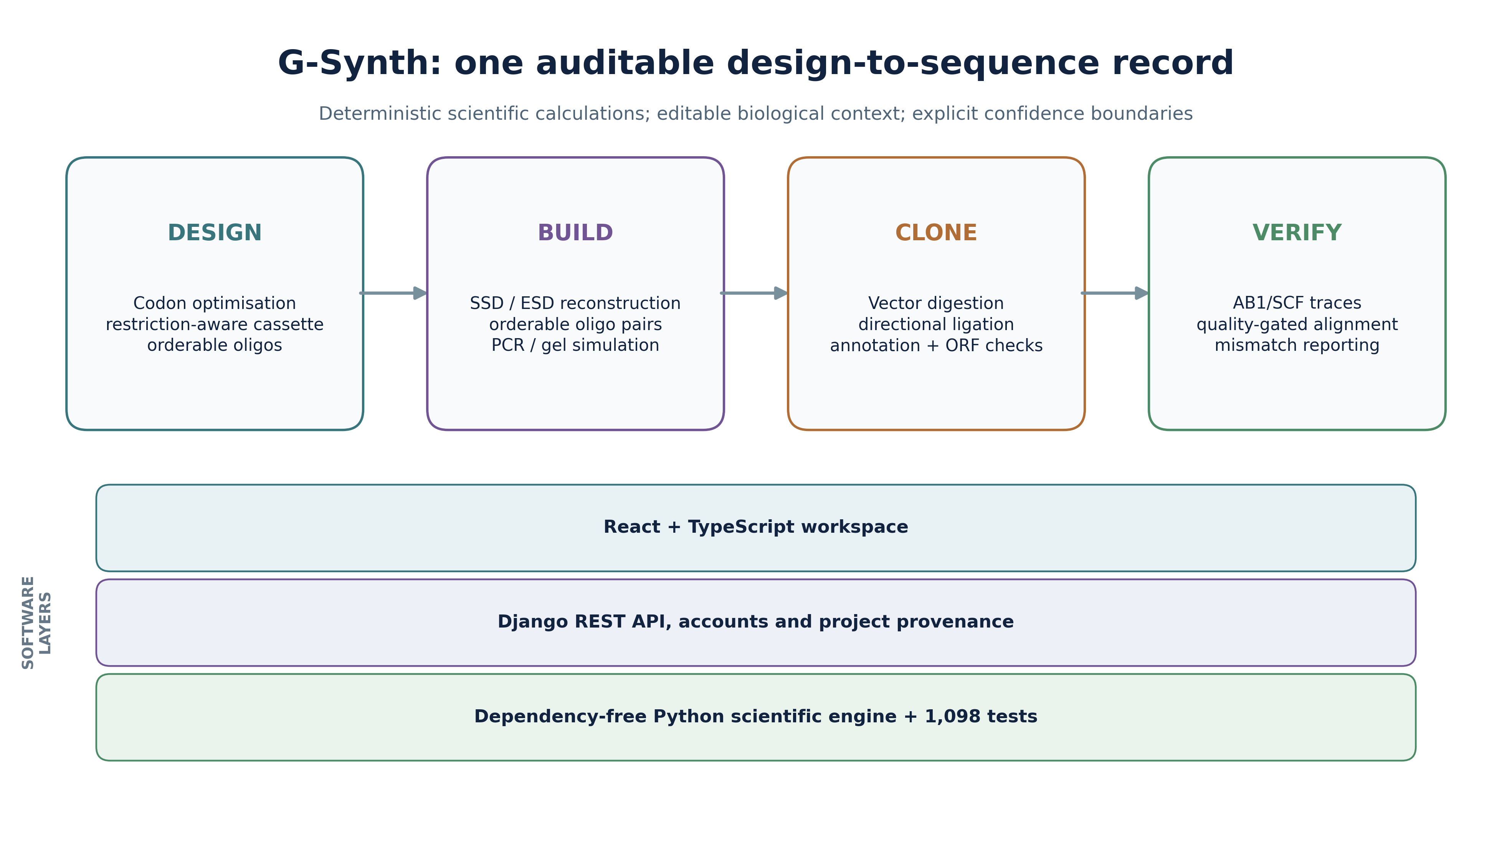
Figure 1. G-Synth workflow and software architecture. The design, build, clone and verify stages share a deterministic Python engine. The API stores project provenance and the web workspace renders the engine outputs without reimplementing biological calculations.

1. Introduction
Synthetic-biology design–build–test–learn cycles depend on an unbroken relationship between a digital construct and the molecules handled at the bench [13,58–60]. GeneDesign automates synthetic-gene design [61,62], j5 optimizes DNA-assembly plans [58], basicsynbio couples BASIC constructs to transferable build instructions [59], and DNA-BOT links a standardized scheme to laboratory automation [60]. Geneious provides broad commercial cloning and sequence analysis [65], whereas DIVA, CloneCoordinate and InSillyClo extend design–implementation–verification or campaign-level construction planning [69–71]. These systems establish that G-Synth cannot credibly be called the first general end-to-end DNA-construction platform. A distinct gap nevertheless remains for laboratories that order short coding constructs as complementary oligonucleotides: restriction sites may be treated as literal tails instead of strand-specific cut geometry; an enzyme-retained start codon may be duplicated; a reverse molecule may receive the wrong cohesive-end remainder; or an apparently plausible chromatogram may be reported as complete verification despite incomplete evidential support.
These problems require a workflow in which each exported sequence is derived from explicit molecular rules and then re-read from the simulated duplex. G-Synth therefore defines SSD for constructs released as one forward/reverse synthesis pair and ESD for longer constructs decomposed into multiple hybridized pairs joined by unique, directional internal overhangs. Their shared end-to-end unit is a traceable molecular record: biological target → synthesis-ready order molecules → reconstructed duplex → recombinant plasmid → annotated construct → sequencing evidence. The engine derives enzyme products from recognition and cut positions, constructs the full coding cassette, creates every strand, re-anneals and re-ligates the strands in silico, checks the outer ends and coding frame, simulates vector digestion and ligation, and maps capillary reads back to the same reference.
Insulin glargine A- and B-chain constructs offered a stringent retrospective case study because their long complementary oligonucleotides had been independently synthesized, hybridized, cloned into pET-21a(+), transformed into Escherichia coli DH5α and sequenced. The original draft used Benchling for reverse-complement operations and Geneious Prime for visual cloning and alignment. Here, those inputs and primary trace files were reanalysed with G-Synth as the primary system. The objectives were to (i) reproduce the exact archived orderable molecules from the optimized chain sequences; (ii) validate terminal-end geometry, junctions, open reading frames and plasmid context; (iii) assemble the physical F/R trace evidence and distinguish complete consensus coverage from bidirectional overlap; and (iv) compare G-Synth's focused, auditable workflow with established software categories.

2. Results: software design and implementation

2.1 Separation of scientific logic, service layer and interface
G-Synth comprises three layers (Figure 1). The gsynth_engine Python package contains sequence normalization, codon optimization, nearest-neighbour thermodynamics, enzyme definitions, duplex construction, multi-oligonucleotide assembly, PCR, cloning, ligation, annotation, gel simulation and read verification. It has no web-framework dependency. A Django REST API validates requests, applies access control and serializes immutable calculation outputs together with project provenance. A React/TypeScript workspace renders the outputs, supports editable annotations and guides the user through Design, PCR, Clone, Check, Compare and Learn. This separation makes the engine importable in scripts and permits molecular regression tests to execute without a database or browser.
Codon optimization is explicitly conditioned on the selected expression host. The bundled profiles cover Escherichia coli, Saccharomyces cerevisiae, Komagataella phaffii, Bacillus subtilis, Homo sapiens, Cricetulus griseus, Spodoptera frugiperda and Nicotiana benthamiana. Species-wide coding frequencies are normalized within each synonymous family; the E. coli default retains the Sharp–Li high-expression reference used to define CAI [81,82]. Every candidate is translated after optimization, and amino-acid identity is a blocking invariant. Because codon preference is strain-, tissue- and cell-line-dependent and cannot alone predict expression, G-Synth exposes the exact table source and accepts a documented user reference-gene set for context-specific analysis [81–83].

2.2 Restriction enzymes as cut geometry
An enzyme is represented by its recognition sequence and top- and bottom-strand cut offsets, not by a prewritten tail. From these offsets the engine derives overhang sequence, length and 5′/3′ polarity for either end of a linear fragment. This matters because the bases that remain on a forward oligonucleotide depend on whether an enzyme is placed at the left or right end and on which strand is ordered. The current enzyme table contains 109 enzymes and is exercised in both terminal positions. HindIII, for example, is rendered from A|AGCTT / TTCGA|A cut coordinates and therefore appears with the correct 5′ cohesive end rather than being lost by a recognition-site-only search. The enzyme-table checksum is stored in provenance records.

2.3 Coding cassette and PCR-free oligonucleotide design
In Small Sequence Design (SSD), the default expression cassette is ATG (unless the retained enzyme product supplies it), a flexible linker, 6×His tag, a second linker, a thrombin-recognition sequence and the user insert. A stop codon can be retained or added according to the intended downstream fusion. G-Synth checks translation, internal selected-enzyme sites, sequence composition, repeats and secondary-structure warnings. Melting temperatures use nearest-neighbour thermodynamics under recorded ionic and strand-concentration assumptions [80], not a GC-only formula.
Within the SSD single-pair length limit, G-Synth generates one forward and one reverse strand with the exact complementary core and asymmetric terminal cohesive ends. Extended Sequence Design (ESD) divides longer constructs into forward/reverse hybridized fragments joined through orthogonal 4–8-nt internal junctions. Every SSD or ESD proposal is simulated end to end: each pair is annealed; ESD fragments are ligated in the declared order; both reconstructed strands must equal the target; every internal overhang must be unique against its reverse complement; and the two outer products must equal the selected restriction-enzyme ends. Export remains blocked if any invariant fails.

2.4 Hybridization as the gate between design and cloning
Alignment and hybridization answer different questions and are therefore presented as separate modes in one workspace. Alignment may introduce gaps to compare sequence similarity; hybridization instead tests an ungapped antiparallel placement of two molecules entered 5′→3′. G-Synth reverse-complements the second input only for the physical drawing, marks every complementary pair and mismatch, and leaves terminal displacement visible as a strand-specific 5′ or 3′ overhang. The simple view summarizes the duplex core and both ends, whereas the detailed view shows every base, coordinate and polarity. Melting temperature is reported only for a perfectly matched overlap under explicit strand, Na⁺, Mg²⁺ and temperature conditions; it is withheld for mismatched duplexes because the implemented nearest-neighbour model does not include mismatch parameters [80].
A verified SSD or ESD design can be transferred directly to this view with its left and right enzyme identities. Editing either enzyme invalidates the inherited molecules and requires redesign, preventing a sequence from being relabelled with ends it does not possess. Only an exactly complementary duplex can continue to cloning. This implements a visible state transition from an orderable pair, through simulated annealing, to an insert whose exposed ends can be compared with the independently digested vector.

Figure 2. G-Synth hybridization view after direct transfer from SSD. Both order molecules remain entered 5′→3′; the lower strand is drawn antiparallel. The 123-bp core is completely paired, while the NdeI-derived 5′-TA and XhoI-derived 5′-TCGA products remain visibly unpaired as cohesive ends.

2.5 Cloning, annotation and virtual experiments
The cloning module imports FASTA, GenBank and SnapGene DNA files and includes verified pET-21a(+) and pET-21(+) sequences. It checks vector identity, requires each selected enzyme to cut once and presents the workflow as Vector + duplex Insert → Product. Before ligation, six compatibility checks report strand pairing, unique vector cuts, orientation, site regeneration and reading-frame consequences. Simple and detailed junction views place each exposed insert end beside the complementary vector end. The product map, diagnostic gel and exports remain hidden until the user explicitly selects Ligate compatible ends; this button simulates joining the phosphodiester backbone and is not represented as an experimental ligation. The coordinate-level annotated view handles circular-origin crossings, strand direction and codon-aligned translation. Curated exact matches to common promoters, operators, tags, linkers and cleavage motifs are suggestions, not silently accepted claims; users can create, name, move or delete features and preserve edits in GenBank export.
PCR simulation separates a primer's annealing 3′ segment from its intentionally unpaired 5′ extension. The extension becomes part of the amplicon only after polymerase copying, a distinction shown explicitly in the hybridization view. Diagnostic digests produce fragment sizes from the simulated molecule, and virtual gels position those products relative to explicit 100-bp, 1-kb and broad-range marker lists. These gels are labelled as in-silico predictions because migration, topology, partial digestion, staining and band intensity are experimental properties.
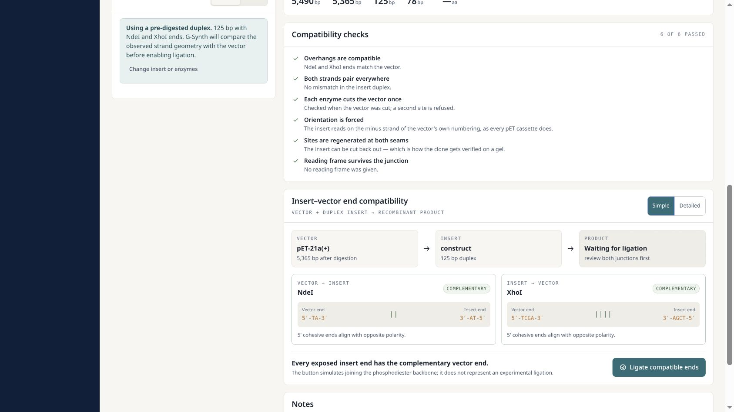
Figure 3A. Pre-ligation compatibility gate. G-Synth shows the NdeI and XhoI vector–insert junctions, their opposite polarities and all six passed checks while withholding recombinant-product analyses.
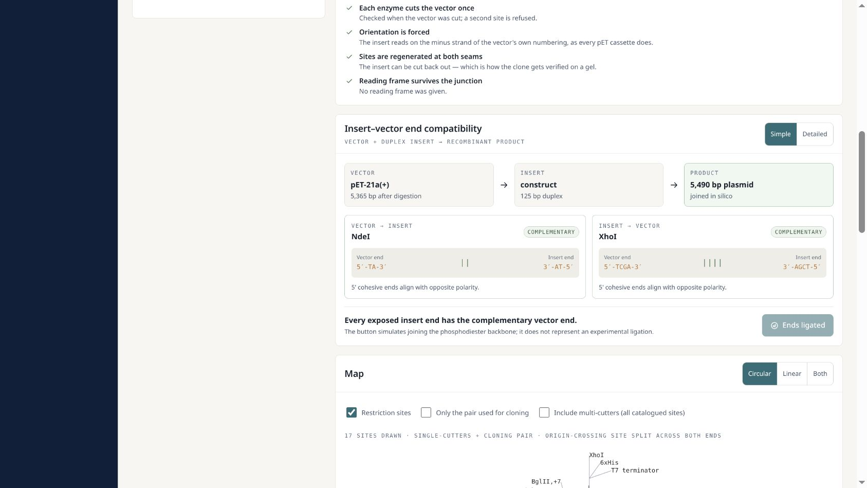
Figure 3B. Post-ligation state for the glargine A-chain construct. The 5,490-bp product is created only after explicit in-silico ligation, after which the plasmid map, diagnostic digest, gel and exports become available.

2.6 Quality-aware capillary-trace verification
G-Synth detects ABI/ABIF and Standard Chromatogram Format (SCF) content, reads called bases, qualities, peak positions and the four fluorescence channels, evaluates both orientations and aligns reads to a linear or circular reference. Forward and reverse calls are transformed into reference orientation and assembled position by position; equal-support conflicts remain N rather than being resolved in favor of the reference. The interface reports assembled-consensus coverage, consensus identity, the fraction supported by both orientations and F/R agreement within that overlap as distinct quantities. Reference-aligned chromatograms display consensus, strand, base qualities, four-channel peaks and mismatches. Optional user-selected quality trimming is retained for prospective workflows, but quality thresholds must be predefined for the relevant instrument, basecaller and study rather than imposed retrospectively. Phred-style quality values are treated as estimates of base-call error probability [78,79].

2.7 Originality and application scope
The originality of G-Synth is the formalization and automation of SSD and ESD, not the invention of restriction cloning, codon optimization, oligonucleotide synthesis or Sanger sequencing individually. GeneDesign, j5, DNA Chisel, basicsynbio, DIVA, CloneCoordinate and InSillyClo provide important but differently scoped automation [58–63,69–71]. In the literature reviewed through 2 September 2026, no system was found that defines SSD and ESD as synthesis-order workflows and requires exact reconstruction of both intended strands from their exported molecules before release, while carrying the same hashed design through restriction cloning and F/R capillary consensus. We therefore describe G-Synth as the first disclosed automation of these specifically defined workflows, to our knowledge, rather than as the first general DNA-design or end-to-end construction platform.
This focus supports applications in which small or modular DNA constructs must move rapidly from concept to synthesis: therapeutic-peptide precursors; affinity-tag and protease-cleavage cassettes; vaccine or diagnostic antigens; peptide standards and positive controls; recombinant growth factors, cytokine fragments and antimicrobial peptides; enzyme domains; regulatory elements; reporter constructs; and modular synthetic-biology parts. The glargine A/B case study is especially relevant because therapeutic peptides impose simultaneous constraints on exact amino-acid identity, purification architecture, cleavage logic, reading frame and post-cloning verification. G-Synth addresses the DNA design-to-sequence portion end to end. Expression yield, processing, oxidative folding, higher-order structure, potency, safety and regulatory comparability remain separate experimental stages.

3. Validation results
Validation combined unit, property, API and interface tests with a retrospective experimental case study. The engine suite contains golden examples, error-path tests, host-profile invariants, enzyme-wide properties and antiparallel-hybridization cases covering 5′/3′ overhangs, blunt ends, ambiguity, mismatches and thermodynamic reporting boundaries. The defining assembly property is equality between the intended construct and both strands reconstructed from the exported oligonucleotides. API tests cover request validation, host selection, serialization, authentication, projects, sequence import, hybridization, PCR and security. Interface tests cover the design and validation views, host-profile selection, automatic Design-to-Hybridization-to-Restriction-cloning handoff, simultaneous compact and nucleotide-level duplex evidence, editable annotations, primer-tail hybridization, gels, Learn content and responsive behaviour. The complete suites were executed from the manuscript working tree on 2 September 2026: 1,098/1,098 engine, 262/262 API and 89/89 interface tests passed.
Validation layer | Primary question | Result
Molecular engine | Do algorithms preserve molecular invariants and reject invalid inputs? | 1,098 passed
HTTP/API | Are calculations exposed consistently with accounts, projects and security controls? | 262 passed
Web interface | Are outputs rendered and interactions retained without reimplementing biology? | 89 passed
Insulin glargine design | Do archived A/B inputs regenerate the four molecules synthesized at the bench? | 4/4 exact
Cloning simulation | Are NdeI/XhoI ends, junctions and ORFs coherent in pET-21a(+)? | A and B passed
Sequencing evidence | Do oriented F/R reads assemble across each insert and agree in their overlap? | 100% consensus coverage and identity; 100% overlap agreement

4. Insulin glargine A/B-chain case study

4.1 Input sequences and cassette logic
The optimized A-chain coding insert was 66 bp and encoded GIVEQCCTSICSLYQLENYCG; the B-chain insert was 99 bp and encoded FVNQHLCGSHLVEALYLVCGERGFFYTPKTRR. The second sequence includes the two C-terminal arginine residues characteristic of insulin glargine's B-chain precursor context. For each construct, G-Synth placed the insert after MGSSHHHHHHSSGLVPRGS, retained TAA termination and selected NdeI at the 5′ end and XhoI at the 3′ end. NdeI's retained bases supply the initiating ATG, so adding a separate ATG would duplicate the start. The resulting products were MGSSHHHHHHSSGLVPRGSGIVEQCCTSICSLYQLENYCG and MGSSHHHHHHSSGLVPRGSFVNQHLCGSHLVEALYLVCGERGFFYTPKTRR.

Figure 4. G-Synth design view for the glargine A-chain input. The release gate reports exact two-strand reconstruction, terminal-end compatibility and the NdeI start-codon note before displaying the orderable construct.
Metric | A-chain construct | B-chain construct
Optimized chain insert | 66 bp | 99 bp
Forward / reverse oligo | 125 / 127 nt | 158 / 160 nt
Forward / reverse GC | 56.8 / 57.5% | 57.0 / 57.5%
Forward / reverse Tm | 83.4 / 84.1 °C | 84.6 / 85.1 °C
Observed terminal products | 5′ TA / 5′ TCGA | 5′ TA / 5′ TCGA
Exact match to archived synthesis record | Forward and reverse | Forward and reverse
Recombinant pET-21a(+) length | 5,490 bp | 5,523 bp
Junction restriction sites | NdeI and XhoI regenerated | NdeI and XhoI regenerated

The reverse oligonucleotide is two nucleotides longer than the forward molecule in each pair (127 versus 125 nt for A; 160 versus 158 nt for B). This is an expected consequence of the strand-specific cohesive-end remainders, not a discrepancy. All four generated sequences were identical to the corresponding archived order records, and the complementary cores reconstructed without mismatch.

4.2 pET-21a(+) cloning and feature-level validation
G-Synth digested the bundled pET-21a(+) sequence with NdeI and XhoI, checked the insert's physical ends and simulated directional ligation. Both junctions were compatible and regenerated their recognition sites. The A and B recombinant molecules were 5,490 bp and 5,523 bp. Translation from the NdeI-supplied ATG reached the intended TAA without frameshift. Because the inserts terminate before the vector's downstream coding region, the pET-21a(+) C-terminal His tag is not translated; the designed N-terminal 6×His cassette remains present. Similarly, cloning at NdeI replaces the vector's optional N-terminal T7 tag with the designed cassette. These are sequence consequences, not predictions of expression, solubility, cleavage efficiency or biological activity.
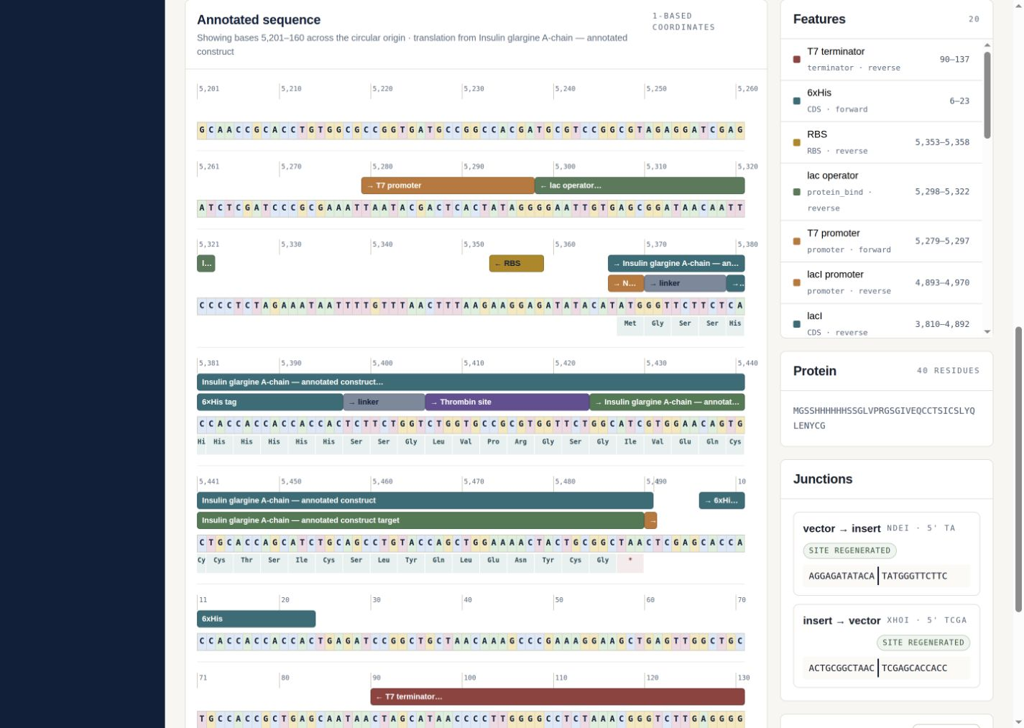
Figure 5A. G-Synth coordinate-level view of the insulin glargine A-chain recombinant pET-21a(+) construct. Editable feature tracks, codon-aligned translation and the regenerated NdeI and XhoI junctions are shown across the circular origin.
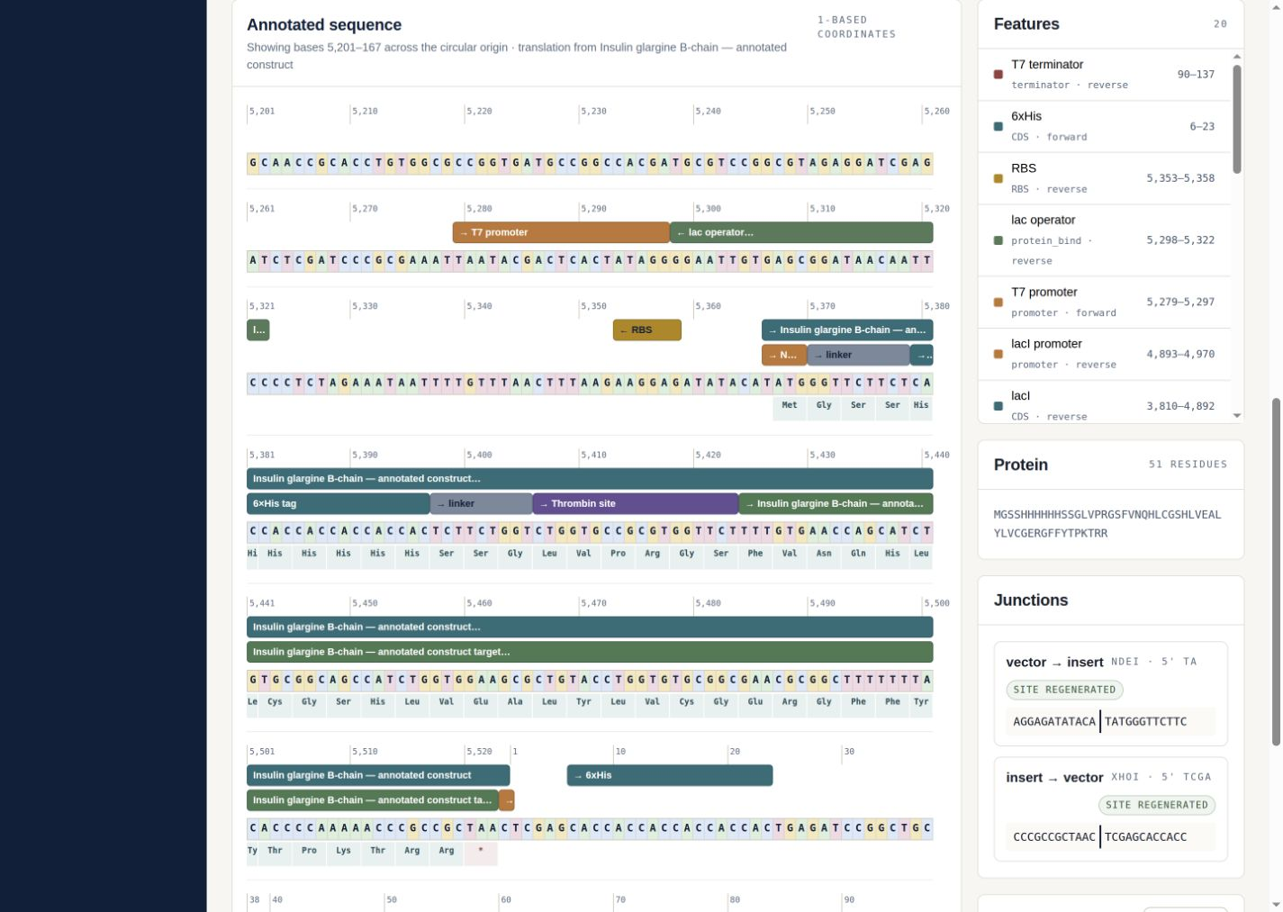
Figure 5B. G-Synth coordinate-level view of the insulin glargine B-chain recombinant pET-21a(+) construct, using the same editable annotation and strand-aware coordinate system.

4.3 Experimental synthesis and cloning evidence
The retrospective data originated from an independent wet-laboratory project at the Genomics Technology Platform of the Higher School of Biological Sciences of Oran. Forward and reverse strands were synthesized on a MerMade 4 instrument at 1 µmol scale, purified, and annealed in 2× SSC with 0.1% SDS after 5 min at 95 °C followed by gradual cooling. The source draft reports single-stranded concentrations of 1,688.51–1,709.40 ng/µL. After hybridization, ScanDrop 260/280 ratios were 1.92 for A and 1.88 for B; Bioanalyzer sizes were 129 bp and 173 bp. These apparent sizes exceed the 123-bp and 156-bp duplex references and should be interpreted within the sizing limitations of the assay rather than as base-resolved sequence evidence.
pET-21a(+) was double-digested with NdeI and XhoI, gel-purified and ligated to each hybridized insert at a nominal 3:1 insert:vector molar ratio. Ligation products were transformed into E. coli DH5α and selected on ampicillin. Colony PCR and capillary sequencing were performed as described in the source experimental record. The present software paper reuses these physical observations as a case study but does not claim expression, purification, oxidative refolding, receptor activity or therapeutic equivalence.

4.4 Post-sequencing validation by G-Synth
Validation was restricted to the four author-designated correct files: A Forward Seq.ab1, A Reverse Seq.ab1, B Forward Seq.ab1 and B Reverse Seq.ab1. No other chromatogram was admitted. The reads were analysed against the 123-bp A and 156-bp B cassette references. Although the filenames used the .ab1 extension, binary magic-number inspection identified SCF content; G-Synth therefore parsed the files by content rather than extension. For each chain, the forward and reverse read were independently placed, reverse-complemented when required, clipped to the reference and merged position by position into a reference-guided consensus. Consensus coverage denotes positions with at least one oriented call; bidirectional overlap denotes positions called from both orientations; overlap agreement denotes the fraction of those positions with identical F/R calls. Because the source experiment did not prespecify a trace-quality threshold, consensus coverage, identity and overlap agreement were the primary retrospective endpoints; a fixed-threshold quality analysis was retained only as supplementary sensitivity information.
Chain | Reference | Consensus coverage | Consensus identity | Consensus differences | F/R overlap | F/R agreement | Independent coverage
A | 123 bp | 100.0% | 100.0% | 0 | 56.1% | 100.0% | 100.0%
B | 156 bp | 100.0% | 100.0% | 0 | 71.2% | 100.0% | 100.0%

The assembled consensus covered 100% of both references with 100% identity and no consensus differences. A contained 56.1% bidirectional overlap and B contained 71.2%; all overlapping F/R calls agreed (100%). Thus the paired reads jointly span each complete insert reference, while the overlap is independently observed on both orientations. Independent local alignments in Biopython 1.87 reproduced 100% combined coverage and 100% identity across aligned bases. The archived Geneious Prime figures reported visually concordant alignments but were not re-executed in the scripted environment.
Scientific interpretation
The oriented F/R assembly establishes complete consensus coverage, 100% identity and perfect agreement wherever the two reads overlap. This validates the intended A- and B-chain insert sequences at consensus-call level. It does not imply that every position was independently observed from both orientations, and the insert-only references do not test both vector–insert junctions; a prospective validation study should address those additional endpoints with predefined sequencing criteria.

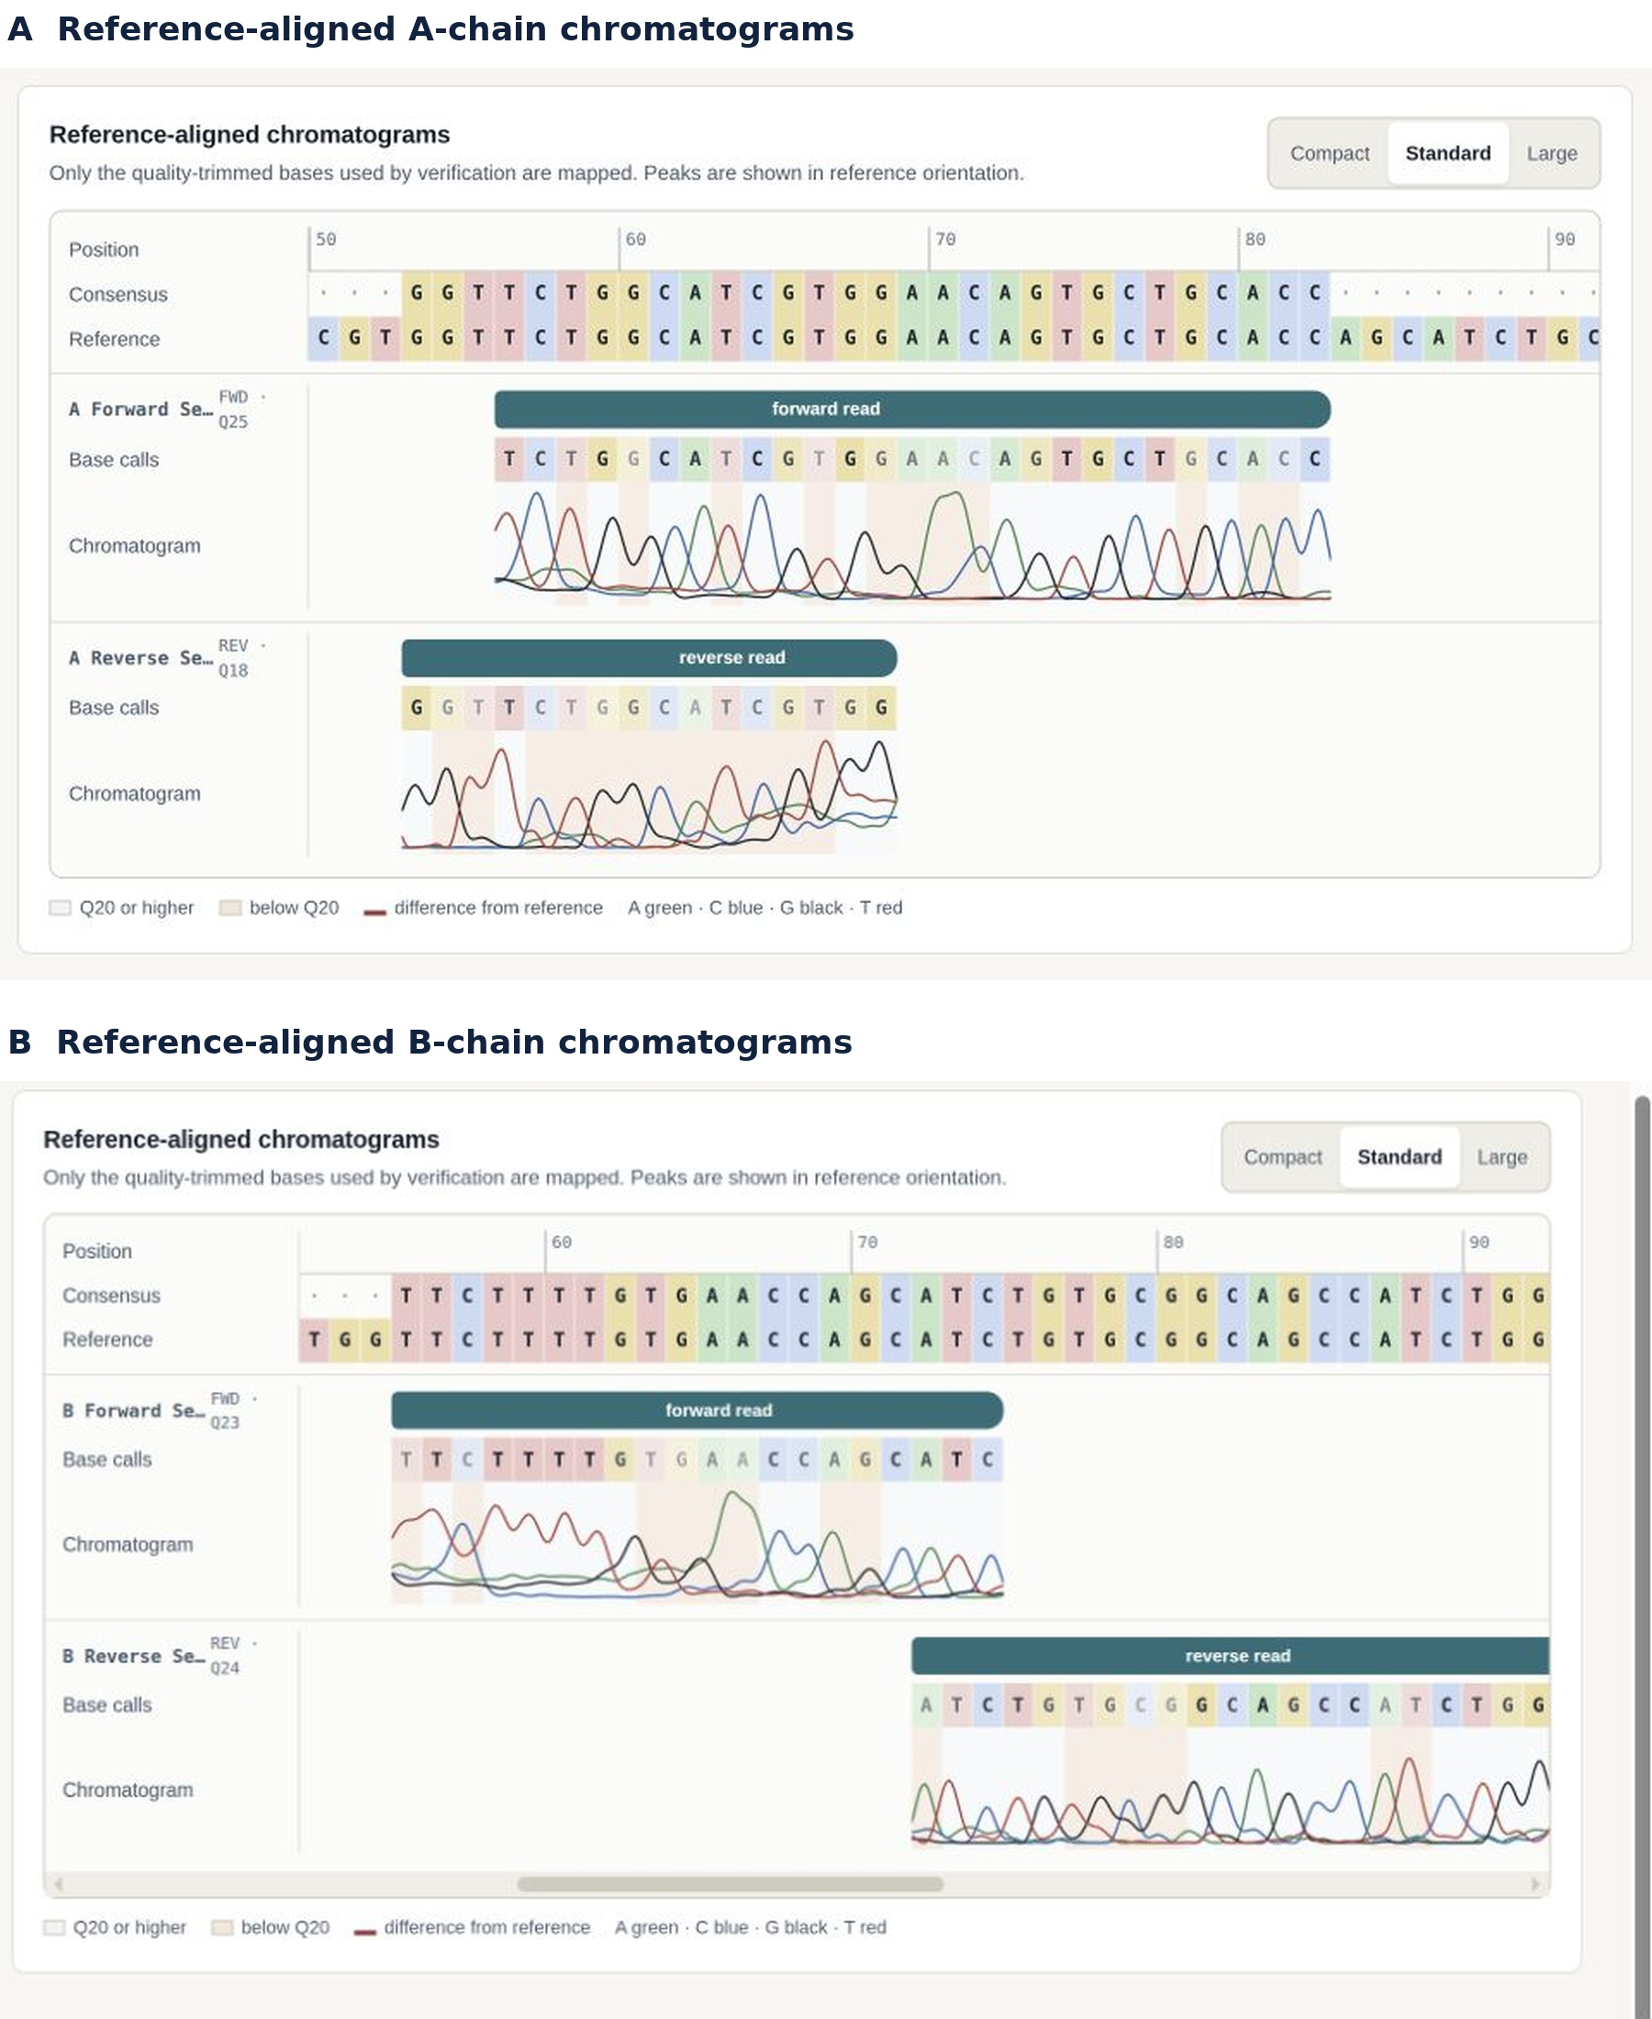
Figure 6. G-Synth's interactive reference-aligned chromatogram view for representative approved A- and B-chain reads. Base calls, consensus, quality context and four-channel peaks are displayed in reference orientation.
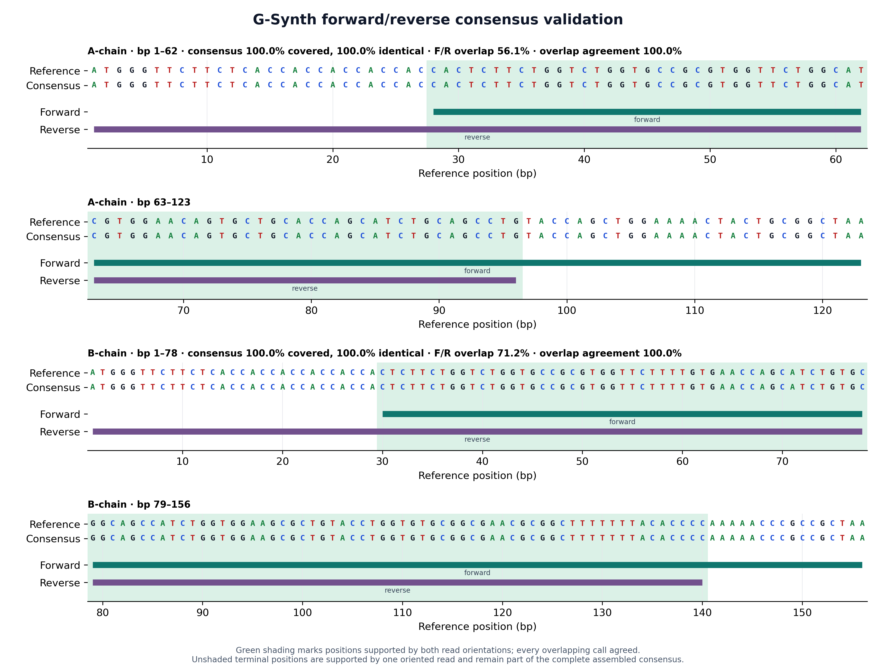
Figure 7. G-Synth F/R consensus validation from the four author-designated chromatograms. The oriented reads jointly cover 100% of both references with 100% consensus identity. Green shading marks bidirectional overlap (56.1% for A and 71.2% for B); every overlapping F/R call agreed.

5. Relationship to existing software
The comparison below separates G-Synth's precise contribution from adjacent functionality. GeneDesign and DNA Chisel focus on synthetic-sequence design and optimization [61–63]; j5, basicsynbio and DNA-BOT address assembly planning or build automation [58–60]; Geneious is a broad commercial environment [65]; DIVA, CloneCoordinate and InSillyClo cover increasingly integrated construction workflows [69–71]; and Biopython supplies reusable analysis primitives [66]. G-Synth is narrower than several of these systems. Its contribution is the coupled SSD/ESD synthesis-order model, exact two-strand release gate and continuity into post-Sanger consensus.
Tool/category | Primary scope | Relationship to SSD/ESD claim
G-Synth | SSD/ESD order molecules, restriction geometry, exact reconstruction, cloning and F/R consensus | Implements the claimed workflows and blocks export when molecular invariants fail
GeneDesign / DNA Chisel | Synthetic-gene design and sequence optimization | Foundational prior art for design automation; no identical SSD/ESD release gate identified
j5 / basicsynbio / DNA-BOT | Assembly design, standardized parts and laboratory build instructions | Broader or method-specific assembly automation; not the same synthesis-order abstraction
Geneious Prime | Broad commercial cloning, annotation and sequence analysis | Secondary qualitative comparator; no automated head-to-head benchmark was executed
DIVA / CloneCoordinate / InSillyClo | Integrated construction planning, coordination or Golden Gate/MoClo campaigns | Directly limits any general end-to-end novelty claim; distinct from the exact SSD/ESD gate
Biopython | Programmatic parsing, alignment and molecular-biology primitives | Independent executable numerical comparator; equivalent logic can be scripted

This table is a workflow-positioning comparison, not a speed or accuracy benchmark. No proprietary Geneious algorithm was reverse-engineered, and no claim is made that G-Synth has broader functionality. Instead, the archived Geneious views provide an independent qualitative check, while the numerical cross-check uses openly scriptable Biopython alignment. A future prospective benchmark should use blinded constructs, identical trimming thresholds and predefined acceptance criteria across platforms.

6. Discussion
The insulin case study demonstrates a useful distinction between design correctness, complete assembled coverage and bidirectional support. The exact match between four G-Synth-generated oligonucleotides and the archived synthesis records, together with correct duplex reconstruction and pET-21a(+) junctions, establishes that the application's design logic reproduces the intended molecular plan. G-Synth's F/R assembly yields complete consensus coverage, 100% identity and 100% agreement across the bidirectional overlaps. Positions outside those overlaps are supported by one oriented read rather than two, a distinction the software reports explicitly instead of obscuring within a single coverage value.
Restriction-aware design is particularly vulnerable to plausible-looking errors because recognition sites are visually familiar while cleavage products are strand-specific. Storing cut positions and calculating remainders avoids pair-specific tail constants. Reading the ends back from the reconstructed molecule adds an independent internal check. The same philosophy applies to primer extensions and virtual gels: G-Synth shows what the model establishes and labels what remains experimental.
Several limitations define the scope. First, long-oligonucleotide chemical synthesis can produce truncations and heterogeneous products; computational exactness does not predict synthesis yield or purification success. Second, orthogonal internal overhangs reduce one class of misassembly but do not model ligation kinetics. Third, restriction-cloning simulation does not predict methylation sensitivity, star activity, buffer compatibility, partial digestion or topology-dependent migration. Fourth, codon optimization and ORF integrity do not establish expression, folding, disulfide formation or insulin receptor activity. Separate production of A and B chains requires validated purification, cleavage, oxidative assembly, structural characterization and bioactivity studies [6–9,35,36,45–47,50,54–57]. Finally, the retrospective traces require prospective confirmation with predefined quality criteria and outside-vector primers spanning both junctions.
The appropriate next validation step is a preregistered, prospective design-to-sequence study. At least three independent constructs should include the NdeI/XhoI glargine path, a mixed 5′/3′ cohesive-end path and an internal-site negative control. Required records should include exported oligos, enzyme and vector lots, uncut/single-cut/double-cut controls, colony screening, raw capillary files, full junction and insert coverage, and independent review. User-centred validation with bench scientists should be reported separately from algorithmic correctness.

7. Conclusions
G-Synth formalizes Small Sequence Design and Extended Sequence Design as auditable synthesis-order workflows and carries the same digital molecule through host-selected codon optimization, oligonucleotide ordering, exact reconstruction, explicit hybridization, staged ligation, editable annotation, virtual PCR/digest/gel experiments and quality-aware post-sequencing review. The software passed 1,449 automated tests across its engine, API and interface. In the insulin glargine case study, SSD exactly regenerated all archived A/B oligonucleotides, produced coherent NdeI/XhoI recombinant pET-21a(+) designs and assembled the approved F/R chromatograms into 100%-covered, 100%-identical consensus sequences with perfect agreement in their bidirectional overlaps. The central contribution is not generic end-to-end software, but the first disclosed automation, to our knowledge, of the specifically defined SSD/ESD two-strand release gate and its continuity into post-sequencing evidence.

8. Materials and Methods

8.1 Reproducible software analyses
The design and cloning case study was executed with tools/publication/design_glargine_case_study.py. The script records the source-manuscript SHA-256 hash, regenerates the oligonucleotides, asserts exact equality with the archived Table 3 molecules, translates the cassette, simulates pET-21a(+) cloning and writes publication_evidence/glargine_ab_design_and_cloning.json. Trace reanalysis was executed with tools/publication/validate_insulin_correct_traces.py, which admits only the four author-designated files, hashes every reference and trace, constructs oriented G-Synth F/R consensus sequences, quantifies bidirectional overlap and agreement, performs an independent Biopython 1.87 local alignment and writes a JSON evidence record plus figure. Full commands are supplied in the Supporting Information.

8.2 Computational hybridization and staged ligation
Both hybridization inputs were normalized as unambiguous DNA written 5′→3′. The second was reverse-complemented for offset evaluation, and every ungapped antiparallel placement was scored as twice the number of complementary columns minus three times the number of mismatches. Deterministic ties favoured more pairs, fewer mismatches, longer overlap, fewer terminally unpaired bases and the placement closest to flush. Internal gaps were not introduced because they represent bulges rather than terminal cohesive ends. Unpaired terminal intervals were classified by strand, side, polarity and sequence; overlaps shorter than four complementary bases were reported as insufficient. Perfect overlaps were evaluated with the implemented SantaLucia nearest-neighbour and Owczarzy salt-correction model under recorded buffer conditions; mismatched overlaps were not assigned a melting temperature.
For cloning handoff, the inherited duplex, enzyme pair and provenance were transferred without rewriting the strands. The vector was independently cut at the two selected unique sites. G-Synth compared the polarity and reverse-complement sequence of both insert–vector end pairs, then evaluated duplex pairing, cut uniqueness, orientation, regenerated sites and coding frame. Recombinant maps and downstream virtual analyses were enabled only after an explicit in-silico ligation state transition.

8.3 Biological inputs, cassette design and G-Synth analysis
Insulin glargine A- and B-chain amino-acid sequences were retrieved from DrugBank record DB00047 (database version 5.1.10). The primary experimental study used GenScript reverse translation and the VectorBuilder codon-optimization tool for Escherichia coli; the exact optimized nucleotide inputs were preserved unchanged. Each cassette comprised an initiating ATG, the N-terminal peptide MGSSHHHHHHSSGLVPRGS (6×His tag, linkers and thrombin-recognition segment), the optimized glargine chain and TAA. G-Synth SSD took the preserved optimized sequence as input, derived NdeI- and XhoI-compatible strand products from cut geometry, generated the order molecules, re-annealed them in silico, verified exact reconstruction on both strands, translated the reconstructed coding sequence, and simulated directional insertion into pET-21a(+). Benchling and ExPASy operations reported in the primary draft are retained as historical design provenance; the present validation was performed first in G-Synth.

8.4 Oligonucleotide synthesis, deprotection and purification
Forward and reverse A- and B-chain oligonucleotides were synthesized at the ESSBO Genomics Technology Platform by phosphoramidite chemistry on a MerMade 4 synthesizer (LGC Biosearch Technologies, Hoddesdon, UK) using Universal Support Columns, DMT-off (N-iPr), 1000 Å and 1 µmol scale. The source program comprised acetonitrile initialization washes; two deblocking deliveries of 3% trichloroacetic acid in dichloromethane; activator/amidite coupling in two subinjection stages; acetonitrile washing; Cap A and Cap B deliveries; iodine oxidation; final deblocking and washing; and cleavage/deprotection in 1 mL concentrated ammonia for 18 h at 70 °C. All volumes, durations and equalization times are reproduced without omission in Table S5.
Purification used an equal volume of butanol prechilled to −20 °C, 30 s vortexing, 30 min at −20 °C and centrifugation at 14,000 rpm for 15 min at 4 °C. Pellets were washed twice with 1 mL of 70% ethanol at −20 °C; each wash was followed by 10 min at 14,000 rpm and 4 °C. Pellets were air-dried for 10–15 min and resuspended in ultrapure sterile water. Purity and concentration were assessed by ScanDrop spectrophotometry (Analytik Jena) and 2% agarose gel electrophoresis at 100 V for 45 min. Rotor radius was not recorded; consequently rpm cannot be converted reproducibly to relative centrifugal force.

8.5 Hybridization and analytical quality control
The 20× SSC stock contained 3 M NaCl and 0.3 M sodium citrate and was adjusted to pH 7.0. For each duplex, 10 µL of each purified complementary strand was combined with 20 µL of 2× SSC containing 0.1% SDS, heated at 95 °C for 5 min and cooled gradually to room temperature over 30 min. Samples were stored at 4 °C for short-term use or −80 °C for long-term storage. Duplex concentration, purity and apparent size were assessed by ScanDrop, 2% agarose electrophoresis (100 V, 45 min) and an Agilent 2100 Bioanalyzer with DNA 1000 reagents (25–1000-bp stated range; ±5% sizing resolution; 15% quantitation CV for 100–500 bp).

8.6 Vector preparation, ligation, transformation and clone screening
pET-21a(+) was digested in 50 µL containing 1 µg vector, 1 µL NdeI (10 U/µL), 1 µL XhoI (10 U/µL), 5 µL 10× CutSmart buffer and nuclease-free water for 2 h at 37 °C. The digest was resolved on 1% agarose and gel-purified with an Invitrogen kit. Ligation used a 3:1 insert:vector molar ratio calculated with NEBioCalculator, 50 ng digested vector, the calculated insert quantity, 1 µL T4 DNA ligase (400 U/µL), 2 µL 10× ligase buffer and water to 20 µL; reactions were held at 16 °C for 2 h and 4 °C overnight. Ligation products were assessed by ScanDrop, Bioanalyzer and 2% agarose electrophoresis (100 V, 45 min).
Competent E. coli DH5α cells were heat-shocked for 50 s at 42 °C, recovered in SOC medium and plated on LB agar containing 100 µg/mL ampicillin. Colonies were screened by PCR using both T7 and insert-specific primer pairs. Positive clones were subjected to plasmid miniprep (Thermo Fisher Scientific) and capillary sequencing. LB medium and ampicillin were from Sigma-Aldrich; SOC medium and DH5α cells were from Thermo Fisher Scientific.

8.7 Capillary sequencing, G-Synth consensus and secondary confirmation
Each 20-µL BigDye Terminator v3.1 reaction contained 20 ng purified DNA, 2 µL BigDye Terminator v3.1, 3 µL 5× sequencing buffer and 1 µL forward or reverse primer at 3 µM. Cycling comprised 96 °C for 60 s followed by 35 cycles of 96 °C for 10 s, 50 °C for 5 s and 60 °C for 4 min. Products were ethanol-precipitated and analysed on an Applied Biosystems 3500 Genetic Analyzer with POP-7 polymer at the ESSBO Genomics Technology Platform.
Only A Forward Seq.ab1, A Reverse Seq.ab1, B Forward Seq.ab1 and B Reverse Seq.ab1 were admitted to the present analysis. Content signatures identified the files as SCF despite their extensions. G-Synth parsed calls, qualities, peak locations and four-channel traces; evaluated both orientations; transformed placed reads into reference orientation; and merged them position by position. Consensus calls were selected by supporting-read count and then cumulative quality; exact ties were emitted as N. Consensus coverage, identity, bidirectional overlap and overlap agreement were computed separately. Because the source experiment had no prespecified trace-quality acceptance threshold, no post hoc cutoff was used for the primary retrospective endpoint. Biopython PairwiseAligner supplied an independent executable numerical comparison, and the archived Geneious Prime 2024.0.7 figure using these same four approved files supplied a secondary qualitative confirmation.

Data and Software Availability
The G-Synth source code, tests and documentation are available under the MIT License at https://github.com/Midotech31/g-synth-app. A versioned archival DOI will be inserted after repository release and Zenodo deposition. Reproducibility scripts, the immutable primary-draft record and JSON evidence are under tools/publication/ and publication_evidence/. Glargine records PQ362993 and PQ362994 are in GenBank. Raw capillary files contain no human data; deposition details will be finalized before submission or supplied confidentially to reviewers when permitted.

Supporting Information
Complete designs and oligonucleotides; algorithmic invariants and executable commands; experimental and QC records; trace manifest; interface evidence; comparison notes; correction ledger; and release checklist (DOCX and PDF).

Author Contributions
M.M. conceived G-Synth and the PCR-free construct strategy, defined the scientific requirements, supervised software development and validation, supplied and adjudicated the experimental evidence, and drafted the manuscript. Z.Y.Z. contributed experimental investigation and manuscript review. Y.S., A.I.H., M.A., K.B., H.S.B. and S.B. contributed experimental investigation. D.S. contributed supervision, experimental review and manuscript review.

Funding and Acknowledgments
This work was conducted at the Genomics Technology Platform of the Higher School of Biological Sciences of Oran and supported by the General Directorate for Scientific Research and Technological Development (DGRSDT), Ministry of Higher Education and Scientific Research of Algeria.

Generative-AI use
OpenAI Codex (GPT-5 family, Codex desktop application; accessed June–September 2026) assisted under Mohamed Merzoug's direct supervision with software review and refactoring, test scaffolding and execution, documentation and manuscript drafting, literature-discovery assistance, copy-editing, release preparation and document-layout quality control. The authors supplied and interpreted the experimental evidence, adjudicated the biological assumptions, reviewed and edited the AI-assisted output and retain responsibility for the accuracy, originality, licensing and scientific claims. Generative AI was not treated as an author, did not generate experimental observations and did not independently determine novelty or scientific validity.

Conflict of Interest
The authors declare no competing financial interest.

References
1. Sebastian, S. A.; Co, E. L.; Mehendale, M.; Hameed, M. Insulin Analogs in the Treatment of Type II Diabetes and Future Perspectives. Disease-a-Month 2023, 69 (3), 101417. https://doi.org/10.1016/j.disamonth.2022.101417.
2. Sherr, J. L.; Heinemann, L.; Fleming, G. A.; Bergenstal, R. M.; Bruttomesso, D.; Hanaire, H.; Holl, R. W.; Petrie, J. R.; Peters, A. L.; Evans, M. Automated Insulin Delivery: Benefits, Challenges, and Recommendations. A Consensus Report of the Joint Diabetes Technology Working Group of the European Association for the Study of Diabetes and the American Diabetes Association. Diabetes Care 2022, 45 (12), 3058–3074. https://doi.org/10.2337/dci22-0018.
3. Zargar, A. A.; Kumar, R.; Kumar, A.; Gangwar, R.; Sharma, A. Centenary of Insulin Therapy: A Review. CDR 2024, 20 (1), e200323214785. https://doi.org/10.2174/1573399819666230320162745.
4. Lefever, E.; Vliebergh, J.; Mathieu, C. Improving the Treatment of Patients with Diabetes Using Insulin Analogues: Current Findings and Future Directions. Expert Opinion on Drug Safety 2021, 20 (2), 155–169. https://doi.org/10.1080/14740338.2021.1856813.
5. Pharmaceutical Biocatalysis: Fundamentals, Enzyme Inhibitors, and Enzymes in Health and Diseases; Grunwald, P., Ed.; Jenny Stanford series on biocatalysis; Jenny Stanford Publishing: Singapore, 2019.
6. Hwang, H.-G.; Kim, K.-J.; Lee, S.-H.; Kim, C.-K.; Min, C.-K.; Yun, J.-M.; Lee, S. U.; Son, Y.-J. Recombinant Glargine Insulin Production Process Using Escherichia Coli. Journal of Microbiology and Biotechnology 2016, 26 (10), 1781–1789. https://doi.org/10.4014/jmb.1602.02053.
7. Baeshen, N. A.; Baeshen, M. N.; Sheikh, A.; Bora, R. S.; Ahmed, M. M. M.; Ramadan, H. A. I.; Saini, K. S.; Redwan, E. M. Cell Factories for Insulin Production. Microb Cell Fact 2014, 13 (1), 141. https://doi.org/10.1186/s12934-014-0141-0.
8. Kaki, S. B.; Naga Prasad, A.; Chintagunta, A. D.; Dirisala, V. R.; Sampath Kumar, N. S.; Naidu, S. J. K.; Ramesh, B. Industrial Scale Production of Recombinant Human Insulin Using Escherichia Coli BL-21. Iran J Sci Technol Trans Sci 2022, 46 (2), 373–383. https://doi.org/10.1007/s40995-022-01269-7.
9. Govender, K.; Naicker, T.; Lin, J.; Baijnath, S.; Chuturgoon, A. A.; Abdul, N. S.; Docrat, T.; Kruger, H. G.; Govender, T. A Novel and More Efficient Biosynthesis Approach for Human Insulin Production in Escherichia Coli (E. Coli). AMB Expr 2020, 10 (1), 43. https://doi.org/10.1186/s13568-020-00969-w.
10. McGill, J. B.; Hirsch, I. B.; Parkin, C. G.; Aleppo, G.; Levy, C. J.; Gavin, J. R. The Current and Future Role of Insulin Therapy in the Management of Type 2 Diabetes: A Narrative Review. Diabetes Ther 2024, 15 (5), 1085–1098. https://doi.org/10.1007/s13300-024-01569-8.
11. Prasanna Kumar, K. M.; Chowdhury, S.; Bantwal, G.; Unnikrishnan, A. G.; Kalra, S.; Aggarwal, S.; Singh, A. K.; Pandit, K.; Shukla, R.; Vishwanathan, V.; Khobragade, K.; Sarda, P. S. Insulin Access Enhancement in India: Expert Views on Integrating Interchangeable Biosimilar Insulin Glargine. Cureus 2024, 16 (5), e60983. https://doi.org/10.7759/cureus.60983.
12. Upadhyay, A.; Manzoor, A.; Bhushan, B.; Tewari, S. Indian Industries and Biologicals. In Quality Control and Regulatory Aspects for Biologicals; CRC Press, 2024; pp 61–81.
13. Brooks, S. M.; Alper, H. S. Applications, Challenges, and Needs for Employing Synthetic Biology beyond the Lab. Nat Commun 2021, 12 (1), 1390. https://doi.org/10.1038/s41467-021-21740-0.
14. Jingqin, Y.; HUANG, W.; Chao, P.; Li, Z.; Hengliang, W. Applications of Synthetic Biology in Developing Polysaccharide Conjugate Vaccines. Synthetic Biology Journal 2024, 5 (2), 338.
15. Naseri, G.; Koffas, M. A. G. Application of Combinatorial Optimization Strategies in Synthetic Biology. Nat Commun 2020, 11 (1), 2446. https://doi.org/10.1038/s41467-020-16175-y.
16. Yan, X.; Liu, X.; Zhao, C.; Chen, G.-Q. Applications of Synthetic Biology in Medical and Pharmaceutical Fields. Sig Transduct Target Ther 2023, 8 (1), 199. https://doi.org/10.1038/s41392-023-01440-5.
17. Muñoz-Talavera, A.; Gómez-Lim, M. Á.; Salazar-Olivo, L. A.; Reinders, J.; Lim, K.; Escobedo-Moratilla, A.; López-Calleja, A. C.; Islas-Carbajal, M. C.; Rincón-Sánchez, A. R. Expression of the Biologically Active Insulin Analog SCI-57 in Nicotiana Benthamiana. Front. Pharmacol. 2019, 10, 1335. https://doi.org/10.3389/fphar.2019.01335.
18. Sarkar, A.; Kim, E. Y.; Jang, T.; Hongdusit, A.; Kim, H.; Choi, J.-M.; Fox, J. M. Microbially Guided Discovery and Biosynthesis of Biologically Active Natural Products. ACS Synth. Biol. 2021, 10 (6), 1505–1519. https://doi.org/10.1021/acssynbio.1c00074.
19. Lipinszki, Z.; Vernyik, V.; Farago, N.; Sari, T.; Puskas, L. G.; Blattner, F. R.; Posfai, G.; Gyorfy, Z. Enhancing the Translational Capacity of E. Coli by Resolving the Codon Bias. ACS Synth. Biol. 2018, 7 (11), 2656–2664. https://doi.org/10.1021/acssynbio.8b00332.
20. Fu, H.; Liang, Y.; Zhong, X.; Pan, Z.; Huang, L.; Zhang, H.; Xu, Y.; Zhou, W.; Liu, Z. Codon Optimization with Deep Learning to Enhance Protein Expression. Sci Rep 2020, 10 (1), 17617. https://doi.org/10.1038/s41598-020-74091-z.
21. Parvathy, S. T.; Udayasuriyan, V.; Bhadana, V. Codon Usage Bias. Mol Biol Rep 2022, 49 (1), 539–565. https://doi.org/10.1007/s11033-021-06749-4.
22. Fischer, M. D.; Mgboji, E.; Liu, Z. Pyrite Cloning: A Single Tube and Programmed Reaction Cloning with Restriction Enzymes. Plant Methods 2018, 14 (1), 91. https://doi.org/10.1186/s13007-018-0359-7.
23. Liu, C.-J.; Jiang, H.; Wu, L.; Zhu, L.-Y.; Meng, E.; Zhang, D.-Y. OEPR Cloning: An Efficient and Seamless Cloning Strategy for Large- and Multi-Fragments. Sci Rep 2017, 7 (1), 44648. https://doi.org/10.1038/srep44648.
24. Marillonnet, S.; Grützner, R. Synthetic DNA Assembly Using Golden Gate Cloning and the Hierarchical Modular Cloning Pipeline. CP Molecular Biology 2020, 130 (1), e115. https://doi.org/10.1002/cpmb.115.
25. Yan, P.; Zeng, Y.; Shen, W.; Tuo, D.; Li, X.; Zhou, P. Nimble Cloning: A Simple, Versatile, and Efficient System for Standardized Molecular Cloning. Front. Bioeng. Biotechnol. 2020, 7, 460. https://doi.org/10.3389/fbioe.2019.00460.
26. Pörtner, R. Biopharmaceutical Manufacturing: Progress, Trends and Challenges. 2024.
27. Rathore, A. S.; Sarin, D. What Should Next-Generation Analytical Platforms for Biopharmaceutical Production Look Like? Trends in Biotechnology 2024, 42 (3), 282–292. https://doi.org/10.1016/j.tibtech.2023.08.008.
28. Zhang, J.; Shen, Y.; Dai, Y.; Xu, X.; Su, Y.; Li, J. Cloning, Prokaryotic Expression, Purification, and Functional Verification of the Insulin Gene in Black Carp (Mylopharyngodon Piceus). Aquaculture and Fisheries 2023, 8 (1), 18–25. https://doi.org/10.1016/j.aaf.2021.03.005.
29. Godman, B.; Haque, M.; Leong, T.; Allocati, E.; Kumar, S.; Islam, S.; Charan, J.; Akter, F.; Kurdi, A.; Vassalo, C.; Bakar, M. A.; Rahim, S. A.; Sultana, N.; Deeba, F.; Khan, M. A. H.; Alam, A. B. M. M.; Jahan, I.; Kamal, Z. M.; Hasin, H.; Munzur-E-Murshid; Nahar, S.; Haque, M.; Dutta, S.; Abhayanand, J. P.; Kaur, R. J.; Rwegerera, G. M.; Nascimento, R. C. R. M. D.; Dias Godói, I. P.; Irfan, M.; Amu, A. A.; Matowa, P.; Acolatse, J.; Incoom, R.; Sefah, I. A.; Acharya, J.; Opanga, S.; Njeri, L. W.; Kimonge, D.; Kwon, H.-Y.; Bae, S.; Khuan, K. K. P.; Abubakar, A. R.; Sani, I. H.; Khan, T. A.; Hussain, S.; Saleem, Z.; Malande, O. O.; Piloya-Were, T.; Gambogi, R.; Hernandez Ortiz, C.; Alutuli, L.; Kalungia, A. C.; Hoxha, I.; Marković-Peković, V.; Tubic, B.; Petrova, G.; Tachkov, K.; Laius, O.; Harsanyi, A.; Inotai, A.; Jakupi, A.; Henkuzens, S.; Garuoliene, K.; Gulbinovič, J.; Wladysiuk, M.; Rutkowski, J.; Mardare, I.; Fürst, J.; McTaggart, S.; MacBride-Stewart, S.; Pontes, C.; Zara, C.; Tagoe, E. T.; Banzi, R.; Wale, J.; Jakovljevic, M. The Current Situation Regarding Long-Acting Insulin Analogues Including Biosimilars Among African, Asian, European, and South American Countries; Findings and Implications for the Future. Front. Public Health 2021, 9, 671961. https://doi.org/10.3389/fpubh.2021.671961.
30. Kang, H.; Wadhwa, M.; Knezevic, I.; Ondari, C.; Simao, M. WHO Guidelines on Biosimilars: Toward Improved Access to Safe and Effective Products. Annals of the New York Academy of Sciences 2023, 1521 (1), 96–103. https://doi.org/10.1111/nyas.14965.
31. Weiskorn, J.; Saboo, B.; Danne, T. Current and Future Strategies in Insulin Development and Treatment. Horm Res Paediatr 2024. https://doi.org/10.1159/000540424.
32. Boyhan, D.; Daniell, H. Low‐cost Production of Proinsulin in Tobacco and Lettuce Chloroplasts for Injectable or Oral Delivery of Functional Insulin and C‐peptide. Plant Biotechnology Journal 2011, 9 (5), 585–598. https://doi.org/10.1111/j.1467-7652.2010.00582.x.
33. Lee, J.; Rha, E.; Yeom, S.-J.; Lee, D.-H.; Choi, E.-S. Generating in Vivo Cloning Vectors for Parallel Cloning of Large Gene Clusters by Homologous Recombination. Plos One 2013. https://doi.org/10.1371/journal.pone.0079979.
34. Unger, T.; Jacobovitch, Y.; Dantes, A.; Bernheim, R.; Peleg, Y. Applications of the Restriction Free (RF) Cloning Procedure for Molecular Manipulations and Protein Expression. Journal of Structural Biology 2010. https://doi.org/10.1016/j.jsb.2010.06.016.
35. Roush, D.; Iammarino, M.; Chmielowski, R.; Insaidoo, F.; McCoy, M. A.; Ortigosa, A.; Rauscher, M. Insulin Purification—Innovation Continuum via Synthesis of Fundamentals, Technology, and Modeling. Biotech & Bioengineering 2024, 121 (8), 2409–2422. https://doi.org/10.1002/bit.28427.
36. Sahoo, A.; Das, P. K.; Dasu, V. V.; Patra, S. Insulin Evolution: A Holistic View of Recombinant Production Advancements. International Journal of Biological Macromolecules 2024, 277, 133951. https://doi.org/10.1016/j.ijbiomac.2024.133951.
37. Gibson, D. G.; Young, L.; Chuang, R.-Y.; Venter, J. C.; Hutchison, C. A.; Smith, H. O. Enzymatic Assembly of DNA Molecules up to Several Hundred Kilobases. Nat Methods 2009, 6 (5), 343–345. https://doi.org/10.1038/nmeth.1318.
38. Engler, C.; Gruetzner, R.; Kandzia, R.; Marillonnet, S. Golden Gate Shuffling: A One-Pot DNA Shuffling Method Based on Type IIs Restriction Enzymes. PLoS ONE 2009, 4 (5), e5553. https://doi.org/10.1371/journal.pone.0005553.
39. Chao, R.; Yuan, Y.; Zhao, H. Recent Advances in DNA Assembly Technologies. FEMS Yeast Res 2014, n/a-n/a. https://doi.org/10.1111/1567-1364.12171.
40. Hughes, R. A.; Ellington, A. D. Synthetic DNA Synthesis and Assembly: Putting the Synthetic in Synthetic Biology. Cold Spring Harb Perspect Biol 2017, 9 (1), a023812. https://doi.org/10.1101/cshperspect.a023812.
41. Fu, H.; Liang, Y.; Zhong, X.; Pan, Z.; Huang, L.; Zhang, H.; Xu, Y.; Zhou, W.; Liu, Z. Codon Optimization with Deep Learning to Enhance Protein Expression. Sci Rep 2020, 10 (1), 17617. https://doi.org/10.1038/s41598-020-74091-z.
42. Pryor, J. M.; Potapov, V.; Kucera, R. B.; Bilotti, K.; Cantor, E. J.; Lohman, G. J. S. Enabling One-Pot Golden Gate Assemblies of Unprecedented Complexity Using Data-Optimized Assembly Design. PLoS ONE 2020, 15 (9), e0238592. https://doi.org/10.1371/journal.pone.0238592.
43. Storch, M.; Casini, A.; Mackrow, B.; Fleming, T.; Trewhitt, H.; Ellis, T.; Baldwin, G. S. BASIC: A New Biopart Assembly Standard for Idempotent Cloning Provides Accurate, Single-Tier DNA Assembly for Synthetic Biology. ACS synthetic biology 2015, 4 (7), 781–787.
44. Ma, Y.; Zhang, Z.; Jia, B.; Yuan, Y. Automated High-Throughput DNA Synthesis and Assembly. Heliyon 2024, 10 (6), e26967. https://doi.org/10.1016/j.heliyon.2024.e26967.
45. Mayer, J. P.; Zhang, F.; DiMarchi, R. D. Insulin Structure and Function. Biopolymers 2007, 88 (5), 687–713. https://doi.org/10.1002/bip.20734.
46. Miyazaki, T.; Ishizaki, M.; Dohra, H.; Park, S.; Terzic, A.; Kato, T.; Kohsaka, T.; Park, E. Y. Insulin-like Peptide 3 Expressed in the Silkworm Possesses Intrinsic Disulfide Bonds and Full Biological Activity. Sci Rep 2017, 7 (1), 17339. https://doi.org/10.1038/s41598-017-17707-1.
47. Steiner, D. F.; Park, S. ‐Y.; Støy, J.; Philipson, L. H.; Bell, G. I. A Brief Perspective on Insulin Production. Diabetes Obesity Metabolism 2009, 11 (s4), 189–196. https://doi.org/10.1111/j.1463-1326.2009.01106.x.
48. Yu, D.; Tan, Y.; Sun, Z.; Sun, X.; Sheng, X.; Zhou, T.; Liu, L.; Mo, Y.; Jiang, B.; Ouyang, N.; Yin, X.; Duan, M.; Yuan, D. In Vitro Seamless Stack Enzymatic Assembly of DNA Molecules Based on a Strategy Involving Splicing of Restriction Sites. Sci Rep 2017, 7 (1), 14261. https://doi.org/10.1038/s41598-017-14496-5.
49. Zeng, F.; Zang, J.; Zhang, S.; Hao, Z.; Dong, J.; Lin, Y. AFEAP Cloning: A Precise and Efficient Method for Large DNA Sequence Assembly. BMC Biotechnol 2017, 17 (1), 81. https://doi.org/10.1186/s12896-017-0394-x.
50. Zhang, Z.-X.; Nong, F.-T.; Wang, Y.-Z.; Yan, C.-X.; Gu, Y.; Song, P.; Sun, X.-M. Strategies for Efficient Production of Recombinant Proteins in Escherichia Coli: Alleviating the Host Burden and Enhancing Protein Activity. Microb Cell Fact 2022, 21 (1), 191. https://doi.org/10.1186/s12934-022-01917-y.
51. Fidan, O.; Secgin, Z. Molecular Farming for the Production of Recombinant Pharmaceutical Proteins in Plants. In Applications of Plant Molecular Farming; Kole, C., Chaurasia, A., Hefferon, K. L., Panigrahi, J., Eds.; Concepts and Strategies in Plant Sciences; Springer Nature Singapore: Singapore, 2024; pp 235–258. https://doi.org/10.1007/978-981-97-0176-6_9.
52. Lebendiker, M. Purification and Quality Control of Recombinant Proteins Expressed in Mammalian Cells: A Practical Review. In Recombinant Protein Expression in Mammalian Cells; Hacker, D. L., Ed.; Methods in Molecular Biology; Springer US: New York, NY, 2024; Vol. 2810, pp 329–353. https://doi.org/10.1007/978-1-0716-3878-1_21.
53. Luitjens, A.; Van Corven, E. Production and Purification of Recombinant Proteins. In Pharmaceutical Biotechnology; Crommelin, D. J. A., Sindelar, R. D., Meibohm, B., Eds.; Springer International Publishing: Cham, 2024; pp 69–94. https://doi.org/10.1007/978-3-031-30023-3_4.
54. Bhoria, S.; Yadav, J.; Yadav, H.; Chaudhary, D.; Jaiwal, R.; Jaiwal, P. K. Current Advances and Future Prospects in Production of Recombinant Insulin and Other Proteins to Treat Diabetes Mellitus. Biotechnol Lett 2022, 44 (5–6), 643–669. https://doi.org/10.1007/s10529-022-03247-w.
55. Panda, C.; Kumar, S.; Gupta, S.; Pandey, L. M. Insulin Fibrillation under Physicochemical Parameters of Bioprocessing and Intervention by Peptides and Surface-Active Agents. Critical Reviews in Biotechnology 2024, 1–22. https://doi.org/10.1080/07388551.2024.2387167.
56. Schmidt, F. R. Recombinant Expression Systems in the Pharmaceutical Industry. Appl Microbiol Biotechnol 2004, 65 (4), 363–372. https://doi.org/10.1007/s00253-004-1656-9.
57. Siew, Y. Y.; Zhang, W. Downstream Processing of Recombinant Human Insulin and Its Analogues Production from E. Coli Inclusion Bodies. Bioresour. Bioprocess. 2021, 8 (1), 65. https://doi.org/10.1186/s40643-021-00419-w.
58. Hillson, N. J.; Rosengarten, R. D.; Keasling, J. D. j5 DNA Assembly Design Automation Software. ACS Synth. Biol. 2012, 1, 14–21. https://doi.org/10.1021/sb2000116.
59. Haines, M. C.; Carling, B.; Marshall, J.; et al. basicsynbio and the BASIC SEVA Collection: Software and Vectors for an Established DNA Assembly Method. Synth. Biol. 2022, 7, ysac023. https://doi.org/10.1093/synbio/ysac023.
60. Storch, M.; Haines, M. C.; Baldwin, G. S. DNA-BOT: A Low-Cost, Automated DNA Assembly Platform for Synthetic Biology. Synth. Biol. 2020, 5, ysaa010. https://doi.org/10.1093/synbio/ysaa010.
61. Richardson, S. M.; Wheelan, S. J.; Yarrington, R. M.; Boeke, J. D. GeneDesign: Rapid, Automated Design of Multikilobase Synthetic Genes. Genome Res. 2006, 16, 550–556. https://doi.org/10.1101/gr.4431306.
62. Richardson, S. M.; Nunley, P. W.; Yarrington, R. M.; Boeke, J. D.; Bader, J. S. GeneDesign 3.0 Is an Updated Synthetic Biology Toolkit. Nucleic Acids Res. 2010, 38, 2603–2606. https://doi.org/10.1093/nar/gkq143.
63. Zulkower, V.; Rosser, S. DNA Chisel, a Versatile Sequence Optimizer. Bioinformatics 2020, 36, 4508–4509. https://doi.org/10.1093/bioinformatics/btaa558.
64. Ham, T. S.; Dmytriv, Z.; Plahar, H.; Chen, J.; Hillson, N. J.; Keasling, J. D. Design, Implementation and Practice of JBEI-ICE: An Open Source Biological Part Registry Platform and Tools. Nucleic Acids Res. 2012, 40, e141. https://doi.org/10.1093/nar/gks531.
65. Kearse, M.; Moir, R.; Wilson, A.; et al. Geneious Basic: An Integrated and Extendable Desktop Software Platform for the Organization and Analysis of Sequence Data. Bioinformatics 2012, 28, 1647–1649. https://doi.org/10.1093/bioinformatics/bts199.
66. Cock, P. J. A.; Antao, T.; Chang, J. T.; et al. Biopython: Freely Available Python Tools for Computational Molecular Biology and Bioinformatics. Bioinformatics 2009, 25, 1422–1423. https://doi.org/10.1093/bioinformatics/btp163.
67. Galdzicki, M.; Clancy, K. P.; Oberortner, E.; et al. The Synthetic Biology Open Language Provides a Community Standard for Communicating Designs in Synthetic Biology. Nat. Biotechnol. 2014, 32, 545–550. https://doi.org/10.1038/nbt.2891.
68. Madsen, C.; Goñi-Moreno, A.; Palchick, Z.; et al. Synthetic Biology Open Language Visual Version 2.2. J. Integr. Bioinform. 2019, 16, 20180101. https://doi.org/10.1515/jib-2018-0101.
69. Plahar, H. A.; et al. Vision and Development of a Design, Implementation, and Verification Automation (DIVA) Software Platform for DNA Construction. ACS Synth. Biol. 2026, 15, 3498–3503. https://doi.org/10.1021/acssynbio.6c00197.
70. Jeon, J.; et al. CloneCoordinate: A Computational Platform for Coordinating DNA Construction. ACS Synth. Biol. 2025, 14, 4802–4818. https://doi.org/10.1021/acssynbio.5c00582.
71. Galez, H.; et al. InSillyClo: Software-Assisted Planning of Golden Gate and MoClo Workflows. ACS Synth. Biol. 2026, 15, 353–358. https://doi.org/10.1021/acssynbio.5c00553.
72. Barker, M.; Chue Hong, N. P.; Katz, D. S.; et al. Introducing the FAIR Principles for Research Software. Sci. Data 2022, 9, 622. https://doi.org/10.1038/s41597-022-01710-x.
73. Taschuk, M.; Wilson, G. Ten Simple Rules for Making Research Software More Robust. PLoS Comput. Biol. 2017, 13, e1005412. https://doi.org/10.1371/journal.pcbi.1005412.
74. Brack, P.; Crowther, P.; Soiland-Reyes, S.; et al. Ten Simple Rules for Making a Software Tool Workflow-Ready. PLoS Comput. Biol. 2022, 18, e1009823. https://doi.org/10.1371/journal.pcbi.1009823.
75. Jiménez, R. C.; Kuzak, M.; Alhamdoosh, M.; et al. Four Simple Recommendations to Encourage Best Practices in Research Software. F1000Research 2017, 6, 876. https://doi.org/10.12688/f1000research.11407.1.
76. Smith, A. M.; Katz, D. S.; Niemeyer, K. E.; FORCE11 Software Citation Working Group. Software Citation Principles. PeerJ Comput. Sci. 2016, 2, e86. https://doi.org/10.7717/peerj-cs.86.
77. Sanger, F.; Nicklen, S.; Coulson, A. R. DNA Sequencing with Chain-Terminating Inhibitors. Proc. Natl. Acad. Sci. U.S.A. 1977, 74, 5463–5467. https://doi.org/10.1073/pnas.74.12.5463.
78. Ewing, B.; Hillier, L.; Wendl, M. C.; Green, P. Base-Calling of Automated Sequencer Traces Using Phred. I. Accuracy Assessment. Genome Res. 1998, 8, 175–185. https://doi.org/10.1101/gr.8.3.175.
79. Ewing, B.; Green, P. Base-Calling of Automated Sequencer Traces Using Phred. II. Error Probabilities. Genome Res. 1998, 8, 186–194. https://doi.org/10.1101/gr.8.3.186.
80. SantaLucia, J., Jr. A Unified View of Polymer, Dumbbell, and Oligonucleotide DNA Nearest-Neighbor Thermodynamics. Proc. Natl. Acad. Sci. U.S.A. 1998, 95, 1460–1465. https://doi.org/10.1073/pnas.95.4.1460.
81. Nakamura, Y.; Gojobori, T.; Ikemura, T. Codon Usage Tabulated from the International DNA Sequence Databases: Status for the Year 2000. Nucleic Acids Res. 2000, 28, 292. https://doi.org/10.1093/nar/28.1.292.
82. Sharp, P. M.; Li, W.-H. The Codon Adaptation Index—A Measure of Directional Synonymous Codon Usage Bias, and Its Potential Applications. Nucleic Acids Res. 1987, 15, 1281–1295. https://doi.org/10.1093/nar/15.3.1281.
83. Alexaki, A.; Kames, J.; Holcomb, D. D.; et al. Codon and Codon-Pair Usage Tables (CoCoPUTs): Facilitating Genetic Variation Analyses and Recombinant Gene Design. J. Mol. Biol. 2019, 431, 2434–2441. https://doi.org/10.1016/j.jmb.2019.04.021.

