Supporting Information
G-Synth: Small Sequence Design and Extended Sequence Design for auditable synthesis-ready DNA and post-sequencing validation
Mohamed Merzougᵃ,* · Zohra Yasmine Zaterᵃ,ᵇ · Yasmine Saidiᵃ · Amaria Ilhem Hammadiᵃ · Marwa Airecheᵃ · Keltoum Bendidaᵃ · Hadjer Soumia Bouderbalaᵃ · Soheir Bouzidiᵃ · Djamal Saidiᵃ
ᵃ Higher School of Biological Sciences of Oran, BP 1042 Saim Mohamed, Cité Emir Abdelkader, 31000 Oran, Algeria
ᵇ Oran 1 University Ahmed Ben Bella, BP 1524 El M'Naouer, 31000 Oran, Algeria
* Corresponding author: Mohamed Merzoug; merzoug.mohamed@essb-oran.edu.dz
Contents: complete glargine sequences; SSD/ESD algorithmic invariants; reproducibility commands; unabridged experimental methods, synthesis script and QC record from the primary ACS draft; trace-file manifest; G-Synth evidence; secondary Geneious comparisons; and a scientific correction ledger.

S1. Exact glargine design inputs and outputs
Sequence type | Description | Sequence (preserved from primary draft)
Peptide Sequences | Insulin Glargine A-Chain | GIVEQCCTSICSLYQLENYCG
Peptide Sequences | Insulin Glargine B-Chain | FVNQHLCGSHLVEALYLVCGERGFFYTPKTRR
Optimized Nucleotide Sequences | Insulin Glargine A-Chain | GGCATCGTGGAACAGTGCTGCACCAGCATCTGCAGCCTGTACCAGCTGGAAAACTACTGCGGCTAA
Optimized Nucleotide Sequences | Insulin Glargine B-Chain | TTTGTGAACCAGCATCTGTGCGGCAGCCATCTGGTGGAAGCGCTGTACCTGGTGTGCGGCGAACGCGGCTTTTTTTACACCCCAAAAACCCGCCGCTAA

S1.1 Insulin glargine A-chain
Optimized coding input (66 bp):
5′→3′ input
GGCATCGTGGAACAGTGCTGCACCAGCATCTGCAGCCTGTACCAGCTGGAAAACTACTGCGGCTAA

Expected chain peptide: GIVEQCCTSICSLYQLENYCG
Forward order molecule (125 nt):
5′→3′ forward
TATGGGTTCTTCTCACCACCACCACCACCACTCTTCTGGTCTGGTGCCGCGTGGTTCTGGCATCGTGGAACAGTGCTGCACCAGCATCTGCAGCCTGTACCAGCTGGAAAACTACTGCGGCTAAC

Reverse order molecule (127 nt):
5′→3′ reverse
TCGAGTTAGCCGCAGTAGTTTTCCAGCTGGTACAGGCTGCAGATGCTGGTGCAGCACTGTTCCACGATGCCAGAACCACGCGGCACCAGACCAGAAGAGTGGTGGTGGTGGTGGTGAGAAGAACCCA

Translated cassette: MGSSHHHHHHSSGLVPRGSGIVEQCCTSICSLYQLENYCG*
Validation flags: exact archived forward match; exact archived reverse match; exact duplex core; expected product translation.

S1.2 Insulin glargine B-chain
Optimized coding input (99 bp):
5′→3′ input
TTTGTGAACCAGCATCTGTGCGGCAGCCATCTGGTGGAAGCGCTGTACCTGGTGTGCGGCGAACGCGGCTTTTTTTACACCCCAAAAACCCGCCGCTAA

Expected chain peptide: FVNQHLCGSHLVEALYLVCGERGFFYTPKTRR
Forward order molecule (158 nt):
5′→3′ forward
TATGGGTTCTTCTCACCACCACCACCACCACTCTTCTGGTCTGGTGCCGCGTGGTTCTTTTGTGAACCAGCATCTGTGCGGCAGCCATCTGGTGGAAGCGCTGTACCTGGTGTGCGGCGAACGCGGCTTTTTTTACACCCCAAAAACCCGCCGCTAAC

Reverse order molecule (160 nt):
5′→3′ reverse
TCGAGTTAGCGGCGGGTTTTTGGGGTGTAAAAAAAGCCGCGTTCGCCGCACACCAGGTACAGCGCTTCCACCAGATGGCTGCCGCACAGATGCTGGTTCACAAAAGAACCACGCGGCACCAGACCAGAAGAGTGGTGGTGGTGGTGGTGAGAAGAACCCA

Translated cassette: MGSSHHHHHHSSGLVPRGSFVNQHLCGSHLVEALYLVCGERGFFYTPKTRR*
Validation flags: exact archived forward match; exact archived reverse match; exact duplex core; expected product translation.
Order molecule | Nucleotide sequence (5′→3′) | Accession / translated product
Synthetic Insulin Glargine A-Chain Forward Sequence | TATGGGTTCTTCTCACCACCACCACCACCACTCTTCTGGTCTGGTGCCGCGTGGTTCTGGCATCGTGGAACAGTGCTGCACCAGCATCTGCAGCCTGTACCAGCTGGAAAACTACTGCGGCTAAC | GenBank accession number PQ362993 MGSSHHHHHHSSGLVPRGSGIVEQCCTSICSLYQLENYCG (4352.87 Da)
Synthetic Insulin Glargine A-Chain Reverse Sequence | TCGAGTTAGCCGCAGTAGTTTTCCAGCTGGTACAGGCTGCAGATGCTGGTGCAGCACTGTTCCACGATGCCAGAACCACGCGGCACCAGACCAGAAGAGTGGTGGTGGTGGTGGTGAGAAGAACCCA | GenBank accession number PQ362993 MGSSHHHHHHSSGLVPRGSGIVEQCCTSICSLYQLENYCG (4352.87 Da)
Synthetic Insulin Glargine B-Chain Forward Sequence | TATGGGTTCTTCTCACCACCACCACCACCACTCTTCTGGTCTGGTGCCGCGTGGTTCTTTTGTGAACCAGCATCTGTGCGGCAGCCATCTGGTGGAAGCGCTGTACCTGGTGTGCGGCGAACGCGGCTTTTTTTACACCCCAAAAACCCGCCGCTAAC | GenBank accession number PQ362994 MGSSHHHHHHSSGLVPRGSFVNQHLCGSHLVEALYLVCGERGFFYTPKTRR (5768.54 Da)
Synthetic Insulin Glargine B-Chain Reverse Sequence | TCGAGTTAGCGGCGGGTTTTTGGGGTGTAAAAAAAGCCGCGTTCGCCGCACACCAGGTACAGCGCTTCCACCAGATGGCTGCCGCACAGATGCTGGTTCACAAAAGAACCACGCGGCACCAGACCAGAAGAGTGGTGGTGGTGGTGGTGAGAAGAACCCA | GenBank accession number PQ362994 MGSSHHHHHHSSGLVPRGSFVNQHLCGSHLVEALYLVCGERGFFYTPKTRR (5768.54 Da)

S2. Molecular invariants enforced by SSD and ESD
- Input sequences are normalized to unambiguous DNA and coding designs are translated before release.
- SSD releases one complementary forward/reverse synthesis pair; ESD tiles longer targets into multiple ordered complementary pairs with directional internal junctions.
- Recognition sequences and strand cut offsets determine terminal products; overhangs are not stored as pair-specific oligo literals.
- An enzyme supplies an initiating ATG only when the bases retained after cleavage place ATG at the coding boundary.
- The forward and reverse oligonucleotide cores must be exact reverse complements.
- Annealing and ordered ligation must reconstruct the designed molecule on both strands, base for base.
- Internal assembly overhangs must be unique against all used overhangs and their reverse complements; designs widen beyond four bases when required.
- Outer reconstructed ends must equal the selected enzyme products with correct sequence and polarity.
- A cloning vector must contain exactly one site for each selected enzyme; physical vector and insert ends must anneal.
- Coding-junction translation, stop-codon consequences, vector-tag outcomes and site regeneration are reported explicitly.
- Full sequence verification requires complete requested-region coverage and zero confident unexplained differences.

S3. Reproducibility
Execute from the repository root with Python 3.12.13 and the locked project dependencies:
Commands
python tools/publication/design_glargine_case_study.py --manuscript <source-draft.docx> --output publication_evidence/glargine_ab_design_and_cloning.json
python tools/publication/validate_insulin_correct_traces.py --root <reference-data-root> --trace-dir publication_evidence/validated_traces --output-dir publication_evidence/sequencing_validation
python -m pytest gsynth_engine/tests -q
cd django_app && python -m pytest -q
cd ../frontend && npm test -- --run

Evidence object | Location | Purpose
Design/cloning JSON | publication_evidence/glargine_ab_design_and_cloning.json | Exact molecules, segments, translations, junctions, warnings and source hash
Sequencing JSON | publication_evidence/sequencing_validation/glargine_approved_trace_validation.json | Approved-file policy, hashes, primary F/R consensus metrics, post hoc quality sensitivity and Biopython check
Design script | tools/publication/design_glargine_case_study.py | Executable glargine case study with equality assertions
Trace script | tools/publication/validate_insulin_correct_traces.py | Executable four-file sequencing analysis and figure generation

S4. Unabridged experimental oligonucleotide synthesis and cloning record
The record below was extracted from the primary ACS draft Manuscript_Merzoug_et_al_2025_ACS_--SB.docx (SHA-256 2338c8d46ecfd709ce4e1bf8007a752719fbd35795fb356b0dbfa953d187b810) without removing technical steps. Laboratory notebooks and instrument exports remain the authoritative operational record. Oligonucleotides were synthesized on a MerMade 4 instrument using 1-µmol, 1000-Å universal supports and DMT-off processing.
Purification used an equal volume of cold butanol, 30 s vortexing, 30 min at −20 °C and 15 min centrifugation at 14,000 rpm and 4 °C. Pellets were washed twice with 1 mL 70% ethanol at −20 °C, centrifuged for 10 min, air-dried and resuspended. Exact rotor radius is not recorded, so relative centrifugal force cannot be reconstructed from rpm; future protocols should report ×g.
Hybridization combined 10 µL of each complementary strand with 20 µL 2× SSC containing 0.1% SDS. Samples were heated at 95 °C for 5 min and cooled to room temperature over 30 min. pET-21a(+) digestion used 1 µg vector, 10 U NdeI, 10 U XhoI and 1× CutSmart buffer in 50 µL for 2 h at 37 °C. Gel-purified vector was ligated to duplex insert at a nominal 3:1 molar ratio with 50 ng vector and 400 U T4 DNA ligase in 20 µL at 16 °C for 2 h followed by 4 °C overnight. E. coli DH5α cells were heat-shock transformed for 50 s at 42 °C, recovered in SOC and selected on 100 µg/mL ampicillin.
Measurement | A forward | A reverse | B forward | B reverse
ssDNA concentration (ng/µL) | 1702.52 | 1709.40 | 1688.51 | 1703.60
dsDNA concentration by ScanDrop (ng/µL) | 830 | 830 | 1936 | 1936
dsDNA A260/A280 | 1.92 | 1.92 | 1.88 | 1.88
Bioanalyzer apparent size (bp) | 129 | 129 | 173 | 173
Bioanalyzer concentration (ng/µL) | 1.15 | 1.15 | 3.39 | 3.39

Caution: UV absorbance, gel mobility and Bioanalyzer sizing assess concentration, purity and approximate fragment size. They do not establish base identity. The different concentration values from ScanDrop and Bioanalyzer reflect method and dilution context and should not be combined without the original dilution records.
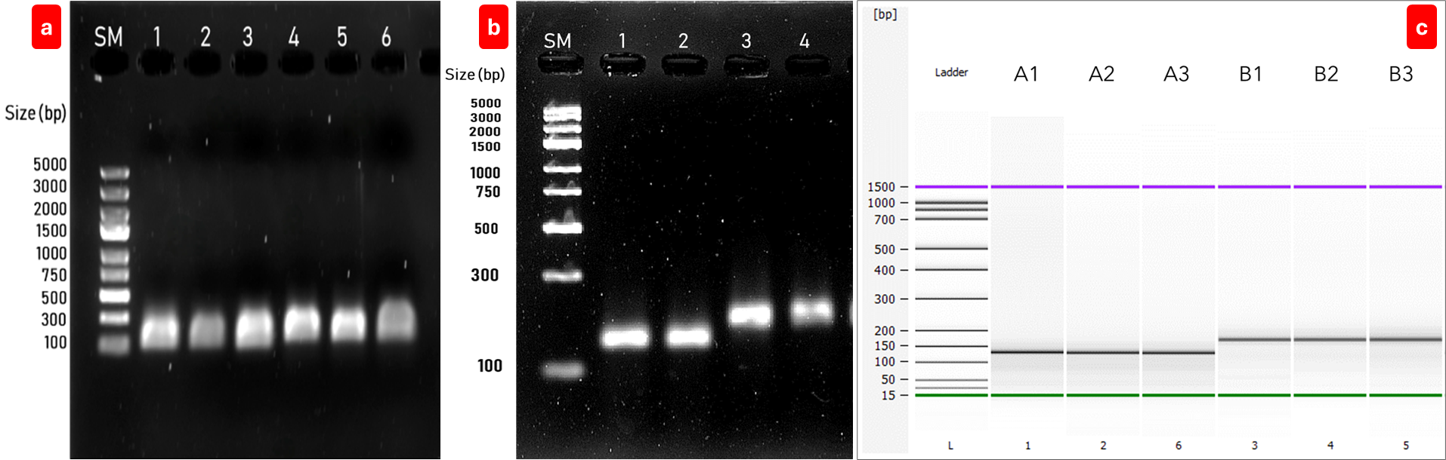
Figure S2. Primary wet-laboratory quality-control evidence. Agarose electrophoresis of the synthesized strands and hybridized duplexes, and Bioanalyzer electropherograms, are reproduced from the source experimental record. These assays support presence and approximate size, not nucleotide identity.

S5. Complete MerMade 4 synthesis program
Script detail | Reagent / manufacturer | No./V primes | Injection | Reaction | Equalize
INITIALIZATION | INITIALIZATION | INITIALIZATION | INITIALIZATION | INITIALIZATION | INITIALIZATION
3 × Washing | Anhydrous Acetonitrile, (emp BIOTECH, Berlin, Germany) | 1 / 10 | 180 µL | 00:00:02 | 00:00:12
RUN STEPS | RUN STEPS | RUN STEPS | RUN STEPS | RUN STEPS | RUN STEPS
Deblocking 1 | 3% Trichloroacetic Acid (TCA) in dichloromethane, (emp BIOTECH, Berlin, Germany) | 1 / 10 | 130 µL | 00:00:02 | 00:00:59
Deblocking 2 | 3% Trichloroacetic Acid (TCA) in dichloromethane, (emp BIOTECH, Berlin, Germany) | 1 / 10 | 100 µL | 00:00:02 | 00:00:45
2 × Washing | Anhydrous Acetonitrile, emp BIOTECH | 1 / 10 | 180 µL | 00:00:02 | 00:00:12
Coupling 1 (2 subinjections) | Activator reagent, (emp BIOTECH, Berlin, Germany) | 1 / 10 | 70 µL | 00:00:02 | 00:01:20
Coupling 1 (2 subinjections) | DNA Amidites (A, C, G, T), (Biosearch Technologies, Petaluma, CA, USA) | 1 / 10 | 50 µL | 00:00:02 | 00:01:20
Coupling 2 (2 subinjections) | Activator reagent, emp BIOTECH | 1 / 10 | 50 µL | 00:00:02 | 00:00:40
Coupling 2 (2 subinjections) | DNA Amidites (A, C, G, T), (Biosearch Technologies, Petaluma, CA, USA) | 1 / 10 | 30 µL | 00:00:02 | 00:00:40
Washing | Anhydrous Acetonitrile, (emp BIOTECH, Berlin, Germany) | 1 / 10 | 180 µL | 00:00:02 | 00:00:12
Capping (2 subinjections) | Cap A: Acetic anhydride in THF, emp BIOTECH | 1 / 10 | 65 µL | 00:00:02 | 00:00:50
Capping (2 subinjections) | Cap B: Acetic anhydride in THF, emp BIOTECH | 1 / 10 | 65 µL | 00:00:02 | 00:00:50
Washing | Anhydrous Acetonitrile, (emp BIOTECH, Berlin, Germany) | 1 / 10 | 180 µL | 00:00:02 | 00:00:12
Oxidation | Iodine in water/pyridine/THF (0.02 M), emp BIOTECH | 1 / 10 | 80 µL | 00:00:02 | 00:01:00
2 × Washing | Anhydrous Acetonitrile, (emp BIOTECH, Berlin, Germany) | 1 / 10 | 180 µL | 00:00:02 | 00:00:12
FINALIZATION | FINALIZATION | FINALIZATION | FINALIZATION | FINALIZATION | FINALIZATION
3 × Deblocking | 3% Trichloroacetic Acid (TCA) in dichloromethane, (emp BIOTECH, Berlin, Germany) | 1 / 10 | 150 µL | 00:00:02 | 00:00:45
3 × Washing | Anhydrous Acetonitrile, (emp BIOTECH, Berlin, Germany) | 1 / 10 | 180 µL | 00:00:02 | 00:00:12
DEPROTECTION OUTSIDE THE OLIGOSYNTHESIZER | DEPROTECTION OUTSIDE THE OLIGOSYNTHESIZER | DEPROTECTION OUTSIDE THE OLIGOSYNTHESIZER | DEPROTECTION OUTSIDE THE OLIGOSYNTHESIZER | DEPROTECTION OUTSIDE THE OLIGOSYNTHESIZER | DEPROTECTION OUTSIDE THE OLIGOSYNTHESIZER
Cleavage & Deprotection | Concentrated ammonia solution, (Sigma-Aldrich, St. Louis, MO, USA) | / | 1 mL | 18 h at 70°C | /

S6. Primer record
Primer | Sequence (5′→3′) | Reported Tm (°C) | Expected product (bp)
SpAB F | ATGGGTTCTTCTCACCACCACCA | 58.6 | 123 A / 156 B
SpA R | TTAGCCGCAGTAGTTTTCCA | 52.3 | 123 A
SpB R | TTAGCGGCGGGTTTTTGG | 53.8 | 156 B
SeqAB F | TGCATCCATATGGGTTCTTCTCACCACCACCA | 67.2 | 144 A / 177 B
SeqA R | TGCATCCTCGAGTTAGCCGCAGTAGTTTTCCA | 65.8 | 144 A
SeqB R | TGCATCCTCGAGTTAGCGGCGGGTTTTTGG | 66.4 | 177 B
T7 F | TAATACGACTCACTATAGGG | 52.0 | 307 A / 340 B
T7 R | GCTAGTTATTGCTCAGCGG | 54.3 | 307 A / 340 B

The source table reported some A/B product sizes together in cells that do not apply to both reverse primers. The corrected product labels above associate SpA R/SeqA R with A and SpB R/SeqB R with B. Before a prospective run, each primer should be re-evaluated in G-Synth against the final recombinant plasmid and the laboratory's polymerase/buffer conditions.

S7. Wet-laboratory PCR and colony-screening evidence
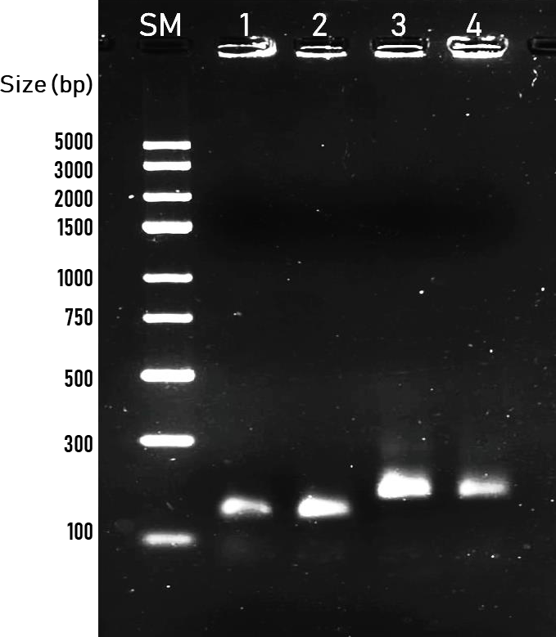
Figure S3. PCR products obtained with insert-specific primers before cloning, reproduced from the primary experimental draft. SM, GeneRuler Express DNA Ladder; lanes 1–2, A insert; lanes 3–4, B insert.
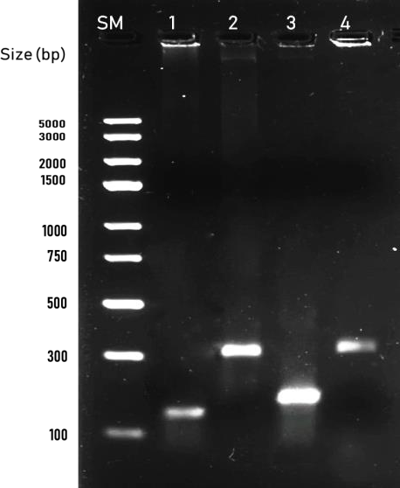
Figure S4. Colony-screening PCR reproduced from the primary experimental draft. Lanes 1 and 3 are A and B products with insert-specific primers; lanes 2 and 4 are the corresponding products with T7 primers.

S8. Sequencing evidence manifest
The validation set is limited to A Forward Seq.ab1, A Reverse Seq.ab1, B Forward Seq.ab1 and B Reverse Seq.ab1. Their SHA-256 hashes are recorded in the evidence JSON; no other chromatogram contributes to any reported result. Each F/R pair was oriented and assembled before consensus coverage was evaluated. Consensus coverage, identity, bidirectional overlap and F/R agreement are the primary retrospective endpoints.
Chain | Ref. bp | Consensus cov. | Identity | F/R overlap | F/R agree | Consensus diff. | Biopython cov.
A | 123 | 100.0% | 100.0% | 56.1% | 100.0% | 0 | 100.0%
B | 156 | 100.0% | 100.0% | 71.2% | 100.0% | 0 | 100.0%

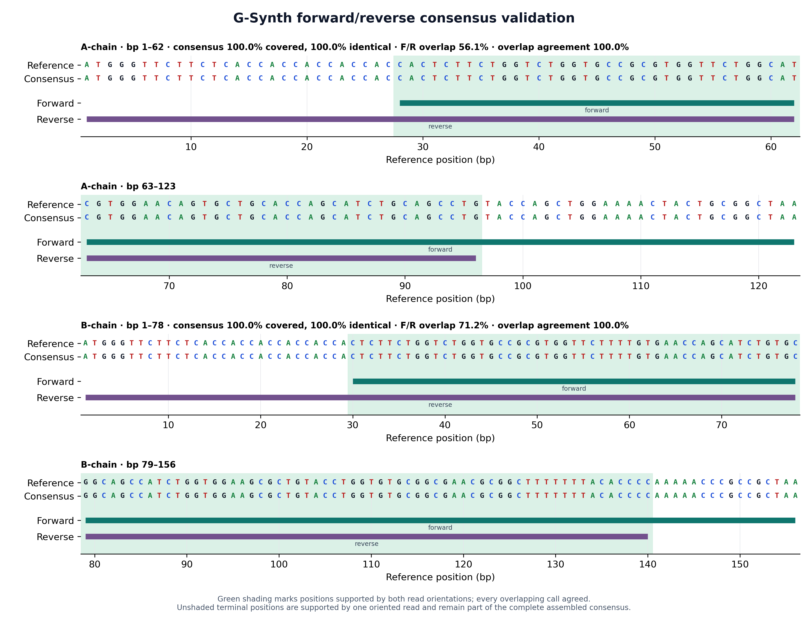
Figure S5. Primary G-Synth F/R consensus evidence map. The two oriented reads jointly cover each reference completely; green shading marks bidirectional overlap, with 100% agreement in both constructs.

S9. Supplementary interface evidence
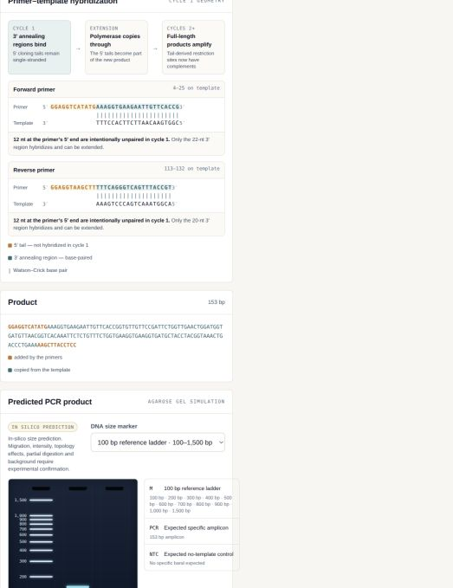
Figure S6. Primer–template hybridization view. The annealing 3′ segment is base-paired; the 5′ cloning extension is explicitly unpaired in cycle 1 and appears in the predicted product after extension.

Figure S7. Detailed SSD duplex hybridization. The two order molecules form a 123-bp exact antiparallel core; the NdeI-derived 5′-TA and XhoI-derived 5′-TCGA terminal products remain exposed and are labelled as cohesive ends.
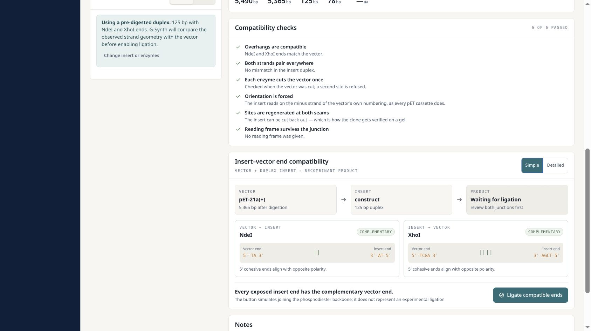
Figure S8. Pre-ligation vector–insert compatibility gate. The simple view preserves enzyme identity, overhang sequence and physical polarity while withholding product analyses.
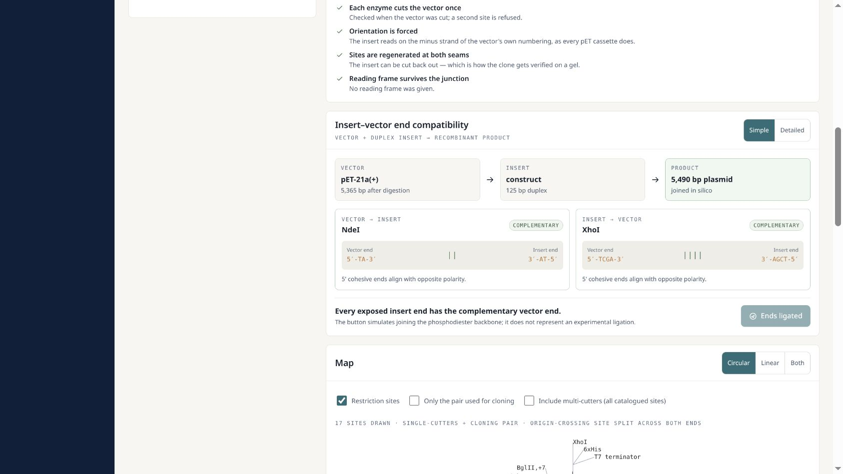
Figure S9. Product state after explicit in-silico ligation. The recombinant length and downstream map are displayed only after both junctions have passed.

Figure S10. HindIII-containing diagnostic digest and predicted gel. The restriction site and complete digest fragments are displayed with a named broad-range marker. The panel is labelled as an in-silico prediction.
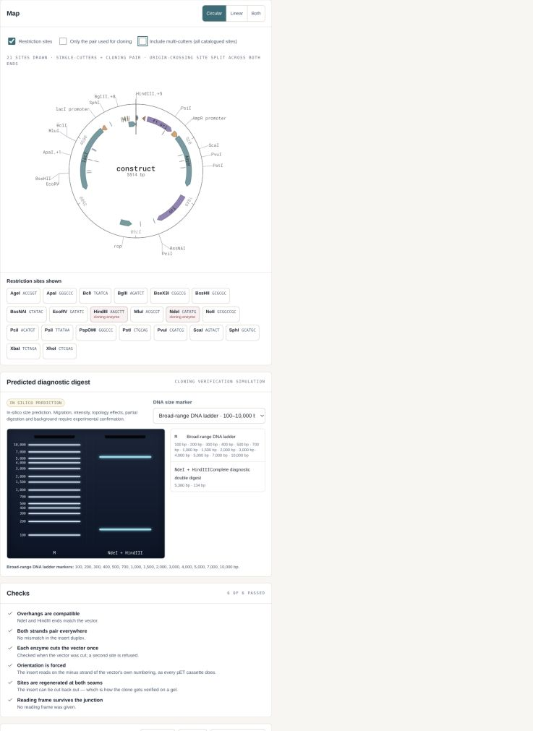
Figure S11. Restriction map showing HindIII as a named site derived from cut geometry.

S10. Secondary Geneious comparison and independent confirmation
The supplied experimental draft used Benchling for reverse complements and Geneious Prime 2024.0.7 for cloning views and trace alignments. G-Synth independently regenerated the same four synthesis molecules from the two optimized coding inputs, and its recombinant maps placed the inserts downstream of the pET-21a(+) T7/lac expression elements with preserved coding frames. The archived Geneious figures and G-Synth therefore agree qualitatively on construct identity and placement. A new automated Geneious run was not performed because the reproducibility environment did not include a licensed command-line execution path. Biopython 1.87 was used as the independent, executable alignment comparator.
A prospective head-to-head study should freeze one set of reference plasmids and raw trace files, define identical trimming thresholds and variant rules, blind sample labels, and compare: read placement; orientation calls; covered intervals; mismatches/indels; consensus; runtime; manual interventions; exportability; and final verdict. The present study is a functional cross-check, not a statistical superiority benchmark.
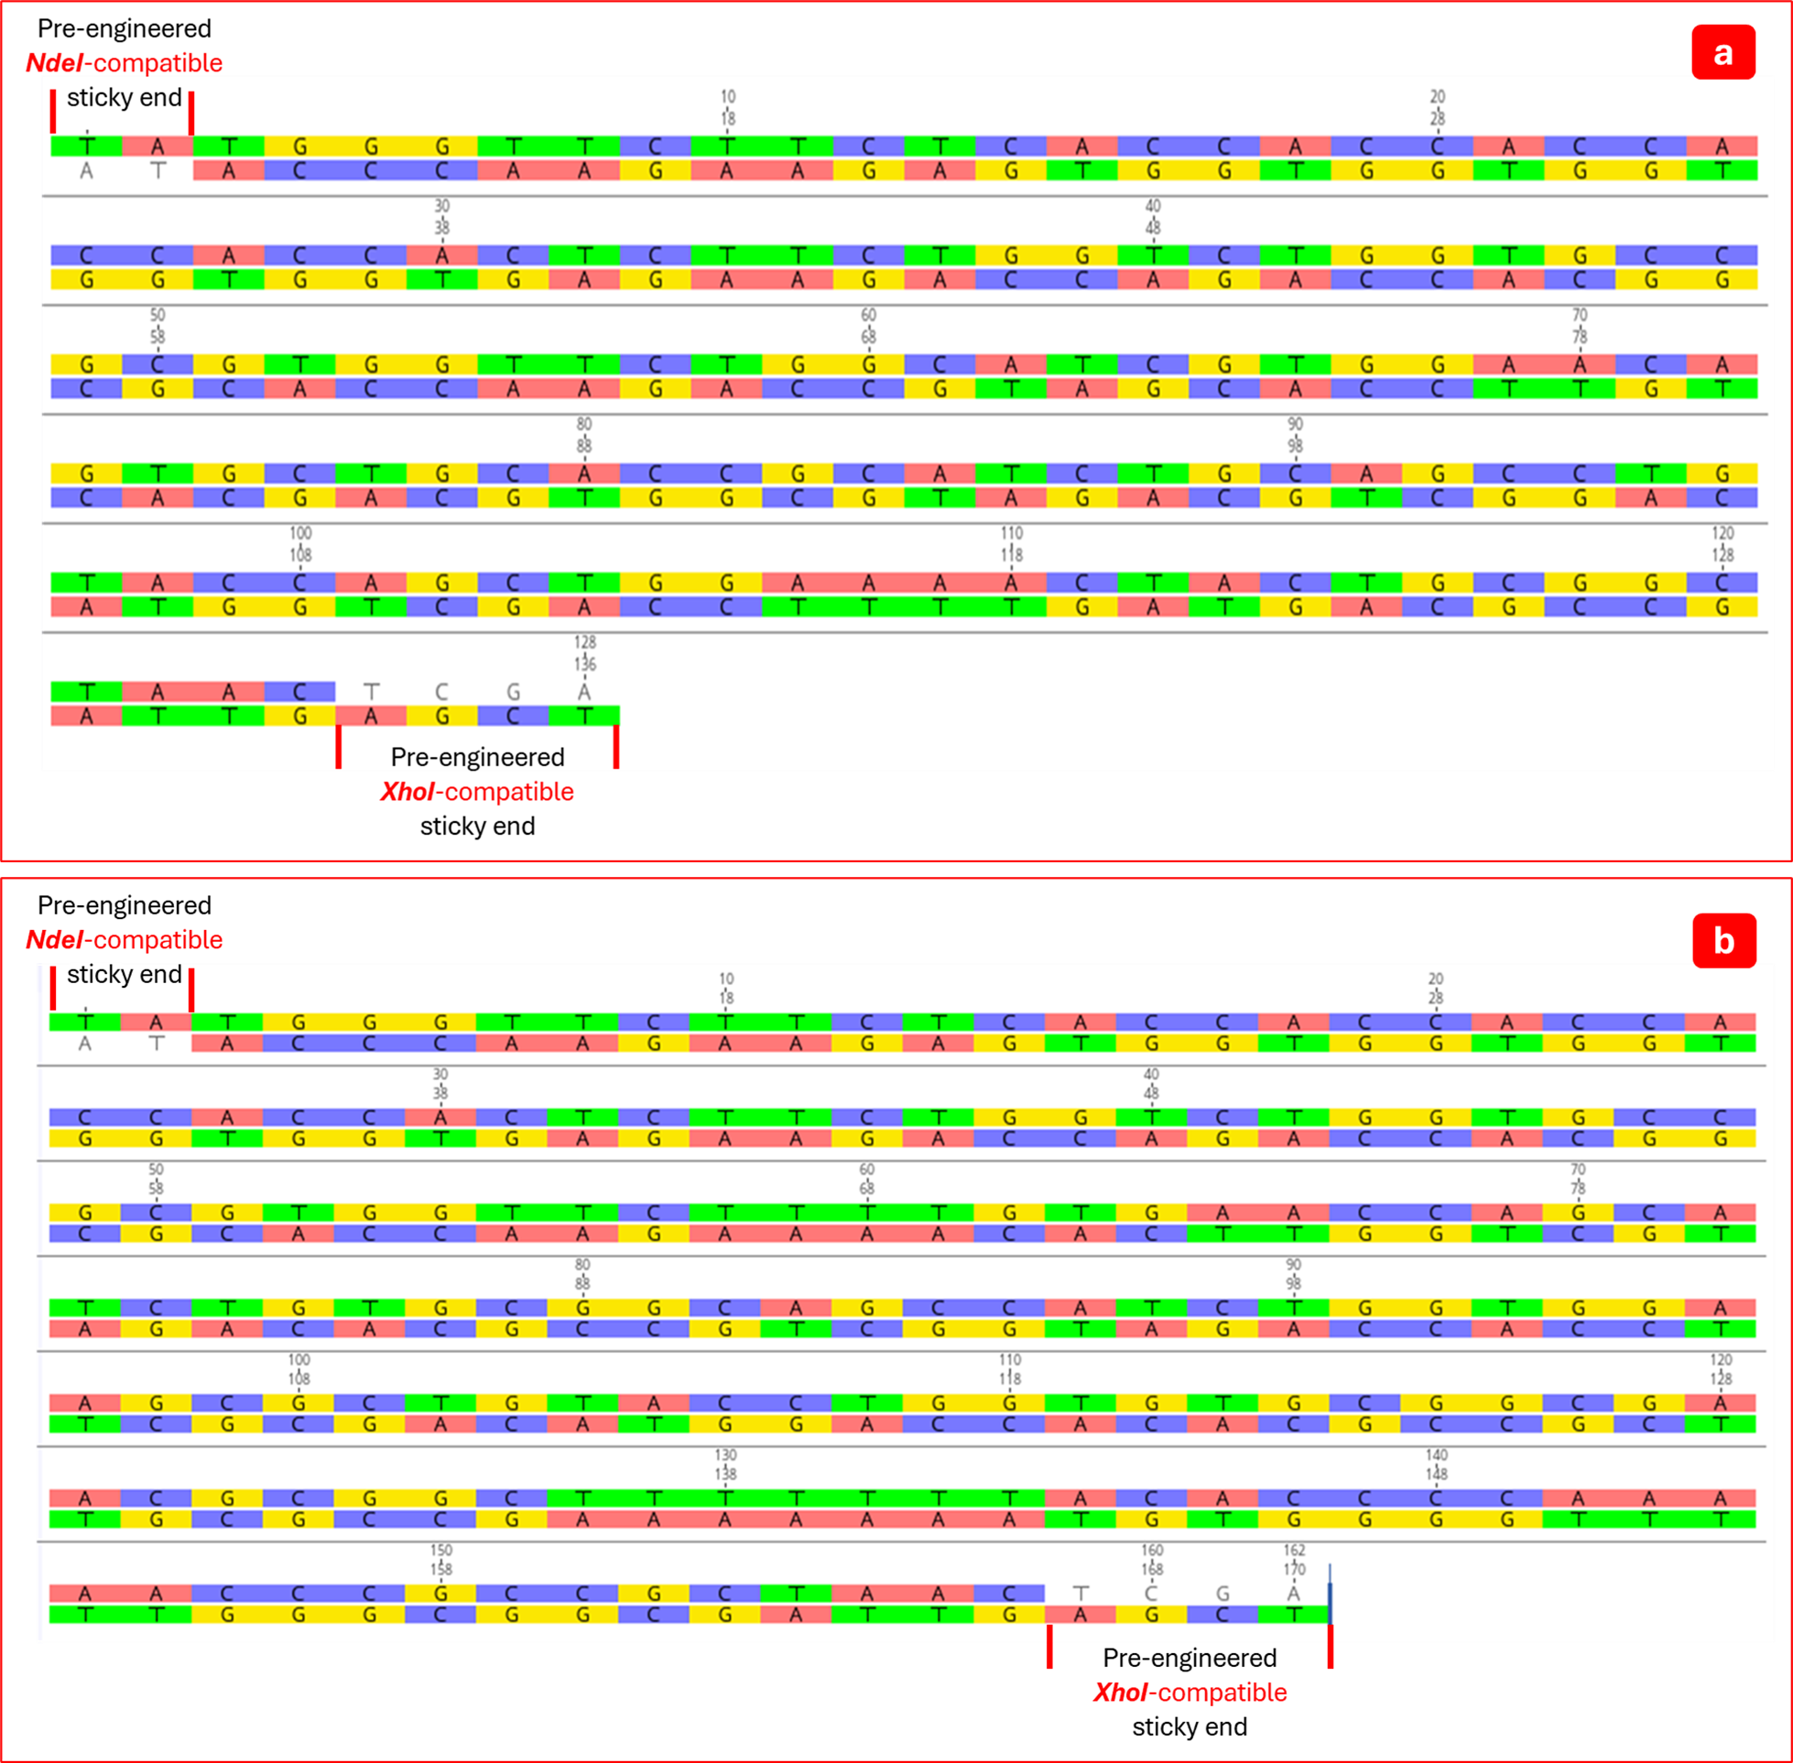
Figure S12. Archived Geneious Prime 2024.0.7 duplex representation of NdeI/XhoI-compatible A- and B-chain inserts. This is secondary qualitative concordance; G-Synth SSD is the primary in-silico reconstruction.
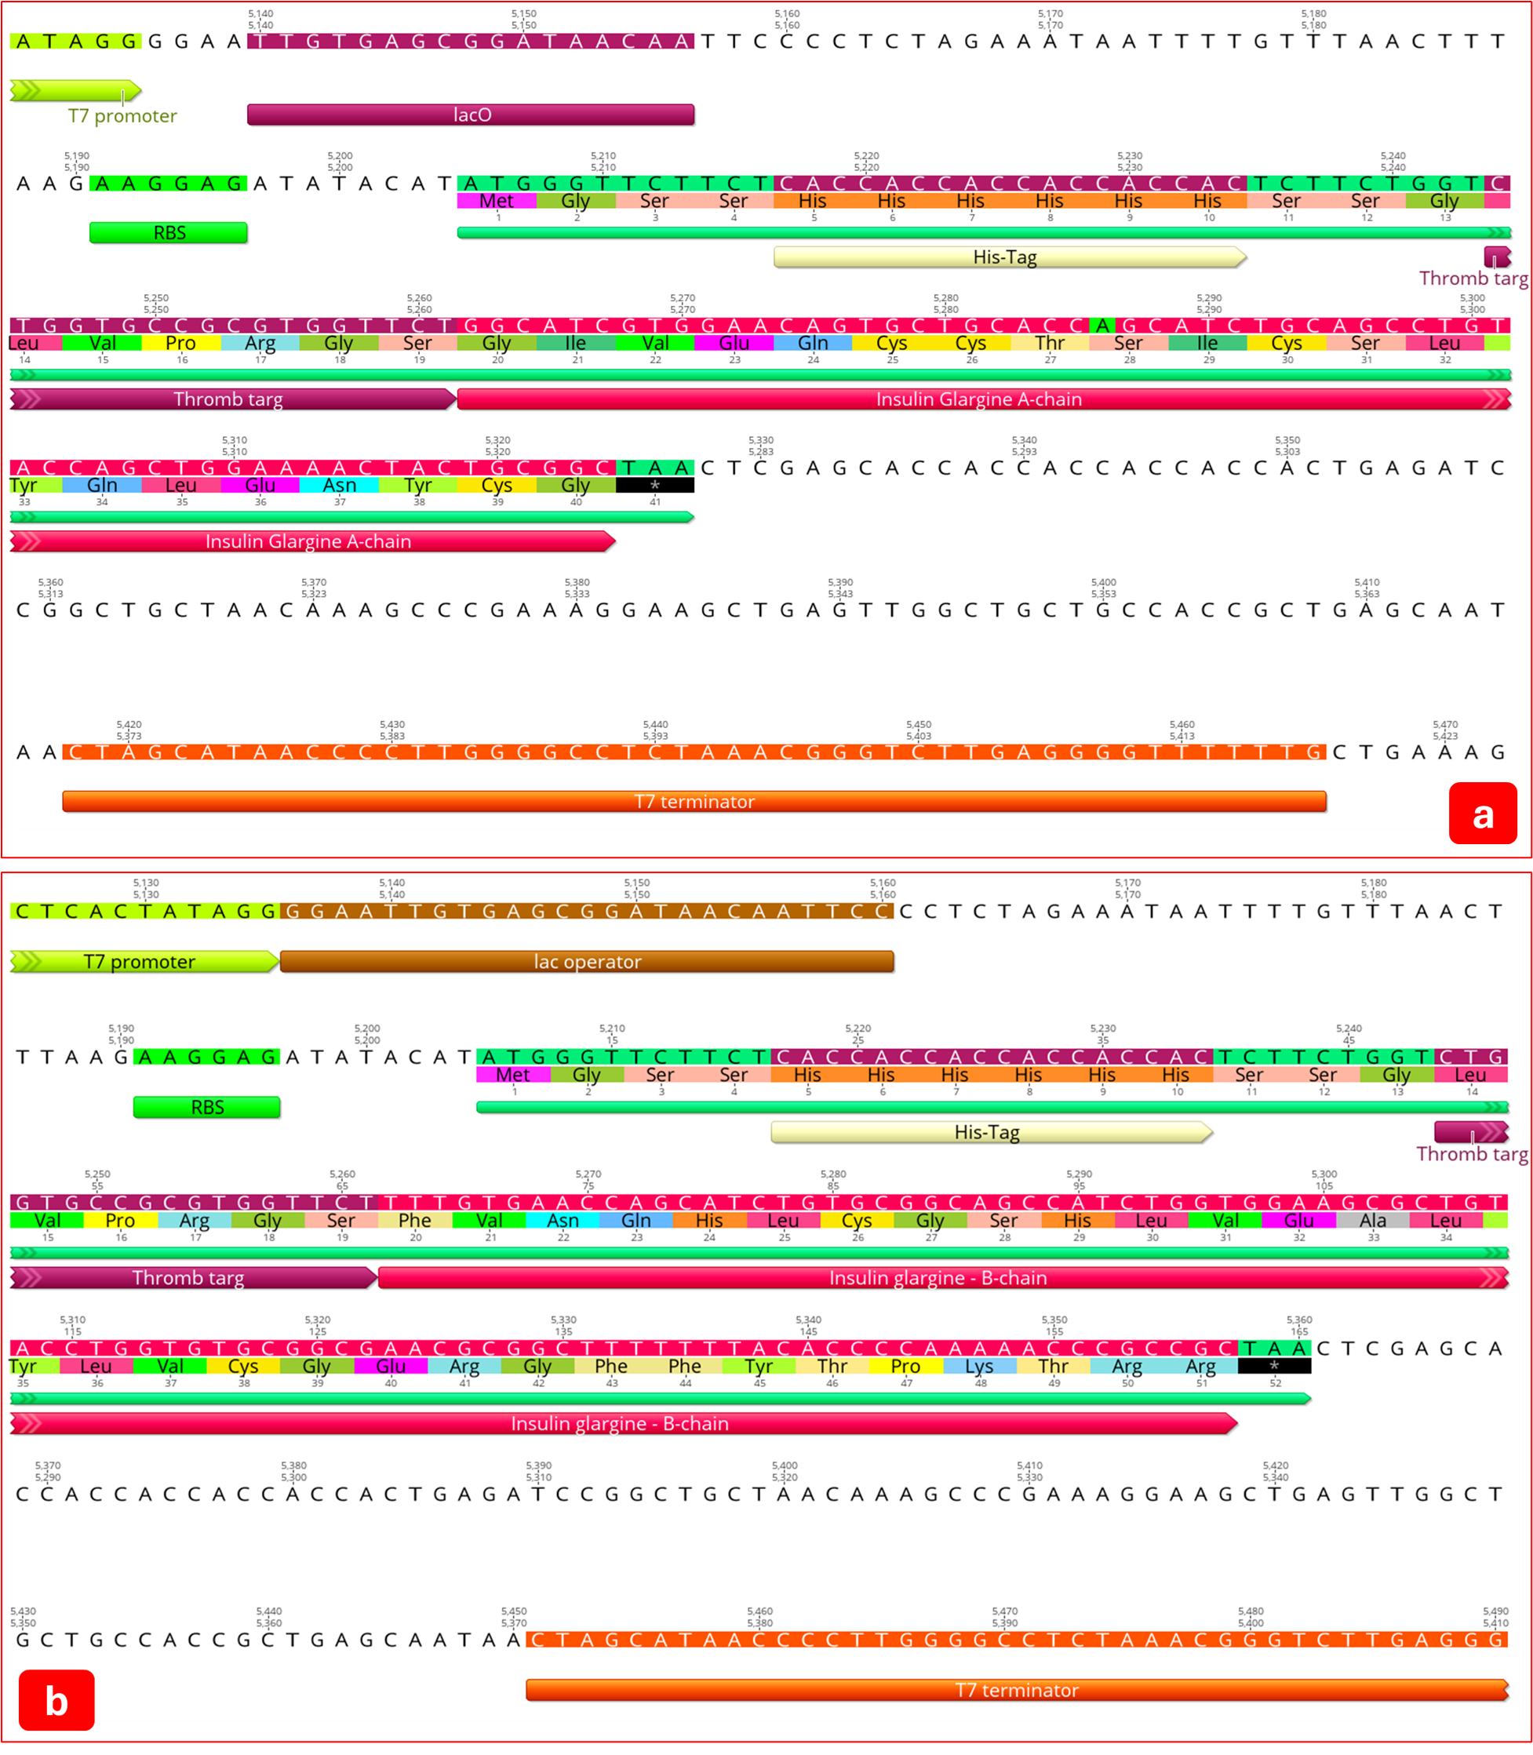
Figure S13. Archived Geneious Prime construct annotation for the glargine A- and B-chain pET-21a(+) designs. G-Synth generated the primary coordinate, ORF and junction validation reported in the main article.
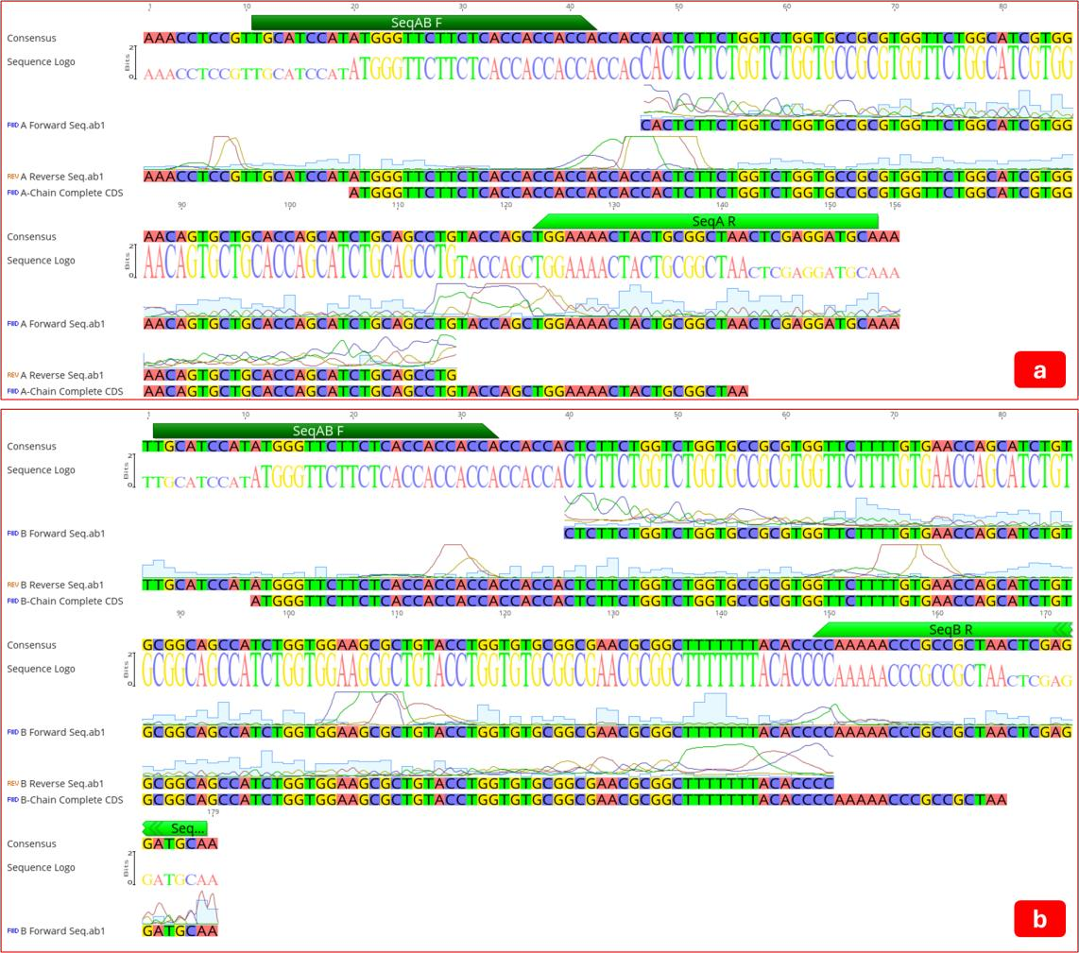
Figure S14. Archived Geneious Prime alignment made with the same four author-approved construct-confirmation files used by G-Synth. It provides secondary visual concordance and was not treated as an independent blinded benchmark.

S11. Scientific correction ledger for the supplied draft
Source-draft implication | Correction in the G-Synth manuscript | Reason
Sequencing showed complete 100% identity | Oriented F/R assembly produced 100% consensus coverage and identity; overlap support was 56.1% (A) and 71.2% (B), with 100% F/R agreement | Separates assembled coverage from bidirectional confirmation without obscuring the complete consensus
The method eliminates enzymatic digestion | Insert preparation is PCR-free and pre-engineered; the pET-21a(+) vector is still digested with NdeI/XhoI | Vector digestion is experimentally required
The constructs enable insulin glargine production | Construct design and cloning were validated; expression, cleavage, refolding and bioactivity were not tested | DNA construction does not establish functional insulin
His-tags and linkers ensure folding remains unaffected | Sequence presence and tag position are reported; folding and cleavage remain experimental | No protein-level evidence was supplied
The workflow is broadly scalable and cost-effective | Potential advantages are framed as hypotheses for prospective benchmarking | No controlled cost, yield or scale comparison was performed
Geneious is the primary validator | G-Synth is the primary design/cloning/trace system; archived Geneious views and executable Biopython provide independent confirmation | Matches the software paper's validation hierarchy
One oligo length per insert | Forward/reverse lengths are reported separately (125/127 nt and 158/160 nt) | Cohesive-end geometry is strand-asymmetric

S12. Release and submission checklist
- Obtain written approval from every listed author for author order, affiliations, CRediT roles and AI disclosure.
- Run prospective bidirectional sequencing until both junctions and 100% of each insert are covered at the predefined quality threshold.
- Deposit raw trace files, reference FASTA/GenBank files, evidence JSON and analysis scripts in a stable repository, subject to institutional approval.
- Publish the version 1.0.0 GitHub release, connect Zenodo and insert the versioned DOI in the manuscript and CITATION.cff.
- Perform a clean-clone execution of all three test suites and both publication scripts; retain logs and environment versions.
- Prepare the target journal's graphical summary, high-resolution figures and machine-readable constructs; confirm its current author guidelines and retain the limitation that functional insulin glargine was not demonstrated.

