Summary:

1. Context
2. Team presentation and MVC
3. UML Diagrams
4. Conclusion
5. Context

LORANN, an abandon ware, mainly known for its gameplay and original story it was popular in the 80’s. We were tasked with recreating this game with five levels stored in a database. The source code will also have to follow the Model-View-Controller design pattern.

1. Team presentation and MVC

MVC corresponds to the Model-View-Controller design pattern. This design pattern helps to organize the source code in three packages, each one serving a precise purpose. For example the Model will hold all the data relating to the code itself while the View will be tasked with displaying the result of this code.

Our team is composed of Alexandre, Thibaut, Dorian and Mehdi.

Alexandre and Thibaut focused on the view, the database and part of the diagrams.

Dorian and Mehdi on the other side worked on the controller, the model and the other part of the diagrams.

1. UML Diagrams

Due to the scale of some diagrams, we were not able to put them in this document. You can find the other diagrams in the same file as this document.

Sequence diagram:

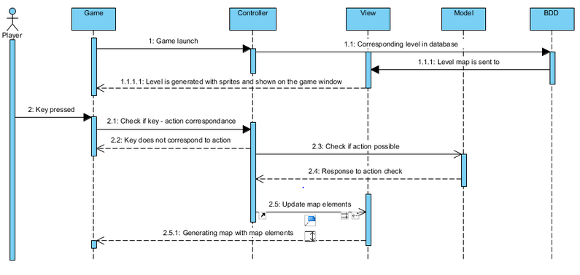

This diagram shows the basic interactions in the program when a user starts the game and when he presses a key.

Class diagrams:

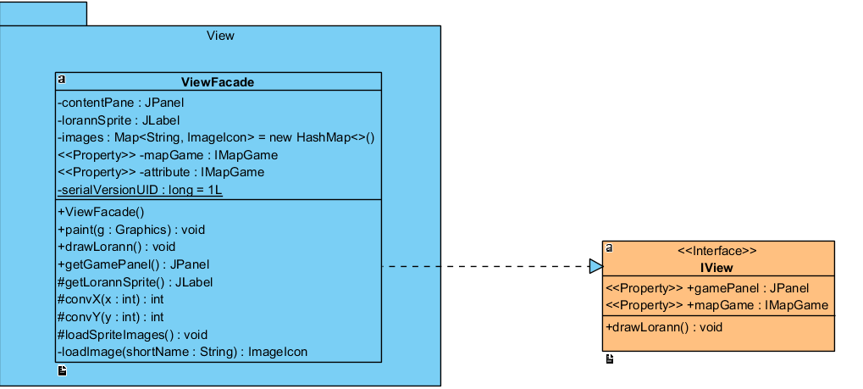View:

The view is going to draw the Interface of the game, with the position of the object stored in the database. It creates the Window and displays Lorann, the monsters and the environment.

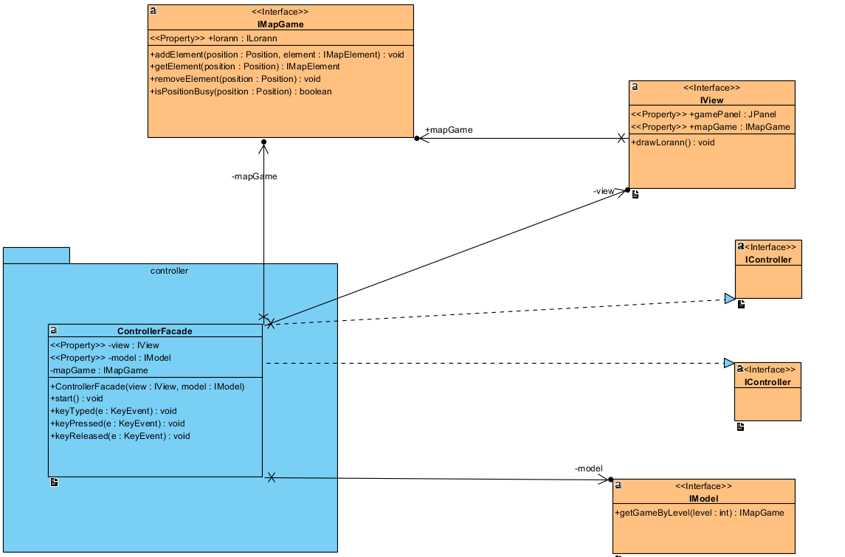Controller

It is the link between the view and the model. It will transfer the orders from one side to the other and will also receive the keys pressed bu the player

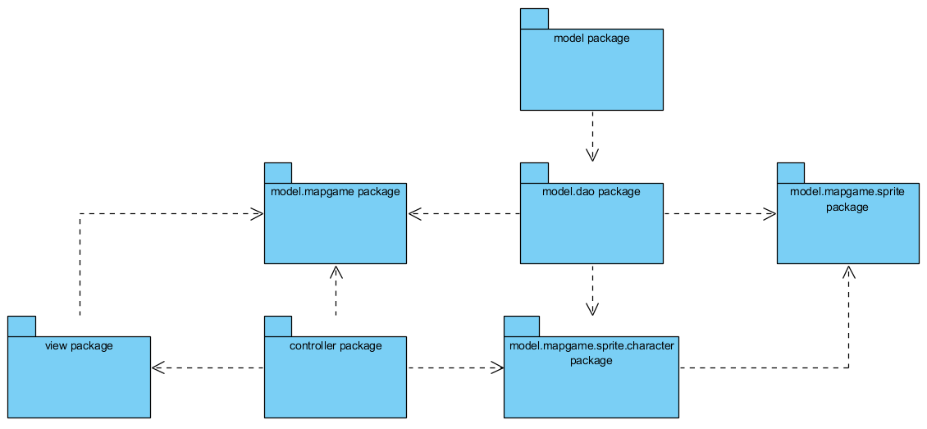Package diagram:

1. Conclusion

This project was a challenge, it was hard at times but our team was able to withstand these difficulties. We learned a lot from this project and from each other; we were helpful towards each other, giving the best of ourselves.