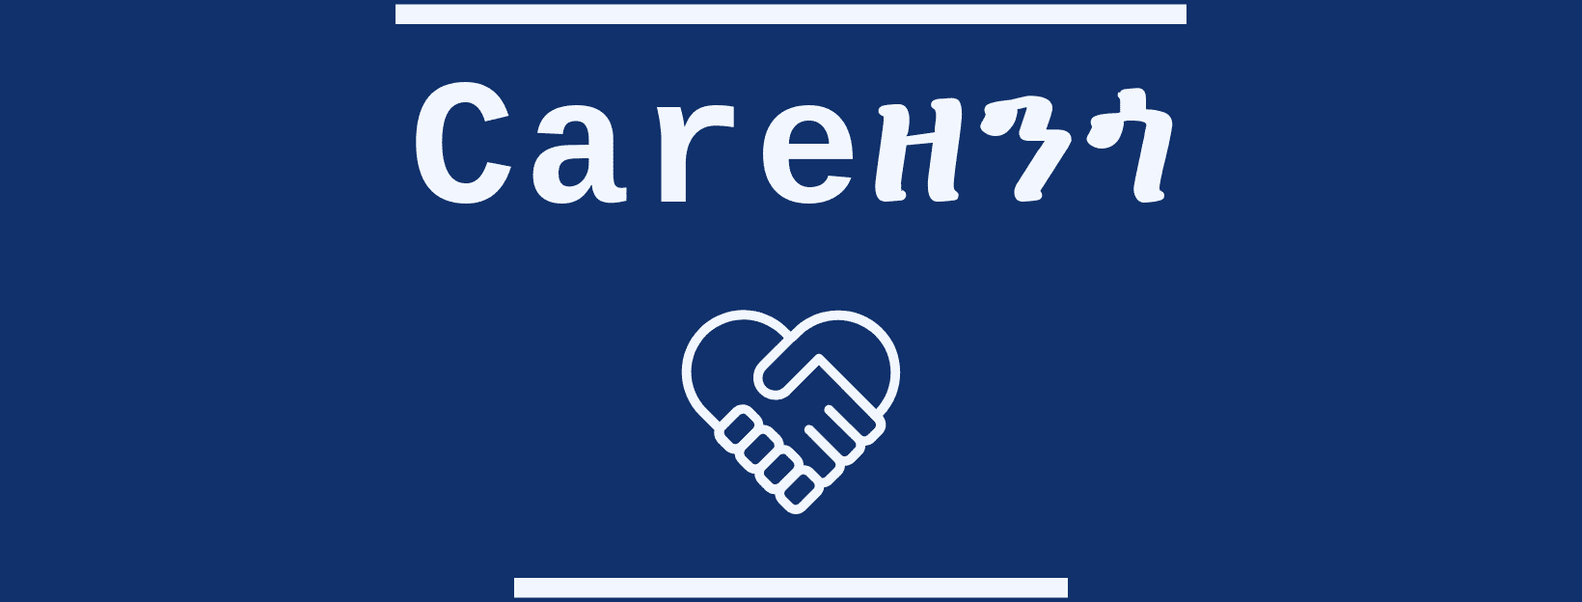



11/10/2019

About

Careዘንጎ

Careዘንጎ is a non-profit and independent site outlet established primarily to promote freedom, democracy and respect for human rights which are most significant issues for the free life of human beings. It is established to serve mainly Ethiopians and the Diaspora around the world.

Ethiopia is one of the countries in the world with the worst record of human rights abuse, ethnic conflict and press freedom. The current situation in Ethiopia is worse than before. The Nobel peace prize Abiy Ahmed couldn’t make peace within the country, after he came to power dozens of people were killed, large number of people are internally displaced because of their identity. Experienced and influential journalists left the country and applied for asylum in Australia and England due to harassment and prosecution they got from the government officials for doing their jobs.

As it was before by TPLF, the current Ethiopian leading party (Prosperity party) is recently planning to control almost all electronic media outlets. The state-run media is solely focused on propaganda and now designing new abusive rule to shuts out critical views. Careዘንጎ aspires to fill that void so that the Ethiopian people will have unfettered access to information, freedom and protection in their daily lives, real democracy and justice!

 CAREዘንጎ

Mifta Zeynu