ISTE-230 Introduction to Database & Data Modeling

## Homework # 5 – HAS-A and IS-A Relationships

DUE:

**Name: Miftahul Huq**

**Submit this document, edited to include your answers, to the HW#5 Assignment folder by the stated deadline.**

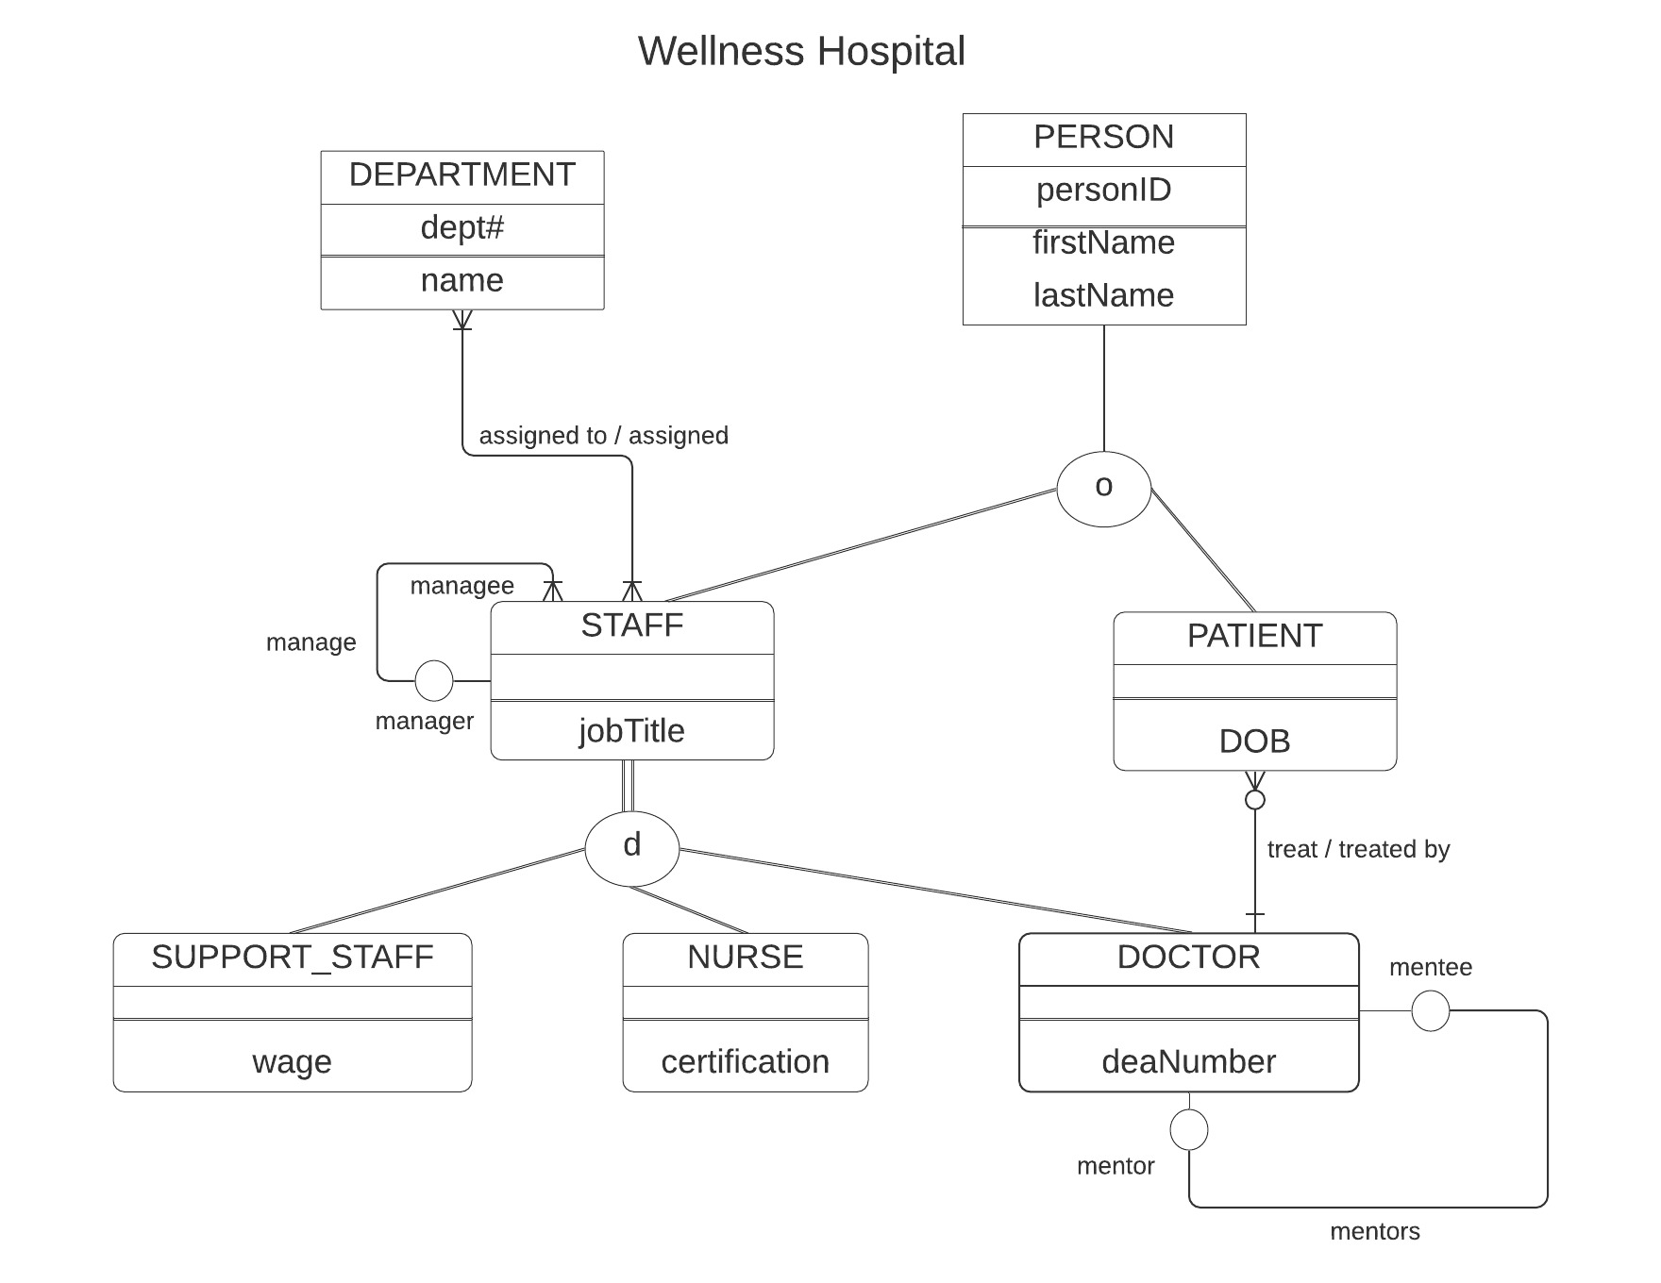

Using the E-R diagram for Wellness Hospital, that appears on the previous page, please provide your answer to the following questions.

1. (5 points) List the relationship verb phrase for each 'HAS-A' relationship that appears in the diagram.

**YOUR ANSWER:**

* 1. Assigned to / assigned
  2. Treat / treated by

1. (5 points) List the relationship verb phrase for each binary relationship that appears in the diagram.

**YOUR ANSWER:**

1. Assigned to / assigned.
2. Treat / treated by
3. (5 points) List the relationship verb phrase for each recursive relationship that appears in the diagram.

**YOUR ANSWER:**

1. Manage
2. Mentors
3. (5 points) List the name of each supertype entity that appears in the diagram.

**YOUR ANSWER:**

1. Staff
2. Person
3. (6 points) List the name of each subtype entity that appears in the diagram.

**YOUR ANSWER:**

1. Staff
2. Patient
3. Support_Staff
4. Nurse
5. Doctor
6. (5 points) Provide an example of an entity instance of PERSON.

**YOUR ANSWER:**

|  |  |  |
| --- | --- | --- |
| **personID** | **firstName** | **lastName** |
| 1 | John | Smith |

1. (5 points) List the relationship verb phrase for every 1:1 relationship that appears in the diagram.

**YOUR ANSWER:**

1. Mentors
2. (5 points) List the relationship verb phrase for every 1:N (N:1) relationship that appears in the diagram.

**YOUR ANSWER:**

1. Manage
2. Treat / threated by
3. (5 points) List the relationship verb phrase for every M:N relationship that appears in the diagram.

**YOUR ANSWER:**

1. Assigned to / assigned
2. (5 points) List the name of each strong entity that appears in the diagram.

**YOUR ANSWER:**

1. Person
2. (6 points) List the name of each weak entity that appears in the diagram.

**YOUR ANSWER:**

1. Staff
2. Patient
3. Support_Staff
4. Nurse
5. Doctor
6. (4 points) Must a STAFF:managee be managed by a manager? Explain how you determined your answer from the E-R diagram provided.

**YOUR ANSWER:** No, the reason is that the recursive relation from managee to manager has a circle which has minimum of zero and maximum of 1. Which means the STAFF:manage does not have to have a manager.

1. (4 points) Can there be an instance of DOCTOR that is not an instance of STAFF? Explain your answer.

**YOUR ANSWER:** No, the reason is that DOCTOR is a subtype of STAFF and DOCTOR depend on STAFF. Therefore no instance of DOCTOR is not not a instnse of STAFF.

1. (4 points) Can a DOCTOR treat more than one PATIENT? Explain how you determined your answer from the E-R diagram provided.

**YOUR ANSWER:** Yes, the doctor can treat more than one patient. The reason is that the sign for many is pointed toward PATIENT. The 3 small line. Which indicates one to many DOCTOR to PATIENT relationship.

1. (4 points) Must every instance of PERSON belong to a subtype? Fully explain how you determined your answer from the E-R diagram provided.

**YOUR ANSWER:** No, the reason is that there is only one line going to from the PERSON Entity to its subtype. That indicates that the PERSON can be its own thing. It’s Partial Specializaotn.

1. (4 points) Could an instance of PERSON be both a STAFF and a PATIENT? Fully explain how you determined your answer from the E-R diagram provided.

**YOUR ANSWER:** Yes, the reason is that there is an O in the circle and it’s the overlap rule. Which means that it can be both a STAFF and a PATIENT.

1. (4 points) Must every instance of STAFF belong to a subtype? Fully explain how you determined your answer from the E-R diagram provided.

**YOUR ANSWER:** Yes, the reason is that there is two line going to its subtype and total specialization. Which means that the STAFF has to belone to a subtype.

1. (4 points) Could an instance of STAFF be both a SUPPORT_STAFF and a DOCTOR? Fully explain how you determined your answer from the E-R diagram provided.

**YOUR ANSWER:** No, the reason is that it follows the disjoint rule and has a d in the circle. Which means that it cannot be both it has to be either one of the subtype and cannot be both.

1. (5 points) If a discriminator were to be added to PERSON, fully explain what that would entail and why?

**YOUR ANSWER:** If a discrimination were to be added to PERSON, then there would be two more attributes and they would be Boolean attribute. The attributes are isStaff and isPatient. Then depending on what the instance is, either one could be true, or both of them could be true, or both of them could be false.

1. (5 points) If a discriminator were to be added to STAFF, fully explain what that would entail and why?

**YOUR ANSWER:** If a discrimination were to be added to STAFF, then there would be an attribute that, for example, staffType, and depending on the instance of the STAFF entity, that attribute would be either SUPPORT_STAFF, NURSE, or DOCTOR.

1. (5 points) Fully state the business rules for the **assigned to/assigned** relationship without using technical terms.

**YOUR ANSWER:**

* A department must have a staff, and every staff must have an department. A department can have more than one staff assigned. A staff can be assigned to many department.