ISTE-230 Introduction to Database & Data Modeling

## Homework # 6 – Transposing

DUE:

**Name: Miftahul Huq**

**Submit this document edited to include your answers, for the two parts, to the HW#6 Dropbox by the stated deadline.**

(It may be helpful to right-click on the  icon and select Hide Spelling Errors and Hide Grammatical Errors.)

**Part #1 – 50 points**

1. (45 points) Transpose the E-R diagram above into relations, implementing all relationships. Denote primary keys and foreign keys appropriately. Use proper relation notation. You need to provide reference statements.

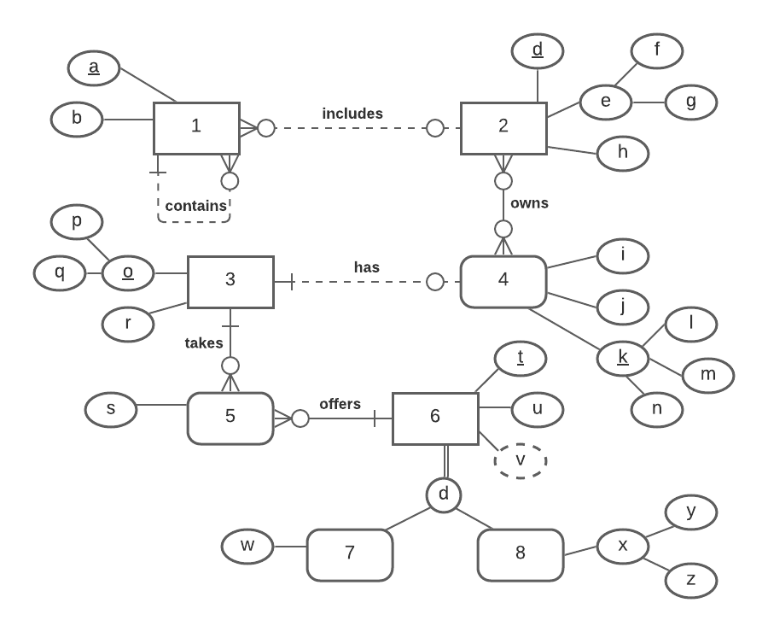

**YOUR TRANSPOSED RELATIONS:**

1(a, b, *d*)

2(d, f, g, h)

3(p, q, r)

4(l, m, n, *p, q*, i, j)

2_4(*d*, *l*, *m*, *n*)

2_4(d) mei 2(d)

2_4(l, m, n) mei 4(l, m, n)

5(*p, q*, *t*, s)

5(p, q) mei 3(p, q)

5(t) mei 6(t)

6(t, u)

7(*t*, w)

7(t) mei 6(t)

8(*t*, y, z)

8(t) mei 6(t)

2. (2 points) Using the E-R diagram above, please explain why entity 7 is weak and what the specific term for that type of entity is.

**REASON:** Entity 7 is dependent on entity 6, and the primary key of entity 7 is the same as entity 6. It’s also a foreign key.

**TERM:** Subtype

3. (2 points) Using the E-R diagram above, please explain why entity 5 is weak and what the specific term for that type of entity is.

**REASON:** Entity 5 is weak because it a created entity from the relation of multiple to multiple between entity 3 and 6. Therefore, entity 5 depends on entity 3 and 6

**TERM:** Assocative

4. ( 1 point) Using the E-R diagram above, please explain what relationship makes entity 4 weak and what about that relationship causes it to be weak.

**EXPLANATION:** Entity 4 is weak and the relationship causes it to be weka because entity 4 requires 3 and dependent on 3. Entity is a strong type and the relationship between 3 and 4 is hasA relationship.

**Part 2 – RIT Savings and Loan (50 points)**

1. (50 points) Transpose the E-R diagram above into relations, implementing all relationships. Denote primary keys and foreign keys appropriately. Use proper relation notation. You need to provide reference statements.

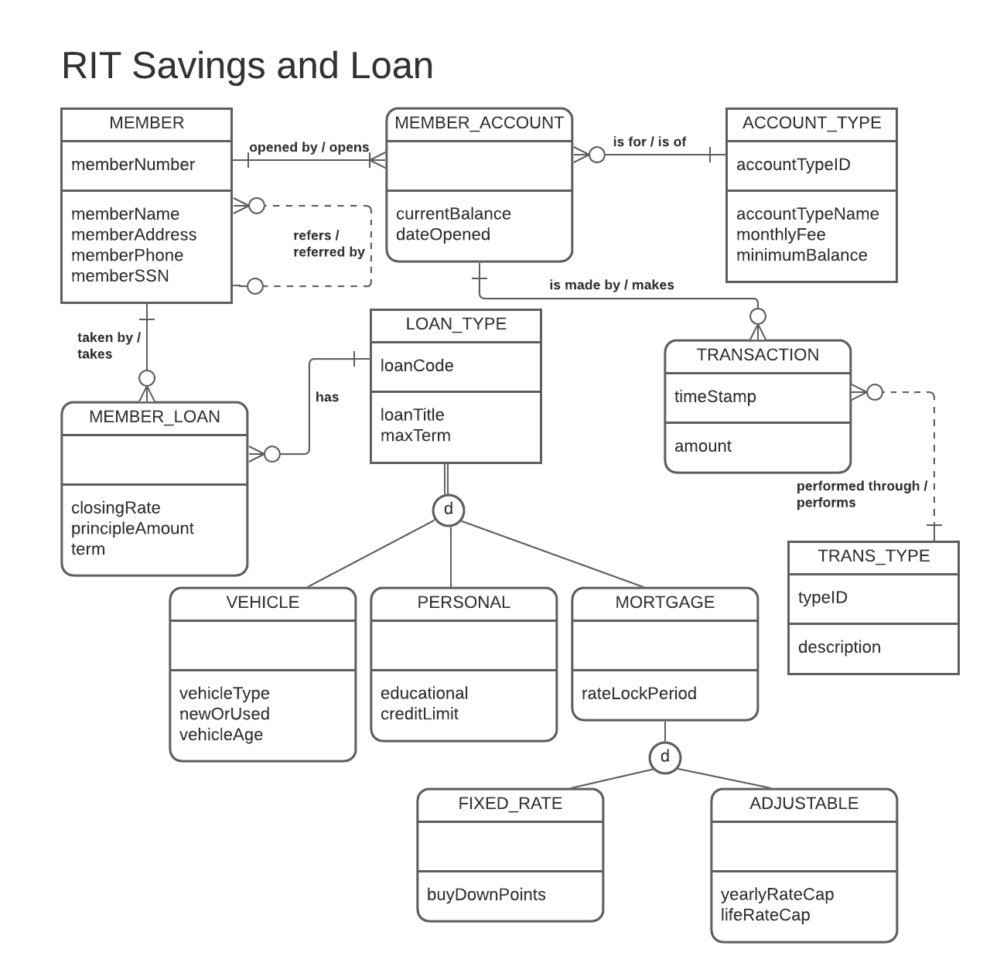

**YOUR TRANSPOSED RELATIONS:**

MEMBER(memberNumber, memberName, memberAddress, memberPhone, memberSSN)

ACCOUNT_TYPE(accountTypeID, accountTypeName, monthlyFee, minimumBalance)

MEMBER_ACCOUNT(*memberNumber, accountTypeID* currentBalance, dateOpened)

MEMBER_ACCOUNT(memberNumber) mei MEMBER(memberNumber)

MEMBER_ACCOUNT(accountTypeID) mei ACCOUNT_TYPE(accountTypeID)

TRANS_TYPE(typeID, description)

TRANSACTION(timestamp, *memberNumber*, *accountTypeID*, *typeID*, amount)

TRANSACTION(memberNumber, accountTypeID) mei MEMBER_ACCOUNT(memberNumber, accountTypeID)

LOAN_TYPE(loanCode, loanTitle, maxTerm)

VEHICLE(*loanCode*, vehicleType, newOrUsed, vehicleAge)

VEHICLE(loanCode) mei LOAN_TYPE(loanCode)

PERSONAL(*loanCode*, educational, creditLimit)

PERSONAL(loanCode) mei LOAN_TYPE(loanCode)

MORTGAGE(*loanCode*, rateLockPeriod)

MORTGAGE(loanCode) mei LOAN_TYPE(loanCode)

FIXED_RATE(*loanCode*, buyDownPoints)

FIXED_RATE(loanCode) mei MORTAGE(loanCode)

ADJUSTABLE(*loanCode*, yearlyRateCap, lifeRateCap)

ADJUSTABLE(loanCode) mei MORTAGE(loanCode)

MEMBER_LOAN(*memberNumber*, *loanCode*, closingRate, principleAmount, term)

MEMBER_LOAN(memberNumber) mei MEMBER(memberNumber)

MEMBER_LOAN(loanCode) mei LOAN_TYPE(loanCode)