ISTE-230 Introduction to Database & Data Modeling

## Homework # 4 – Normalization

DUE:

**Name:** Miftahul Huq

**All assignments will be graded with regard to the standards that were discussed in class, which can be found in the Standards Content area. Submit this document edited to include your answers, for the six tasks, to the HW#4 Assignment Folder by the stated deadline.**

**Task #1 (12 points)**

MUSIC(title, artist, numGrpMembers, year, producer, producerURL, category, categorySales, media, mediaPrice)

Business Rules:

1. Each “album” (CD) is uniquely identified by its title. Note that, for the rest of the business rules, the “Title” attribute of MUSIC refers to the name of the “album”.
2. An artist may either be a single person or a band made up of multiple members (the count being recorded in NumGrpMembers, which can be 1).
3. Each album has one release year.
4. Each album is produced by one music production company (producer).
5. Each producer has one company URL.
6. A specific album has only one artist.
7. Each album is classified into one music category (Rock, Country, etc.)
8. Each category is associated with one category sales value, which is the year-to-date sales for that given category.
9. For convenience, the music company sells all of its music at the same price based on the media type. For example, all cassettes are $9.99, all CDs are $16.99, etc.

List ALL **functional** dependencies for the MUSIC relation above, according only to the business rules listed. Use the format A 🡪 B. Then, for each functional dependency denote with a ‘Y’ or ‘N’ if the respective functional dependency causes 2NF or 3NF violation in the MUSIC relation.

|  |  |  |
| --- | --- | --- |
| **Functional Dependencies** | **2NF violation?** | **3NF violation?** |
| **artist 🡪** numGrpMember | **N** | **Y** |
| **title 🡪** artist | **Y** | **N** |
| **title 🡪** year | **Y** | **N** |
| **title** 🡪 producer | **Y** | **N** |
| **title 🡪** category | **Y** | **N** |
| **producer 🡪** producerURL | **N** | **Y** |
| **category 🡪** categorySales | **N** | **Y** |
| **media 🡪** mediaPrice | **Y** | **N** |

**Task #2 (9 points)**

For the relation below, determine the *highest* normal form the relation is in, the reason, **and** if necessary normalize the relation, and all resulting relations, through BCNF. Use proper relational notation and include reference statements for any foreign keys.

Q1( a, b, c, d ) – *(a,b) is the composite primary key*

Functional Dependencies:

a, b 🡪 c, d – *The composite primary key determines the Non-Key attribute*

c 🡪 d – *A Non-Key depends on another Non-Key*

**YOUR ANSWER:** The relation is in 2nd normal form. The reason is that the Non-Key attributes are dependent on the full composite primary key, and is not partially dependent on it. However, It violates the 3rd normal form. The reason is that the Non-Key attribute, d, is dependent on the other Non-Key attribute, c.

Q1(a, b, *c*)

Q1(c) mei Q1c(c)

Q1c(c, d)

**Task #3 (12 points)**

For the relation below, determine the *highest* normal form the relation is in, the reason, **and** if necessary normalize the relation, and all resulting relations, through BCNF. Use proper relational notation and include reference statements for any foreign keys.

Q2(a, b, c, d)

Functional dependencies:

a, b 🡪 c, d – *(a,b) are composite primary key, and the Non-Key attributes depends on them*

a 🡪 c – A Non-Key attribute depends partially on the composite primary key, c depends on a

b 🡪 d – A Non-Key attribute depends partially on the composite primary key, d depends on b

**YOUR ANSWER:** The relation is in 1st normal form. The reason is that it has composite primary key that uniquely determines the Non-Key attributes. However, this relation violates the 2nd normal form. The reason is that the Non-Key attributes, each, depends partially depends on the composite primary key.

Q2(*a, b*)

Q2(a) mei Q2a(a)

Q2(b) mei Q2b(b)

Q2a(a, c)

Q2b(b, d)

**Task #4 (17 points)**

Given the E-R diagram, the resulting relation, and the functional dependencies below, normalize the ITEM relation and resulting relations through BCNF. Be sure to use proper relational notation and reference statements for foreign keys.

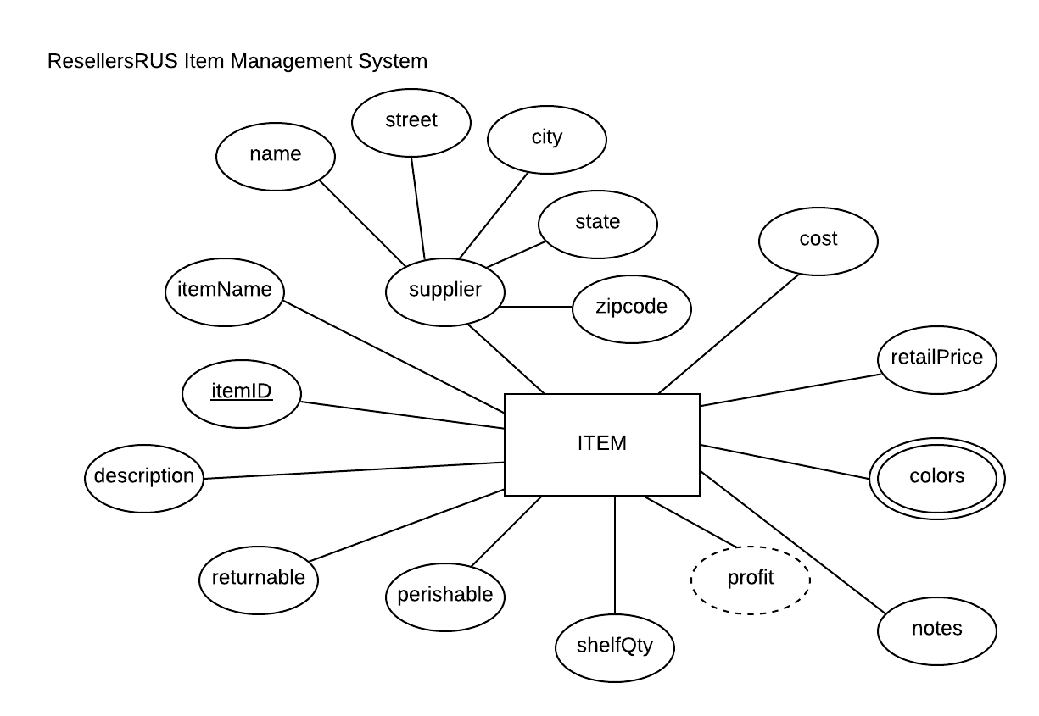

Resulting Relation:

ITEM(itemID, itemName, name, street, city, state, zipcode, cost, retailPrice, color1, color2, notes, shelfQty, perishable, returnable, description)

Functional Dependencies:

itemID 🡺 itemName, name, street, city, state, zipcode, cost, retailPrice, color1, color2, notes, shelfQty, perishable, returnable, description – All attributes are dependent on the primary key

name 🡺 street, city, state, zipcode – Non-Key attributes are dependent on another Non-Key attribute

**YOUR ANSWER (Final set of relations normalized to BCNF):** The relation is in 2nd normal form. However, violates the 3rd normal form. The reason is the Non-Key attribute street, city, state, and zipcode are dependent on another Non-Key attribute, name.

ITEM (itemID, itemName, *name*, cost, retailPrice, notes, shelfQty, perishable, returnable, description)

ITEM(name) mei CUSTOMER(name)

ITEM(itemID) mei COLOR(itemID)

CUSTOMER(name, street, city, state, zipcode)

COLOR(*ItemID*, color)

COLOR(itemID) mei ITEM(itemID)

**Task #5 (23 points)**

Given the relation and functional dependencies below, normalize the SALE relation and resulting relations through BCNF. Be sure to use proper relational notation and reference statements for foreign keys.

SALE(invoice#, item#, custID, custName, custAddress, itemName, itemPrice, itemQtyPurch, salesPerson#, salesPersonName, subtotal, tax, totalDue)

Functional Dependencies:

invoice#, item# 🡪 custID, custName, custAddress, itemName, itemPrice, itemQtyPurch, salesPerson#, salesPersonName, subtotal, tax, totalDue – All attributes are dependent on composite primary key

item# 🡪 itemName, itemPrice – Non-Key attributes partially depends on a composite primary key

invoice# 🡪 custID, custName, custAddress, salesPerson#, salesPersonName, subtotal, tax, totalDue – Non-Key attributes partially depends on a composite primary key

custID 🡪 custName, custAddress – Non-Key attributes depends on Non-Key attributes

salesPerson# 🡪 salesPersonName - Non-Key attributes depends on Non-Key attributes

**YOUR ANSWER (Final set of relations normalized to BCNF):** The relation is in 1st normal form and violates the 2nd normal form. The reason is that Non-Key attributes depend on another Non-Key attribute.

SALE(*invoice#,* *item#*, itemQtyPurch)

SALE(invoice#) mei INVOICE(invoice#)

SALE(item#) mei ITEM(item#)

ITEM(item#, itemName, itemPrice)

INVOICE(invoice#, *custID*, *salesPerson#,* subtotal, tax, totalDue)

INVOICE(custID) mei CUSTOMER(custID)

INVOICE(salesPerson#) mei SALES_PERSON(salesPerson#)

CUSTOMER(custID, custName, custAddress)

SALES_PERSON(salesPerson#, salesPersonName)

**Task #6 (27 points)**

Given the relation and functional dependencies below, normalize the relation and resulting relations through BCNF. Be sure to use proper relational notation and reference statements for foreign keys.

A(1, 2, 3, 4, 5, 6, 7, 8, 9, 10)

Functional Dependencies:

1, 2, 3, 4->5, 6, 7, 8, 9, 10 – All Non-Key attributes are fully dependent on the composite primary key

1->5, 6 –Non-Key attributes are partially dependent on composite primary key

5->1,6 – A Non-Key attribute is dependent on a Non-Key attribute

2,3->7,8 – A Non-Key attribute is partially dependent on composite primary key

7->8 – A Non-Key attribute is dependent on a Non-Key attribute

4->9,10 – Non-Key attributes are partially dependent on composite primary key

9->10 – A Non-Key attribute is dependent on another Non-Key attribute

10->9 – A Non-Key attribute is dependent on another Non-Key attribute

**YOUR ANSWER (Final set of relations normalized to BCNF):** The relation is in 1st normal form. However, it violates the 2nd normal form.

A(*1, 2, 3, 4*)

A(1) mei B(1)

A(2, 3) mei C(2, 3)

A(4) mei E(4)

B(1, 5, 6)

C(2, 3, *7*)

C(7) mei D(7)

D(7, 8)

E(4, *9*)

E(9) mei F(9)

F(9, 10)