**Stock Market Analysis – Real Estate**

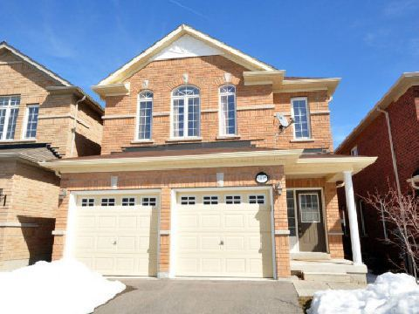

Let us use our home as an analogy to understand the balance sheet, the income statement, and the cash flow statement. Let us model our home as a company **Challenger Inc** with the following statistics:

**Number of Shares:** 100,000

**Price per Share:** $10.00

**Dividends:** $10,000

**Cash:** $20,000

**Market Capitalization (net worth):** $10/share x 100,000 shares = $1,000,000

**Revenue (rental):** $30,000/year

**Running Expenses (utilities, taxes, insurance,…):** $12,000/year

**Debt (mortgage):** $500,000

**Interest payments:** $500,000 x 2%/year = $10,000/year

**The Balance Sheet**

**Assets:**

Equity: $1,000,000

**Liabilities:**

Debt: $500,000

**Debt/Equity = 50%**

**The Income Statement**

Revenue: $30,000/year

Running Expenses: $12,000/year

Interest on Debt: $10,000/year

**Income:** (revenue – running expenses – interest on debt) =

($30,000 – $12,000 - $10,000)/year = **$8,000/year**

**Earnings Per Share:** Income/number of shares = $8,000/year / 100,000/shares = $**0.08/share**

**Price Per Earnings:** price per share / earnings per share = $10.00/share / $0.08/share **= 125**

**Dividend Per Share:** dividends/number of shares = $10,000 / 100,000shares = **$0.10/share**

**Dividend Yield:** 100% x Dividends / Market Cap = $10,000 / $1,000,000 = **1%**

100% x Dividend Per Share / Price Per Share = 100% x 0.10/10 = **1%**

**Dividend Payout Ratio:** 100% x dividends per share / earnings per share = 100% x 0.10 / 0.08 = **125%**

**The Cash Flow Statement**

Cash: $20,000

Income: $8,000/year

Dividend Payout: $10,000/year

**Change in Cash:** income – dividend payout = **-$2,000/year**