**Members:**

* Wencel De Lara
* Yvan Sinues
* Vinard James Damasco
* John Miguel Jusayan

**accounts_tbl**

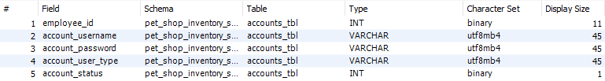

**activity_logs_tbl**

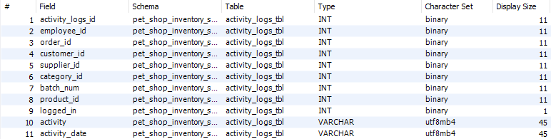

**customers_tbl**

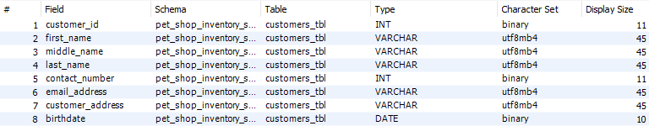

**employees_tbl**

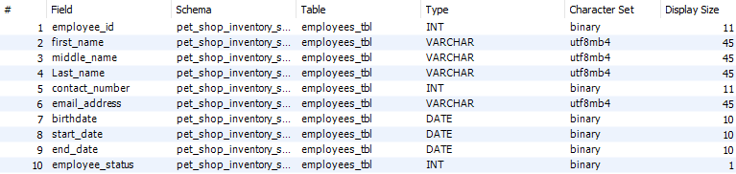

**inventories_tbl**

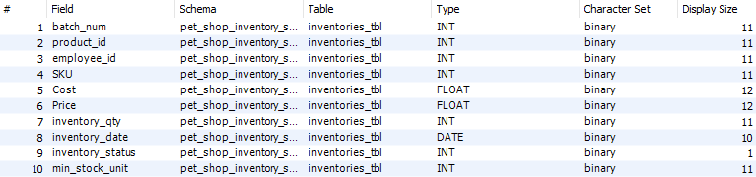

**order_details_tb**

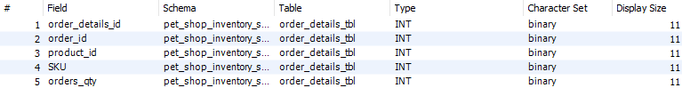

**orders_tbl**

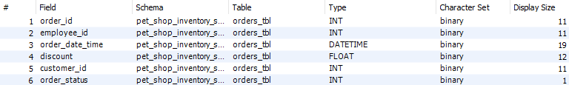

**product_category_tbl**



**products_tbl**

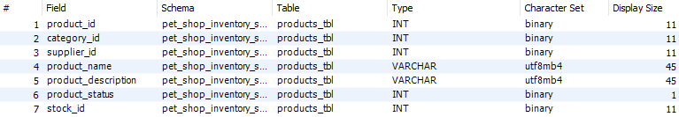

**supplier_tbl**

