|  |  |  |  |
| --- | --- | --- | --- |
| **Name:** | George Miguel V. Batalan | **Date:** | 15/09/2023 |
| **Program:** | III-CPE | **Section:** | A361 |

**Intended Learning Outcomes:**

1. Write functions to react to events.
2. Validate HTML forms.

Design a simple form that contains the following details:

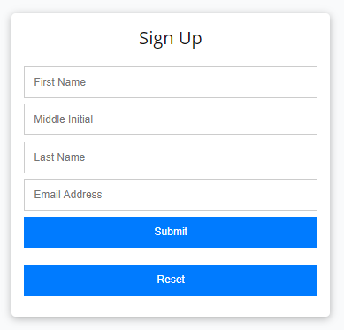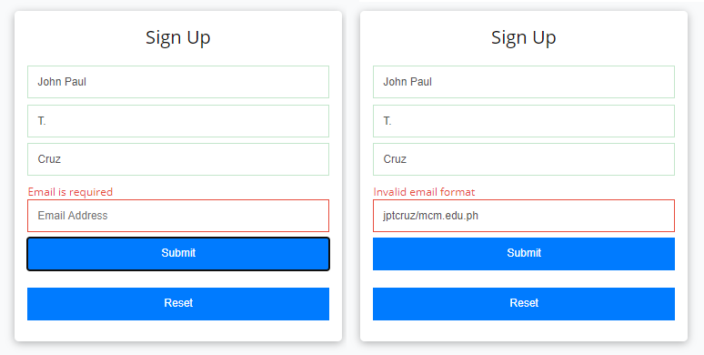

Emmy Grace

Emmy Grace

T.

T.

Requillo

Requillo

Email Address

egtolentino/mcm.edu.ph

* + First Name
  + Middle Initial
  + Last Name
  + E-Mail Address Here is an example form:

The form must be able to validate if the First Name, Middle Initial, and Last Name fields have corresponding inputs (regardless of content). The form must also validate if there is an invalid e-mail address format presented. There must be an alert message to signify that there are invalid inputs.

Here is a sample output:

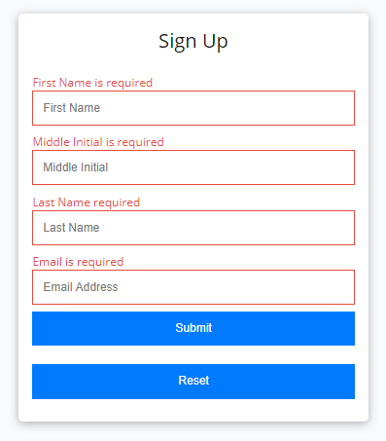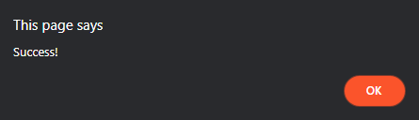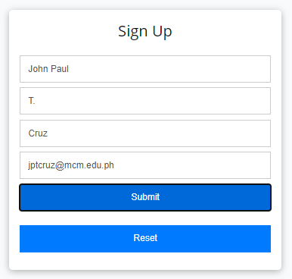

The form must be able to see if there are no inputs placed. Here is a sample output:

Once the form validates all inputs, an alert box must be seen that says **Success!**

Here is a sample output:

Emmy Grace T.

Requillo [egtolentino@mcm.edu.ph](mailto:egtolentino@mcm.edu.ph)

================================================================================

**HTML Source Code:**

<!-- Name: George Miguel V. Batalan -->

<!-- Course: Bachelor of Science in Computer Engineering -->

<!DOCTYPE html>

<html>

<head>

<title>Validating Form Validation</title>

<link rel = "stylesheet" href = "data.css">

</head>

<body>

<form id="myForm">

<label for = "firstName">First Name</label>

<input type = "text" id = "firstName" required>

<label for = "middleInitial">Middle Initial</label>

<input type = "text" id = "middleInitial" required>

<label for = "lastName">Last Name</label>

<input type = "text" id = "lastName" required>

<label for = "email" >E-Mail Address</label>

<input type = "text" id = "email" required>

<input type = "submit" value = "Submit">

</form>

<script src = "script.js"></script>

</body>

</html>

**CSS Source Code:**

body {

font-family: Arial, sans-serif;

text-align: left;

}

form {

margin: 20px auto;

max-width: 400px;

padding: 20px;

border: 1px solid #cccccc;

border-radius: 5px;

}

label {

display: block;

margin-bottom: 5px;

}

input[type = "text"] {

width: 90%;

padding: 10px;

margin-bottom: 10px;

border: 1px solid #cccccc;

border-radius: 5px;

}

input[type = "submit"] {

background-color: #db34c5;

color: #fff;

border: none;

padding: 10px 20px;

border-radius: 5px;

cursor: pointer;

}

input[type="submit"]:hover {

background-color: #bd0f0f;

}

**JavaScript Source Code:**

const form = document.getElementById("myForm")

form.addEventListener("submit", function(event) {

event.preventDefault();

const firstName = document.getElementById("firstName").value;

const middleInitial = document.getElementById("middleInitial").value;

const lastName = document.getElementById("lastName").value;

const email = document.getElementById("email").value;

if (!firstName || !middleInitial || !lastName || !isValidEmail(email)) {

alert("Invalid inputs. Please check your entries.");

} else {

alert("Success!");

form.reset();

}

});

function isValidEmail(email) {

const emailRegex = /^[^\s@]+@[^\s@]+\.[^\s@]+$/;

return emailRegex.test(email);

}

**Output:**

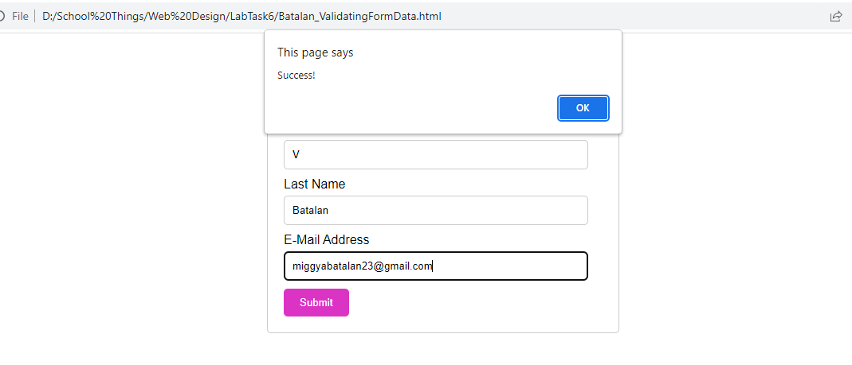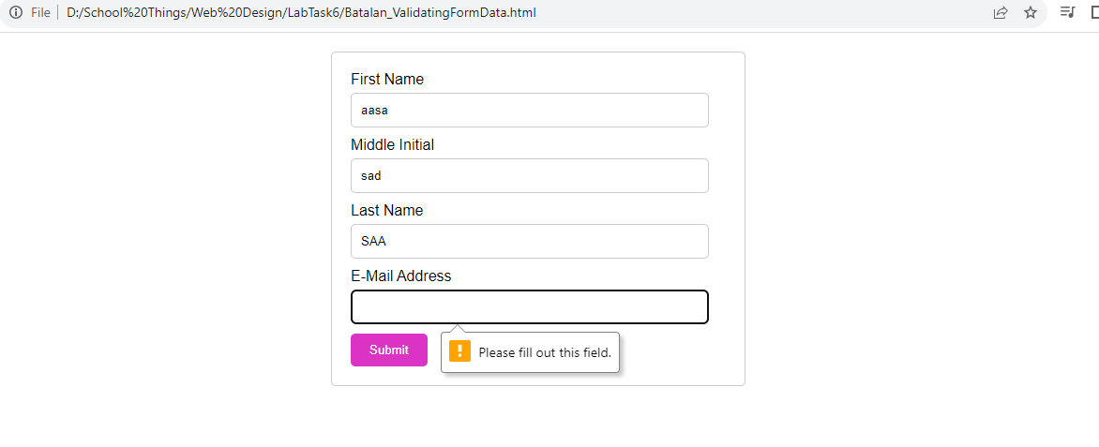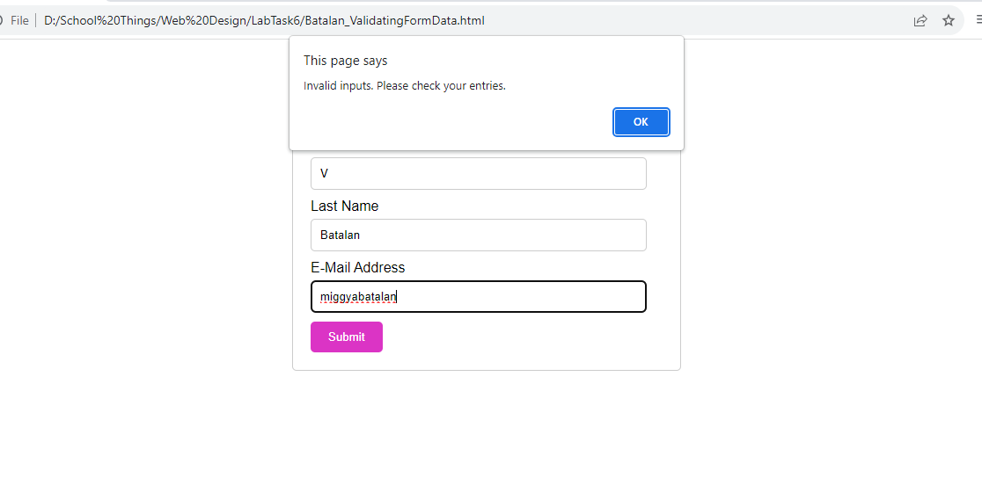

**Findings and Observations:**

I observed that this task can be used to our upcoming final lab exam so we can see the profile of the person using the website.