**Automating Data Transfer from Google Sheets to Web Forms using Chrome Extension and Selenium**

**By: Lacanienta, Miguel, M.**

**A Practicum Report Submitted to the School of Information Technology In Partial Fulfillment of the Requirements for the Degree Program Bachelor of Science in Computer Science**

**Mapua University**

**Date submitted Jan 9, 2025**

**APPROVAL SHEET**

## Mapua Institute of Technology School of Information Technology

This is to certify that I/we have supervised the preparation of and read the practicum report prepared by Miguel M. Lacanienta and that the said practicum has been submitted for final examination by the Oral Examination Committee.

## John Paul Q. Tomas

Technical Adviser/OJT Supervisor

As members of the Oral Examination Committee, we certify that we have examined this practicum report, presented before the committee on , and hereby recommended that it be accepted as fulfillment of the practicum requirement for the degree in Program Bachelor of Science in Computer Science.

Panel Member Panel Member

This practicum report is hereby approved and accepted by the School of Information Technology as fulfillment of the practicum requirement for the degree in Program Bachelor of Science in Information Technology

## Ariel Kelly Balan

Dean, School of IT

**ACKNOWLEDGEMENTS**

I would like to express my deepest gratitude to all those who have supported and guided me throughout the course of this project. First and foremost, I would like to thank my Supervisor, Sir Greg, for their continuous support, invaluable guidance, and insightful feedback, which were instrumental in the successful completion of this project.

I am also deeply thankful to my colleagues and friends, for their assistance and encouragement throughout this journey. Their advice and suggestions were essential in overcoming the technical challenges encountered along the way.

I would also like to acknowledge the support provided by Ollopa Corporation, whose resources and tools made this project possible.

Finally, I would like to extend my heartfelt appreciation to my family, especially my dad, for their unwavering patience, understanding, and encouragement during this period.

**ABSTRACT**

This project presents the development of an automated tool designed to streamline data processing tasks by integrating Google Sheets with a Chrome extension and Selenium for web automation. The objective was to create a system that automatically retrieves specific rows from Google Sheets and inputs the data into designated fields on a web application, significantly reducing manual data entry and improving operational efficiency.

The project utilized several technologies, including a custom-built Chrome extension to capture user inputs and interact with Google Sheets, and a Python Flask backend to process the data and control a Selenium WebDriver for web-based automation. Through the extension, users can dynamically select Google Sheets data, open a specified web application, and automate form- filling processes.

This solution provides a seamless and efficient method for automating repetitive tasks, particularly in data management workflows. The project highlights the potential of automation tools in reducing human error, improving productivity, and minimizing time consumption in business processes.

|  |  |  |
| --- | --- | --- |
|  | **TABLE OF CONTENTS** |  |
| Title Page |  | 1 |
| Approval Sheet |  | 2 |
| Acknowledgements |  | 3 |
| Abstract of the Project |  | 4 |
| Table of Contents |  | 5 |
| Certificate of OJT Completion |  | 6 |
| Chapter 1 |  |  |
| Company Profile |  |  |
| Company History |  | 7 |
| Vision/Mission |  | 7 |

Chapter 2 Trainee

Specific Department Where the Trainee Assigned 8

Duties and Responsibilities 8

Training with Your Company 8

Learnings Acquired from the Training 8

Corporate Learning 9

Technical Learning 9

Assessment and Evaluation on the Company 9

Career Path Assessment 9

Chapter 3 Project

Project Overview 10

Problem/Opportunities Statement 10

Objectives Statement 11

Significance 12

Scope and Limitations 12

Brief Methodology 13

Proof of Output

Screen Shots 15

Diagrams/Flowcharts 24

Appendices

Resume 25

Project Approval Form 26

Accomplishment Reports 27

**CERTIFICATE OF OJT COMPLETION**

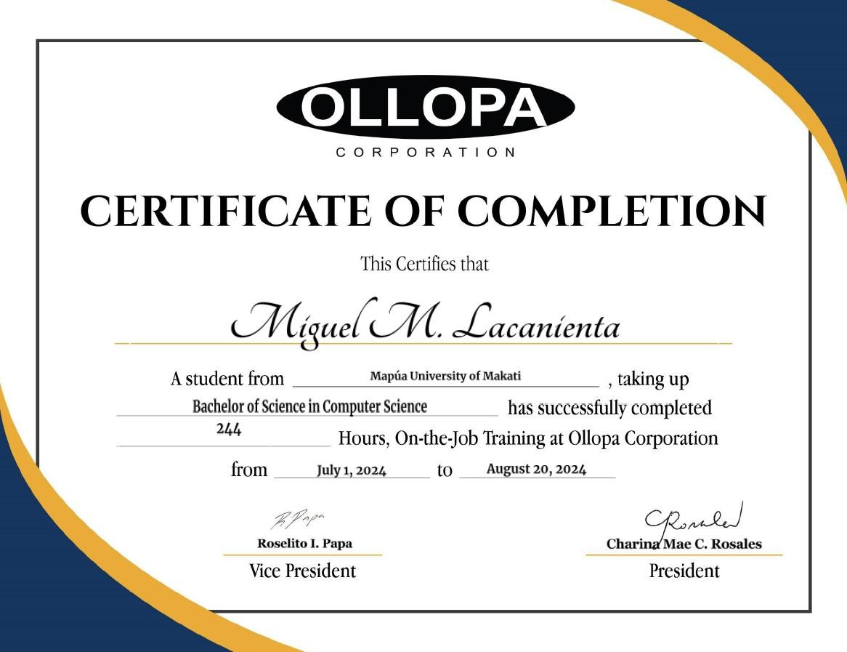

**CHAPTER 1**

**COMPANY PROFILE**

## Company History

Ollopa Corp, a leading brand in the Philippines, has grown substantially since its inception in 2017. Initially operating locally, Ollopa Corporation now manages multiple lines of business under the eWorldTrade global umbrella. These include eGetinnz, Frontier Semi-Conductor Company, FifiTours, and its newest venture, FifiBuy.

FifiBuy, launched in January 2021, is a rapidly expanding online shopping and marketplace platform. In just a few months, FifiBuy aims to be a major e-commerce player by offering a seamless, secure, and diverse online shopping experience. The platform features an extensive product range, from electronics and household goods to toys, fashion, and sports equipment.

Although FifiBuy began by focusing on the Philippine market, its ambitious growth plans include expansion into the Southeast Asian market within three months and into the United States market within six months. The company's commitment to offering a wide variety of high-quality, authentic products has made it a trusted name among consumers and suppliers alike.

By partnering with various sellers, FifiBuy has ensured that its customers enjoy a seamless shopping experience. The platform's unique approach includes offering discounted and unbranded items, which customers can discover through browsing instead of searching. FifiBuy's wide product selection and affordable pricing make it a preferred destination for online shoppers.

FifiBuy's dedication to customer satisfaction is reflected in its exceptional service standards. With a focus on valuing customers' time and providing knowledgeable and resourceful support, FifiBuy continuously aims to exceed expectations.

## Vision/Mission Vision

Our vision is to create a place where people can easily find and discover anything they wish to buy online. We aim to become a global e-commerce leader, providing the best brands and ensuring a seamless shopping experience for everyone.

## Mission

FifiBuy is committed to delivering the highest quality of customer service with warmth, friendliness, and a strong sense of pride and company spirit. Our mission is to ensure every customer's shopping experience is convenient, enjoyable, and reliable.

**CHAPTER 2**

**TRAINEE**

## Specific Department Where the Trainee Assigned

During my training, I was assigned to the IT Department. My primary role involved handling various tasks, including video transcription, backend card creation, website checking, card checking, and the requalification process. In essence, I worked as an encoder, contributing to the efficient functioning of these systems.

## Duties and Responsibilities

My main duties and responsibilities included the following:

* + **Card Creation:** I was responsible for creating and editing cards within the Firebase backend system for FiBeiGreetings.com, ensuring they were ready for activation.
  + **Card Checking:** I routinely checked the cards for errors or inconsistencies, making sure they met company standards.
  + **Card Requalification:** I assisted in the review and requalification of cards that did not meet the required standards.
  + **Website Quality Checks:** Once a week, I conducted quality checks on the website to ensure its proper functionality. In case of issues, I would fix formatting errors in the backend or report other site-related problems for further resolution.
  + **Video Transcription:** Occasionally, I was tasked with transcribing video content as part of my duties in the IT Department.
  + **Mobile App Checking:** I was also assigned to check the functionalities of two mobile apps: one was a game from the Google Play Store, and the other was an app version of FiBeiGreetings.com. My role was to ensure their functionalities worked as intended and to provide feedback.

## Training with Your Company

Training was primarily conducted through Skype calls with my team leader or supervisor. These sessions were supplemented with detailed PowerPoint presentations that outlined specific tasks and responsibilities. This method of training ensured clear communication and provided me with the knowledge I needed to perform my duties effectively.

## Learnings Acquired from the Training

Through my training, I gained practical skills that enhanced my knowledge of web development, database management, and quality assurance. Specifically, I became proficient in using Ollopa’s Firebase backend, which enabled me to create and edit cards for the FiBeiGreetings.com platform. My experience in video transcription, card creation, and checking helped me refine my attention to detail, time management, and the ability to handle multiple responsibilities simultaneously.

## Corporate Learning

My time at the company provided me with insight into the company’s operations and its commitment to delivering high-quality products and services. The work environment is both relaxed and efficient, encouraging employees to take ownership of their tasks while maintaining flexibility. The company’s focus on continual improvement and open feedback reinforced the importance of adaptability and learning from constructive criticism, which is essential in any corporate setting.

## Technical Learning

I became well-versed in using Ollopa’s Firebase backend, a user-friendly platform that allowed me to create and edit cards for FiBeiGreetings.com. This hands-on experience strengthened my understanding of backend management within a live production environment.

Additionally, I gained valuable technical experience in backend operations, web development tools, and quality control processes. I learned to use Firebase for backend data entry, performed website functionality testing, and streamlined workflows by automating repetitive tasks. My exposure to automation tools like Selenium also provided me with a deeper understanding of how to increase efficiency in everyday tasks.

## Assessment and Evaluation on the Company

The company fostered a relaxed and supportive environment, making it easy to focus on my work and learn new things without feeling pressured. The open and flexible work culture was conducive to personal and professional growth, and I always felt comfortable seeking guidance and feedback when needed.

## Career Path Assessment

My time with the company has given me valuable exposure to different aspects of IT, particularly in coding and backend development. These experiences have ignited a genuine interest in pursuing a career that involves solving complex problems through code.

While my role as an encoder was relatively straightforward, it’s clear to me that my future lies in more technically challenging IT roles. The automation project I worked on highlighted the importance of coding, and I found that I thoroughly enjoyed the problem-solving and development aspects of the role. This experience has strengthened my determination to further develop my skills in coding, software development, and IT.

**CHAPTER 3**

**PROJECT OVERVIEW**

## Project Overview

This project focuses on the automation of data entry tasks from Google Sheets to the FiBeiGreetings platform using a Chrome extension and Selenium. The manual process of copying and pasting information from Google Sheets into a web-based platform was time-consuming and prone to human errors. To streamline this process, I developed a solution that automates the extraction of data from specified rows in Google Sheets and inputs it directly into the FiBeiGreetings card creation form.

The system consists of two main components:

1. A **Chrome extension** that extracts data from the active Google Sheets document, dynamically selecting rows and spreadsheets.
2. A **Selenium-powered backend** that automates filling the FiBeiGreetings form fields based on the data retrieved from Google Sheets.

The goal of the project is to improve efficiency, reduce manual labor, and eliminate potential errors caused by repetitive data entry tasks. With this automation in place, employees can focus on more critical tasks while ensuring the accuracy of the information entered into the FiBeiGreetings platform.

By leveraging **JavaScript**, **Google Sheets API**, and **Selenium**, the project demonstrates how browser automation can be integrated into daily workflows to optimize time management and data accuracy.

## Problem/Opportunities Statement

In the current workflow at FiBeiGreetings, employees are tasked with manually copying data from Google Sheets into the FiBeiGreetings card creation form. This manual process is repetitive, time- consuming, and highly susceptible to human error, particularly when large volumes of data are involved. Even minor mistakes, such as typing errors or incorrect data entry, can lead to issues in card production, affecting both efficiency and quality.

The opportunity lies in automating this process. By leveraging automation tools such as a Chrome extension and Selenium, this project presents an opportunity to streamline the entire data entry workflow. Automating the transfer of data from Google Sheets to the FiBeiGreetings platform not only reduces the time spent on manual data entry but also enhances accuracy and consistency, eliminating errors commonly associated with repetitive tasks.

This project addresses the following key problems:

* **Inefficiency**: The manual entry of card details is a slow and labor-intensive process.
* **Human Error**: Repeated manual tasks often lead to mistakes that can affect the final product.
* **Time Wastage**: Valuable employee time is spent on tasks that could be automated.

The proposed automation solution offers the following opportunities:

* **Increased Productivity**: Employees can focus on more critical tasks as automation handles the repetitive data entry.
* **Improved Accuracy**: Automation ensures that data is transferred accurately, reducing the risk of errors.
* **Optimized Workflow**: Streamlining this process frees up time and resources, leading to more efficient operations within the IT department and across other departments involved in card creation.

By addressing these problems and seizing the opportunity for automation, this project aims to enhance operational efficiency and contribute to a more seamless, error-free workflow at FiBeiGreetings.

## Objectives Statement

The primary objective of this project is to develop and implement an automation solution that streamlines the manual process of transferring data from Google Sheets into the FiBeiGreetings card creation platform. The automation aims to reduce human error, increase efficiency, and optimize the workflow within the IT department.

Specifically, this project aims to achieve the following:

## Develop a Chrome Extension:

* + Create a user-friendly Chrome extension that enables employees to automate the process of transferring data from Google Sheets to the FiBeiGreetings platform.

## Integrate Selenium for Automation:

* + Use Selenium to automatically open the FiBeiGreetings card creation form, fill out the necessary fields with data from the Google Sheets document, and ensure that all required details are correctly entered.

## Eliminate Human Error in Data Entry:

* + Automate the data entry process to reduce mistakes such as typos, incorrect information, or missing fields that can occur with manual input.

## Improve Workflow Efficiency:

* + Minimize the time spent on repetitive tasks like manually copying and pasting information from Google Sheets to the FiBeiGreetings platform, thereby improving overall efficiency.

## Enable Dynamic Selection of Spreadsheet and Row:

* + Allow the user to dynamically select both the Google Sheets document and specific row of data to be transferred, enhancing the flexibility and adaptability of the tool for different tasks.

## Provide Clear Documentation:

* + Create comprehensive documentation for future developers or users, explaining the functionality of the extension and how to maintain or further enhance the system if required.

By accomplishing these objectives, the project aims to deliver a robust, time-saving, and error-free automation solution, thereby improving productivity in the IT department and facilitating better workflow management.

## Significance

This project holds considerable significance for the IT Department and the broader operational efficiency of FiBeiGreetings. By automating the process of copying data from Google Sheets and entering it into the backend system, the project addresses several key operational challenges, such as manual data entry, error correction, and time inefficiencies.

Key benefits include:

1. **Enhanced Accuracy:** Manual data entry can be prone to human error, especially when dealing with large datasets. By automating the process, the project ensures a higher degree of accuracy in transferring data, reducing the need for error correction and improving the quality of information used by the system.
2. **Increased Productivity:** Automation significantly reduces the time required to perform repetitive tasks, allowing team members to focus on more complex and strategic responsibilities. This increases overall productivity and enables more efficient use of human resources within the company.
3. **Cost Efficiency:** By streamlining workflows and reducing the need for manual interventions, the project helps save time and, consequently, costs associated with operational inefficiencies. Fewer errors also mean less time spent on corrections, leading to overall savings in terms of both time and resources.
4. **Scalability:** As the company grows and deals with larger volumes of data, the automation framework can easily be scaled to handle increased workloads, ensuring the system remains robust and efficient even as demands rise.
5. **Improved Employee Satisfaction:** By reducing the burden of tedious, repetitive tasks, the project contributes to greater job satisfaction for employees. It allows them to engage in more meaningful work that adds greater value to the company and their professional development.

In essence, this project not only improves immediate workflow efficiency but also lays the foundation for more scalable and efficient operations in the long term. It represents a shift toward leveraging technology to create smarter, more resilient systems that will benefit FiBeiGreetings for years to come.

## Scope and Limitations Scope

The scope of this project is to automate the process of transferring data from Google Sheets into FiBeiGreetings' backend system using a Chrome extension and Selenium. The key functionalities within the scope include:

* **Data Retrieval from Google Sheets:** The extension retrieves specified rows and columns from Google Sheets, dynamically pulling data based on the user’s input (such as sheet names and row numbers).
* **Backend System Integration:** The project automates the process of inputting retrieved data into specific fields in FiBeiGreetings' backend system (via a Chrome extension and Selenium), ensuring seamless integration.
* **Error Handling:** The system includes basic error-handling capabilities, such as ensuring the active sheet and row number are correctly identified before proceeding with data transfers.
* **Automation of Card Creation:** The automation focuses primarily on tasks related to creating and editing greeting cards within the FiBeiGreetings system. This includes filling out forms in the backend system with data fetched from Google Sheets.
* **Cross-Platform Compatibility:** The system is designed to work in a Chrome environment, with the flexibility of running across multiple platforms, provided the necessary prerequisites (like Chrome debugging) are met.

## Limitations

While the project aims to automate the data entry process effectively, there are certain limitations to its scope, including:

* **Limited to Chrome:** The automation process is designed specifically for the Chrome browser using Selenium and Chrome's debugging capabilities. The solution may not be fully compatible with other browsers like Firefox or Safari unless further modifications are made.
* **Manual Debugging Setup:** The Chrome instance must be started with a specific debugger port, requiring manual setup by the user. Without this, the automation script cannot connect to Chrome for data entry.
* **Single User Interaction:** The project is built for a single-user interaction at a time, meaning it cannot handle multiple simultaneous data entry tasks across different users or systems.
* **Static Backend Structure:** The solution assumes that the structure of the FiBeiGreetings backend system remains static. Significant changes to form field names or the structure of the website may require updates to the automation script.
* **Limited Error Recovery:** While basic error handling is implemented, the system has limited capabilities in recovering from significant failures (e.g., if the Google Sheet is inaccessible or the backend server is down). These situations would require manual intervention.
* **Dependent on Internet Connectivity:** Since the project relies on external platforms such as Google Sheets and the FiBeiGreetings backend, internet connectivity is a critical requirement for the system to function properly. Any disruption in connectivity will halt the automation process.

This project, while efficient in automating specific tasks, is limited by its reliance on manual setup, browser-specific functionality, and static configurations within the backend. Future iterations could focus on enhancing scalability, improving error recovery, and supporting multiple browsers.

## Brief Methodology

The methodology of the project was focused on creating an efficient system to automate the process of transferring data from Google Sheets to the FiBeiGreetings backend. The key steps involved in the project methodology were as follows:

* 1. **Requirement Gathering:** The first step was identifying the key processes that could benefit from automation. The primary goal was to automate the manual process of copying data from Google

Sheets and pasting it into the FiBeiGreetings backend, specifically during card creation. Initial discussions with the team helped establish the tasks that would be automated.

* 1. **Design and Planning:** After identifying the requirements, a structured approach was developed for how the automation would work. This involved planning the integration between Google Sheets, a custom Chrome extension, and Selenium. The architecture was designed to ensure seamless communication between these components.
  2. **Development of Chrome Extension:** A Chrome extension was developed to facilitate the automation. This extension interacts with the current Google Sheets tab, retrieves the selected row and sheet, and then triggers the automation process. The extension also handles the task of opening a new tab for card creation in the FiBeiGreetings backend.
  3. **Google Sheets Integration:** Integration with Google Sheets was accomplished using Google’s Sheets API (via gspread). The project involved setting up credentials and a service account to access specific Google Sheets. The Chrome extension dynamically retrieves data based on the sheet and row provided by the user, which is then sent to the backend for further automation.
  4. **Backend Automation using Selenium:** Selenium was used to automate the process of filling out forms in the FiBeiGreetings backend system. The script identified the form fields using XPaths and populated them with data fetched from Google Sheets. Selenium was also responsible for switching to the correct tab for card creation, ensuring the right data was entered in the corresponding fields.
  5. **Command-Line and Terminal Setup:** Running the automation system involved setting up and running Flask in the terminal/command prompt. Flask was used to facilitate communication between the Chrome extension, Google Sheets, and Selenium. To start the Flask backend, commands were executed in the terminal, including activating the Python virtual environment (venv) and running app.py. Additionally, a separate terminal command was used to launch Chrome with the --remote-debugging-port option to allow Selenium to attach to the active Chrome session for automation.
  6. **Error Handling and Debugging:** Throughout the project, error handling mechanisms were implemented to address issues such as missing data, incorrect sheet/row input, or failed connections. Regular debugging was performed both in the browser's developer console and through the terminal's log outputs to ensure the system could handle errors gracefully and alert the user to any issues that needed attention.
  7. **Testing and Validation:** The project underwent several rounds of testing to ensure it performed as expected. Test cases included verifying that the correct data was pulled from Google Sheets, confirming that the data was accurately transferred to the backend, and ensuring the process worked across multiple instances and environments. Testing involved running commands in the terminal and observing the correct flow of the automation.
  8. **Documentation and Finalization:** After testing, thorough documentation was created to guide future users on how to set up and operate the system. This includes instructions for starting Chrome with the necessary debugger port, using the Chrome extension, and configuring the integration with Google Sheets and Selenium. The terminal/command prompt usage was also documented to ensure smooth backend operation through Flask and Selenium.

This structured approach ensured that the solution was developed in a systematic manner, focusing on user needs and maintaining a clear flow of data from Google Sheets to the FiBeiGreetings backend system while leveraging terminal/command prompt operations for running the backend and debugging.

**PROOF OF OUTPUT**

1. **Screenshots**

* **Google Sheets**

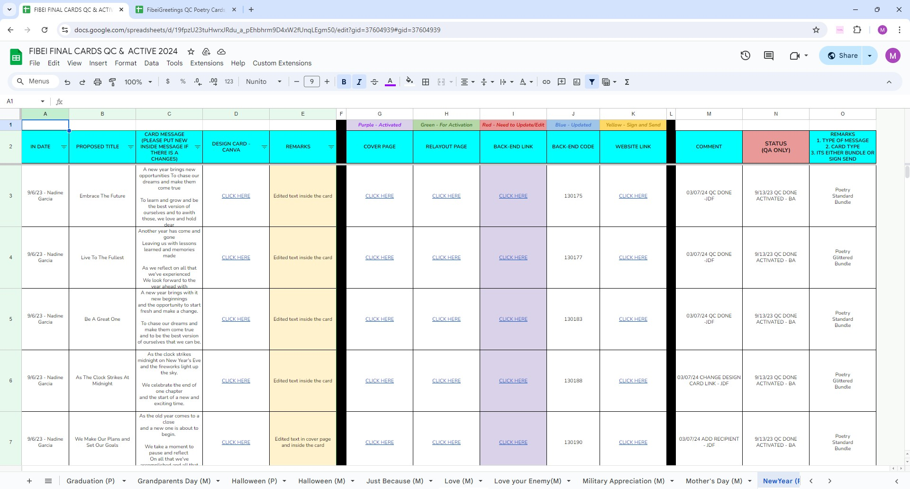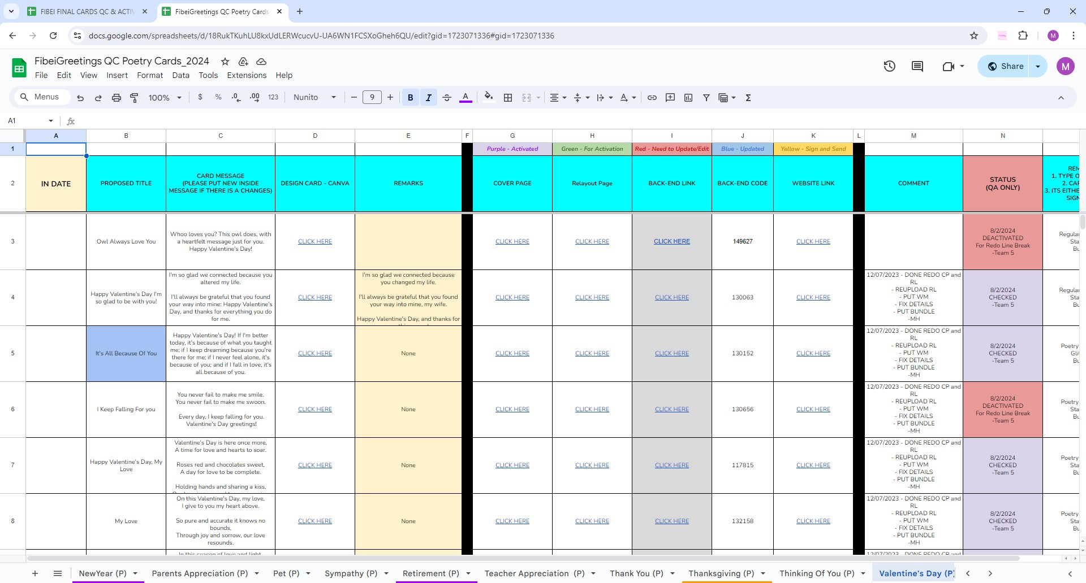

* **Chrome Extension**

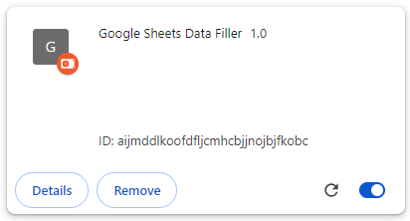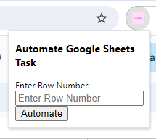

* **Flask/Selenium Running**

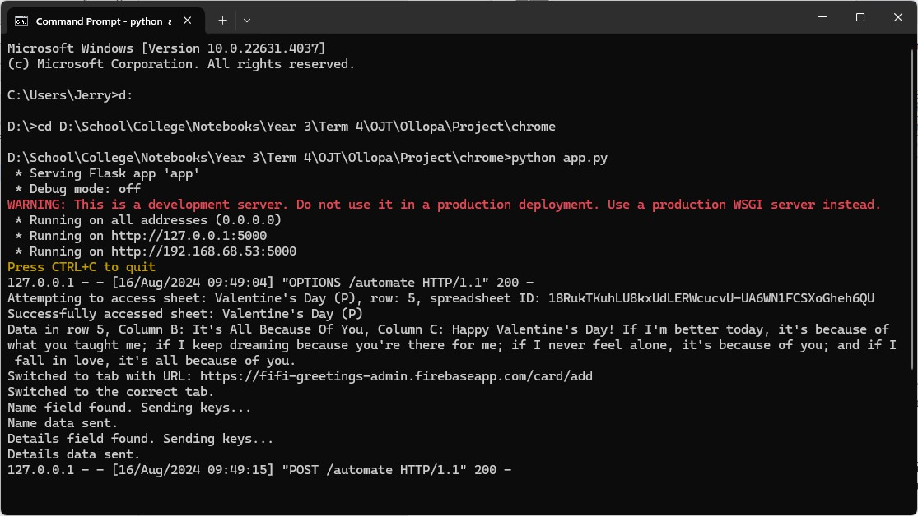

* 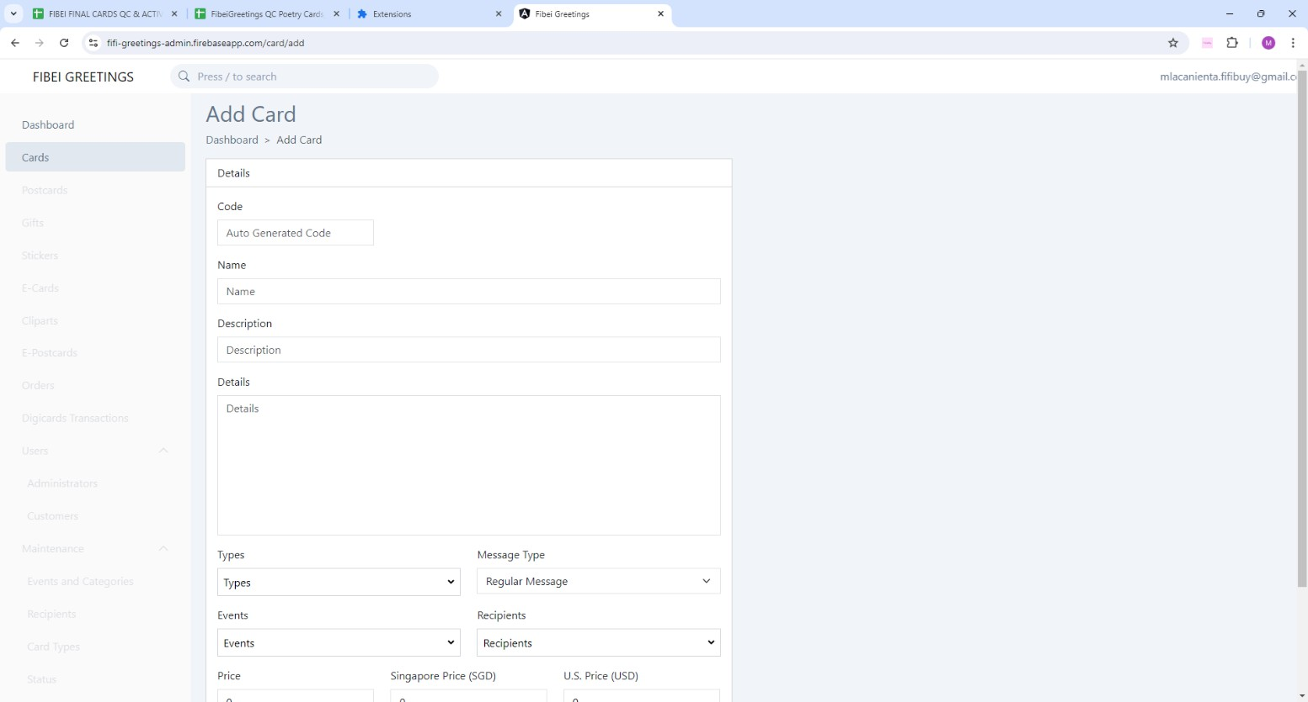**FiBeiGreetings Admin Panel Before**

**After**

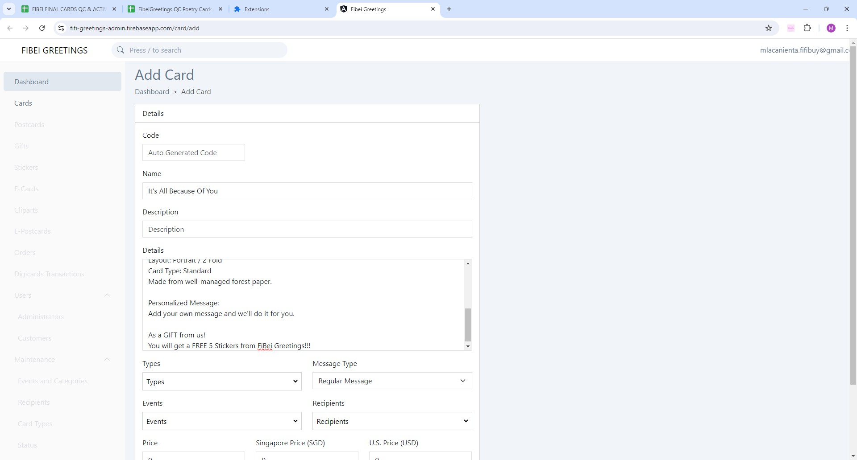

* 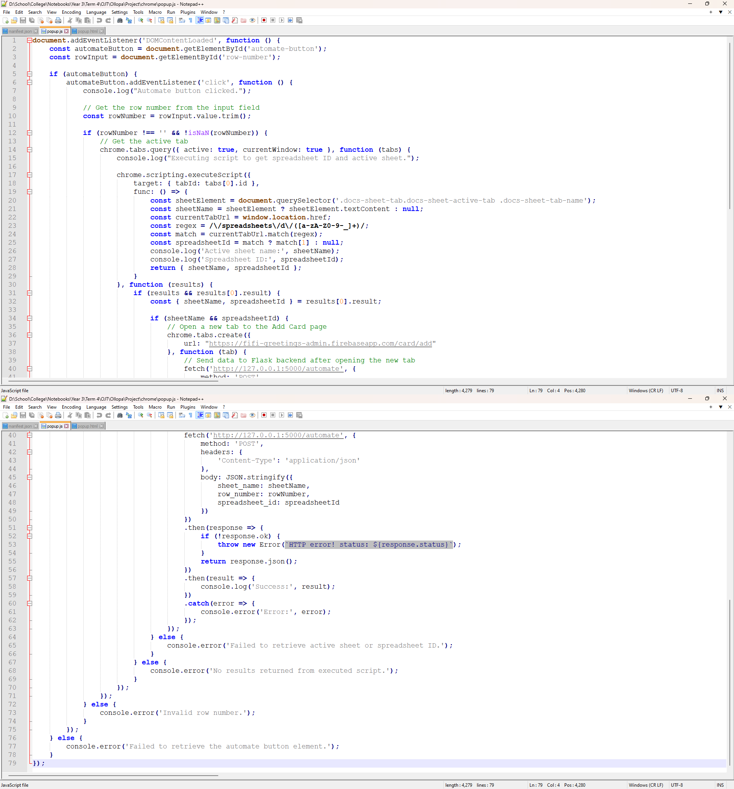**Code Screenshots JavaScript (Chrome Extension)**

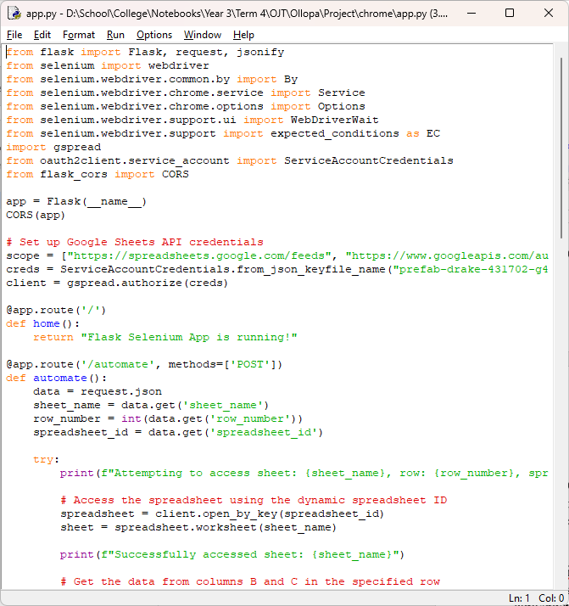**Python (Flask and Selenium)**

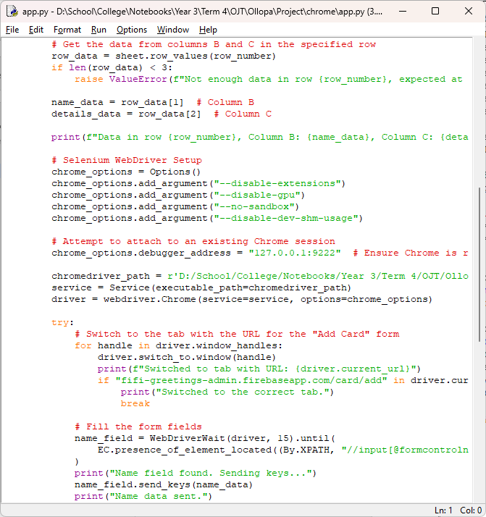

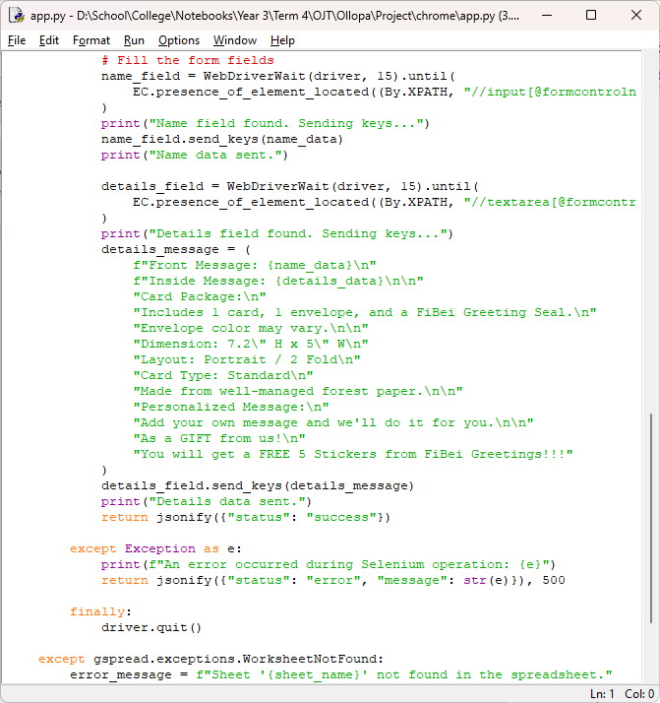

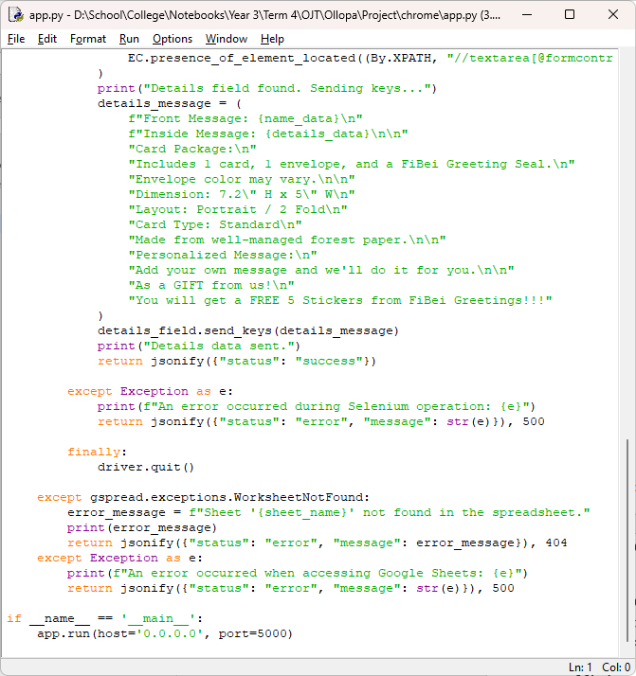

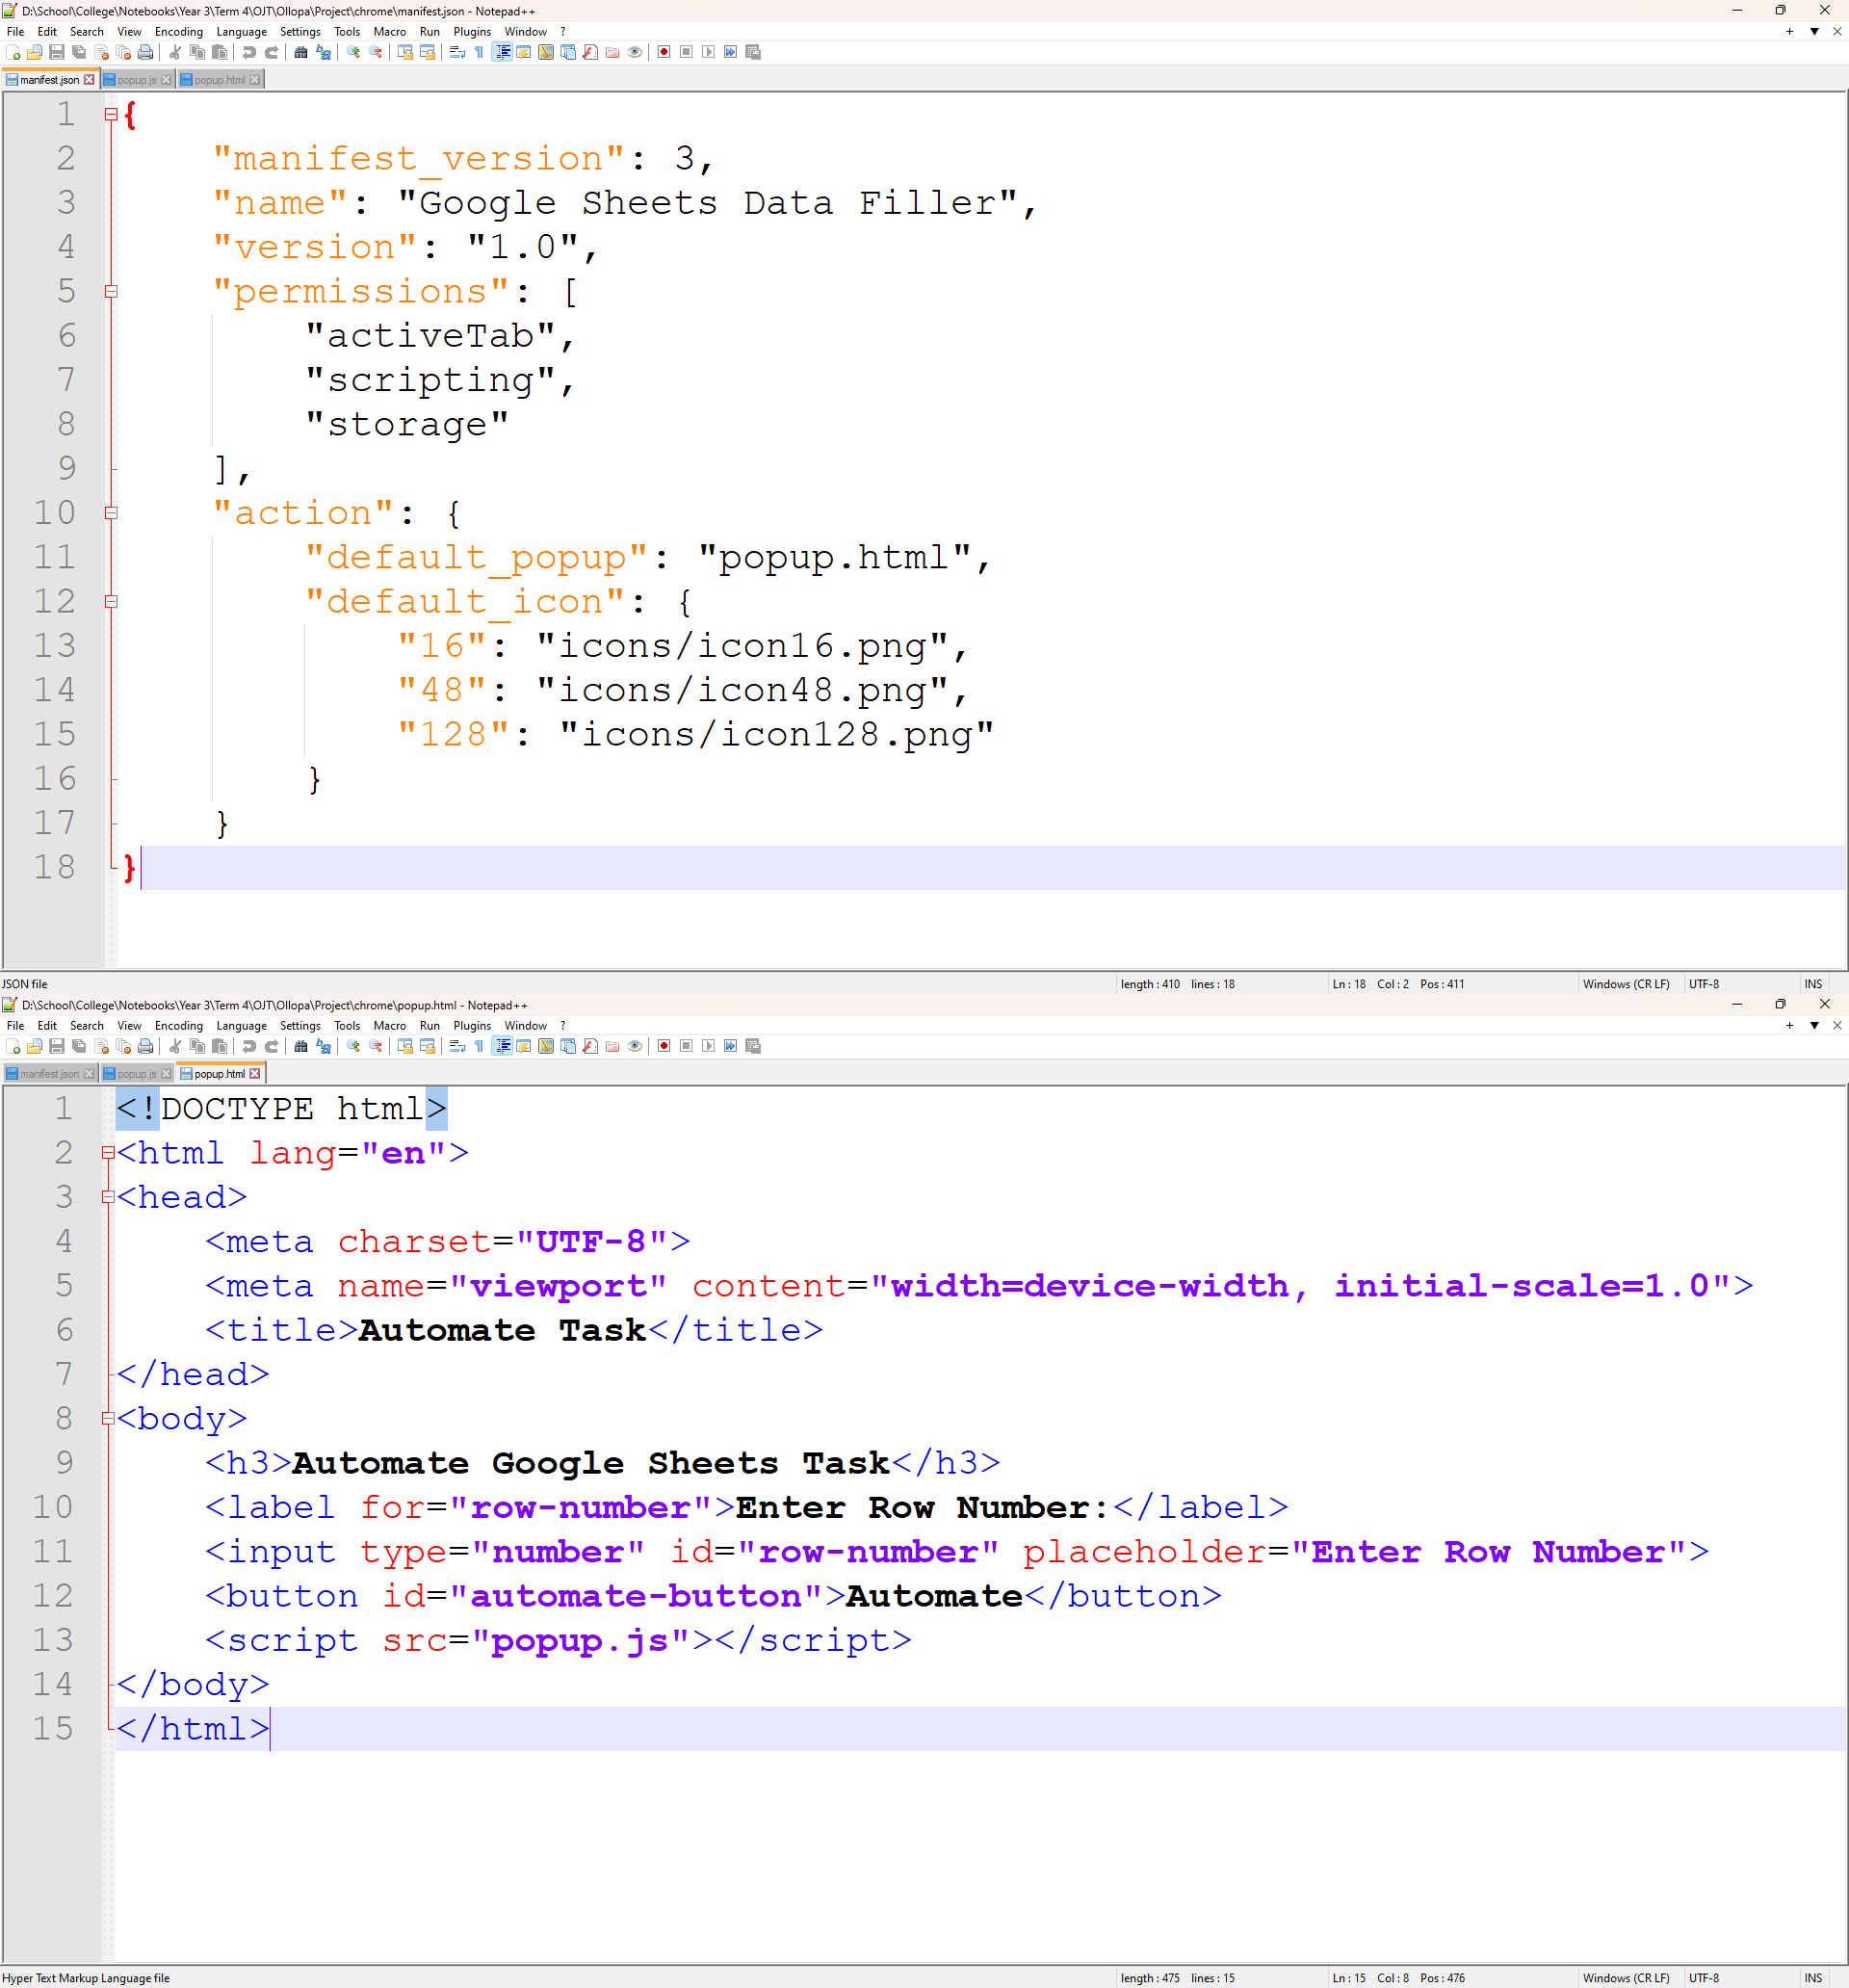**Other**

1. **Diagrams/Flowcharts**

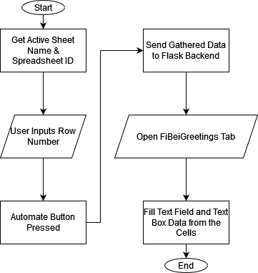

* 1. **Start**
  2. **Get Active Sheet Name & Spreadsheet ID** (retrieve required Google Sheets information)
  3. **User Inputs Row Number** (get the specific row to fetch data from)
  4. **Automate Button Pressed** (trigger the process)
  5. **Send Gathered Data to Flask Backend** (gather data and send it to Flask for processing)
  6. **Open FiBeiGreetings Tab** (open the tab for card creation)
  7. **Fill Text Field and Text Box Data from the Cells** (populate the fields with data)

## End

M I G U E L L A C A N I E N T A

Objective: Seeking a position in Development or DevOps, utilizing skills in Power Platform, Python, JavaScript, and cloud technologies such as Azure and Oracle Cloud Infrastructure.

# Certifications:

* Microsoft Certified: Azure AI Fundamentals ([2024 [](https://learn.microsoft.com/api/credentials/share/en-us/MiguelLacanienta-6919/F032C9D4235F160A?sharingId=62008B5267B9E87E) )](https://learn.microsoft.com/api/credentials/share/en-us/MiguelLacanienta-6919/F032C9D4235F160A?sharingId=62008B5267B9E87E)
* Microsoft Certified: Azure AI Engineer Associate ([2024 [](https://learn.microsoft.com/api/credentials/share/en-us/MiguelLacanienta-6919/F11E0084170EE9FE?sharingId=62008B5267B9E87E) )](https://learn.microsoft.com/api/credentials/share/en-us/MiguelLacanienta-6919/F11E0084170EE9FE?sharingId=62008B5267B9E87E)
* Microsoft Certified: Power Platform Fundamentals. ([2024 [](https://learn.microsoft.com/api/credentials/share/en-us/MiguelLacanienta-6919/DABB968D662BBE3A?sharingId) )](https://learn.microsoft.com/api/credentials/share/en-us/MiguelLacanienta-6919/DABB968D662BBE3A?sharingId)
* Oracle Cloud Infrastructure 202**X** Architect Associate, ([2023 [](https://catalog-education.oracle.com/pls/certview/sharebadge?id=72CEC591344786FF545926CC1D5976D5970C43AEEF12D8CA6906390532A14CAC) , [2024 [](https://catalog-education.oracle.com/pls/certview/sharebadge?id=72CEC591344786FF545926CC1D5976D59581CB949F3ACC8B761B2AC267DF5024) )](https://catalog-education.oracle.com/pls/certview/sharebadge?id=72CEC591344786FF545926CC1D5976D59581CB949F3ACC8B761B2AC267DF5024)](https://catalog-education.oracle.com/pls/certview/sharebadge?id=72CEC591344786FF545926CC1D5976D5970C43AEEF12D8CA6906390532A14CAC)
* Oracle Cloud Infrastructure 2023 Multicloud Architect Certified Associate, ([2023 [](https://catalog-education.oracle.com/pls/certview/sharebadge?id=B490DA122C4E0CF71259F883504B5415CF68BAF1DC1A2CA8853C2B4B7F6ACDA4) )](https://catalog-education.oracle.com/pls/certview/sharebadge?id=B490DA122C4E0CF71259F883504B5415CF68BAF1DC1A2CA8853C2B4B7F6ACDA4)
* Oracle Cloud Infrastructure 2024 Generative AI Certified Professional, ([2024 [](https://catalog-education.oracle.com/pls/certview/sharebadge?id=72CEC591344786FF545926CC1D5976D5290AAC7E6674973CAC6D8D00589644CA) )](https://catalog-education.oracle.com/pls/certview/sharebadge?id=72CEC591344786FF545926CC1D5976D5290AAC7E6674973CAC6D8D00589644CA)
* Oracle Cloud Infrastructure 202**X** AI Certified Foundations Associate, ([2023 [](https://catalog-education.oracle.com/pls/certview/sharebadge?id=F557E7A98873251E671C8803C89AA06F47067625694CACA6CE2714A256800957) , [2024 [](https://catalog-education.oracle.com/pls/certview/sharebadge?id=015FB2CCE8DB7E574556EC249FDD03A5406657B8323CF000A6EE2D2EBFD67EF0) )](https://catalog-education.oracle.com/pls/certview/sharebadge?id=015FB2CCE8DB7E574556EC249FDD03A5406657B8323CF000A6EE2D2EBFD67EF0)](https://catalog-education.oracle.com/pls/certview/sharebadge?id=F557E7A98873251E671C8803C89AA06F47067625694CACA6CE2714A256800957)
* Oracle Cloud Infrastructure for Sunbird Ed Specialty, ([2024 [](https://catalog-education.oracle.com/pls/certview/sharebadge?id=33D3AA5E3A9AA97C2373B262D8D2ACDF4258FE64D1B287C11F98B48D461D5318) )](https://catalog-education.oracle.com/pls/certview/sharebadge?id=33D3AA5E3A9AA97C2373B262D8D2ACDF4258FE64D1B287C11F98B48D461D5318)
* Oracle Cloud Infrastructure 202**X** Certified Foundations Associate, ([2021 [](https://catalog-education.oracle.com/pls/certview/sharebadge?id=A864DDF3367DB5CFAC6A212FFF75BE458B28F9CF3E72CBC6546D1F8B9B407BAF) , [2022 [](https://catalog-education.oracle.com/pls/certview/sharebadge?id=0AC1801FF727D0C0C4FECBE96AD89AF92E6D25E60EA8593ACBAC5A1F2C65FCCD) , [2023 [](https://catalog-education.oracle.com/pls/certview/sharebadge?id=0AC1801FF727D0C0C4FECBE96AD89AF926F1D580E26C906F7F2A3B5D954C3B78) )](https://catalog-education.oracle.com/pls/certview/sharebadge?id=0AC1801FF727D0C0C4FECBE96AD89AF926F1D580E26C906F7F2A3B5D954C3B78)](https://catalog-education.oracle.com/pls/certview/sharebadge?id=0AC1801FF727D0C0C4FECBE96AD89AF92E6D25E60EA8593ACBAC5A1F2C65FCCD)](https://catalog-education.oracle.com/pls/certview/sharebadge?id=A864DDF3367DB5CFAC6A212FFF75BE458B28F9CF3E72CBC6546D1F8B9B407BAF)
* Oracle Cloud Data Management 202**X** Certified Foundations Associate, ([2022 [](https://catalog-education.oracle.com/pls/certview/sharebadge?id=0D2811458E1B952C97C9A17FAF67C9981F8AA99DDDA7C009C8D0F425D8F8E4EC) , [2023 [](https://catalog-education.oracle.com/pls/certview/sharebadge?id=0D2811458E1B952C97C9A17FAF67C998A001E864EF5BB69CCDA48775CE38AE46) )](https://catalog-education.oracle.com/pls/certview/sharebadge?id=0D2811458E1B952C97C9A17FAF67C998A001E864EF5BB69CCDA48775CE38AE46)](https://catalog-education.oracle.com/pls/certview/sharebadge?id=0D2811458E1B952C97C9A17FAF67C9981F8AA99DDDA7C009C8D0F425D8F8E4EC)
* [PCEP-30-01] PCEP – Certified Entry-Level Python Programmer, ([2019 [](https://www.credly.com/badges/23c672e2-c811-4bb6-8f59-233cc2126f38) )](https://www.credly.com/badges/23c672e2-c811-4bb6-8f59-233cc2126f38)
* JSE – Certified Entry-Level JavaScript Programmer, ([2023 [](https://www.credly.com/badges/053879c6-1f64-4a26-be66-41d9506913eb) )](https://www.credly.com/badges/053879c6-1f64-4a26-be66-41d9506913eb)

# Applied Skills:

* Create and manage automated processes by using Power Automate, ([2024 [](https://learn.microsoft.com/api/credentials/share/en-us/MiguelLacanienta-6919/B6F668615D517919?sharingId=62008B5267B9E87E) )](https://learn.microsoft.com/api/credentials/share/en-us/MiguelLacanienta-6919/B6F668615D517919?sharingId=62008B5267B9E87E)
* Create and manage canvas apps with Power Apps, ([2024 [](https://learn.microsoft.com/api/credentials/share/en-us/MiguelLacanienta-6919/BCBA9F75787C5BFD?sharingId=62008B5267B9E87E) )](https://learn.microsoft.com/api/credentials/share/en-us/MiguelLacanienta-6919/BCBA9F75787C5BFD?sharingId=62008B5267B9E87E)
* Create and manage model-driven apps with Power Apps and Dataverse, ([2024 [](https://learn.microsoft.com/api/credentials/share/en-us/MiguelLacanienta-6919/D591B3EB35D371AD?sharingId=62008B5267B9E87E) )](https://learn.microsoft.com/api/credentials/share/en-us/MiguelLacanienta-6919/D591B3EB35D371AD?sharingId=62008B5267B9E87E)

# Education:

B.S. in Computer Science **Mapúa University** SY 2021-2025

* Programming Languages, Part A**, University of Washington**, ([2023 [](https://www.coursera.org/account/accomplishments/verify/YURGYF44BZWJ) )](https://www.coursera.org/account/accomplishments/verify/YURGYF44BZWJ)
* Operating Systems and You: Becoming a Power User**, Google**, ([2023 [](https://www.coursera.org/account/accomplishments/verify/FFD9Y2Q8YEJA) )](https://www.coursera.org/account/accomplishments/verify/FFD9Y2Q8YEJA)
* Data Warehouse Concepts, Design, and Data Integration**, University of Colorado System**, ([2023 [](https://coursera.org/share/8f210d8d706dcb7085f6159387c22814) )](https://coursera.org/share/8f210d8d706dcb7085f6159387c22814)
* Computer Simulations**, University of California, Davis**, ([2023 [](https://coursera.org/share/b741d5ab2cc879cde80438ee81b5343d) )](https://coursera.org/share/b741d5ab2cc879cde80438ee81b5343d)
* Engineering Practices for Building Quality Software**, University of Minnesota**, ([2023 [](https://coursera.org/share/86e40084b7476ee7c7f3138d5765e25c) )](https://coursera.org/share/86e40084b7476ee7c7f3138d5765e25c)
* Greedy Algorithms, Minimum Spanning Trees, and Dynamic Programming**, Stanford University**, ([2023 [](https://coursera.org/share/de42e624fcf1d71c968b586933855595) )](https://coursera.org/share/de42e624fcf1d71c968b586933855595)
* Agile Software Development**, University of Minnesota**, ([2023 [](https://coursera.org/share/4bc8ea79779b3c1e1954c6381c6f49b8) )](https://coursera.org/share/4bc8ea79779b3c1e1954c6381c6f49b8)
* Introduction to Data Science in Python**, University of Michigan**, ([2023 [](https://coursera.org/share/e724b13ff09ff46836aa52f8e4cf6f81) )](https://coursera.org/share/e724b13ff09ff46836aa52f8e4cf6f81)
* Introduction to Graph Theory**, University of California San Diego**, ([2023 [](https://coursera.org/share/2aaa4087ccf7f349164fc26fd3c3ec23) )](https://coursera.org/share/2aaa4087ccf7f349164fc26fd3c3ec23)
* Visual Elements of User Interface Design**, California Institute of the Arts**, ([2022 [](https://coursera.org/share/5bd046f30be493488da21e89538b0169) )](https://coursera.org/share/5bd046f30be493488da21e89538b0169)
* Deep Learning for Business**, Yonsei University**, ([2022 [](https://coursera.org/share/5dd4ebefc76d4deaeea137fc42a0bace) )](https://coursera.org/share/5dd4ebefc76d4deaeea137fc42a0bace)
* Machine Learning for All**, University of London**, ([2022 [](https://coursera.org/share/ffbffb8db98804191f2ac4ca931e54b7) )](https://coursera.org/share/ffbffb8db98804191f2ac4ca931e54b7)
* Quantitative Methods**, University of Amsterdam**, ([2022 [](https://coursera.org/share/4b405ec552756cc25ce62a5b8cb12935) )](https://coursera.org/share/4b405ec552756cc25ce62a5b8cb12935)
* An Introduction to Interactive Programming in Python (Part 1)**, Rice University**, ([2022 [](https://coursera.org/share/e0403014258327930d6bbfe7c2138310) )](https://coursera.org/share/e0403014258327930d6bbfe7c2138310)
* Introduction to Artificial Intelligence (AI)**, IBM**, ([2022 [](https://coursera.org/share/f51788cb9c6d817e0e76f4847e61e619) )](https://coursera.org/share/f51788cb9c6d817e0e76f4847e61e619)
* Python Classes and Inheritance**, University of Michigan**, ([2022 [](https://coursera.org/share/d079f2f01fb3e5b969251e574d05f89e) )](https://coursera.org/share/d079f2f01fb3e5b969251e574d05f89e)
* Database Management Essentials**, University of Colorado System**, ([2022 [](https://coursera.org/share/1d98fd4a0b773c9a687c10b675befb19) )](https://coursera.org/share/1d98fd4a0b773c9a687c10b675befb19)
* Data Structures**, University of California San Diego**, ([2022 [](https://coursera.org/share/0daace5e088d9bfdf1606ce6e85bb5ff) )](https://coursera.org/share/0daace5e088d9bfdf1606ce6e85bb5ff)
* Introduction to Computer Programming**, University of London**, ([2021 [](https://coursera.org/share/2e22f02833fe6af3fad3fbe25f82ab98) )](https://coursera.org/share/2e22f02833fe6af3fad3fbe25f82ab98)
* Programming for Everybody (Getting Started with Python)**, University of Michigan**, ([2021 [](https://coursera.org/share/413d16e95bf840814ec9ca160179fa67) )](https://coursera.org/share/413d16e95bf840814ec9ca160179fa67)
  + Tower A - 1819 Jazz Residences, Jupiter St., N. Garcia, Makati, Metro Manila, Philippines, 1200 ●

● +63 (922) 833 8444 ● [mmlacanienta@gmail.com [](mailto:mmlacanienta@gmail.com) ● [linkedin.com/in/miguel-lacanienta/ [](https://www.linkedin.com/in/miguel-lacanienta/) ●](https://www.linkedin.com/in/miguel-lacanienta/)](mailto:mmlacanienta@gmail.com)

**ACCOMPLISHMENT REPORT**

## Monday:

**Current Progress:**

* Successfully developed a Python script utilizing Selenium to automate the card creation process in the backend. The script reads and copies the title and message from two designated cells in Google Sheets and pastes this data into their respective fields in the backend system.
* Automated the login process to the backend, streamlining the repetitive task of manual data entry.

## Next Steps:

* Plan to simplify the approach by creating a Chrome extension, removing the need to manually edit the code to select which cells to copy. The goal is to make the process more user-friendly by automating the functionality within the browser.

## Tuesday:

**Current Progress:**

* Transitioned from a purely Python-Selenium script to working on a different approach using

**Flask** and **Python** to integrate the functionality directly into a **Chrome Extension**.

* This alternative solution is aimed at improving flexibility and reducing complexity, allowing the process to run directly within the browser environment.

## Wednesday:

**Current Progress:**

* Successfully implemented the feature where the Chrome extension can open a new tab and prepare it to paste the data from the Google Sheets.
* Encountered some errors during the process, which were promptly addressed, and made significant progress in fixing the issues.
* Managed to make the automation work for a single row of data. I'm currently working on making both the selected sheet and the row dynamic, so the automation will adjust according to the user's current selection, enhancing the flexibility of the tool.

## Thursday:

**Current Progress:**

* Completed the Chrome Extension. It now allows users to input the row number for the sheet they are currently working on. The extension works dynamically across different spreadsheets, gathering data from two cells (columns B and C) based on the user's input.
* Upon clicking the "Automate" button, the extension gathers data from the specified sheet and row, pastes the information into the appropriate fields in the backend of FiBeiGreetings.com.
* The project is now fully operational, and I am currently documenting the completed solution and its processes.

## Friday:

**Current Progress:**

* Documentation of the entire project, from initial Python-Selenium scripting to the final Chrome Extension solution.
* Completed the final version of the project, summarizing the workflow and technical details.

**Summary of Accomplishments:**

* Developed an effective and efficient tool that automates card creation by integrating Google Sheets data into the backend of FiBeiGreetings.com.
* Transitioned from Python-Selenium to a more robust Flask-based Chrome extension, improving user interaction and flexibility.
* Implemented a dynamic system that allows users to automate data entry without having to manually adjust the script.
* The project resulted in a streamlined workflow, reducing manual data entry time and enhancing productivity.