AGREEMENT BETWEEN EMPLOYER AND STUDENT

Company Name: Serttech Inc.
Complete Address: Blk2 lot 15 Tierra Grande Royal, Brgy. Manggahan, General trias, Cavite
Building Floor: 1st Floor Department/Room: Technical/ Dev
Phone number: 0917 551 3200

Immediate Job Supervisor Name: Sert Guro
Position: Biz Dev Manager

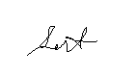
Work Period: Beginning Date: March 6,2023 Ending Date: June 2023
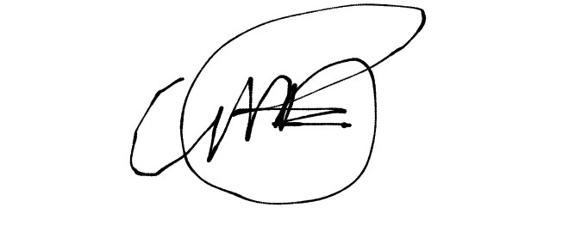
Type and Description of work: Dev Team, Programming and Technical Team Work.

_______________________ _________________________
ZUHARTE O. GURO CARLOS MIGUEL N. PAREJA
Immediate Job Supervisor Signature over printed name
Signature / Date BIT42

Noted By:

Emelyn D. Mayuga
Computer Studies Practicum Supervisor

