Task 2: Test log
Description of test | Test data to be used (if required) | Expected outcome | Actual outcome | Comments and intended actions
Registration page  Username  Email  Age  Password |  |  | 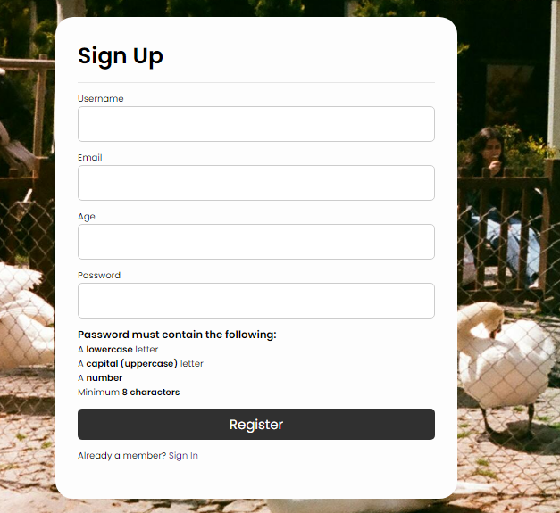 | When the users register an account, it will store it in the database.
Login page  Email  Password |  |  | 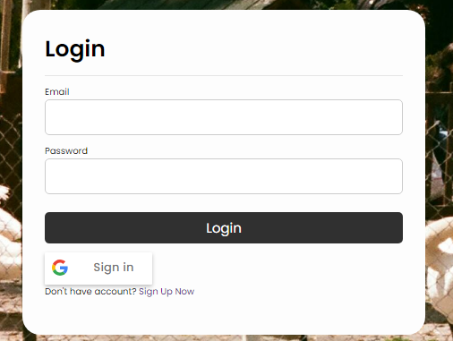 | The user will be redirected to a different page where they can view there profile and their books.
Email | Valid – band@gmail.com  Invalid – bandgmailcom  Erroneous - 0000 | 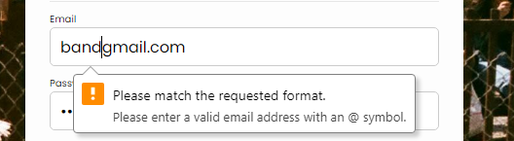 | 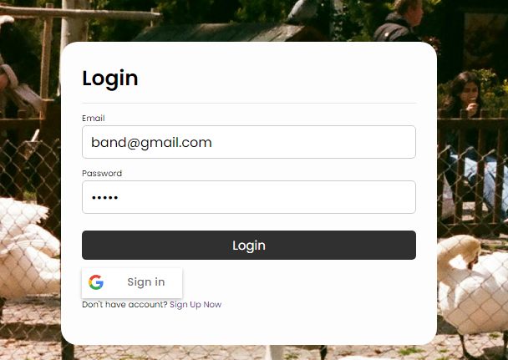 | The users must have an ‘@’ in their email otherwise it will not continue to the next page.
Password | Valid – Brand123#  Invalid – brand  Erroneous – left blank | 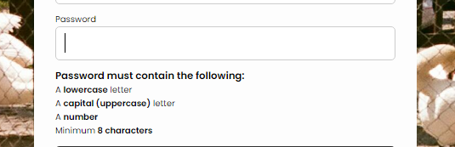 |  | The users will need to have the following requirement to chose a strong password.
Add more rows and tables as required.

