VNN Learned Feature Interpretation — Short Report
Hypothetical visual/physical meaning of selected VNN channels

Overall Finding
The selected VNN channels appear to learn different levels of lesion representation: some are strongly associated with a diagnostic class (Channels 65 and 89), while others capture shared lesion properties such as localization, contrast and internal heterogeneity (Channels 8, 114 and 120). These are hypotheses from activation patterns, not proven biological meanings.
Channel | Hypothetical feature | Evidence | Importance
Channel 65 (Rank #1) | NV-associated pigmentation and overall lesion structure | All 10 top-activating samples are NV, and activation consistently covers the localized lesion region. | High: strongest class-associated feature among the five; useful candidate for studying class-specific representations.
Channel 89 (Rank #2) | Compact lesion structure with local boundary/contrast patterns | All 10 top-activating samples are NV; activation is concentrated around compact lesion regions and often emphasizes a side/boundary. | Medium–High: potentially useful for understanding local lesion boundaries, but the repeated spatial pattern should be checked for positional bias.
Channel 114 (Rank #3) | General lesion localization, extent and lesion–background contrast | Top activations span NV, BCC, BKL and DF, while maps broadly cover the lesion region rather than one class. | High for general representation: good example of a class-agnostic feature.
Channel 120 (Rank #4) | Intra-lesion pigmentation heterogeneity and internal structure | Top samples include MEL, NV and BKL; activation covers heterogeneous internal regions with noticeable dark/light variation. | Medium–High: useful candidate for studying texture/pigmentation complexity across lesion classes.
Channel 8 (Rank #5) | Localized lesion structure and lesion–background contrast | Top samples span BKL, AKIEC, MEL and NV; activation generally follows the lesion rather than a single diagnostic class. | Medium: good general lesion feature, but less class-specific and therefore harder to assign a unique semantic meaning.

Channel-wise Visual Evidence

Channel 65 (Rank #1)
Likely feature: NV-associated pigmentation and overall lesion structure
Why: All 10 top-activating samples are NV, and activation consistently covers the localized lesion region.
Importance: High: strongest class-associated feature among the five; useful candidate for studying class-specific representations.
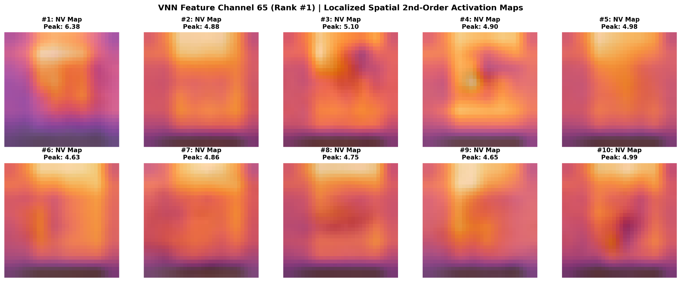
Localized activation maps
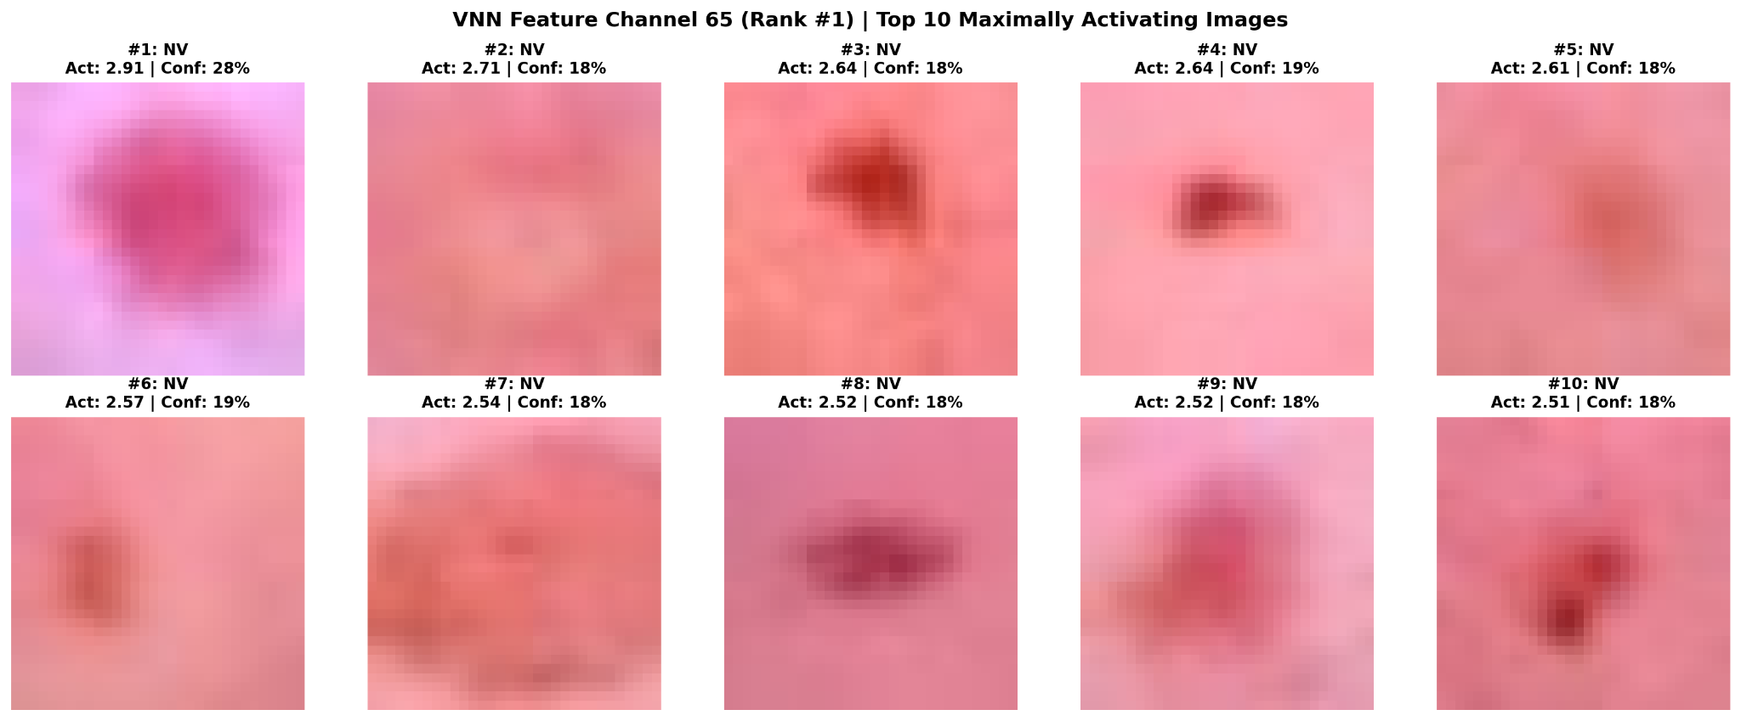
Top activating images

Channel 89 (Rank #2)
Likely feature: Compact lesion structure with local boundary/contrast patterns
Why: All 10 top-activating samples are NV; activation is concentrated around compact lesion regions and often emphasizes a side/boundary.
Importance: Medium–High: potentially useful for understanding local lesion boundaries, but the repeated spatial pattern should be checked for positional bias.
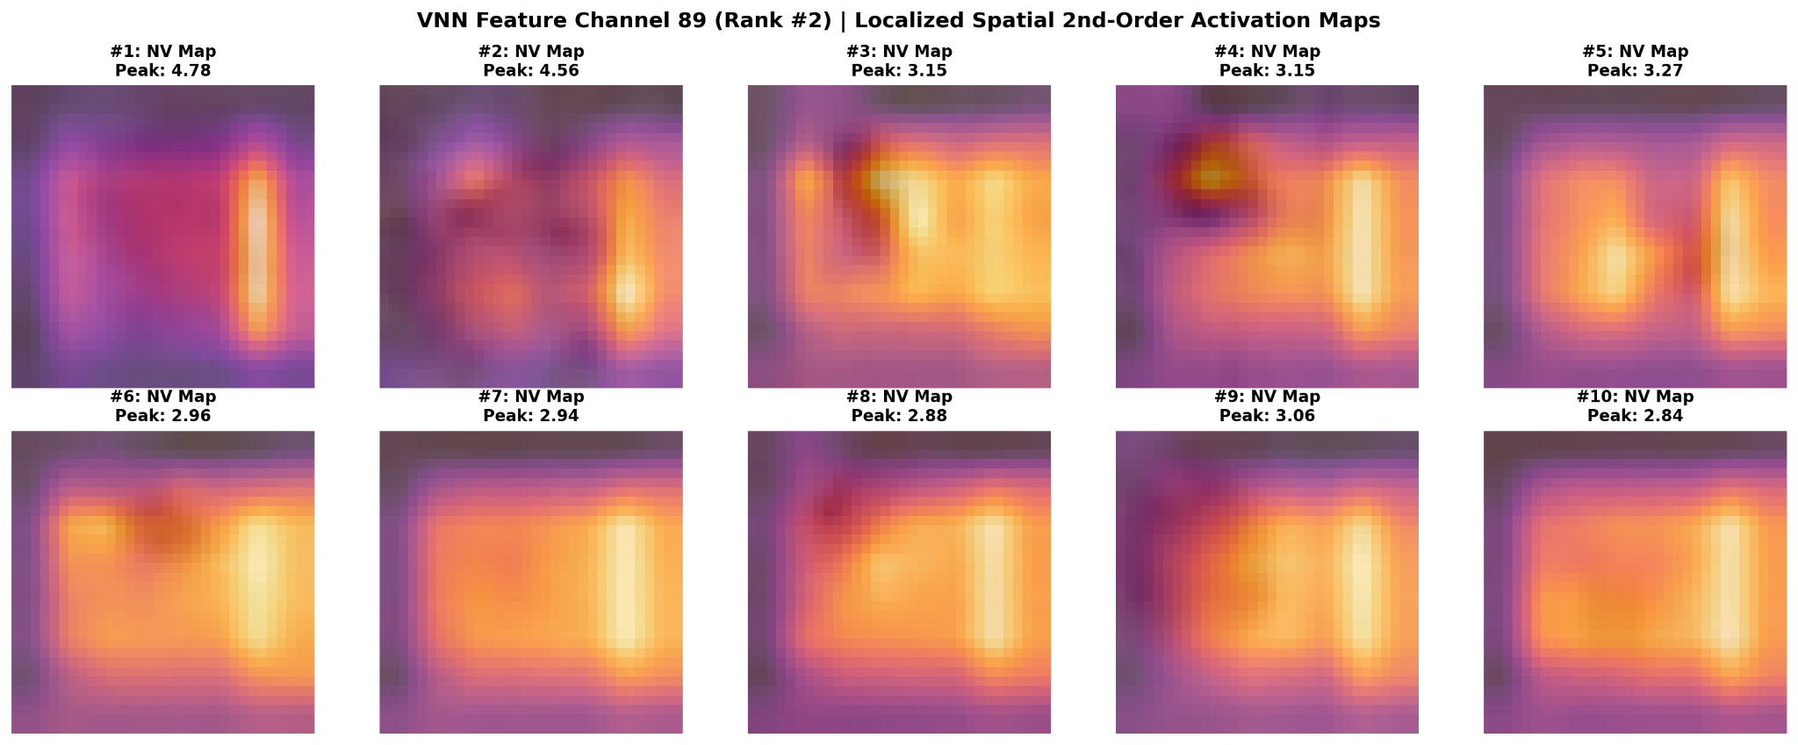
Localized activation maps
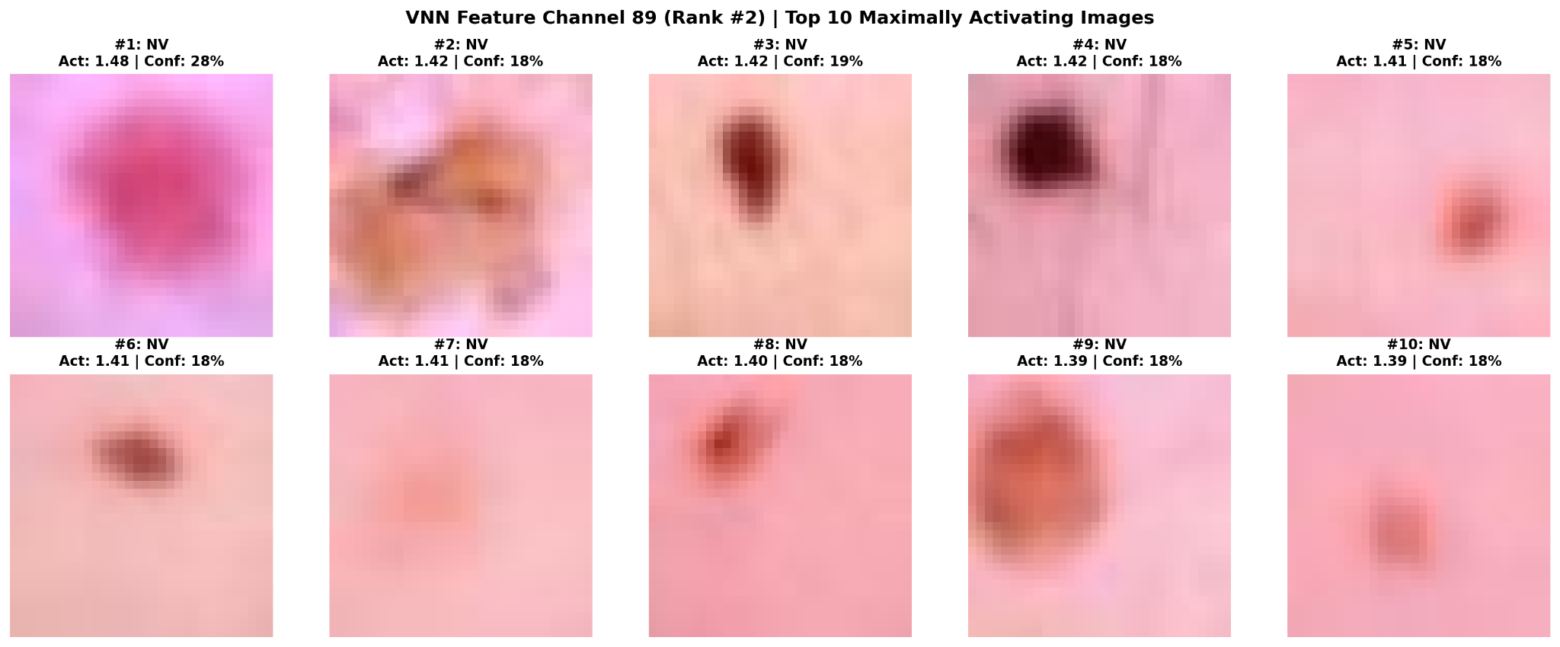
Top activating images

Channel 114 (Rank #3)
Likely feature: General lesion localization, extent and lesion–background contrast
Why: Top activations span NV, BCC, BKL and DF, while maps broadly cover the lesion region rather than one class.
Importance: High for general representation: good example of a class-agnostic feature.
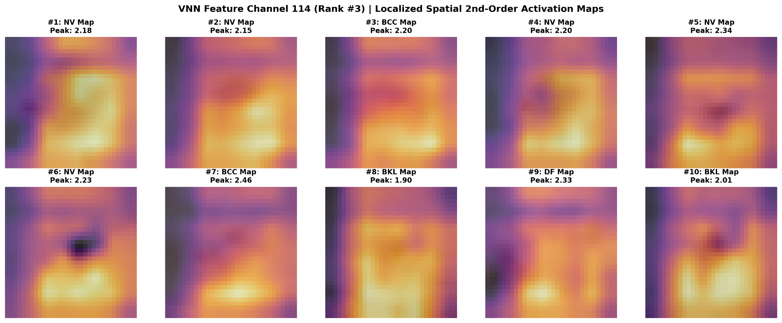
Localized activation maps
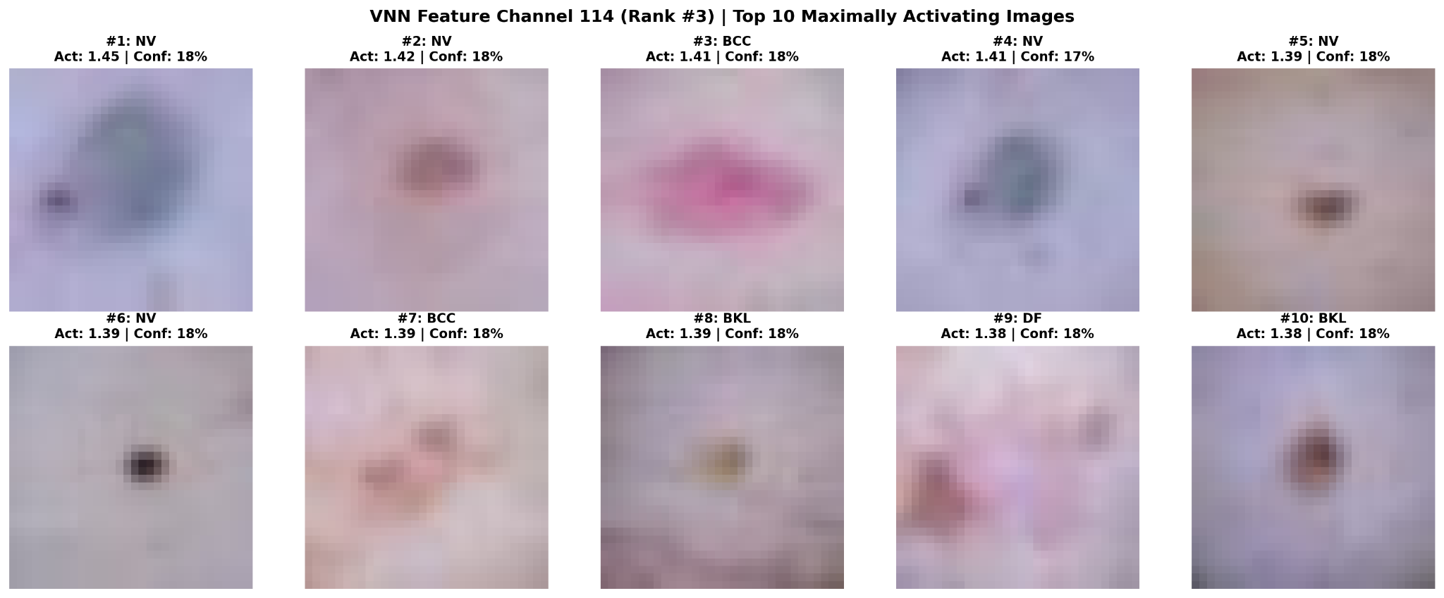
Top activating images

Channel 120 (Rank #4)
Likely feature: Intra-lesion pigmentation heterogeneity and internal structure
Why: Top samples include MEL, NV and BKL; activation covers heterogeneous internal regions with noticeable dark/light variation.
Importance: Medium–High: useful candidate for studying texture/pigmentation complexity across lesion classes.
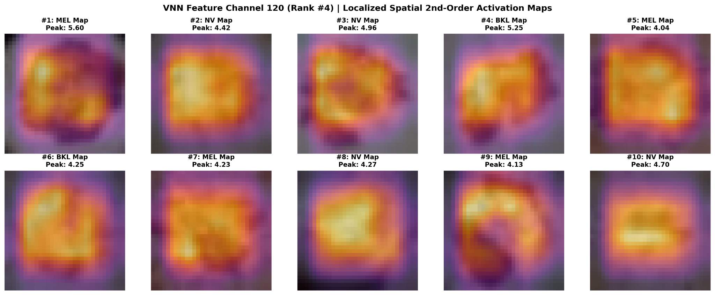
Localized activation maps
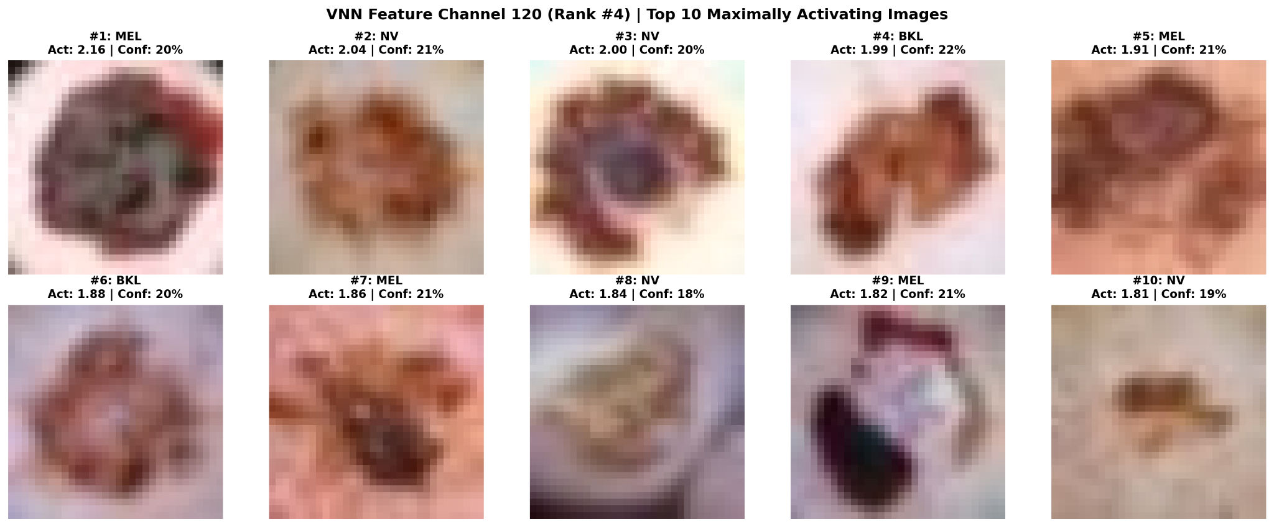
Top activating images

Channel 8 (Rank #5)
Likely feature: Localized lesion structure and lesion–background contrast
Why: Top samples span BKL, AKIEC, MEL and NV; activation generally follows the lesion rather than a single diagnostic class.
Importance: Medium: good general lesion feature, but less class-specific and therefore harder to assign a unique semantic meaning.
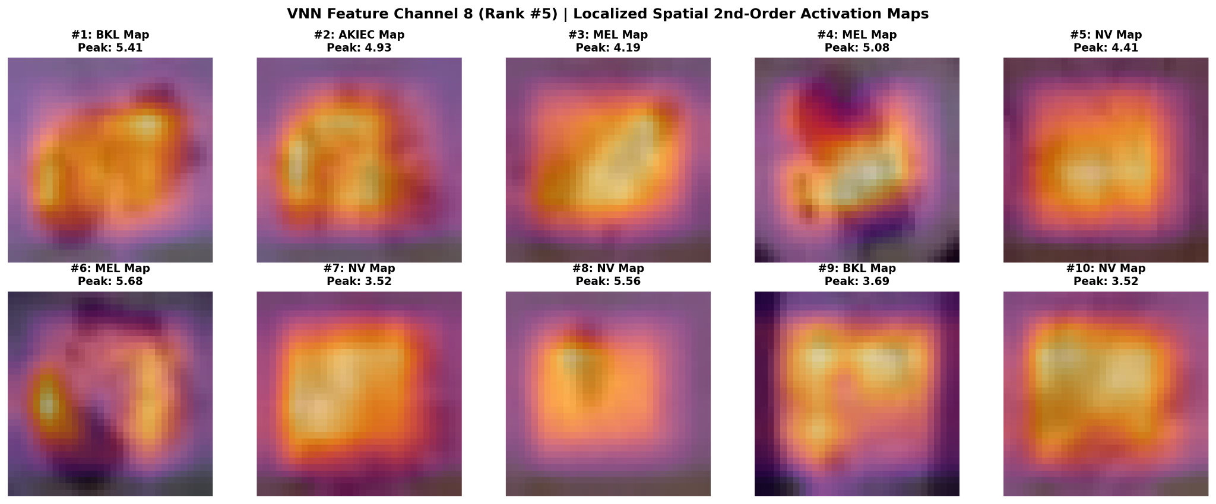
Localized activation maps
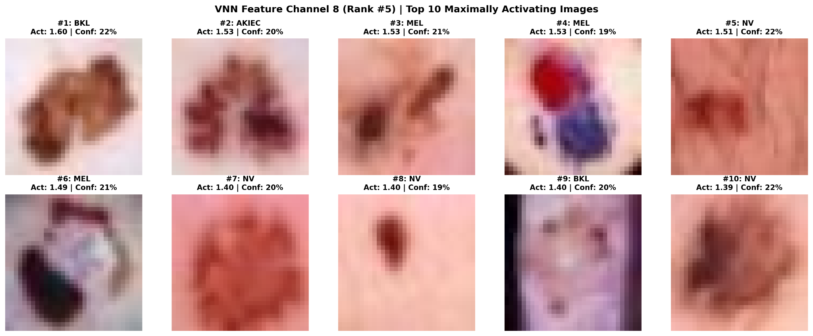
Top activating images

Important Limitation
The proposed meanings are visual hypotheses based on top-activating examples and spatial activation maps. They should not be described as biological or clinical mechanisms without quantitative validation. A simple next step would be to correlate selected channel activations with measurable image properties such as contrast, edge strength or texture.

