eMAS Regulatory, Technical & Migration Assessment Guide
From regulatory submission concepts to evidence-based machine-readable migration assessment rules
Version 2.0 | 12 September 2026
EXTEDO | a cormeo brand
Status: Master eMAS reference - Bible candidate for controlled review and adoption
Regulatory sources verified against authoritative websites available on 12 September 2026.

Document control and positioning
Item | Value
Purpose | Provide one consolidated regulatory/technical guide explaining how eMAS can identify unknown regulatory submissions, assess technical completeness, support migration readiness and perform post-migration reconciliation.
Audience | Regulatory Affairs, Regulatory Operations/Publishing, technical and migration consultants, validation managers, business analysts, product owners and eMAS developers.
Primary internal baseline | eMAS Enterprise Requirements Specification v4.0, with Mapping Workbook and Runtime JSON Requirements v5.0; earlier v2 documentation is historical where superseded.
Regulatory currency | Authority sources verified to 12 September 2026; controlled release should re-verify effective versions before use.
Important boundary | eMAS is a read-only migration assessment framework. Technical completeness is not equivalent to formal authority validation, scientific review, customer validation or business acceptance.
Traceability | Internal eMAS documentation references Confluence ID 1386873065. Regulatory statements use source IDs S01–S31 in this guide.

Design boundary | The guide deliberately distinguishes regulatory requirements, regulatory interpretation, eMAS detection rules, migration rules, recommendations and assumptions. A migration-oriented finding must not be presented as an EMA/FDA/ICH mandate unless the cited source actually establishes that requirement.

How to read the guide
The guide follows the journey of an unknown submission folder. It first teaches the regulatory concepts required to understand the evidence, then shows how that evidence appears in folders and XML, and finally translates the evidence into eMAS rules, severity, confidence, readiness and reconciliation outcomes.
The recurring evidence chain is: regulatory source → regulatory interpretation → physical/XML evidence → eMAS rule → finding → severity and confidence → migration action. This chain is the core traceability pattern for a GxP-oriented assessment framework.

Contents
Part | Chapters
I. Regulatory and eCTD foundation | 1–4: regulatory concepts, CTD/eCTD, v3.2.2, v4.0
II. Regional implementations | 5–9: Module 1, EU, US, Canada/UK/CH/AU/JP/SG, NeeS/ASMF/DMF/legacy
III. Identification and technical assessment | 10–17: dossier/region/sequence identification, structures, XML-file correlation, integrity, archive verification, technical completeness
IV. eMAS rule and migration framework | 18–25: rule model, RAG, confidence, effort, scenarios, readiness, reconciliation, GxP, workbook/JSON runtime
V. Case studies and decision model | 26–27: realistic end-to-end examples and consolidated decision flow
VI. eMAS Operating Bible | 28–40: complete processing workflow, discovery/ZIP handling, grouping, stages, scenarios, source/DB/archive integrity, rule applicability, current workbook/JSON governance, edge cases and release safeguards
Appendices | A–P: glossary, regional/XML maps, rule matrices, readiness/reconciliation, sources, open decisions, edge cases, source-stage matrix, V1→V2 gap closure and master completeness checklist

PART I — Regulatory and eCTD Foundation
Build the regulatory mental model before interpreting folders or XML.

1. The regulatory journey: why a dossier exists
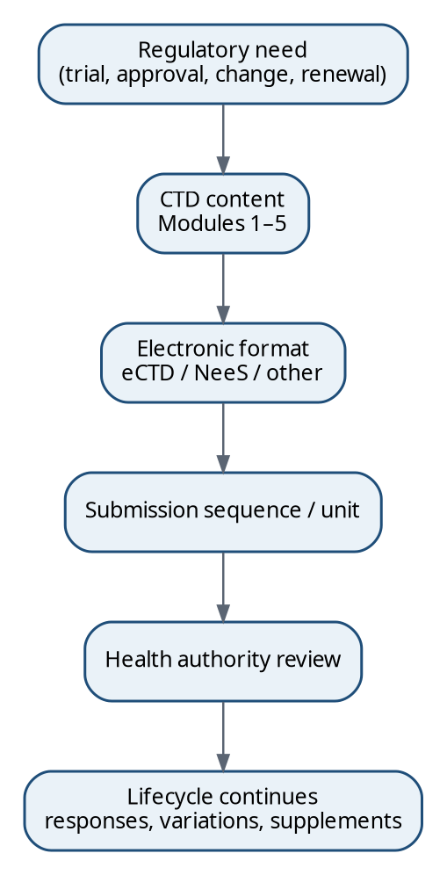
Figure 1. Regulatory information is created for a business/regulatory purpose, organised as CTD, packaged electronically and maintained through a lifecycle.
A regulatory dossier exists because a sponsor or applicant needs a health authority to review information and take a regulatory action. Typical purposes include authorising a clinical trial, granting a marketing authorisation, approving a post-authorisation change, renewing an authorisation, or reviewing updated safety or manufacturing information.
The dossier is not the same thing as the transport format. The same regulatory objective can be represented in different accepted formats depending on region, historical period and product context. eCTD is therefore best understood as an electronic regulatory information and lifecycle standard, not as a synonym for the medicinal-product application itself.
Sources: [S01], [S02]

1.1 CTD: the common content organisation
Module | Purpose | Beginner question
Module 1 | Regional/administrative information | Who is applying, what is being requested, and what region-specific information is required?
Module 2 | CTD summaries and overviews | What are the key scientific conclusions from the detailed data?
Module 3 | Quality | What is the substance/product and how is it manufactured, controlled and kept stable?
Module 4 | Nonclinical | What did pharmacology, pharmacokinetic and toxicology studies show?
Module 5 | Clinical | What did human clinical studies show about safety, efficacy and use?

Module 1 is intentionally regional. Modules 2–5 are the harmonised CTD scientific structure. That is why the same product may have substantially reusable scientific content across regions while its Module 1, application identifiers, authority metadata and business lifecycle differ.
Sources: [S01]

1.2 Dossier, application, regulatory activity, submission and sequence
Concept | Practical meaning | Migration relevance
Dossier / application lifecycle | The long-lived regulatory collection for a product/application. | Primary unit for grouping sequences and preserving history.
Regulatory activity | A business objective such as initial application, variation/supplement, renewal or response cycle. | Useful metadata, but not always necessary for file-level migration; region-dependent.
Submission | A term used differently by authorities/systems; may mean an activity or delivery. | Do not use as an unqualified count unless its source definition is known.
Sequence (v3 terminology) | One numbered eCTD delivery within the lifecycle. | Core physical unit for inventory, continuity and reconciliation.
Submission Unit (v4 terminology) | One v4 message/delivery unit. | Core v4 package/message unit; model differs from v3.

One dossier can contain many regulatory activities, and one activity can generate several sequences or submission units. A response to questions may be a new sequence without being a new application. For migration, the essential hierarchy is usually dossier/application → sequence/submission unit → CTD context → document/lifecycle object.

1.3 Application type, dossier type, format and lifecycle purpose are different dimensions
Dimension | Question answered | Examples
Region / authority | Where and to whom? | EU/EMA or NCA; US/FDA; Canada/Health Canada; AU/TGA
Technical format | How is it electronically packaged? | eCTD v3.2.2; eCTD v4.0; NeeS; legacy/non-eCTD
Application/pathway type | What legal/regulatory pathway is being used? | MAA, NDA, ANDA, BLA, IND, CTA
Dossier/content type | What kind of regulatory dossier/content is this? | Human medicinal product, ASMF, master file, investigational dossier
Lifecycle purpose | What is this delivery doing now? | Initial, response, variation/supplement, renewal, update

Regulatory interpretation | ASMF is a regulatory master-file/dossier concept, not a unique electronic transport format. An EU ASMF can itself be submitted in eCTD. Therefore eMAS should not infer Format = ASMF merely because ASMF evidence exists.

Sources: [S13], [S20]

1.4 Region, authority and procedure: the EU example
“EU” does not mean “EMA” in every case. A centrally authorised product is scientifically assessed through EMA/CHMP and formally authorised by the European Commission; other products can be authorised through national competent authorities using national, mutual-recognition or decentralised routes. In DCP, applications are submitted simultaneously to a Reference Member State (RMS) and Concerned Member States (CMS). In MRP, an existing national authorisation is recognised by additional Member States.
Procedure | Core concept | Primary authority model
Centralised (CP) | Single central application and EU-wide authorisation. | EMA scientific assessment / European Commission authorisation.
Decentralised (DCP) | No existing relevant authorisation; apply simultaneously in several Member States. | RMS + CMS national competent authorities.
Mutual Recognition (MRP) | Existing authorisation in one Member State is recognised by others. | RMS + CMS national competent authorities.
National | Authorisation in one Member State. | National competent authority.

Sources: [S11], [S12]

2. eCTD v3.2.2: package, XML backbone and lifecycle
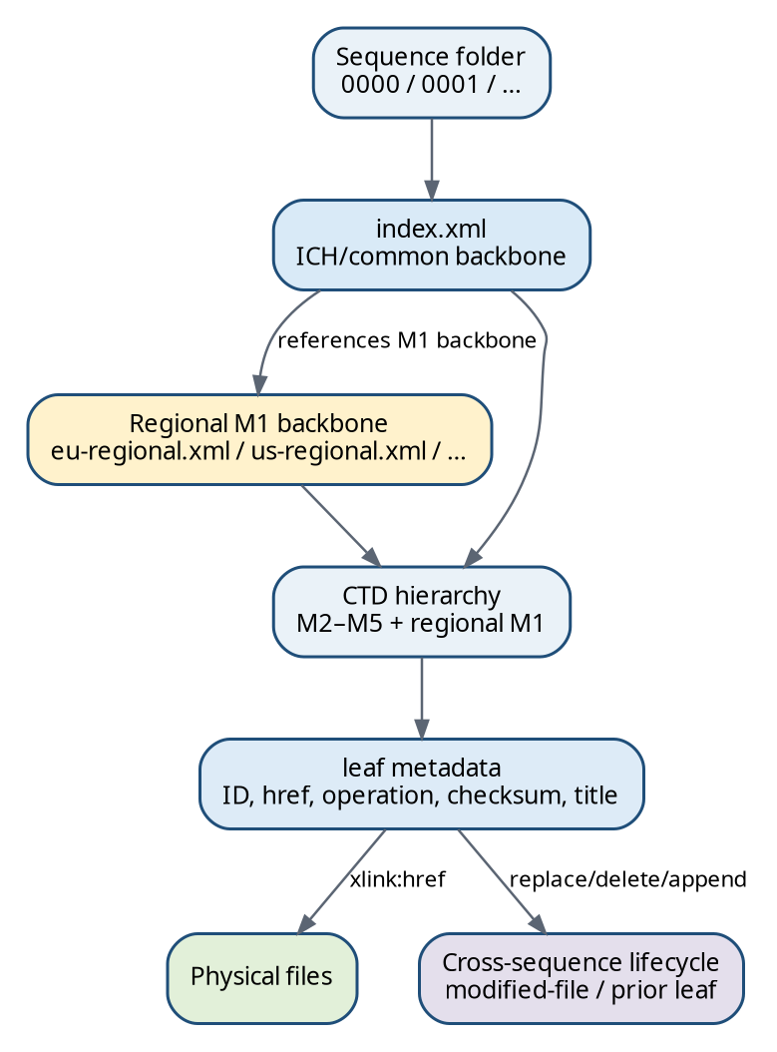
Figure 2. eCTD v3 combines a sequence folder, a common ICH backbone, a regional Module 1 backbone, leaf metadata, physical files and cross-sequence lifecycle relationships.
ICH eCTD v3.2.2 provides the harmonised electronic implementation of CTD. The ICH XML backbone is based on a DTD. The common backbone describes the CTD hierarchy and document leaves; regional guidance supplies Module 1 requirements. The electronic lifecycle allows later sequences to add, replace, append (historically) or delete logical content while retaining the historical sequence packages.
Sources: [S02]

2.1 Representative v3 sequence structure
Representative conceptual structure. Exact regional locations and support files are implementation-specific.
ApplicationRoot/
└── 0005/
├── index.xml
├── index-md5.txt
├── m1/
│ └── <region>/
│ └── <regional-backbone>.xml
├── m2/ # only when this sequence contains M2 content
├── m3/ # only when this sequence contains M3 content
├── m4/ # only when this sequence contains M4 content
├── m5/ # only when this sequence contains M5 content
└── util/ # specification/support files where required by the implementation
Regulatory interpretation | A sequence does not have to contain all five module directories. Missing m2/m4/m5 is not automatically an error when the sequence contains no content for those modules. The mandatory backbone and regional requirements must be evaluated according to the applicable specification and sequence context.

2.2 The leaf is XML metadata, not the PDF itself
Simplified v3 leaf using ICH-defined element/attribute names; values are illustrative.
<leaf
ID="leaf-123"
operation="replace"
modified-file="../0003/index.xml#leaf-087"
checksum="..."
checksum-type="md5"
xlink:href="m3/.../specification.pdf">
<title>Drug Product Specification</title>
</leaf>
XML field | Meaning | eMAS use
leaf/@ID | Identity of the logical leaf object. | Detect duplicate IDs; resolve lifecycle targets.
leaf/@operation | Lifecycle action: new/append/replace/delete. | Classify lifecycle behaviour; verify required prior reference.
leaf/@modified-file | Reference to a prior sequence index.xml and leaf ID. | Resolve cross-sequence lifecycle relationship.
leaf/@xlink:href | Relative path to the physical file. | Verify file existence, path safety and physical correlation.
leaf/@checksum + @checksum-type | Expected referenced-file digest. | Optional integrity comparison where calculation is in scope.
leaf/title | Display/regulatory title. | Document inventory and reporting.
Ancestor XML node | CTD logical location. | Derive 3.2.S, 3.2.P, 5.3.5 etc. without guessing from filenames.

Sources: [S02]

2.3 Current view versus physical history
If sequence 0000 introduces Specification v1 and sequence 0005 introduces v2 with operation="replace" and a valid modified-file reference, both physical files remain part of the historical delivery record, but v2 becomes the current logical content. A migration that copies only the latest PDFs can therefore preserve current documents while destroying lifecycle history. eMAS must treat history and current view as different concepts.

3. eCTD v4.0: a different message model
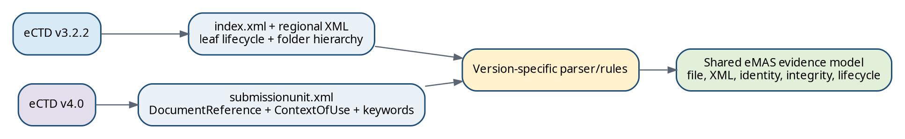
Figure 3. eCTD v4.0 does not simply rename v3 XML. It changes the message and lifecycle model; eMAS needs version-specific parsers but can reuse a shared evidence/result model.
eCTD v4.0 is based on the HL7 Regulated Product Submission model. ICH v4.0 replaces the v3 set of message files (including index/regional/STF XML) with a submissionunit.xml message. Documents are represented using DocumentReference, their CTD placement is represented by Context of Use, and additional context is expressed using controlled-vocabulary keywords. Lifecycle replacement is expressed through related Context of Use relationships rather than v3 leaf/@modified-file semantics.
Sources: [S03], [S04]

3.1 v4 package indicators
EU practical example. eCTD v4 itself is less dependent on physical folder naming than v3; regional guidance may recommend/require package conventions.
ApplicationRoot/
└── 1/
├── submissionunit.xml
├── sha256.txt
├── m1/
├── m2/ # as applicable
├── m3/ # as applicable
├── m4/ # as applicable
└── m5/ # as applicable
EU practical guidance states that a Submission Unit includes submissionunit.xml, a sha256.txt checksum file and module content; it also explains that v4 naming semantics increasingly move from folder names into Context of Use controlled vocabularies. FDA likewise requires the sequence number folder to correspond with the sequence number represented by the submission unit for its current implementation.
Sources: [S10], [S19]

3.2 Context of Use and DocumentReference
Conceptualised from ICH v4 support documentation; exact XML depends on the message and regional implementation.
<contextOfUse>
<id root="[new CoU UUID]"/>
<code code="ich_3.2.p.5.1" codeSystem="..."/>
<statusCode code="active"/>
<derivedFrom>
<documentReference>
<id root="[document UUID]"/>
</documentReference>
</derivedFrom>
... keywords ...
</contextOfUse>
A Context of Use assigns a document to a CTD heading and can carry keyword context such as manufacturer, indication, country or language depending on the code system and regional implementation. A DocumentReference identifies the document itself. This separation is one reason v4 rules must not be implemented by simply searching for v3 leaf attributes.
Sources: [S04]

3.3 Version-specific rule reuse
Assessment concept | v3.2.2 implementation | v4.0 implementation | Shared eMAS result
Package identification | index.xml + regional M1 XML | submissionunit.xml + regional v4 metadata/CVs | Format/version evidence
Document identity | leaf/@ID and href | DocumentReference identifiers and file linkage | Document inventory
CTD placement | ancestor XML element | ContextOfUse code + keywords | Logical CTD location
Lifecycle replacement | leaf/@operation + modified-file | related/replacement Context of Use | Lifecycle relationship
Checksum | MD5 in v3 model / index-md5 | SHA-256 package/message conventions and file hashes per implementation | Integrity finding
Region metadata | separate regional backbone | regional implementation/CVs inside v4 message model | Region/application metadata

eMAS detection rule | Use a version router before parsing regulatory semantics. v3 and v4 should feed the same canonical evidence model, but they require different XML extractors and version-specific rule catalogues.

4. Current implementation snapshot (12 September 2026)
Region | v3 / legacy position | v4 position relevant to eMAS
EU | eCTD v3.2.2 with EU M1 v3.1.1 and VC v8.2 mandatory for current v3 submissions from 1 Dec 2025. | Optional for new CAP MAAs; strong recommendation planned Q1 2027, mandatory for new CAP MAAs planned Q1 2028; forward compatibility still under pilot/readiness work.
US FDA | v3.2.2 remains supported with US M1 / regional DTD 3.3. | FDA accepts new NDA/BLA/ANDA/IND/MF applications in v4.0 since 16 Sep 2024; forward compatibility phases continue.
Canada | v3 eCTD with Canadian Module 1 schema 2.2 and current validation rules. | Treat v4 availability as authority-roadmap data to be confirmed at controlled release; do not infer v4 from ICH alone.
UK MHRA | Current guidance uses EU-format Modules 1–5 with UK-specific information for IRP lifecycle submissions. | Apply explicit MHRA guidance when v4 is introduced; do not assume EU v4 dates automatically apply.
Switzerland | v3.2.2 with Swiss M1 v1.5. | Technical implementation to complete by end 2026; go-live planned in 2027 after pilot, with v3 continuing during transition.
Australia | AU M1 v3.2 is current and mandatory from Nov 2025. | TGA has published AU v4 regional guidance and validation material; rollout follows TGA implementation plan.
Japan | Legacy v3.2.2 acceptance for qualifying approval applications ended after 31 Mar 2026 according to PMDA transition page. | Current domestic v4 package v1.6.0.3 published Jun 2026.
Singapore | SG-HSA eCTD v1.1 is the official standard from 1 Apr 2026; non-eCTD modes remain available during phased adoption. | Region is newly implementing its current ICH-based regional standard; do not label it “eCTD v4” without the SG package stating so.

Sources: [S06], [S09], [S15], [S16], [S19], [S21], [S23], [S24], [S25], [S26], [S27], [S28], [S29], [S30]

PART II — Regional Implementations
Module 1 and application metadata are where regions diverge.

5. Regional Module 1: common scientific dossier, different administrative systems
The CTD makes Modules 2–5 broadly common, but Module 1 is intentionally regional. Consequently, a parser should not assign universal meaning to a heading such as “1.3” without first knowing the regional implementation. The EU and FDA Module 1 hierarchies, metadata and application concepts are different even when both packages use the same ICH v3.2.2 common backbone.
Evidence layer | Common / regional? | Examples
ICH common backbone | Common to v3 implementations | index.xml, CTD hierarchy, leaf metadata, lifecycle attributes
Regional M1 backbone | Regional | eu-regional.xml, us-regional.xml, ca-regional.xml, au-regional.xml
Regional metadata | Regional | EU procedure/agency/submission unit; FDA application/submission/sequence coded values
Physical regional path | Regional supporting evidence | m1/eu, m1/us, m1/ca, m1/au
Business interpretation | Regional | MAA/variation vs NDA/IND/supplement; CP/DCP/MRP vs FDA submission types

eMAS principle | Region identification should combine strong structured evidence (regional XML root/namespace/schema + controlled metadata) with supporting evidence (path/folder conventions). Folder-name evidence alone should normally receive lower confidence.

6. European Union: eCTD v3 regional walkthrough

6.1 EU physical evidence and current specification
Representative EU M1 v3 hierarchy; actual directories present depend on sequence content.
0005/
├── index.xml
├── index-md5.txt
└── m1/
└── eu/
├── eu-regional.xml
├── 10-cover/
├── 12-form/
├── 13-pi/
├── 14-expert/
├── 15-specific/
├── 16-environrisk/
├── 17-orphan/
├── 18-pharmacovigilance/
├── 19-clinical-trials/
├── 110-paediatrics/
├── responses/
└── additional-data/
The current EU v3 standard uses ICH eCTD v3.2.2 for common modules and EU M1 v3.1.1 with Validation Criteria v8.2. EU M1 v3.1.1 deliberately retained DTD version 3.1, so a parser must distinguish the specification revision from the DTD version. The v3.1.1 specification page is therefore part of version resolution logic, not merely a document reference.
Sources: [S05], [S06], [S07]

6.2 EU regional XML structure
Illustrative values; element/attribute names follow the EU M1 DTD family.
<eu:eu-backbone dtd-version="3.1" ...>
<eu-envelope>
<envelope country="...">
<identifier>...</identifier>
<submission type="var-type2">
<procedure-tracking><number>...</number></procedure-tracking>
</submission>
<submission-unit type="response"/>
<applicant>Example Pharma GmbH</applicant>
<agency code="EU-EMA"/>
<procedure type="centralised"/>
<invented-name>Drug X</invented-name>
<inn>Example Substance</inn>
<sequence>0013</sequence>
<related-sequence>0012</related-sequence>
<submission-description>Response to Type II variation questions</submission-description>
</envelope>
</eu-envelope>
<m1-eu>...</m1-eu>
</eu:eu-backbone>
Business information | EU XML evidence | Interpretation / eMAS use
Region | Root eu:eu-backbone + EU namespace + m1/eu/eu-regional.xml | High-confidence EU regional implementation.
EU M1 DTD | eu:eu-backbone/@dtd-version | DTD 3.1; do not alone claim specification 3.1.1.
Submission / activity type | submission/@type | Controlled value such as maa, var-type2, renewal, asmf, psur, rmp.
Submission unit purpose | submission-unit/@type | Sequence purpose such as initial/response/additional-info etc.
Procedure | procedure/@type | centralised, decentralised, mutual-recognition or national.
Authority | agency/@code | EMA or NCA code from allowed values.
Procedure number | submission/procedure-tracking/number | Procedure/tracking identity when populated.
Applicant | applicant | Applicant/holder textual metadata.
Product name | invented-name | Product/invented name.
INN | inn | International Nonproprietary Name.
Sequence | sequence | Cross-check against physical four-digit sequence folder.
Related sequence | related-sequence | Groups subsequent submission units with the regulatory activity start.
Human-readable description | submission-description | Supporting text; lower authority than controlled attributes for classification.

Sources: [S07], [S08]

6.3 EU Module 1 content model
Section | EU purpose | Machine-readable evidence
1.0 | Cover letter | m1-0-cover and leaf metadata
1.1 | Comprehensive TOC | Electronic XML backbone rather than ordinary document section
1.2 | Application form | m1-2-form
1.3 | Product information: SmPC, labels, leaflet, mock-ups etc. | m1-3-pi; pi-doc attributes may express country/language/type
1.4 | Information about experts | m1-4-expert
1.5 | Specific/legal-basis requirements | m1-5-specific
1.6 | Environmental risk | m1-6-environrisk
1.7 | Orphan information | m1-7-orphan
1.8 | Pharmacovigilance / risk management | m1-8-pharmacovigilance
1.9 | Regional clinical-trial information | m1-9-clinical-trials
1.10 | Paediatric information | m1-10-paediatrics
Responses / Additional data | Supporting response or specific additional regional material | m1-responses / m1-additional-data

6.4 EU procedure and ASMF evidence
For eMAS, EU procedure classification should primarily use procedure/@type and authority metadata when available, with folder/title heuristics only as secondary evidence. The EU submission/@type vocabulary can also carry an ASMF value; that is strong evidence for an ASMF regulatory context, but it must not overwrite the technical format. A correct canonical classification can therefore be Region=EU, Format=eCTD v3.2.2, Dossier/Regulatory Context=ASMF, Procedure=<value if present>.
Sources: [S07], [S13]
eMAS design decision | Model ASMF separately from Format. If the current mapping workbook lists ASMF in a Format catalogue, treat that as a legacy design artefact to be resolved in the decision register rather than a regulatory fact.

7. United States: FDA regional XML immediately after EU

7.1 US package and current v3 standards
Representative FDA eCTD v3 regional structure.
0008/
├── index.xml
├── index-md5.txt
└── m1/
└── us/
└── us-regional.xml
FDA currently supports eCTD v3.2.2 and v4.0. For v3, the common backbone remains ICH 3.2.2 while the US Module 1 regional DTD is 3.3. FDA’s Module 1 specification identifies us-regional.xml as the regional backbone containing the admin and m1-regional structures.
Sources: [S15], [S16], [S17]

7.2 US regional XML structure and exact extraction
Illustrative values; actual coded meanings are resolved through FDA valid-value/attribute lists.
<fda-regional:fda-regional ...>
<admin>
<applicant-info>
<id>...</id>
<company-name>Example Pharma Inc.</company-name>
<submission-description>Response package</submission-description>
... contacts ...
</applicant-info>
<application-set>
<application application-containing-files="true">
<application-information>
<application-number application-type="fdaat...">123456</application-number>
<cross-reference-application-number application-type="fdaat...">012345</cross-reference-application-number>
</application-information>
<submission-information>
<submission-id submission-type="fdast...">0006</submission-id>
<sequence-number submission-sub-type="fdasst...">0008</sequence-number>
<form form-type="fdaft..."><leaf ... /></form>
</submission-information>
</application>
</application-set>
</admin>
<m1-regional>...</m1-regional>
</fda-regional:fda-regional>
Business information | US XML evidence | Interpretation / eMAS use
Region | fda-regional:fda-regional root + m1/us/us-regional.xml | High-confidence US/FDA implementation.
Applicant | applicant-info/company-name | Applicant/sponsor textual identity.
Application number | application-number element value | Persistent FDA application identifier.
Application type | application-number/@application-type | Controlled code resolved via current FDA valid-values (e.g., NDA/IND/ANDA/BLA/MF context).
Cross-reference | cross-reference-application-number + @application-type | Dependency/reference to another FDA application/master file.
Regulatory activity/submission ID | submission-id element value | Groups the FDA regulatory activity.
Submission type | submission-id/@submission-type | Controlled FDA submission type.
Sequence | sequence-number element value | Cross-check with physical sequence folder.
Sequence/submission subtype | sequence-number/@submission-sub-type | Controlled purpose of the specific delivery.
Form type | form/@form-type | Resolve through current FDA form-type controlled list.
M1 document structure | m1-regional descendants + leaf | FDA-specific Module 1 hierarchy and document references.

Sources: [S17], [S18]

7.3 IND, NDA, ANDA and BLA in the eMAS model
Application type | Regulatory purpose (simplified) | eMAS treatment
IND | Investigational New Drug framework for clinical investigation. | ApplicationType=IND; format/version derived separately from eCTD evidence.
NDA | New Drug Application for marketing approval. | ApplicationType=NDA.
ANDA | Abbreviated New Drug Application, typically generic pathway. | ApplicationType=ANDA.
BLA | Biologics License Application. | ApplicationType=BLA.
MF / DMF context | Master-file information supporting one or more applications. | Dossier/master-file context separated from transport format; cross-reference evidence retained.

The application type is authoritative when resolved from current FDA controlled values. Folder names containing “NDA” or “IND” are useful only as supporting evidence because customer exports and legacy repositories often include internal naming conventions.
Sources: [S15], [S20]

8. Additional regional implementations

8.1 Canada
Health Canada uses a Canadian Module 1 backbone named ca-regional.xml in m1/ca for eCTD v3. The Canadian schema root is hcsc_ectd and includes two major areas: ectd-regulatory-transaction-information and m1-administrative-and-product-information. Health Canada validation rules explicitly check the m1/ca folder, the ca-regional.xml file and dossier-identifier/application-folder relationships. These are strong eMAS identification signals.
Evidence | Strength | Use
m1/ca/ca-regional.xml | Strong | Canadian regional implementation candidate.
Root hcsc_ectd + schema-version="2.2" | Very strong | Confirm Canadian M1 schema family.
ectd-regulatory-transaction-information | Strong | Extract transaction-level metadata.
dossier-identifier vs parent application folder | Strong integrity rule | Cross-check dossier identity where applicable.
Canadian validation rule set | Authoritative technical rule source | Do not transpose EU/FDA severity assumptions.

Sources: [S21], [S22]

8.2 United Kingdom
Current MHRA guidance for International Recognition Procedure marketing-authorisation and post-authorisation applications requires eCTD sequences and states that Modules 1–5 should be in EU format with UK-specific information in Module 1. That means an eMAS rule must not blindly equate an EU-format Module 1 structure with “EU authority”. UK identification should combine submission context, MHRA-specific metadata/content, delivery evidence and applicable UK guidance.
Sources: [S23]
False-positive consideration | “m1/eu” can be strong evidence of the EU-format regional structure, but for post-Brexit UK submissions it is not always sufficient to identify the receiving jurisdiction. Authority/context evidence must be considered.

8.3 Switzerland
Swissmedic states that current Swiss eCTD is based on ICH v3.2.2 with a Switzerland-specific Module 1. Swiss M1 specification v1.5 remains the current v3 regional reference. Swissmedic’s v4 page states that technical implementation is expected by end-2026, with go-live in 2027 after pilots and v3 continuing during transition. eMAS should therefore treat Swiss v3 and v4 as separate supported rule families with effective-date governance.
Sources: [S24], [S25]

8.4 Australia
TGA Module 1 v3.2 uses an Australian regional XML schema (au-regional.xsd) and regional backbone. TGA explicitly defines an envelope containing sequence metadata and uses sequence number and related-sequence concepts. A notable regional rule is that 0000 is generally a baseline sequence and the first new regulatory activity is typically 0001. This illustrates why sequence-gap and numbering logic must be region-aware rather than universally hardcoded.
Sources: [S26]
Regulatory interpretation | A four-digit sequence pattern is a useful v3-format indicator, but the meaning of 0000 and continuity expectations differ by regional business process. eMAS should report observations against the applicable regional rule set, not a universal numeric assumption.

8.5 Japan
PMDA’s v3 information page documents the historical Japanese v3.2.2 implementation and states that v3-formatted materials prepared under the former notices could be accepted for qualifying approval applications only through 31 March 2026. PMDA now publishes a domestic eCTD v4 implementation package; version 1.6.0.3 was updated 3 June 2026. For current migration analysis, historical Japanese v3 dossiers remain important even though new-current submission rules have moved to v4.
Sources: [S28], [S29]

8.6 Singapore
HSA officially began accepting actual eCTD dossiers on 1 April 2026 using SG-HSA eCTD v1.1. The package includes regional schemas, defined lists, document/submission matrices and sample submissions. HSA also continues non-eCTD submission modes during phased adoption. Therefore Singapore classification must use the SG regional schema/package and must not assume that every Singapore dossier encountered in migration is eCTD.
Sources: [S30], [S31]

9. Non-eCTD and special dossier concepts

9.1 NeeS
NeeS (Non-eCTD electronic Submission) was an EU transitional electronic format. It follows CTD-oriented electronic organisation but does not provide the same eCTD XML lifecycle model. EMA now states that NeeS is accepted only in specific cases. A technical classifier should therefore look for CTD-style module organisation combined with the absence of the eCTD v3/v4 backbone, while also checking regional/historical context before assigning NeeS with high confidence.
Sources: [S05], [S14]
Indicator | Interpretation
CTD-style m1–m5 structure | Supports CTD/NeeS candidate but is not sufficient by itself.
No index.xml / no submissionunit.xml | Rules out a normal complete eCTD v3/v4 package but does not itself prove NeeS.
NeeS navigation/TOC conventions and historical customer confirmation | Strengthens NeeS classification.
Current procedure requires eCTD | May indicate legacy/archive content rather than a currently submit-able package.

9.2 ASMF
The EU ASMF procedure exists to protect confidential active-substance manufacturing know-how while allowing authorities to evaluate the complete information needed for the medicinal product. ASMF is therefore a regulatory master-file procedure/content concept. It can be represented using eCTD, and EU Module 1 metadata can explicitly carry an ASMF submission type. eMAS should use metadata, content patterns and customer/authority evidence together and should keep Region, Format and DossierType/RegulatoryContext separate.
Sources: [S13], [S07]
Field | Correct example
Region | EU
Format | eCTD v3.2.2
Dossier / regulatory context | ASMF
Submission type evidence | eu-regional.xml submission/@type = asmf
Confidence | High when XML and structural evidence agree

9.3 FDA DMF
A Drug Master File is an FDA submission containing confidential detailed information about facilities, processes or articles used in drug manufacture/processing/packaging/storage. An NDA/IND/ANDA/BLA can reference a DMF. FDA regional XML also supports cross-reference application metadata. The eMAS canonical model should therefore support a master-file type and cross-application dependency without conflating that dependency with the eCTD format.
Sources: [S20], [S17]

9.4 Legacy, mixed and unknown structures
Migration repositories frequently contain exports, archive copies, working folders, legacy CTD trees, partial sequence sets or vendor-specific wrappers. eMAS should prefer Unknown/Ambiguous over overconfident classification. A mixed repository can contain valid eCTD dossiers alongside NeeS, source documents, rejected packages or non-regulatory artefacts; classification is therefore dossier-scoped rather than root-folder-scoped whenever practical.

PART III — Identification and Technical Assessment
Turn folders and XML into defensible evidence without claiming formal authority validation.

10. Dossier and region identification decision model
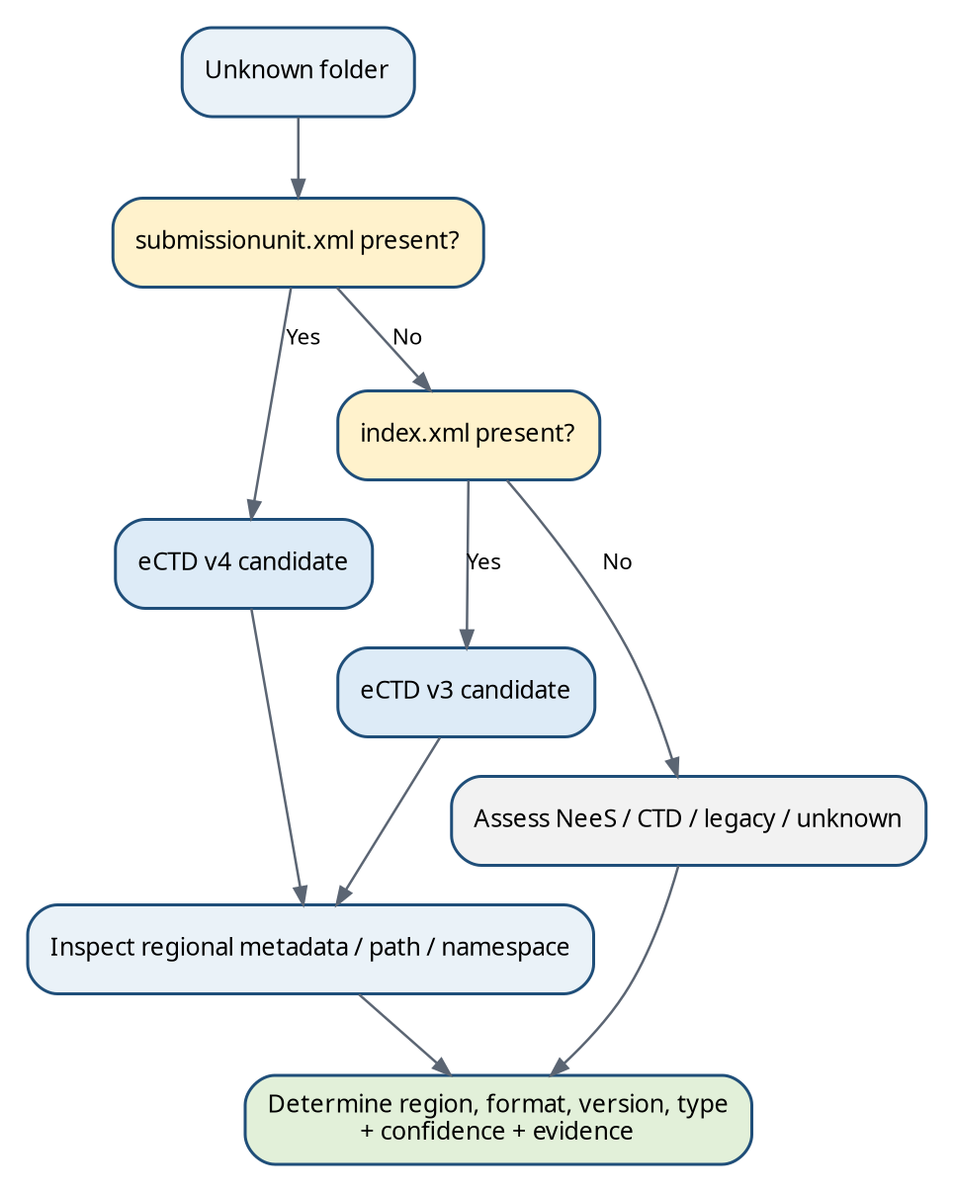
Figure 4. High-level dossier-format identification flow. Regional and version evidence is evaluated only after the package family is recognised.
The identification engine should use positive evidence, contradictory evidence and evidence strength. “Detected” is not the same as “valid”. A malformed eu-regional.xml can still be strong region evidence while simultaneously producing an XML-readability/integrity finding.
Priority | Evidence class | Typical weight
1 | Structured authority metadata: XML root, namespace/schema/DTD, controlled values | Highest
2 | Backbone relationships and regional XML reference from the common message | Very high
3 | Official physical regional path / package structure | High
4 | CTD/module organisation and sequence naming | Medium
5 | Folder/file names containing EU/FDA/ASMF/etc. | Low/supporting
6 | Free-text descriptions/customer labels | Supporting; may be authoritative only when controlled customer metadata is explicitly accepted

10.1 Identification rule template
Field | Example
Rule ID | ID-EU-V3-001
Target | Region=EU; Format=eCTD v3.x
Primary evidence | m1/eu/eu-regional.xml parses with eu:eu-backbone root
Secondary evidence | index.xml references the regional backbone; four-digit sequence folder
Contradictory evidence | US/CA/AU regional root; v4 submissionunit.xml as primary package message
Confidence | High when primary + independent secondary evidence agree
False-positive note | UK may use EU-format modules; jurisdiction must be checked separately
Regulatory source | S06/S07/S23
eMAS output | Classification + evidence + rule ID; no claim of authority validity

11. Dossier identity and sequence identification

11.1 Dossier identity
Several sequences belong to the same regulatory dossier/application when authoritative identifiers, application-folder identity and lifecycle evidence agree. The best identifier differs by region. FDA application-number is strong application identity. Canada uses dossier identifiers tied to the application folder. EU procedure/product identifiers and the persistent EU envelope identifier can contribute to identity, but grouping logic should be defined per implementation rather than through one global folder rule.
Region | Preferred identity evidence | Supporting evidence
US | us-regional.xml application-number + application-type | Application root path; FDA forms; customer system IDs
EU | EU envelope identifier + procedure/product/tracking metadata according to M1 rules | Application root; product/procedure name; agency and procedure context
Canada | dossier-identifier + required parent application folder relationship | ca-regional.xml transaction metadata
Australia | e-Identifier/application identity + AU envelope metadata | Application root, sequence/related-sequence
Other regions | Regional identifier defined by authority implementation | Folder name only when mapped and documented

11.2 Sequence identification
For v3, the physical four-digit sequence directory is an important observable. Where regional XML also contains the sequence value, eMAS should cross-check the XML value against the folder name. For v4, the sequence number is represented in the submission-unit model and regional packaging guidance; package folder conventions may use non-zero-padded integers depending on region.
Condition | Observation | Recommended interpretation
0000, 0001, 0002 | Continuous v3-style numbering. | No sequence-gap finding from numbering alone.
0000, 0001, 0003 | 0002 absent. | Sequence gap observation. Do not automatically declare invalidity; assess regional rules and lifecycle references.
0003 contains modified-file to ../0002/index.xml#leaf-X; 0002 absent | Concrete broken lifecycle dependency. | High-confidence lifecycle-integrity finding; stronger than numbering gap alone.
Same sequence directory appears twice under conflicting dossier roots | Potential duplicate/copy or ambiguous dossier boundary. | Manual review; determine canonical application identity.
Folder 0012 but regional XML says sequence 0013 | Folder/XML mismatch. | High-confidence structural/integrity finding.
Nested 0012/0012/index.xml | Unexpected package nesting. | Migration/packaging observation; severity mapping depends on import expectations.

11.3 Missing sequence example: 0000 / 0001 / 0003
Regulatory interpretation | A missing numeric value is not automatically proof that the source regulatory lifecycle is invalid or incomplete. It may reflect a partial export, selected-scope delivery or region-specific lifecycle convention. Severity rises when authoritative metadata or cross-sequence XML proves that the absent sequence is required by the observed lifecycle.

eMAS rule | Detect the gap deterministically, then search later lifecycle references and compare against customer/source-system inventory. Report “Sequence gap observed” separately from “Broken lifecycle reference” and “Confirmed missing source sequence”.

12. Expected folder and file structure

12.1 Structural rule categories
Rule state | Meaning
Mandatory | Explicitly required by the applicable specification/authority for the package/context.
Conditional | Required only when a specified business/content condition is true.
Optional | Permitted but not required.
Region-specific | Requirement belongs to the regional implementation.
Format-specific | Requirement applies only to eCTD v3, v4, NeeS, etc.
Legacy/historical | Useful for identifying historical dossiers but not necessarily current submission expectations.

12.2 Representative format matrix
Format / region | Strong root/sequence evidence | Regional evidence | Important caution
ICH eCTD v3.2.2 | Four-digit sequence; index.xml; index-md5.txt per applicable rules | Regional M1 XML referenced by index.xml | Do not require all m1–m5 folders in every sequence.
EU eCTD v3 | index.xml + EU sequence model | m1/eu/eu-regional.xml; EU M1 DTD/metadata | M1 spec 3.1.1 uses DTD 3.1.
US eCTD v3 | index.xml + US sequence model | m1/us/us-regional.xml; FDA M1 DTD 3.3 | Application/submission types are coded values.
CA eCTD v3 | index.xml | m1/ca/ca-regional.xml; hcsc_ectd schema 2.2 | Canadian application-folder/dossier-identifier rules are region-specific.
AU eCTD v3 | index.xml + four-digit sequence | m1/au/au-regional.xml/XSD model | 0000 baseline semantics differ from many generic examples.
eCTD v4 | submissionunit.xml; sequence/submission-unit package; checksum file per region | Regional metadata/CVs inside v4 model | Do not search for v3 leaf/modified-file or separate regional XML as if v3.
NeeS | CTD-style electronic structure, no normal eCTD lifecycle backbone | EU/legacy guidance and navigation conventions | Absence of XML alone is not enough to prove NeeS.
Unknown/legacy | Insufficient or conflicting evidence | May be vendor export/source folder | Keep Unknown and preserve evidence.

13. XML backbone walkthrough and XML ↔ physical-file correlation

13.1 Common v3 extraction map
Business information | File | XML path / element | Attribute | eMAS use
Backbone DTD version | index.xml | ectd:ectd | dtd-version | Version-family evidence
Document identity | index.xml | .../leaf | ID | Duplicate/lifecycle target checks
Lifecycle action | index.xml | .../leaf | operation | new/replace/delete/append handling
Prior target | index.xml | .../leaf | modified-file | Resolve prior sequence/leaf
Physical file | index.xml | .../leaf | xlink:href | Existence/path/integrity check
Expected file digest | index.xml | .../leaf | checksum + checksum-type | Hash comparison if in scope
Document title | index.xml | .../leaf/title | — | Inventory/display title
Regulatory location | index.xml | Leaf ancestor chain | section-specific attributes | CTD section and contextual metadata

13.2 XML-to-file decision flow
XML leaf / DocumentReference
│
├── relative path / document linkage
▼
Physical file
│
├── exists?
├── accessible/readable?
├── non-zero?
├── extension/type consistent?
├── checksum/hash matches (when defined and in scope)?
└── lifecycle/reference target valid?
A file physically present but not referenced is a different condition from an XML reference whose target is missing. The first is an orphan/unreferenced-file candidate; the second is a referential-completeness defect. eMAS should preserve that distinction because the migration action and severity can differ.

14. Missing references and file integrity
Check | Technical observation | Do not overstate as
XML references missing file | Referenced target does not exist at resolved path. | Scientific/regulatory content deficiency unless the applicable authority rule is actually executed.
Physical file has no XML reference | Orphan/unreferenced candidate. | Automatically invalid dossier; could be export artefact or working material.
Invalid relative path / traversal | Reference resolves outside expected package or cannot be normalised safely. | Authority validation result unless mapped to an official rule.
Duplicate leaf ID | XML identity collision. | Automatically migrated incorrectly until source/target context is checked.
Duplicate file reference | Several leaves reference same file; may be valid reuse or a defect depending on model/version. | Duplicate content without contextual analysis.
Zero-byte file | Physical object exists but contains zero bytes. | Readable/valid document.
Unreadable/corrupted file | Parser/open operation fails. | File missing; report inaccessible/corrupt distinctly.
Extension/content mismatch | Magic/type inspection differs from extension where detectable. | Regulatory rejection unless official rule applied.
Checksum mismatch | Observed digest differs from declared digest. | Business content difference only; it is an integrity discrepancy.
Malformed XML | XML is not well formed/readable. | Full schema/authority validation result.
Schema/DTD mismatch | Declared/expected schema family conflicts with observed XML. | Scientific invalidity.
Broken modified-file / related lifecycle target | Referenced prior lifecycle object unavailable. | Simple numbering gap; this is stronger lifecycle evidence.

14.1 Path and security observations
For a read-only assessment, path traversal patterns, absolute external references, inaccessible UNC locations and unusual path depth are migration risks even when they are not expressed as authority validation errors. eMAS should normalise paths without following unsafe escapes outside the assessment root unless the rule explicitly expects an external dependency.

15. Archive file verification
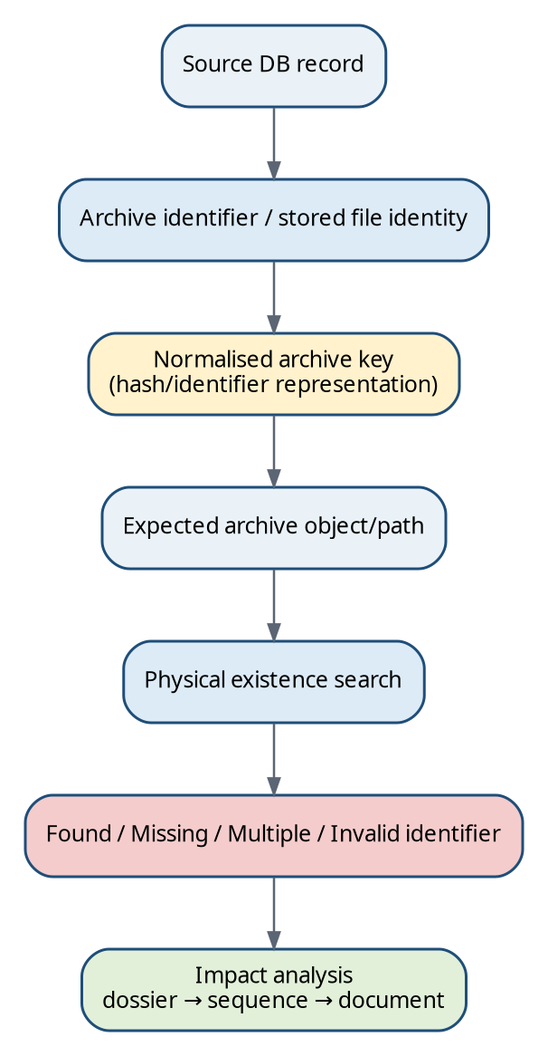
Figure 5. Conceptual archive verification previously defined for eCTDmanager migrations.
Archive verification is primarily a pre-migration and post-migration capability for eCTDmanager/database-based scenarios, not a lightweight pre-sales requirement. The conceptual chain is database record → stored archive identifier/file identity → normalised archive key → expected physical archive object. A valid database row does not prove that the physical archive object exists, and a physical file alone does not prove that its business relationship is complete.
Outcome | Meaning | Migration implication
Found | Exactly one expected archive object resolves. | Positive physical-existence evidence; still reconcile DB/dossier/sequence/document relationship.
Missing | No expected archive object found. | Potential blocker/remediation item depending on object criticality and recovery path.
Multiple matches | More than one physical candidate resolves to the same expected identity. | Ambiguity/duplication review; do not select automatically.
Invalid/unresolvable identifier | Stored identity cannot be normalised according to the approved rule. | Mapping/data-quality issue; manual investigation.
Hash/identity mismatch | Object exists but identity/digest does not match expected representation. | Integrity discrepancy requiring source-system/archive review.

Implementation boundary | The guide documents archive-verification logic, not proprietary SQL. Exact source tables, identifier encoding and path derivation must be versioned customer/system mappings with qualified review.

16. Size, volume and structural/technical observations

16.1 Metrics
Metric | Why it matters
Dossier count | Primary scope and reconciliation unit.
Sequence/submission-unit count | Lifecycle volume and import granularity.
Document/file count | Processing volume, validation and reconciliation scale.
Total and per-dossier GB | Transfer/staging/storage planning.
Per-sequence size | Detect unusually large units and estimate import/runtime risk.
Largest files | Transfer, tool and file-format risk.
XML count | Package/lifecycle complexity and parser workload.
PDF vs non-PDF count | File-format mix and review needs.
Orphan count | Potential export residue or incomplete XML mapping.
Missing-reference count | Direct completeness risk.
Duplicate indicators | Potential storage duplication, ambiguous import or intentional content reuse.
Path-depth / long-path count | OS/import/staging risk.
Unknown format/region count | Classification uncertainty and manual-review effort.

16.2 Technical observations
Technical observations may include PDF version, PDF security/encryption where detectable, filename/path length, invalid characters, extension/content mismatch, XML encoding, malformed XML, duplicate IDs, unsupported file types, unusual hierarchy depth, unexpected regional structures and empty sequence directories. Each observation must state whether it is (a) an explicit regulatory technical requirement from a cited rule, (b) an eMAS technical recommendation, or (c) a migration-risk observation.
Example | “Path length exceeds the approved eMAS migration threshold” is an eMAS migration-risk rule unless the cited authority explicitly defines the same limit. It should not be labelled “EMA validation failure” merely because the migration tool cannot process it.

17. Technical completeness: a layered definition
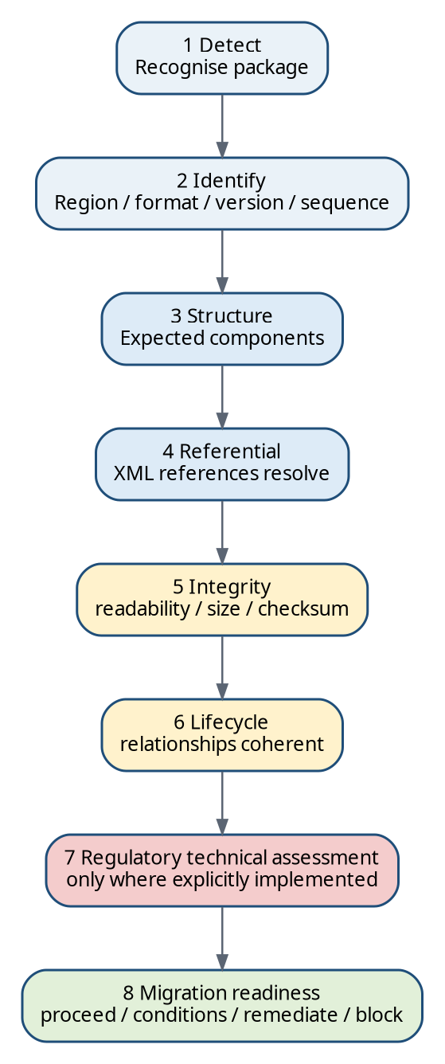
Figure 6. Technical completeness is layered; authority validation is a distinct layer from migration readiness.
eMAS technical completeness means that the available package and source evidence can be identified, parsed, correlated and evaluated for migration-relevant structural, referential, integrity and lifecycle conditions. It does not mean that the dossier has passed the authority’s complete validation criteria, scientific assessment or business acceptance process.
Layer | Question | Typical outputs
1 Detect | What kind of package/repository is present? | candidate format, roots, evidence
2 Identify | Which region, version, dossier/application and sequence? | classification + confidence
3 Structure | Are applicable technical package components present? | mandatory/conditional findings
4 Referential | Do XML/document references resolve? | missing/orphan/path findings
5 Integrity | Are objects accessible, non-zero, internally consistent and hash-consistent where checked? | integrity findings
6 Lifecycle | Can observed lifecycle links be resolved coherently? | broken-target/gap findings
7 Regulatory technical | Do explicitly implemented authority technical rules pass? | only when rule source/version is controlled
8 Migration readiness | Can migration proceed under the agreed scenario? | Ready / conditions / remediation / blocked / manual review

PART IV — eMAS Rule and Migration Framework
Convert regulatory knowledge into controlled, explainable runtime assessment.

18. eMAS rule model
The current enterprise baseline separates generic technical processing from business/regulatory interpretation. The controlled mapping workbook is maintained internally, validated and used to export one runtime JSON configuration. PowerShell consumes that JSON; it should not need to reinterpret the workbook at runtime. This supersedes the older v2 design in which scripts directly consumed the mapping workbook.
Sources: [INT01], [INT02]
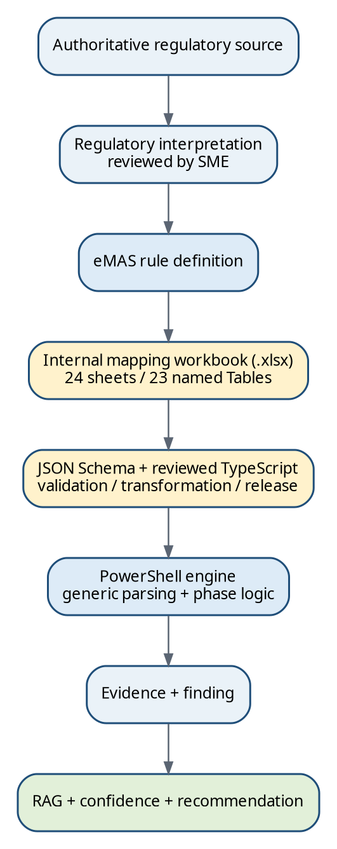
Figure 7. Controlled regulatory knowledge flow from source to runtime finding.

18.1 Recommended canonical rule fields
Field group | Representative fields
Identity | RuleId, RuleName, IsActive, Version, EffectiveFrom/To
Scope | Region, Authority, SubmissionFormat, DossierType, eCTDVersion, ApplicationType, LifecycleContext
Requirement | RequirementType, RequirementText, Mandatory/Conditional/Optional, ConditionExpression
Evidence | SourceFile, XMLDocument, Namespace, XMLPath, Attribute, FolderCondition, FilePattern
Evaluation | ExpectedCondition, DetectionLogic, PositiveEvidence, NegativeEvidence, ContradictoryEvidence
Decision | Severity/RAG impact, Confidence impact/weight, MigrationImpact, RecommendationCode
Traceability | RegulatorySourceId, SourceDocumentVersion, SourceSection, VerificationDate, Reviewer/ValidationStatus
Runtime mapping | JSON path/key, parser hint, result field mapping

18.2 Fully populated rule examples
Rule ID | Requirement / evidence | Detection | RAG | Confidence | Action
ID-EU-V3-REGION | EU regional backbone. S06/S07. | index.xml M1 reference + m1/eu/eu-regional.xml + eu:eu-backbone root | Green evidence / classification | High when all agree | Set Region=EU; retain evidence paths.
INT-V3-MISSING-REF | Every assessed XML file reference should resolve to a physical file for technical completeness. | Resolve leaf/@xlink:href under package root; target absent | Red by eMAS migration rule (configurable) | High | Search source/export/archive; block affected object until disposition.
OBS-V3-SEQ-GAP | Numeric gap observed. | Sort sequence directories; expected integer absent | Info/Amber depending context | Medium by numbering alone | Check regional rules, export scope and lifecycle references.
LIFE-V3-BROKEN-MOD | Replace/delete target must resolve for lifecycle reconstruction. | modified-file points to missing sequence/index/leaf | Red | High | Recover missing source lifecycle or document accepted exception.
ID-US-APP | FDA application identity. S17. | Read application-number and resolve @application-type CV | Classification evidence | High | Group sequences by authoritative application identity.
ID-ASMF-EU | ASMF regulatory context. S07/S13. | EU submission/@type=asmf plus EU regional evidence | Classification only | High | Set DossierContext=ASMF; keep Format=eCTD.
ARCH-OBJ-MISSING | Expected DB-linked archive object absent. Internal approved mapping. | DB record → normalised archive key → no physical match | Red/Blocker when in migration scope | High if mapping deterministic | Restore/archive-recover or approve documented exclusion.

19. RAG / severity and confidence

19.1 Severity answers “How serious is the finding?”
Status | Definition | Typical examples
RED | Potential blocker or high migration/technical risk supported by the configured rule. | Missing required backbone; XML-referenced file missing; broken lifecycle target; missing archive object in required scope.
AMBER | Review/remediation is required but the condition does not automatically prevent assessment/migration. | Unknown folder; sequence gap without dependency proof; unsupported/ambiguous file type; inaccessible optional path.
GREEN | Expected assessed condition is met. | Required backbone present and readable; reference resolves; identity values agree.
INFORMATIONAL | Observation useful for scope or review without direct failure implication. | Large file, rare extension, sequence count, product metadata.
UNKNOWN / NOT ASSESSED | Insufficient evidence or input unavailable/not applicable. | Repository inaccessible; region cannot be determined; post-migration file detail not supplied.

19.2 Confidence answers “How sure are we?”
Confidence | Evidence pattern
High | Authoritative structured metadata or multiple independent strong indicators agree; no material contradiction.
Medium | One strong indicator or several weaker indicators agree but authoritative evidence is incomplete.
Low | Primarily folder/name/text heuristics, partial repository or unresolved contradictions.
Unknown | Evidence is unavailable, unreadable or insufficient to apply a maintained rule.

Severity and confidence are independent. A missing XML-referenced PDF can be RED / High Confidence. A folder pattern that merely suggests sequence 0002 is missing may be AMBER / Medium or Low Confidence. A Green result can also have low confidence if the assessment could not reach the authoritative evidence layer.

19.3 Suggested evidence weighting
Evidence class | Illustrative weight | Rationale
Authoritative XML controlled metadata | 5 | Strongest structured evidence.
Official schema/DTD/namespace/root | 5 | Strong format/region/version evidence.
Backbone reference linkage | 4 | Independent relationship from common to regional message.
Official regional path/package convention | 3 | Strong but can be copied/mispackaged.
CTD/module/sequence structure | 2 | Useful format-family evidence.
Folder/file naming text | 1 | Easy to spoof or inherit from internal conventions.
Uncontrolled free text | 1 | Supporting only unless explicitly governed as source data.

Assumption | Numerical confidence weights are a design proposal, not a regulatory standard. They must be validated against controlled test scenarios before production use.

20. Effort drivers and recommendation engine
Effort driver | Why it increases work
Dossier/sequence/document volume | More inventory, transfer, import and reconciliation operations.
Total GB and largest objects | Longer staging/transfer/backup and possible tool limits.
Format/region diversity | More rule families, parsers and specialist review.
Unknown classifications | Manual investigation and customer clarification.
Missing references/orphans | Recovery/disposition work and exception handling.
Malformed XML/lifecycle breaks | Specialist remediation or controlled exclusion.
Missing archive objects | Source-system recovery and potential migration blocking.
Legacy/non-eCTD structures | Conversion/import strategy and more manual mapping.
DMS/source-system dependency | Coordination with export interfaces and metadata mapping.
Database/version dependency | Additional source-specific extraction and reconciliation.
Manual remediation count | Direct consultant effort and review burden.

Effort should be reported as drivers and a validated complexity band unless a formally approved estimation model converts them to hours. A finding can increase effort without being a blocker; conversely, one missing critical archive object can be a blocker even in a small migration.

20.1 Actionable recommendation pattern
Finding | Recommended action
XML-referenced file missing | Verify source export, source-system record, prior sequence and archive. Recover the authoritative source or document an approved exclusion before migration.
Orphan/unreferenced PDF | Determine whether it is intentionally unreferenced working/support material, an export artefact or evidence of incomplete XML. Do not import automatically.
Malformed regional XML | Compare against source system and applicable regional schema/DTD; regenerate/export through the validated source process where possible.
Sequence gap only | Confirm export scope and regional lifecycle; search authoritative metadata and references before escalating severity.
Broken lifecycle target | Recover the missing sequence/leaf or agree a documented migration exception with impact analysis.
Archive object missing | Trace database record and archive key; restore from authoritative backup/archive if available; block affected object when recovery is required.
Unknown region/format | Collect regional XML/package evidence or source-system metadata; keep classification Unknown rather than forcing a guess.

21. Migration scenarios
Scenario | Assessment emphasis
Existing eCTDmanager: on-prem → cloud | DB/archive identity, source version, archive/storage accessibility, export/lifecycle inventory, target import/reconciliation.
Existing eCTDmanager: on-prem → on-prem | Same core evidence with infrastructure/storage differences and target-version compatibility.
MS Access → MS SQL | Database conversion risk plus archive/dossier reconciliation.
Oracle/legacy DB → SQL | Source-specific identity extraction, archive relationship and controlled mapping; avoid assuming SQL field semantics.
External eCTD system → eCTDmanager | Dossier/sequence discovery, region/format/version, XML/file integrity, import-ready structure.
New customer with system export only | Export-focused assessment; source database/archive logic may be Not Assessed.
Archive-only / storage-only | Volume/path/access sizing; dossier semantics limited unless package structures are available.
Unknown/incomplete repository | Clarifications, low confidence, explicit scope limitation; do not report unavailable checks as Pass.
DMS-integrated source | Add document identity/source-reference mapping and confirm whether exported renditions or source objects are authoritative.
eSUBmanager usage in scope | Treat as migration-scenario metadata/dependency; do not conflate eSUBmanager storage with eCTD dossier validity.

Sources: [INT01], [INT02]

22. Pre-migration readiness
Pre-migration readiness is a decision-support outcome based on the agreed scope and evidence. The current enterprise v4.0 baseline requires deeper checks than pre-sales and a baseline suitable for post-migration verification. The readiness decision must preserve blockers, warnings, accepted exceptions and Not Assessed items.
Readiness criterion | Example evidence
Dossier identified | Region/format/type/version evidence with rule IDs and confidence.
Sequence inventory established | Observed sequences; gap/duplicate/nesting findings; source-system count where available.
Archive/source accessible | Approved roots and permissions verified; inaccessible paths logged.
Database/source mapping understood | Source system/version and metadata mapping known for relevant scenarios.
XML and reference integrity assessed | Readable backbone; referenced file checks; lifecycle target checks as configured.
Critical missing references dispositioned | Recovered, excluded with approval, or migration blocked.
Unsupported structures identified | Manual import/conversion route documented.
Volume measured | Dossier/sequence/file/size metrics and transfer/staging constraints.
Remediation ownership assigned | Action, owner, target date/status captured.
Evidence retained | Execution ID, script/JSON/template versions, source paths and logs recorded.

Final readiness status | Controlled meaning
Ready | All mandatory applicable readiness coverage is complete and no unresolved blocking finding remains.
Ready with Accepted Exceptions | A material difference remains only where a specific project exception has been independently approved and is traceable to the baseline.
Blocked | Mandatory coverage is incomplete, a blocking finding exists, or an unsupported/unresolved condition prevents a defensible readiness decision.

Current baseline | Enterprise v4.0 and Mapping/Runtime v5.0 retain three final pre-migration outcomes: Ready, Ready with Accepted Exceptions, and Blocked. Remediation Required and Manual Review Required may be used as finding/action states, not silently introduced as alternative final statuses.

23. Post-migration reconciliation
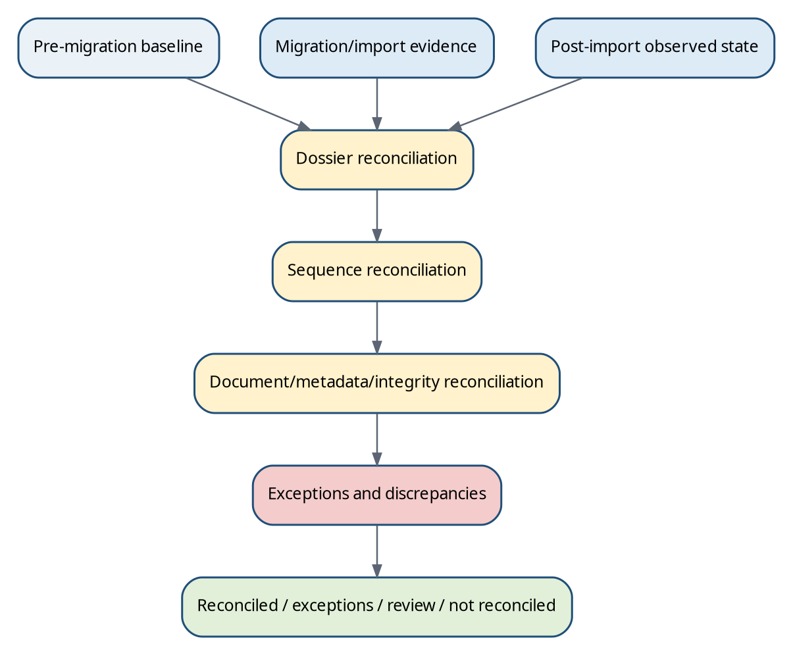
Figure 8. Post-migration verification compares the approved baseline, migration/import evidence and observed target state.
The current enterprise v4.0 eMAS design requires post-migration verification to use the approved pre-migration baseline and available import/post-import evidence rather than relying on target folder scanning alone. Reconciliation should be multi-level and exception-aware.
Level | Examples of comparison
Dossier | Expected vs observed dossier/application identity and presence.
Sequence / submission unit | Expected vs observed sequence number, count, identity and import status.
Document | File/document count, logical identity, path/reference and presence where source/target data allow.
Metadata | Region/application/procedure identifiers, titles and other mapped values.
Integrity | Hashes/checksums or deterministic identity evidence where available.
Lifecycle | Prior/replacement relations and current-view consistency where target exposes them.
Archive | Expected DB-linked archive objects and target archive existence for applicable eCTDmanager scenarios.
Exception | Approved exclusions/transformations separated from unexplained discrepancies.

Final result | Meaning
Reconciled | Expected assessed scope matches target evidence.
Reconciled with Accepted Exceptions | Differences exist but are approved and traceable.
Review Required | Unresolved warnings/differences require investigation.
Not Reconciled | Material unexplained mismatch remains.

Sources: [INT01], [INT02]

24. GxP and validation considerations
eMAS may support GxP-relevant migration decisions, but describing controls does not itself make the tool validated or compliant. A controlled implementation needs requirements traceability, risk-based testing, controlled configuration/rule versions, reproducible executions, retained evidence, exception management, review and release governance. The current enterprise v4.0 baseline explicitly requires script/configuration/schema/template/release identity, verified configuration digest, execution identity and evidence traceability.
ALCOA+ / control concept | eMAS implementation expectation
Attributable | Record execution ID, Windows identity, reviewer and rule/source ownership.
Legible | Human-readable workbook/logs and stable rule IDs.
Contemporaneous | Timestamp execution and evidence capture.
Original / source-preserving | Read-only operation; do not overwrite source or raw evidence.
Accurate | Validated parsers/calculations; controlled mappings; reconciliation checks.
Complete | Capture warnings, errors, Not Assessed and exclusions, not only passes.
Consistent | Versioned configuration, deterministic rules and standard output schemas.
Enduring | Controlled project archive and retained runtime/configuration versions.
Available | Reports/logs/source registers retrievable for review.
Change control | Mapping workbook/JSON/scripts/templates reviewed, versioned and regression-tested.
Manual override | Explicit reason, approver/reviewer and original automated result retained.
Validation evidence | URS/requirements, risk assessment, test cases, expected vs actual, defects, release record.

Sources: [INT02]

25. Workbook, runtime JSON and PowerShell connection
The current enterprise architecture separates internal rule authoring from customer/project runtime. Regulatory and migration interpretation is authored in a macro-free Excel .xlsx workbook, governed by an independently versioned JSON Schema and explicit Excel-to-JSON field mappings. Reviewed TypeScript/Office Scripts perform deterministic validation/transformation on a controlled processing copy. Power Automate coordinates frozen candidate generation, attributable independent approval and immutable release. Offline PowerShell consumes only the released Runtime JSON plus trusted release evidence; it does not open or convert the authoring workbook.
Sources: [INT02], [INT03]
Figure 9. Current authoring → schema/controlled generation → immutable runtime JSON → offline PowerShell evidence chain.

25.1 Workbook areas and runtime relationship
Workbook area | Purpose / inputs | Runtime/output relationship
1 Migration Scenarios | Customer/source context and supported pathways. | Selects applicable assessment strategy and required evidence.
2 Questionnaire | Non-technical discovery questions. | Populates scenario/context; creates clarification items for missing answers.
3 Dossier & Sequence Identification | Region/format/type/version/sequence evidence rules. | Classification rules and canonical output fields.
4 Expected Folder & File Structure | Mandatory/conditional/optional patterns by scope. | Structural rules; version/region-specific expectations.
5 Missing References & File Integrity | Reference, orphan, zero-byte, path, checksum/lifecycle checks. | Technical completeness rules and finding codes.
6 Size & Volume Metrics | Counts/bytes and aggregation definitions. | Effort/transfer metrics.
7 Structural / Technical Observations | PDF/XML/path/file-type observations. | Informational/warning findings.
8 RAG / Severity Rules | Impact definitions and escalation. | Finding severity.
9 Confidence Rules | Evidence weighting/combinations. | Classification/finding confidence.
10 Effort Drivers | Thresholds and contributions. | Complexity/effort drivers.
11 Recommendations / Actions | Finding-to-action catalogue. | Customer/consultant recommendations.
12 Pre-Migration Readiness | Blocker/condition/required-input rules. | Readiness decision support.
13 Post-Migration Reconciliation | Comparison keys, tolerances and exception rules. | Reconciliation status.
14 Final Config Master / Summary | Flattened approved runtime rule view. | Primary export basis.
15 JSON Field Mapping | Workbook fields → JSON schema paths. | Deterministic runtime JSON generation.

25.2 Conceptual runtime JSON
Conceptual illustration only. Runtime contract details are governed by the independently versioned schema and Mapping/Runtime Requirements v5.0; this fragment must not be treated as the production schema.
{
"configurationVersion": "...",
"regions": [...],
"formats": [...],
"rules": [
{
"ruleId": "INT-V3-MISSING-REF",
"scope": {"format": "eCTD-v3"},
"evidence": {"xmlField": "leaf/@xlink:href"},
"condition": "referencedTargetMissing",
"severity": "RED",
"confidence": "HIGH",
"recommendationCode": "REC-REF-001",
"sourceIds": ["S02"]
}
]
}

PART V — Realistic Case Studies and Final Decision Model
Apply the method end to end.

26. End-to-end case studies

26.1 Case Study A — EU eCTD v3 dossier with a sequence anomaly
A customer supplies an application root containing sequences 0000, 0001 and 0003. Each observed sequence contains index.xml and an EU regional backbone. Sequence 0003 contains a replace leaf whose modified-file points to ../0002/index.xml#leaf-qc-17. Sequence 0002 is not in the delivered export.
Step | Evidence | Conclusion
Discover | Four-digit sequence folders; index.xml files. | eCTD v3 candidate.
Region | index.xml references m1/eu/eu-regional.xml; root is eu:eu-backbone. | Region EU, High confidence.
Version | Common dtd-version 3.2; EU DTD 3.1; effective current mapping ties the package family to ICH v3.2.2 / EU M1 rule set. | Version evidence recorded; do not derive “3.1.1” from DTD alone.
Procedure | procedure/@type=decentralised. | EU DCP context.
Sequence inventory | 0000,0001,0003. | Gap observation: 0002 absent.
Lifecycle | 0003 modified-file explicitly targets sequence 0002 leaf. | Broken lifecycle target; confirmed technical incompleteness of delivered lifecycle.
RAG / confidence | Missing target is migration-critical and directly evidenced. | RED / High Confidence.
Action | Request/recover sequence 0002 or authoritative lifecycle source; assess whether accepted exception is legally/technically permissible for migration. | Readiness = remediation/blocking until disposition.

Sources: [S02], [S07], [S08]

26.2 Case Study B — FDA IND
The supplied application contains sequence 0017 with index.xml and m1/us/us-regional.xml. The US regional XML contains application-number with an application-type code that resolves to IND, submission-id with a controlled submission type, and sequence-number 0017. The physical folder and XML sequence agree.
Evidence | eMAS interpretation
fda-regional:fda-regional root | US/FDA regional implementation.
application-number value + application-type code | Authoritative FDA application identity/type after CV resolution.
submission-id + submission-type | Regulatory activity/submission context.
sequence-number=0017 + physical folder 0017 | Sequence identity match.
All leaf xlink:href targets present | Positive referential completeness for assessed references.
One orphan PDF under m1/us not referenced by XML | AMBER/Info per rule; investigate export artefact vs missing XML reference.
Overall | Region/format/application identified High confidence; readiness depends on orphan disposition and other required checks.

Sources: [S16], [S17], [S18]

26.3 Case Study C — ASMF in EU eCTD
An export folder is named “ASMF_Example”, but eMAS does not classify from the name. index.xml identifies a normal v3 package, its Module 1 leaf references eu-regional.xml, and the EU regional metadata contains submission/@type=asmf. Module 3.2.S content dominates the dossier.
Field | Result | Evidence strength
Region | EU | High: regional XML root/path
Format | eCTD v3.2.2 family | High: index.xml + common DTD + EU M1
Dossier/regulatory context | ASMF | High: controlled submission/@type plus ASMF content
Procedure | As populated in EU envelope | High if controlled metadata present
Folder name “ASMF_Example” | Supporting only | Low by itself

Lesson | ASMF is not a transport format. A folder-name-only rule could misclassify a PDF/legacy/other-format ASMF as “Format=ASMF”, which is semantically wrong.

26.4 Case Study D — broken dossier with mixed defects
Defect | Detection | Finding / action
Referenced PDF missing | leaf/@xlink:href target absent | RED/High; recover source or approved exclusion.
Orphan PDF | Physical inventory minus referenced-file set | AMBER/Medium; determine purpose.
Malformed regional XML | XML parse fails | RED or AMBER per rule/context; region may still be probable from path/index reference, but metadata is Not Assessed.
0002 gap | Directory inventory | Observation first; do not auto-fail.
0004 replace target points into missing 0002 | Lifecycle resolver | RED/High; concrete broken dependency.
DB expects archive object, none found | Approved archive-key mapping | RED/High for in-scope object; restore/investigate.
Long path | OS/path measurement | Migration risk; severity per target tool/environment, not authority claim.

26.5 Case Study E — post-migration reconciliation
The approved pre-migration baseline contains one EU dossier with 12 sequences and 3,842 referenced physical documents. The import report shows all sequences imported, but the post-import verification identifies 3,841 documents and an archive verification indicates one target archive object is missing. The migrated dossier therefore cannot be reported as fully reconciled merely because every sequence imported.
Level | Baseline | Target/evidence | Result
Dossier | 1 | 1 | Match
Sequence | 12 | 12 imported/present | Match
Documents | 3,842 | 3,841 | Mismatch
Archive objects | All expected present | 1 expected target object missing | Mismatch
Accepted exceptions | 0 | 0 | No disposition
Final | — | — | Not Reconciled / remediation required

27. Final decision model
- Discover the repository without modifying it.
- Classify format generation before applying version-specific parsing.
- Identify region using structured regional evidence before relying on names.
- Identify dossier/application and sequence/submission-unit using authority metadata and physical structure.
- Parse common and regional XML into a canonical evidence model.
- Correlate logical document references with physical files and source/archive records.
- Assess structure, references, integrity and lifecycle as distinct technical layers.
- Apply controlled eMAS rules with source/version traceability.
- Assign severity and confidence independently.
- Generate actionable recommendations and effort drivers.
- Make the phase-appropriate migration-readiness decision with explicit Unknown/Not Assessed items and accepted exceptions.
- After migration, reconcile dossier, sequence, document, metadata, lifecycle/archive and exception evidence against the approved baseline.
Final principle | eMAS should be able to explain every material conclusion as: “This evidence was observed here; this reviewed rule interpreted it this way; this is the confidence; this is the migration impact; this is the recommended action.” That explainability is more important than producing a single simplistic Pass/Fail label.

PART VI — eMAS Operating Bible
The complete discovery, assessment, rule-governance and migration-evidence methodology consolidated from Version 2 requirements.

28. Master eMAS processing workflow
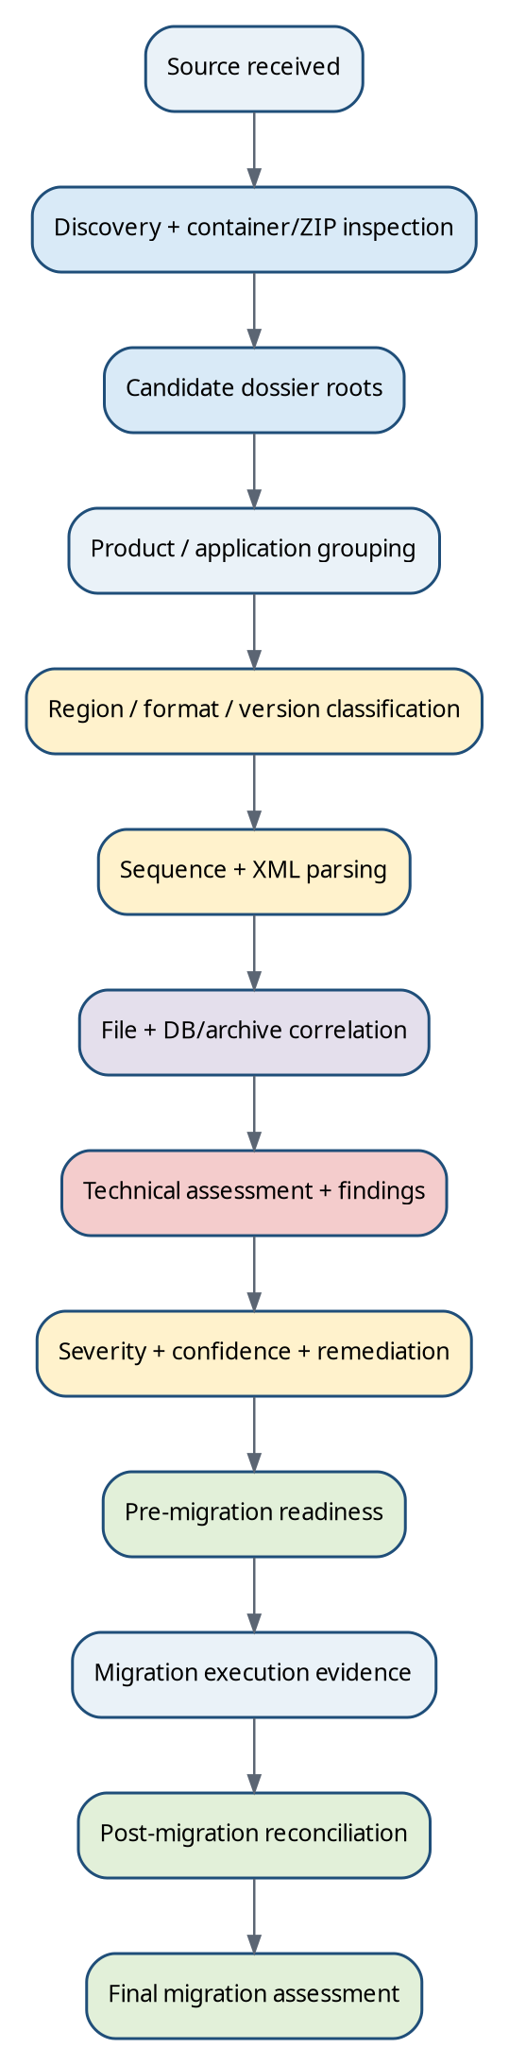
Figure 10. Master eMAS processing flow from source receipt through final reconciliation. Migration execution itself remains outside eMAS; eMAS consumes or produces assessment evidence around it.
Step | What eMAS does | Primary output / boundary
1 Source received | Record declared source scope, source system(s), environment(s), available export/archive/database/DMS evidence and assessment phase. | Execution context; missing inputs remain explicit.
2 Source discovery | Read-only enumeration of roots, folders, files, sizes, containers and accessible metadata. | Inventory evidence; no modification or extraction into source.
3 ZIP/container inspection | Identify archives and nested containers; inspect safely according to an approved container policy. | Container findings and candidate internal roots; ZIP handling is an eMAS design decision, not a regulatory requirement.
4 Candidate dossier-root detection | Score folders/containers for sequence/backbone/regional evidence and isolate one or more candidate dossiers. | Candidate roots with evidence and confidence.
5 Product/application grouping | Associate candidate roots with product/application identities without treating every wrapper folder as a regulatory level. | Product/application grouping with provenance.
6 Region/format/version classification | Use structured XML/schema/DTD/namespace, physical conventions and source metadata according to context-sensitive evidence priority. | Multi-dimensional classification + state + confidence.
7 Sequence/submission-unit identification | Inventory deliveries; cross-check physical and XML values; detect gaps, duplicates, nesting and identity conflicts. | Sequence baseline and anomaly findings.
8 XML parsing | Parse common and regional backbones using version-specific parsers; retain XPath/element/attribute evidence. | Structured metadata and parse/readability results.
9 File correlation | Resolve XML references, actual files, orphan candidates, checksum/size/type/readability evidence and lifecycle targets. | Technical completeness findings.
10 DB/archive correlation | For applicable source-system scenarios, link database file identity to physical archive objects and business impact. | Source-system integrity evidence.
11 Technical assessment | Evaluate applicable structural, integrity, lifecycle and migration rules. | Findings; never silently upgrade to formal regulatory validation.
12 Severity/confidence/remediation | Apply current RAG, evidence confidence, migration impact and recommendation/owner logic. | Actionable, traceable finding set.
13 Pre-migration readiness | Evaluate mandatory coverage, blockers and accepted project exceptions. | Ready / Ready with Accepted Exceptions / Blocked baseline.
14 Migration execution evidence | Consume migration/import records where available; eMAS does not execute migration. | Expected↔actual object mapping and execution status evidence.
15 Post-migration reconciliation | Compare approved baseline, import evidence and post-import/target evidence at multiple levels. | Reconciled / Reconciled with Accepted Exceptions / Review Required / Not Reconciled.

Scope boundary | Detection, classification, structural assessment, technical completeness, migration readiness and reconciliation are different activities. Regulatory validation means evaluating the authority validation criteria applicable to a submission; eMAS must not use that term unless the implemented and versioned official rule set actually supports the claim.

29. Repository discovery, ZIP handling and dossier-root detection
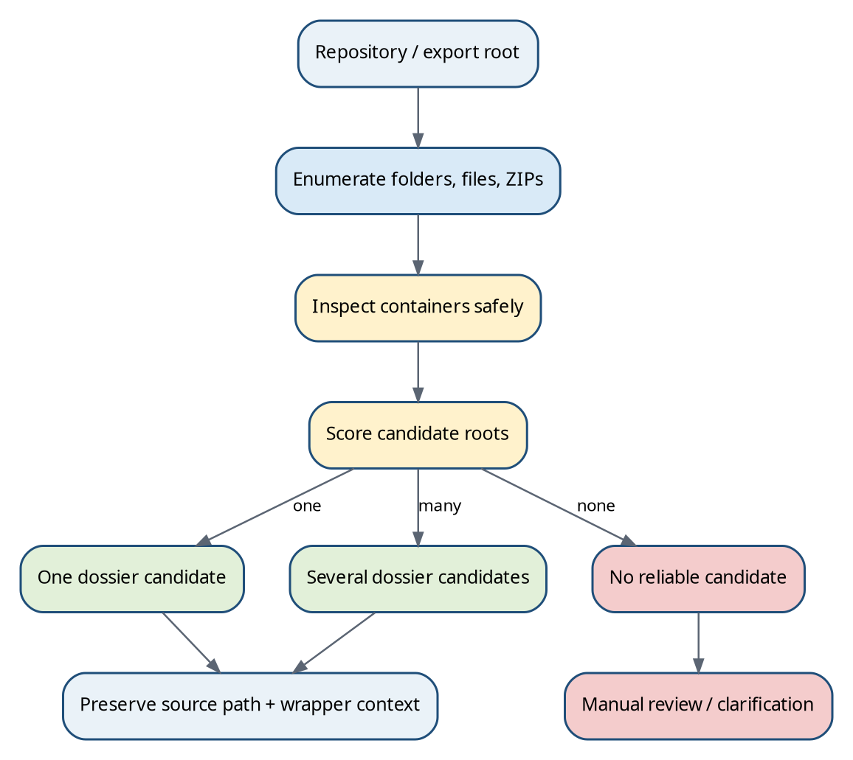
Figure 11. Repository discovery treats wrappers and archives as containers until regulatory evidence identifies a candidate dossier root.
Customer source locations are frequently not clean regulatory packages. A repository may contain one dossier, many dossiers, application wrappers, product wrappers, exports nested below transport folders, ZIPs, old backups, partial extractions, temporary files and unrelated operational artefacts. eMAS therefore separates container discovery from regulatory classification.

29.1 Container and folder anomaly catalogue
Condition | Detection / traversal behaviour | Finding class / default interpretation | Recommended action
Single ZIP at source root | Record archive metadata; inspect entries when approved container policy permits. Do not modify source ZIP. | Migration/container observation; classification remains inside archive. | Discover candidate roots inside; retain original ZIP as source evidence.
Multiple ZIPs | Treat each archive as a candidate container; compare internal roots and identity evidence. | Possible multiple dossiers, versions or duplicate exports. | Create separate candidates unless strong evidence proves duplicates.
ZIP inside ZIP | Detect recursively only to an approved depth/size/entry limit. | Manual-review/security/performance risk; not a regulatory defect. | Inspect within safety limits; otherwise Not Assessed with reason.
Partially extracted ZIP + original ZIP | Compare visible extraction with archive entry inventory where technically supported. | Potential incomplete export/extraction. | Prefer original immutable archive as evidence; flag incomplete extraction.
Extra wrapper folder(s) | Continue traversal while preserving wrapper path. | Usually export/transport structure. | Log logical normalization; do not rename source.
Sequence folders directly at root | Candidate dossier root may be the repository root. | Potentially valid export layout. | Evaluate application identity before grouping.
Application/dossier folder wrapping sequences | Strong common layout when identity evidence agrees. | Normal candidate structure. | Use wrapper only as supporting identity unless XML/source metadata confirms.
Submission folder containing another submission/sequence folder | Detect numeric-sequence descendants beneath a numeric sequence. | Unexpected nesting; may be extraction/copy defect. | Manual review; do not merge levels automatically.
Multiple unexpected nesting levels | Measure depth; search for backbone/sequence clusters. | Complexity/effort driver; possible wrapper artefact. | Normalize logically only; preserve physical path.
Duplicate sequence directories | Same sequence identity appears more than once under candidate scope. | Potential duplicate/copy/conflicting history. | Compare backbone/application identity and binary evidence; manual disposition.
Empty folder / empty sequence | Count entries and expected evidence. | Migration-quality observation; severity depends on applicable expectations. | Clarify whether placeholder/export artefact; do not infer valid sequence.
Mixed dossier structures in one root | Independent region/format/backbone clusters found. | Repository-level mixed scope, not one dossier. | Split into candidate dossiers and classify independently.
Multiple applications/products under one root | Distinct authoritative application identities found. | Normal repository with multiple candidates. | Group by authoritative identity, not just path.
Multiple regulatory formats under one source | eCTD/NeeS/legacy candidates coexist. | Mixed-format migration scope and effort driver. | Apply format-specific rules independently.
Unexpected root/sequence files | Inventory files outside expected paths. | Informational/Amber candidate depending rule and import impact. | Classify as package artefact, source-system file or unknown; preserve evidence.
Backup/archive/temp/system/hidden files mixed with content | Name/type/attributes and known patterns. | Migration observation, possible duplicate/size noise. | Exclude only through approved rule; never silently delete or ignore.
Folder name conflicts with XML/application metadata | Compare path label against structured identity. | Conflicting evidence. | Prefer authoritative structured metadata for classification; flag path conflict.
No recognized dossier structure | No strong format/identity candidate after supported scans. | Unknown / Manual Review Required. | Generate clarification; preserve raw inventory.

Proposed ZIP policy | ZIP recursion depth, maximum uncompressed size, maximum entry count, supported compression/encryption and anti-zip-bomb controls are eMAS technical design decisions that require explicit approval and testing. A regulatory source does not define these migration safety limits.

30. Product, application and dossier grouping
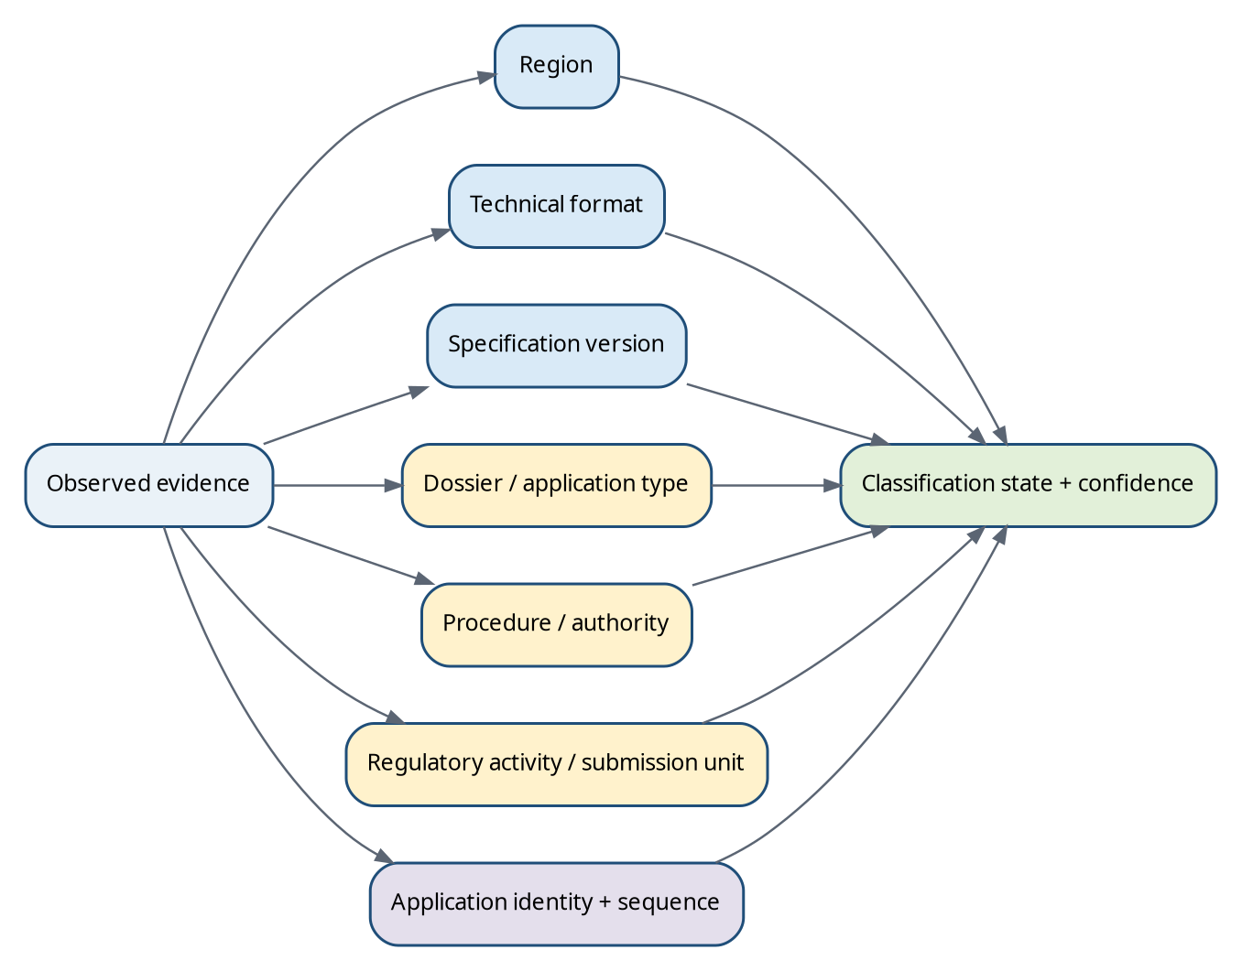
Figure 12. eMAS classification is multi-dimensional. Region, technical format, version, dossier/application type and lifecycle concepts are stored separately rather than collapsed into one label.
Conceptual regulatory hierarchy. Physical directory levels are evidence, not automatically equivalent to these regulatory levels.
Product
└─ Application / Dossier
└─ Regulatory Activity
└─ Sequence / Submission Unit
└─ CTD Context / Document / Lifecycle Object
Observed structure | How to interpret it | Confidence rule
One product folder → one application → sequences | Simple source organisation if XML/source identity agrees. | Product folder name is supporting; application XML/DB identity is stronger.
One product → several applications | Common when different jurisdictions/application numbers exist. | Keep separate application identities even if product label matches.
Several products → one repository | Repository container, not one dossier. | Create independent application/dossier candidates.
Product name only in folder | Inferred product label. | Low confidence unless confirmed by structured metadata/customer verification.
Product name in regional XML or authoritative source DB | Structured product evidence. | High/strong evidence subject to parser/source validity.
Folder product name conflicts with XML/DB | Conflict. | Do not silently overwrite; retain both observations and resolve by context-sensitive authority.
Additional product discovered during scan | Scope expansion candidate. | Generate clarification and effort/scope impact; do not auto-accept into migration scope.

Evidence rule | A physical parent folder is not automatically a Product, Dossier or Application. eMAS should record the physical path separately from inferred/canonical regulatory identities and retain ValueProvenance.

31. Assessment stages and migration-scenario model
Figure 13. The four assessment layers have different depth, inputs and decision language. Migration execution remains operationally separate from eMAS assessment.

31.1 Stage boundaries
Stage | Purpose | Typical checks | Must not claim
A Pre-sales / discovery | Estimate scope, complexity and missing information before full project definition. | Access, counts, size, candidate dossiers/sequences, high-level region/format/type, high-level folder RAG, file-type mix, effort drivers, confidence, clarification questions. | Readiness, exhaustive reference integrity, full checksum validation, migration success or formal regulatory validation.
B Detailed pre-migration | Establish a controlled, evidence-based source baseline and readiness. | Deep inventory; classification; sequence/XML; referenced-file checks; zero-byte/long-path/readability; duplicates/nesting; DB/archive where applicable; staging/backup; remediation/exceptions. | Automatic regulatory validity or customer acceptance.
C Migration execution support evidence | Track what the migration process attempted and produced. | Expected source object, target object, copy/transform result, error/retry/skip/manual remediation, batch status, source/target IDs. | Migration execution by eMAS itself. The execution contract is external evidence unless separately implemented.
D Post-migration reconciliation | Compare approved baseline to import and target evidence. | Dossier/sequence/document/metadata/integrity/lifecycle/archive/exception reconciliation. | Formal business acceptance or validation completion.

Sources: [INT02], [INT03]

31.2 Migration-scenario taxonomy
Scenario family | Examples / source evidence | Assessment consequences
Existing EXTEDO customer | eCTDmanager/eSUBmanager; on-prem→EXTEDO Cloud; on-prem→new on-prem; legacy→newer EXTEDO. | DB/archive/storage knowledge may permit source-system integrity checks and stronger reconciliation.
New / third-party customer | Third-party regulatory system or filesystem export → EXTEDO. | Export is primary evidence; archive/database checks depend on source access and mapping.
Database + archive migration | SQL/Access/Oracle + archive available. | Perform DB↔archive integrity during detailed pre/post stages; source-version mapping required.
Export-only migration | Regulatory export available; source database/archive not available or intentionally out of scope. | Technical package assessment possible; source-system completeness confidence limited.
Archive available, DB unavailable | Physical volume/content can be inventoried, but DB-linked object expectation is weak/unknown. | Archive orphans/expectedness cannot be fully resolved without alternate manifest.
DB available, archive unavailable | Logical expected objects known, physical presence cannot be confirmed. | Archive integrity Not Assessed / INPUT_UNAVAILABLE; readiness may block if required.
Neither DB nor archive; regulatory export only | Assess supplied packages only. | Scope declaration is critical; do not infer complete source lifecycle.
DMS-integrated source | Veeva/Documentum/other DMS integration. | Define whether source document, rendition, exported PDF or target object is the reconciliation identity.
Mixed sources/environments | Multiple databases, archives, products or source systems. | Partition evidence by source system/environment; prevent cross-source identity collisions.
Unsupported/legacy infrastructure | Old DB/OS/application versions or historical formats. | Raises effort/risk; may require manual extraction/conversion; do not confuse infrastructure support with regulatory validity.

31.3 Business-first questionnaire and follow-up logic
Question | Why it matters | If unanswered
Existing EXTEDO customer? | Selects source-system discovery path. | Follow-up: identify current source application/vendor.
Current system/product and version? | Determines supported metadata/archive mappings. | Technical classification may continue from export; source-system integrity remains limited.
Current hosting and target hosting? | Defines on-prem/cloud transfer/staging context. | Migration scenario remains provisional.
Database type and available? | Enables logical source inventory and archive expectation. | DB-dependent checks Not Assessed.
Archive available and accessible? | Enables physical source verification and sizing. | Archive integrity Not Assessed; may block if scenario requires it.
Regulatory export available? | Enables dossier/sequence/XML assessment. | Dossier classification may rely on DB/customer evidence or remain Unknown.
eSUBmanager in use? | May add storage/publishing/export scope. | Generate clarification if migration scope depends on it.
External DMS in use? | Affects document identity and source-of-truth mapping. | Require DMS/export responsibility decision.
Approximate dossiers/volume/regions/formats? | Supports early effort and test-sampling strategy. | Use detected values if available; otherwise Low/Unknown confidence.
Historical/legacy data and complete archive vs active only? | Defines lifecycle completeness expectation. | Sequence gaps cannot be interpreted confidently.
Validation/GxP expectations? | Defines evidence, review and project validation scope. | Do not assume compliance target or sign-off model.

Questionnaire behavior | Reusable question definitions belong in configuration; actual customer answers, detected values, verification evidence and overrides belong in project assessment/report evidence. Critical unanswered questions generate follow-up items rather than guessed defaults.

Sources: [INT02], [INT03]

32. Multi-dimensional classification, evidence hierarchy and conflict handling
Dimension | Example values | Never conflate with
Region / jurisdiction | EU, US, Canada, UK, Switzerland, Australia, Japan, Singapore, Unknown | Authority, procedure or format.
Technical format | eCTD v3.x, eCTD v4.0, NeeS, legacy CTD electronic structure, document collection, Unknown | NDA/IND/MAA/ASMF.
Specification/version | ICH eCTD 3.2.2; regional M1/DTD/schema versions; eCTD v4 implementation version | Sequence number.
Dossier/application/regulatory concept | MAA, IND, NDA, ANDA, BLA, ASMF, DMF, clinical-trial context | Transport format.
Procedure / authority | EU CP/DCP/MRP/National; FDA; NCA; other regional routes | Application type.
Regulatory activity / submission type | Variation, supplement, response, amendment, renewal, etc. | Sequence itself.
Sequence / submission unit | 0000, 0017, v4 submission unit identifier | Document version.
Application identity | FDA application number, regional dossier/procedure/application identifiers | Product folder name.

Illustrative multi-dimensional record; no one field substitutes for the others.
Region = EU
Technical Format = eCTD
Specification = ICH 3.2.2 / EU M1 applicable rule set
Regulatory Concept = ASMF
Procedure Context = National or medicinal-product relationship as evidenced
Application/Dossier = <authoritative identifier if available>
Sequence = 0042
Activity = <submission/@type and submission-unit/@type where applicable>

32.1 Evidence classes
Evidence class | Examples | Typical use
Primary / authoritative structured | Regional backbone controlled value; application number; schema/namespace/root; source-system authoritative ID; database archive identifier for archive checks. | Can establish classification/identity when parser/source validity is confirmed.
Supporting strong | Common backbone links to regional backbone; physical sequence value matches XML; independent database/export metadata agrees. | Raises confidence and confirms consistency.
Supporting/structural | Official regional path, CTD module hierarchy, expected folder/file pattern. | Supports classification; usually insufficient alone for business identity.
Weak / heuristic | Folder name, ZIP name, filename text, free-text label. | Candidate generation only; Low confidence without stronger evidence.
Conflicting | Two strong sources indicate different applications/regions/versions. | Do not hide with priority; output Unknown/Ambiguous plus conflict finding.

32.2 Context-sensitive evidence priority
There is no single global evidence ranking for every question. Regional XML may be authoritative for submission metadata, while the source-system database may be authoritative for the set of archive objects that should exist. A physical hash match may prove archive presence but not regulatory placement. Therefore each rule defines its target question and evidence authority.
Question | Preferred evidence | Fallback / supporting evidence
What region/format is this? | Regional/common backbone root, namespace/schema/DTD and cross-reference. | Regional path, module structure, customer metadata, folder names.
Which FDA application is this? | us-regional.xml application-number and controlled application type. | Source-system application metadata, application folder.
Which file should exist in eCTDmanager archive? | Source database record + archive identifier mapping for the relevant product/version. | Migration manifest/known archive export; visible business filename is not primary.
Did target preserve a document? | Approved reconciliation key/manifest + source/target IDs and hash/size where available. | Filename/path comparison only when explicitly approved.
Is a sequence missing? | Complete-source declaration/database inventory and lifecycle references. | Numeric gap alone is an observation, not proof.

32.3 Classification states and confidence
Classification state | Meaning | Relationship to confidence
Confirmed | Required authoritative evidence is present, internally consistent and rule coverage is complete. | Usually High, but state is a decision result, not a synonym for confidence.
Highly Probable | Strong authoritative evidence plus independent support, minor non-material limitations. | High or Medium according to approved rule.
Probable | One strong source or several consistent supporting sources. | Usually Medium.
Ambiguous | Material strong evidence conflicts or more than one classification remains plausible. | Unknown confidence; conflict finding retained.
Unknown | Insufficient usable evidence. | Unknown.
Unsupported | Evidence identifies a region/format/version that the active eMAS release does not support. | Confidence in identity may be High while assessment support is Unsupported.
Manual Review Required | Automation cannot safely decide because of missing/unsupported/conflicting evidence. | Any lower confidence state; reason must be explicit.

Sources: [INT03]

33. Master regional comparison matrix
The table below is an identification/assessment matrix, not a guarantee that every listed implementation is enabled in a particular eMAS release. Exact effective versions must be re-verified at rule activation and before controlled release.
Region | v3 / legacy regional evidence | v4 / current direction | Identity/activity evidence useful to eMAS | Key assessment note / source
EU | index.xml + m1/eu/eu-regional.xml; EU M1 Specification 3.1.1 uses DTD 3.1; EU validation criteria maintained separately. | EU v4 practical guidance/pilot implementation uses submissionunit.xml and regional CV/business rules. | EU envelope identifier; submission/@type; submission-unit/@type; agency/@code; procedure/@type; sequence/related-sequence; product metadata. | Do not infer exact 3.1.1 solely from dtd-version=3.1. S05–S10.
United States / FDA | ICH v3.2.2 + US Module 1 regional backbone DTD 3.3; us-regional.xml. | FDA supports eCTD v4 for defined application types; use current FDA regional v4 IG/CVs. | application-number/@application-type; submission-id/@submission-type; sequence-number/@submission-sub-type; cross-reference application. | Codes require current FDA controlled lists. S15–S19.
Canada / Health Canada | m1/ca/ca-regional.xml; root hcsc_ectd; schema-version 2.2 in current v3 regional model. | Follow Health Canada published transition/current standards when enabled. | dossier-identifier, regulatory transaction metadata, application-folder relationship. | Folder/application identifier relationship is region-specific. S21–S22.
United Kingdom / MHRA | Current guidance uses EU-format modules with UK-specific Module 1/business requirements; lifecycle sequence submissions continue via MHRA platform. | Verify current MHRA implementation before enabling v4 rules. | UK application/procedure/platform metadata and package evidence. | Do not classify UK as EU solely because folder conventions resemble EU. S23.
Switzerland / Swissmedic | ICH v3.2.2 with Swiss-specific Module 1; M1 specification v1.5 in current v3 materials. | Swiss v4 implementation package published; pilot/transition with go-live planned after 2026 pilot period. | Swiss application/eCTD identifiers and regional M1 metadata. | Use effective-date rule; v3 and v4 may coexist during transition. S24–S25.
Australia / TGA | AU Module 1 v3.2 current guidance; AU regional schema/backbone and envelope model. | TGA publishes v4 regional guidance/pilot materials. | AU envelope/application identifiers; sequence/related-sequence and controlled regional metadata. | AU sequence semantics must use AU rules, not generic EU/US assumptions. S26–S27.
Japan / PMDA | Historical v3.2.2/M1 implementation remains relevant for migrated legacy dossiers. | PMDA v4 domestic implementation package v1.6.0.3 (Jun 2026) and v4 lifecycle is current direction. | Japan regional controlled metadata, application/submission-unit identifiers according to PMDA package. | Historical v3 acceptance/transition dates matter for migration inventory. S28–S29.
Singapore / HSA | Legacy/current package context depends on submission date. | SG-HSA eCTD v1.1 official standard accepted from 1 Apr 2026; use HSA package/schema/defined lists. | Singapore regional backbone/schema metadata and HSA submission identifiers. | Do not infer HSA structure from EU/FDA tags. S30–S31.
Other / future | No rule should be activated without verified authoritative source and parser capability. | Unsupported future eCTD revision remains Unsupported/Unknown until controlled expansion. | Preserve raw evidence and customer-provided identity. | Do not force nearest-region classification.

Sources: [S05], [S06], [S15], [S16], [S21], [S23], [S24], [S25], [S26], [S27], [S28], [S29], [S30], [S31]

34. Dossier-format and application-concept catalogue
Category | Examples | How eMAS should model it | Identification caution
Technical submission format | eCTD v3.x, eCTD v4.0, NeeS, CTD-style electronic tree, legacy electronic, document collection, Unknown. | Separate Format + SpecificationVersion fields; apply format-specific parser and structural rules. | An IND/NDA/ASMF label does not prove format.
Regulatory application / dossier concept | MAA, IND, NDA, ANDA, BLA, CTA/clinical-trial context, ASMF, DMF. | Separate DossierType/ApplicationType/RegulatoryConcept fields plus region/procedure. | ASMF/DMF are not unique transport formats.
Lifecycle business activity | Variation, supplement, amendment, response, renewal, annual report, etc. | RegulatoryActivity/SubmissionType fields where authority metadata supports them. | Do not derive from sequence number alone.
Procedure | EU Centralised/DCP/MRP/National; authority-specific routes. | ProcedureType separate from application type. | EU procedure concepts do not apply to FDA.
Legacy eMAS catalogue values | VNeeS, Paper, Medical Device Technical File and other historical/internal categories. | Keep only as explicitly verified/configured format/type values; mark Unsupported or Unverified until authoritative rules are added. | Legacy catalogue presence is not regulatory proof or current support.

34.1 NeeS versus eCTD example
Candidate A
m1/ m2/ m3/ m4/ m5/
index.xml + valid regional backbone
→ eCTD candidate
Candidate B
CTD-style module hierarchy
no normal eCTD backbone/lifecycle message
other NeeS navigation/evidence consistent with applicable guidance
→ NeeS candidate
Candidate C
m1/ m2/ m3/ only, no backbone, no verified NeeS evidence
→ CTD-like / legacy / Unknown; do not force NeeS
Sources: [S02], [S14]

35. Sequence anomalies and file-level integrity catalogue

35.1 Sequence anomalies
Scenario | Safe eMAS interpretation | Severity/confidence approach
0000, 0001, 0003 | Sequence-number gap observed. | Observation until complete-source/lifecycle evidence proves a missing required source sequence.
Duplicate 0003 | Potential duplicate/copy/conflict. | Manual review; compare application identity, XML and binary evidence.
0003a / nonnumeric folder | Not a standard v3 sequence by generic pattern. | Could be wrapper/export artefact; do not treat as sequence without authority/source evidence.
0003/0004 nested | Unexpected sequence nesting. | Migration/packaging finding; assess import impact and lifecycle identity.
Folder 0004 misplaced under wrong application | Application identity conflict. | High if authoritative XML/DB proves different application.
Folder sequence exists, DB sequence absent | Cross-source inconsistency. | Context-dependent; determine whether DB or export is authoritative for migration scope.
DB sequence exists, folder missing | Potential incomplete export. | Stronger source-completeness risk where DB inventory is authoritative.
Malformed sequence XML | Parse failed; classification may still use other evidence. | Not Assessed for XML-derived checks; separate parse finding.
Application identity changes unexpectedly across sequence set | Potential mixed/copied dossier. | Ambiguous/Manual Review unless authority lifecycle rules explain change.
Later sequence lifecycle reference points to absent prior sequence/leaf | Broken lifecycle dependency. | High-confidence technical completeness finding.

35.2 File-level integrity conditions
Condition | Assessment meaning | Regulatory vs migration classification
Expected XML-referenced file exists | Reference resolves physically. | Technical referential integrity; not scientific completeness.
Expected referenced file missing | XML points to absent target. | Technical/regulatory package integrity issue; migration blocker according to applicable rule.
Unexpected/unreferenced physical file | Orphan candidate; could be artefact, source file or invalid package content. | Migration/structural observation until regional rule says otherwise.
Duplicate path/reference | Same logical target referenced unexpectedly multiple times. | Technical review; authority-specific validity separate.
Duplicate binary content | Hash-identical files at different paths/names. | Migration optimization/duplicate indicator; not automatically regulatory defect.
Same filename, different binary | Name collision with different content. | Migration identity risk.
Same binary, different filenames | Potential duplication/reuse. | Migration observation; preserve distinct regulatory references where required.
Zero-byte file | Physical target unusable despite path existence. | Technical integrity finding.
Unreadable/corrupt file | Parser/open/read failure. | Technical integrity; document validity may require dedicated format validator.
Password-protected/encrypted PDF/file | Detected protection prevents normal processing. | Migration/technical blocker where importer/rendition requires access; authority rules separate.
Extension vs file signature/MIME mismatch | Declared filename type differs from binary evidence. | Technical integrity/security observation.
Invalid/unsupported extension or format | Outside approved migration/import support. | Migration compatibility risk; may also violate authority rule only if cited.
Invalid characters / excessive path length | Path/filesystem/import compatibility issue. | Migration risk, not normally regulatory rule.
Inaccessible/locked file | Evidence unavailable or transiently unavailable. | Not Assessed / ACCESS_DENIED or specific lock reason; never ConfirmedAbsent.
Checksum missing | Expected digest metadata absent where applicable. | Rule-specific; do not universally call Red.
Checksum mismatch | Calculated bytes do not match expected digest. | Strong integrity finding.
Unsupported checksum type | Cannot perform configured integrity check. | Unsupported/Not Assessed until approved capability exists.
Case sensitivity mismatch | Potential cross-platform/path resolution issue. | Migration observation; Windows may resolve case-insensitively while target may differ.
Broken relative path / path traversal | Reference resolves outside expected package or is syntactically invalid. | Technical/security finding; apply specification rule where sourced.
Absolute path / URL / external reference | External dependency or unexpected reference model. | Manual review; allowedness is format/region/version specific.
Previous-sequence target missing | Lifecycle target unavailable. | Strong lifecycle completeness issue.
Replace/delete without valid target | Lifecycle relationship cannot be resolved. | Technical lifecycle finding; authority validation equivalence not claimed.

36. Archive and source-system integrity methodology
Figure 14. eCTDmanager archive verification is a source-system integrity assessment. Database identity is used to derive the physical archive key, then business impact is traced back through database relationships.
Archive verification must be kept separate from generic eCTD XML validation. For eCTDmanager migration scenarios with an authoritative source database and archive, the database defines which stored objects are expected and how the physical archive object is identified. The visible regulatory filename may not be the physical archive filename.
Layer | Required logic | Evidence/result
1 Database identification | Identify expected file/document records, archive-related identifier, dossier/submission/document relationships and source environment. | Expected object inventory and traceability IDs.
2 Identifier normalization | Convert database representation into the filesystem lookup representation. Remove DB-only decoration; normalize case where appropriate; do not invent an extension or hash algorithm. | Archive lookup key + transformation/source-version evidence.
3 Archive verification | Select correct archive root; recursively search approved scope; handle access errors; capture all physical matches and full paths. | Found / Missing / Multiple / Invalid identifier / Inaccessible.
4 Alternate environment comparison | Check PROD/DEV/TEST/backup/migration source/target only when in scope. | Found primary, found alternate, missing both, mismatch.
5 Deeper integrity | Compare extension/type, size and checksum/hash when source data and approved method exist. | Presence vs identity distinction.
6 Impact analysis | Use DB relationships to identify every logical document, sequence/submission and dossier referencing the object. | Impacted business/regulatory object list.

Archive status | Meaning
VERIFIED - FILE FOUND | Derived expected archive object exists in the checked archive; optional deeper identity checks may still be pending.
MISSING - FILE NOT FOUND | Expected object cannot be located after correct key/root/scope/access have been verified.
FOUND IN ALTERNATE ARCHIVE | Primary archive lacks the object but another approved archive/environment contains it.
MULTIPLE MATCHES | One expected key resolves to several physical objects and needs investigation.
INVALID / UNUSABLE IDENTIFIER | The source record does not yield a reliable physical lookup key.
DATABASE RELATIONSHIP REQUIRES REVIEW | File exists, but expected logical/business relationship cannot be established reliably.
NOT ASSESSED | Required DB/archive/source mapping or access is unavailable.

False-missing safeguard | Before declaring a physical archive object missing, verify the selected DB record/field, identifier conversion, database-only formatting, archive root, recursive scope, extension assumptions, permissions/reachability and any relevant alternate archive.

Sources: [INT04]

37. Evidence sources, stage use and traceability

37.1 Evidence-source catalogue
Evidence source | Discovery / pre-sales | Detailed pre-migration | Post-migration / reconciliation
File system / exported submission | Primary volume/candidate evidence. | Deep structure, paths, readability, reference targets. | Source baseline and/or target export comparison.
ZIP/container | Candidate discovery and transfer volume. | Entry inventory, extraction completeness, nested-container findings. | Compare preserved package where target/output exposes it.
index.xml / submissionunit.xml | High-level format/version evidence when cheap to parse. | Detailed XML, lifecycle, references, identities. | Compare agreed structural/metadata expectations.
Regional XML / v4 regional metadata | High-level region evidence. | Application/procedure/activity/sequence metadata and controlled values. | Compare mapped target identity where applicable.
DTD/XSD/schema / controlled vocabulary | Usually configuration/source evidence, not customer data. | Parser/version/controlled-value validation where implemented. | Reference version used for baseline interpretation.
Source-system database | High-level size/info if supplied. | Authoritative logical inventory and DB↔archive mapping for supported scenarios. | Source expected identity/count/reference baseline.
Source archive/storage | Sizing/access. | Physical expected-object verification and integrity. | Source side of archive reconciliation.
DMS / API / export metadata | Optional scenario evidence. | Source identity/version/rendition mapping where supported. | Source/target object linkage.
Migration manifest / import logs | Normally unavailable/not used. | May define planned scope after baseline. | Primary actual migration attempt/result evidence.
Target database/archive | Not used. | Not used except approved dry-run contexts. | Observed target identity/content/integrity.
MigrationSummary / post-import verification | Not used. | Defines expected downstream evidence fields. | Required evidence according to current post-migration contract.

37.2 Observation-to-decision traceability
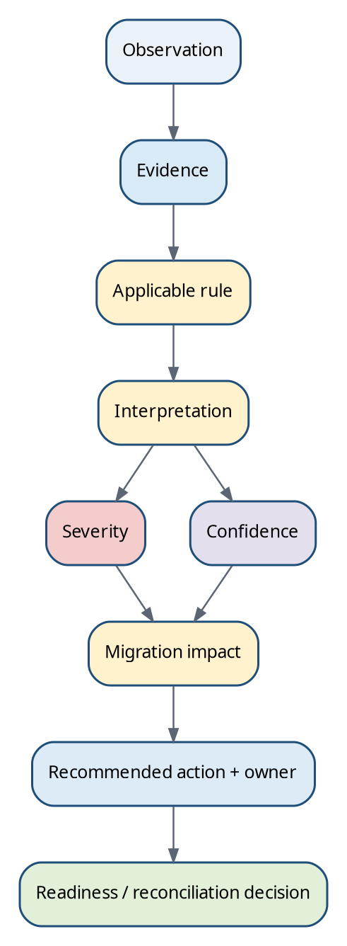
Figure 15. Every material decision should be explainable from observation through source evidence, applicable rule, interpretation, severity/confidence, impact and action.
Traceability field | Minimum expectation
Observation | Raw fact or failed observation, entity and scope.
Evidence reference | Physical path, XML XPath/element/attribute, DB/manifest key, source document section or error.
Rule | Stable RuleId, family, applicability scope and condition result.
Interpretation | Regulatory requirement, regulatory interpretation, eMAS design decision, migration rule or recommendation label.
Severity | Finding RAG/severity with reason and aggregation behavior.
Confidence | Evidence authority/independence/consistency plus classification state.
Migration impact | Scope, data-loss/import/reconciliation/readiness consequence.
Action | Recommendation code, owner, status, due/closure evidence where project process requires it.
Decision | Readiness/reconciliation result with coverage and exceptions.
Configuration identity | ConfigurationId, MappingVersion, SchemaVersion, ReleaseId, ConfigSha256 and script/template/execution identity.

Sources: [INT02], [INT03]

38. RAG, confidence, applicability, ownership and decision semantics

38.1 Current assessment-state model
Concept | Controlled values / rule
AssessmentStatus | Assessed; Not Assessed; Unknown.
AssessmentReason | NONE; INPUT_UNAVAILABLE; ACCESS_DENIED; PARSE_FAILED; NOT_PERFORMED; NOT_APPLICABLE; CONFLICTING_EVIDENCE; INSUFFICIENT_EVIDENCE.
EvidenceState | Present; ConfirmedAbsent; Unavailable; Invalid, with raw evidence/error reference.
RagStatus | Green; Amber; Red; Unknown; Not Assessed.
Coverage | Expected required applicable checks, completed checks, valid non-applicable checks, optional skipped checks and incomplete required coverage remain distinct.

A successfully observed absence can support a missing-file rule; a denied path or parse failure cannot. Not Applicable requires a successful applicability determination. Missing evidence never becomes Green. Condition evaluation is three-valued: True, False or Undetermined.

38.2 RAG aggregation and context-sensitive severity
Situation | Current baseline behavior
Confirmed Red finding | Overall RAG can become Red according to applicable aggregation rules.
No Red, but required coverage incomplete or material evidence conflict | Overall Unknown rather than Green/Amber certainty.
No Red/coverage conflict, at least one Amber | Amber outranks Green.
All required applicable checks successfully satisfied | Green may be possible.
All checks validly Not Applicable | Not Assessed; never Green by default.
Optional check skipped | Visible as optional skipped; does not masquerade as required completion.

Severity is not determined by file name alone. Regulatory impact, data-loss/migration impact, recoverability, source availability, volume affected, confidence, automatic-remediation possibility and manual regulatory-review need can change the final interpretation. A missing referenced file that is recoverable from an authoritative archive may still be severe but have a different remediation path from a permanently missing source object.

38.3 Confidence and conflicts
Evidence situation | Confidence ceiling / result
Multiple independent strong indicators agree | High may be allowed.
One strong indicator only | Medium maximum under current v5 guidance.
Only weak/heuristic evidence | Low maximum.
Strong contradictory evidence | Unknown; retain conflict finding.
No usable evidence | Unknown.
Unsupported format/version identified strongly | Identity confidence can be High while support state is Unsupported.

38.4 Rule applicability
Example A
Phase = Pre-Migration
AND Region = EU
AND Format = eCTD
AND SpecificationVersion = 3.2.2
Example B
MigrationScenario = Database+Archive
AND SourceProduct = eCTDmanager
Example C
Phase = Post-Migration
AND EntityLevel = Sequence
Scope filters are ANDed. ALL is an unrestricted scope value; UNKNOWN is a real classification, not a wildcard. If a required scope value cannot be evaluated because evidence is unavailable, applicability is Undetermined rather than a definite mismatch or Not Applicable.

38.5 Assessment-stage tags and finding ownership
Stage tag | Example rule use
Discovery | Container/ZIP/candidate-root observations.
Pre-Sales | High-level classification, volume, complexity and clarifications.
Pre-Migration | Detailed structural/integrity/readiness baseline.
Migration Execution | Interpret external migration result evidence only where contract is defined.
Post-Migration | Reconciliation rules.
Regulatory Classification | Region/format/application/procedure identity.
Technical Completeness | Reference/integrity/lifecycle checks.
Reconciliation | Expected↔actual comparison.

Likely owner | Examples
Regulatory Operations / Publishing | Regulatory identity, dossier structure, authority-specific manual review.
Customer IT | Path access, source exports, ZIPs, storage/network availability.
Migration Team | Import compatibility, transformation, batch/retry/skipped objects.
Database Team | DB queries/mappings, archive identifier relationships.
Application Support | Source/target application behavior or unsupported constructs.
DMS Team | Source document/rendition identity and connector/export evidence.
Validation Team | Rule qualification, exceptions, baseline/reconciliation evidence and project validation.
Business Owner | Scope and accepted business exceptions.

Sources: [INT03]

39. Current workbook, Final Config Master and runtime JSON governance
Version 2 of this guide supersedes the earlier simplified “XLSM workbook exports JSON” explanation. The current baseline is a macro-free internal .xlsx authoring workbook with an independently defined JSON-first contract. Runtime PowerShell never reads or interprets the workbook.

39.1 Current 24-sheet authoring workbook
# | Sheet | Role
1 | Home | Start page, versions, status and task navigation.
2 | User_Guide | Task instructions, glossary and field catalogue.
3 | Document_Control | Configuration record and separately identified version concepts.
4 | Assessment_Profile | Supported phase/scenario combinations and required evidence.
5 | Classification_Rules | Region/format/type/authority/specification interpretation.
6 | Folder_Rules | Expected folder structure.
7 | File_Rules | Expected files and supported checks.
8 | RAG_Rules | Finding interpretation.
9 | Effort_Drivers | Point contributions/complexity floors.
10 | Confidence_Rules | Evidence confidence interpretation.
11 | Decision_Rules | Phase-specific decisions.
12 | Recommendations | Central recommendation catalogue.
13 | Value_Lists | Canonical codes/operators/evidence keys.
14 | JSON_Field_Mapping | Explicit review/mapping registry; not executable arbitrary code.
15 | Schema_Control | Runtime contract compatibility.
16 | Validation_Controls | Core/advisory validation definitions.
17 | Validation_Results | Basic/full validation evidence.
18 | JSON_Preview | Illustrative preview initially; generated preview later.
19 | Export_History | Mirror of controlled candidate/release events.
20 | Change_History | Attributable semantic changes.
21 | Rule_Conditions | Normalized grouped conditions.
22 | Source_References | Regulatory/internal source provenance.
23 | Questionnaire_Fields | Reusable business questions and evidence mapping.
24 | Review_Observations | Laptop/web review, defect and retest records.

Sources: [INT03]

39.2 Relationship to the earlier 16 knowledge areas
Knowledge area developed during design | Current v5 home in authoring/runtime model
Migration Scenarios | Assessment_Profile + canonical scenario Value_Lists + questionnaire definitions.
Questionnaire | Questionnaire_Fields; actual answers remain in project evidence/reports.
Dossier & Sequence Identification | Classification_Rules + Rule_Conditions + Source_References.
Expected Folder & File Structure | Folder_Rules + File_Rules.
Missing References & File Integrity | File_Rules / technical evidence keys + RAG interpretation.
Size & Volume Metrics | Engine evidence registry + Effort_Drivers / assessment profiles.
Structural / Technical Observations | Engine observations interpreted through applicable rules.
RAG / Severity Rules | RAG_Rules.
Confidence Rules | Confidence_Rules plus engine caps/conflict safeguards.
Effort Drivers | Effort_Drivers.
Recommendations / Actions | Recommendations.
Pre-Migration Readiness | Decision_Rules + Assessment_Profile + required coverage.
Post-Migration Reconciliation | Decision_Rules + post-migration engine/evidence contract.
Final Config Master / Final Summary | Human-readable combined/filterable view may be retained for review, but production JSON is generated from named normalized Tables under the v5 contract.
JSON Field Map | JSON_Field_Mapping + independently versioned JSON Schema.
Open Questions / Decision Register | Review_Observations / controlled requirements decisions; this guide Appendix K retains cross-cutting open questions.

Current architecture clarification | The legacy “Final Config Master is the primary export basis” was a useful human-review concept. Under v5.0, the authoritative generation input is the normalized 24-sheet/23-Table contract and reviewed transformation implementation. A consolidated view can still support filtering and SME review but must not become an uncontrolled parallel source of truth.

39.3 Filtering the human-readable rule repository
Filter example 1
Region = EU
Format = eCTD
SpecificationVersion = 3.2.2
Dossier/RegulatoryConcept = ASMF
→ show applicable classification, structure, file, confidence, RAG and recommendation rules
Filter example 2
Region = US
ApplicationType = IND
Format = eCTD
→ show FDA application/sequence metadata rules plus phase-specific technical rules

39.4 Runtime JSON rule concepts
Runtime concept | Required purpose
Stable RuleId | Trace finding to maintained rule across sorting/versioning.
Rule family/category | Classification, folder, file, RAG, effort, confidence, decision.
Scope/applicability | Phase, scenario, region, authority, format, dossier type, specification version, entity level.
Condition groups | AND within group, OR across groups; Always explicitly unconditional.
Evidence key/source | Registered technical observation; source provenance separately retained.
Expected target/value | Typed comparison or expected folder/file/readability/count.
Severity/confidence/effect | Controlled output or contribution; engine safeguards still apply.
Recommendation link | Stable RecommendationCode and owner/action text.
Source reference | SourceId + precise section/rationale/verification identity/date.

Conceptual only. The exact production schema, field names, null/list semantics and normalization are governed by Runtime Config Schema v1.0.0 and Mapping/Runtime Requirements v5.0.
{
"ruleId": "STRUCT-001",
"family": "folder",
"scope": {
"phase": "PRE_MIGRATION",
"region": "EU",
"format": "ECTD",
"specificationVersion": "3.2.2"
},
"conditionMode": "Groups",
"recommendationCode": "REC-STRUCT-001",
"sourceId": "Sxx"
}

39.5 Controlled authoring and release chain
Regulatory / migration source
↓
Reviewed eMAS interpretation + stable rule IDs
↓
Macro-free .xlsx authoring workbook
↓
Exact workbook snapshot + SnapshotSha256
↓
Reviewed TypeScript validation / deterministic transformation
↓
Frozen candidate Runtime JSON + ConfigSha256 + ContentFingerprint
↓
Independent attributable approval of exact candidate bytes
↓
Immutable released JSON + trusted release evidence
↓
Offline PowerShell verifies digest/compatibility and executes phase logic
↓
Phase report + log + configuration/execution evidence
Sources: [INT02], [INT03]

40. Edge cases, safe behavior and implementation safeguards
Edge case | Safe behavior
No index.xml in v3-like folder tree | Do not call it valid eCTD v3. Assess NeeS/legacy/partial export; if XML expected by applicable rule, create missing-backbone finding.
Multiple index.xml files in one candidate sequence | Do not choose silently. Identify locations and potential duplicate/nested packages; manual review.
Regional XML without expected common index | Region evidence may exist, but common-backbone relationship is incomplete/unusual; classify evidence separately from structural finding.
Broken XML | Retain file/path/root-name evidence if safely observable; XML-derived checks Not Assessed/PARSE_FAILED; create parse finding.
Wrong namespace/schema | Potential version/region mismatch; do not “fix” namespace; classify as conflict/unsupported as rules dictate.
eCTD-like folders but no XML | CTD-like/legacy/partial export; do not force eCTD.
Folder named 0000 but not an eCTD sequence | Sequence naming is supporting evidence only; require backbone/format evidence.
Two regional implementations mixed in same candidate | Split candidates if package roots support it; otherwise Ambiguous/Manual Review with conflict.
Copied sequences from unrelated applications | Application identity conflict across sequence set; isolate/correct scope before readiness.
Misleading ZIP/folder name | Ignore as weak evidence when structured metadata disagrees; retain naming conflict.
Old backup mixed with current dossier | Do not automatically import/merge; identify candidate lineage and scope declaration.
Partial export | Report delivered scope; do not declare source lifecycle complete without independent evidence.
Application number missing | Use other evidence; identity may remain Unknown/Probable. Do not invent number.
Application identity changes between sequences | Potential dossier mixing; Manual Review unless authority/source rules explain lifecycle change.
Unrecognized region | Region=Unknown/Unsupported; preserve evidence and generate clarification.
Future eCTD/schema version | Support state=Unsupported until parser/rules/source verification are released; do not coerce to nearest version.
Access denied | Evidence Unavailable; AssessmentStatus Not Assessed / ACCESS_DENIED; never ConfirmedAbsent.
Source/target metadata conflict post-migration | Create reconciliation discrepancy; apply approved transformation/exception rule only if traceable.

40.1 Safety and implementation controls
Control | Requirement
Read-only source operations | No delete/move/rename/repair/write to source or customer input workbooks/databases.
Container safety | Approved recursion, decompression and resource limits; encrypted/unsupported archive stays Not Assessed/manual.
Path safety | Reject traversal for configuration-authored relative patterns; report unexpected absolute/external references.
Large repositories | Streaming/memory-conscious enumeration; avoid logging every file to console.
Missing evidence | Explicit status/reason; never default to Pass/Green/Very Low.
Unknown/conflict | Retain raw evidence and manual-review path rather than forcing a category.
Configuration integrity | Verify released JSON digest against trusted release evidence before assessment.
Determinism | Stable IDs, normalized conditions and reproducible serialization/evaluation.
Version pinning | Approved pre-migration baseline pins configuration/script/template/execution identity for post-migration comparability.
Exception separation | Configuration release warnings, migration finding exceptions and report review are separate controls.

Sources: [INT02], [INT03]

APPENDICES
Reference material for implementation, training and controlled rule maintenance.

Appendix A — Regulatory terminology glossary
Term | Definition
ASMF | Active Substance Master File; EU master-file procedure/content concept supporting medicinal-product applications.
Backbone | Machine-readable XML message that describes submission structure/metadata.
BLA | US Biologics License Application.
CMS | Concerned Member State in EU DCP/MRP.
Context of Use (CoU) | eCTD v4 object assigning a document reference to a CTD heading plus contextual keywords.
CTD | Common Technical Document; harmonised dossier organisation into Modules 1–5.
Dossier | Long-lived regulatory collection/application lifecycle.
DMF | US Drug Master File.
DCP | EU Decentralised Procedure.
eCTD | Electronic Common Technical Document.
IND | US Investigational New Drug application framework.
Leaf | eCTD v3 XML object referencing a physical document and carrying lifecycle metadata.
MAA | Marketing Authorisation Application.
MRP | EU Mutual Recognition Procedure.
NDA | US New Drug Application.
NeeS | Non-eCTD electronic Submission; legacy/transitional EU electronic format.
NCA | National Competent Authority.
RMS | Reference Member State.
Sequence | Numbered v3 electronic delivery within an application lifecycle.
Submission Unit | eCTD v4 message/delivery unit.
Technical completeness | eMAS-defined technical state covering identification, structure, references, integrity and lifecycle; not equivalent to formal regulatory validation.

Appendix B — Regional XML / backbone reference map
Region / format | Regional evidence | Root/schema clues | Current note
EU v3 | m1/eu/eu-regional.xml | eu:eu-backbone; DTD 3.1 | M1 spec 3.1.1 / VC 8.2 current for v3.
US v3 | m1/us/us-regional.xml | fda-regional:fda-regional; US DTD 3.3 | FDA M1 spec/valid values current; common v3.2.2.
Canada v3 | m1/ca/ca-regional.xml | hcsc_ectd; schema-version 2.2 | Health Canada M1 schema 2.2.
Australia v3 | m1/au/au-regional.xml | AU regional XSD/envelope | AU M1 v3.2 current.
Switzerland v3 | Swiss regional M1 | Swiss M1 spec 1.5 | ICH v3.2.2 common modules.
Japan historical v3 | Japanese M1 schema | JP regional schema | Historical migration support; current submission transition moved to v4.
Singapore | SG regional schema/files | SG-HSA package defined lists/matrices | SG-HSA v1.1 official from Apr 2026.
eCTD v4 | submissionunit.xml | HL7/RPS message + regional IG/CVs | No v3 index.xml/regional-backbone assumption.

Appendix C — Important XML fields and extraction paths
Scope | Business value | File / element / attribute
v3 common | DTD family | index.xml: ectd:ectd/@dtd-version
v3 common | Document identity | index.xml: leaf/@ID
v3 common | Lifecycle operation | index.xml: leaf/@operation
v3 common | Prior lifecycle target | index.xml: leaf/@modified-file
v3 common | Physical file | index.xml: leaf/@xlink:href
v3 common | Digest | index.xml: leaf/@checksum + @checksum-type
EU | Submission/activity type | eu-regional.xml: submission/@type
EU | Submission unit purpose | eu-regional.xml: submission-unit/@type
EU | Procedure | eu-regional.xml: procedure/@type
EU | Agency | eu-regional.xml: agency/@code
EU | Sequence | eu-regional.xml: sequence
EU | Related sequence | eu-regional.xml: related-sequence
EU | Product | eu-regional.xml: invented-name / inn
US | Application number/type | us-regional.xml: application-number + @application-type
US | Submission ID/type | us-regional.xml: submission-id + @submission-type
US | Sequence/subtype | us-regional.xml: sequence-number + @submission-sub-type
US | Cross-reference | us-regional.xml: cross-reference-application-number
Canada | Regulatory transaction metadata | ca-regional.xml: ectd-regulatory-transaction-information
v4 | Document identity | submissionunit.xml: DocumentReference concept
v4 | CTD placement | submissionunit.xml: ContextOfUse code + keywords
v4 | Replacement relationship | related/replacement ContextOfUse

Appendix D — Dossier-format identification matrix
Target | Strong evidence | Weak/supporting evidence | False-positive control
EU eCTD v3 | eu-regional.xml parses + EU root; index.xml links it | m1/eu path; EU product/procedure names | UK may use EU-format modules; confirm jurisdiction/authority.
US eCTD v3 | us-regional.xml + FDA root + application metadata | m1/us; NDA/IND text in names | Do not classify from “FDA” folder name alone.
Canada eCTD v3 | ca-regional.xml + hcsc_ectd schema | m1/ca | Do not treat generic “ca” folder without schema as definitive.
eCTD v4 | submissionunit.xml validates against expected message family; regional metadata matches | sequence folder integer, sha256.txt | Do not require index.xml or v3 leaf lifecycle.
NeeS | CTD electronic structure + NeeS-specific legacy evidence + no eCTD backbone | m1–m5 folders | A plain source-document tree can resemble CTD.
ASMF | Controlled regional metadata (e.g., EU submission type) + content context | ASMF folder/title | ASMF is not format; keep technical format separate.
Unknown | Conflicting/insufficient evidence | generic product folders | Prefer Unknown over forced classification.

Appendix E — eMAS rule catalogue summary
Category | Representative rule families
Identification | Region, format, version, dossier/application type, procedure, authority, sequence/submission unit.
Structure | Required/conditional package roots, backbones, regional files, module/path rules.
References | Referenced target exists; orphan candidate; duplicate reference; unsafe path.
Integrity | Zero-byte, readability, checksum, file-type/extension, encoding/XML parse.
Lifecycle | Prior target exists, operation relationship valid, related sequence/activity grouping.
Archive | DB-linked archive key resolves; duplicate/missing/identity mismatch.
Volume | Counts, sizes, largest objects, path depth, unknown content.
Readiness | Required inputs, blockers, conditions, accepted exceptions.
Reconciliation | Baseline vs target dossier/sequence/document/metadata/integrity/exception comparisons.

Appendix F — RAG decision matrix
Evidence / impact | Low migration impact | Medium impact | High/blocking impact
High-confidence fact | GREEN/INFO when expected condition met | AMBER when remediation/review required | RED when approved blocking condition met
Medium-confidence evidence | INFO/AMBER | AMBER | RED only if rule explicitly permits; otherwise manual review
Low-confidence heuristic | INFO / Low confidence | AMBER / Low confidence | Do not call blocker solely from heuristic; seek stronger evidence

Appendix G — Confidence scoring matrix
Score concept | Example
5 — authoritative structured metadata | Regional XML controlled value, schema/DTD/root match.
4 — independent backbone linkage | index.xml points to the regional backbone that also parses.
3 — official physical convention | Expected m1/<region> path and sequence-package layout.
2 — CTD structural pattern | m1–m5/sequence pattern without decisive regional XML.
1 — name/text heuristic | Folder contains “EU”, “FDA”, “ASMF”, etc.
Contradiction penalty | Strong evidence for another region/version lowers or blocks classification.
Suggested High | At least one 5-level source plus independent supporting evidence and no strong contradiction.
Suggested Medium | One strong source without independent confirmation, or several 2–3 level sources.
Suggested Low | Mostly heuristic evidence or incomplete/partial export.

Appendix H — Pre-migration readiness checklist
Check | Status options / evidence
Migration scenario identified | Observed/provided/confirmed; unknown → clarification.
Source roots accessible | Yes/No/Partial; permission/error evidence.
Dossier identities established | Count + rule IDs + confidence.
Sequence inventories established | Counts, gaps, duplicates, mismatches.
Backbones readable | Per dossier/sequence result; Not Assessed where absent/non-eCTD.
Referenced files assessed | Missing/orphan counts.
Lifecycle dependencies assessed | Broken target count or scope limitation.
Archive verification completed where applicable | Found/missing/multiple/invalid identifier.
Volume/staging requirements measured | GB, counts, largest objects.
Blockers dispositioned | Open/remediated/accepted exception.
Baseline frozen | Execution ID, script/JSON/template versions, date, reviewer.

Appendix I — Post-migration reconciliation checklist
Level | Minimum comparison
Dossier | Identity and expected presence.
Sequence | Identity/count and import result.
Document | Count/identity/path/reference where target exposes it.
Metadata | Mapped identifiers and region/application values.
Integrity | Hash/checksum/size where available and approved.
Lifecycle | Replacement/related links or equivalent target relationships.
Archive | DB→archive relationships and physical object presence for applicable scenarios.
Exceptions | Approved exclusions/transformations explicitly matched.
Final | No unexplained material discrepancy before Reconciled status.

Appendix J — Regulatory references and source verification register
ID | Authority | Document / page | Version / context | Rules supported | URL / internal reference
S01 | ICH | Common Technical Document (CTD) overview | Current web page | CTD organisation and harmonised Modules 2–5 | https://admin.ich.org/page/ctd
S02 | ICH | Electronic Common Technical Document Specification v3.2.2 | 16 Jul 2008 | eCTD v3 backbone, lifecycle, leaf metadata, DTD, directory model | https://admin.ich.org/sites/default/files/inline-files/eCTD_Specification_v3_2_2_0.pdf
S03 | ICH | eCTD v4.0 Implementation Guide package | v1.7, Jun 2026 | Harmonised v4 message model, schemas, Context of Use / DocumentReference concepts | https://admin.ich.org/page/ich-electronic-common-technical-document-ectd-v40
S04 | ICH | eCTD v4.0 Support Documentation | current support package | Context of Use, keywords, DocumentReference and lifecycle explanation | https://admin.ich.org/sites/default/files/inline-files/eCTDv4_0_SupportDocumentation_v1_6_0.pdf
S05 | EMA / EU eSubmission | Human eCTD project page | verified Sep 2026 | EU eCTD v3.2.2 status, current M1 package, NeeS status | https://esubmission.ema.europa.eu/ectd/
S06 | EU eSubmission | EU Module 1 eCTD Specification page | EU M1 v3.1.1 mandatory from 1 Dec 2025 | EU M1 versions, DTD status, Validation Criteria v8.2 | https://esubmission.ema.europa.eu/eumodule1/index.htm
S07 | EU eSubmission | EU Module 1 eCTD Specification v3.1 | Jun 2024; DTD retained by v3.1.1 | EU XML element/attribute model and Module 1 hierarchy | https://esubmission.ema.europa.eu/eumodule1/EU%20M1%20eCTD%20Spec%20v3.1%20-%20June%202024%20-%20final%20version.pdf
S08 | EU eSubmission | Harmonised Technical Guidance for eCTD Submissions in the EU | v6.0 / 6.0.1 family | EU sequence, related sequence, file/folder and lifecycle guidance | https://esubmission.ema.europa.eu/ectd/docs/Harmonised%20guidance%20eCTD%20-%20version%206.0.pdf
S09 | EMA / EU eSubmission | eCTD v4.0 project page | verified Sep 2026 | EU v4 implementation timeline, validation criteria v1.1, pilots | https://esubmission.ema.europa.eu/eCTD%20NMV/eCTD.html
S10 | EU eSubmission | EU eCTD v4.0 Practical Guidance | v1.0 Dec 2025 | submissionunit.xml, sha256.txt, sequence folders, flat M1 and controlled-vocabulary use | https://esubmission.ema.europa.eu/eCTD%20NMV/docs/EU%20eCTD%20v4.0%20Practical%20Guidance%20v1.pdf
S11 | EMA | Authorisation of medicines | verified Sep 2026 | centralised procedure and relation to national procedures | https://www.ema.europa.eu/en/about-us/what-we-do/authorisation-medicines
S12 | European Commission | Authorisation procedures - national authorisation procedures | verified Sep 2026 | MRP, DCP and national procedures | https://health.ec.europa.eu/medicinal-products/legal-framework-governing-medicinal-products-human-use-eu/authorisation-procedures-national-authorisation-procedures_en
S13 | EMA | Active Substance Master File procedure - Revision 4 | effective 17 Jun 2019 | ASMF purpose and distinction from medicinal-product application | https://www.ema.europa.eu/en/active-substance-master-file-procedure-scientific-guideline
S14 | EU eSubmission | Harmonised Technical Guidance for NeeS | v4.0 Oct 2013 | legacy/non-eCTD electronic submission model | https://esubmission.ema.europa.eu/tiges/docs/NeeS%20eGuidance%20Document%20v4%200_final%20for%20publication%20Nov%202013.pdf
S15 | FDA | Electronic Common Technical Document (eCTD) | verified Sep 2026 | FDA eCTD applicability and supported v3.2.2/v4.0 | https://www.fda.gov/drugs/electronic-regulatory-submission-and-review/electronic-common-technical-document-ectd
S16 | FDA | eCTD Submission Standards for v3.2.2 and Regional M1 | updated Aug 2026 | current v3 backbone/M1/validation versions | https://www.fda.gov/drugs/electronic-regulatory-submission-and-review/ectd-submission-standards-ectd-v322-and-regional-m1
S17 | FDA | The eCTD Backbone Files Specification for Module 1 | v2.6 | us-regional.xml, admin, application-set, submission/sequence metadata | https://www.fda.gov/media/159382/download
S18 | FDA | Example Submissions using the eCTD Backbone Files Specification for Module 1 | v1.4 | concrete us-regional.xml patterns and controlled values | https://www.fda.gov/files/drugs/published/Example-Submissions-using-the-eCTD-Backbone-Files-Specification-for-Module-1-Version-1.4.pdf
S19 | FDA | eCTD Submission Standards for v4.0 and Regional M1 | updated Aug 2026 | FDA v4 support, regional IG/CV and validation versions | https://www.fda.gov/drugs/electronic-regulatory-submission-and-review/ectd-submission-standards-ectd-v40-and-regional-m1
S20 | FDA | Drug Master Files: Guidelines | current FDA guidance page | DMF concept and reference model | https://www.fda.gov/regulatory-information/search-fda-guidance-documents/drug-master-files-guidelines
S21 | Health Canada | Creation of the Canadian Module 1 Backbone | final guidance | ca-regional.xml, hcsc_ectd, regional transaction information | https://www.canada.ca/en/health-canada/services/drugs-health-products/drug-products/applications-submissions/guidance-documents/ectd/notice-creation-canadian-module-1-backbone-2012-health-canada-consultation-document.html
S22 | Health Canada | Validation rules for eCTD regulatory transactions | updated 2025 | Canadian regional/backbone/file validation expectations | https://www.canada.ca/en/health-canada/services/drugs-health-products/drug-products/applications-submissions/guidance-documents/ectd/notice-validation-rules-regulatory-transactions-submitted-health-canada-electronic-common-technical-document-format-2016-12-1.html
S23 | MHRA | eCTD guidance for marketing authorisation and post-authorisation applications | updated 3 Sep 2026 | UK submission use of EU-format Modules 1–5 plus UK-specific M1 content | https://www.gov.uk/government/publications/international-recognition-procedure/ectd-guidance-for-irp-mas-and-lifecycle
S24 | Swissmedic | eCTD | verified Sep 2026 | Swiss v3.2.2 with Swiss-specific Module 1 and current supporting documents | https://www.swissmedic.ch/swissmedic/en/home/services/submissions/ectd.html
S25 | Swissmedic | eCTD v4.0 | updated Jul 2026 | Swiss v4 implementation and transition position | https://www.swissmedic.ch/swissmedic/en/home/services/submissions/ectd-v4-0-2.html
S26 | TGA | eCTD AU Module 1 and regional information v3.2 | updated Sep 2026 | au-regional.xsd, envelope, sequence and related-sequence model | https://www.tga.gov.au/resources/resources/user-guide/ectd-au-module-1-and-regional-information-v32
S27 | TGA | eCTD v4.0 AU Module 1 and regional information | current 2026 | Australian v4 regional/validation model | https://www.tga.gov.au/resources/resources/user-guide/ectd-v40-au-module-1-and-regional-information
S28 | PMDA | eCTD version 3 series | current archive/transition page | Japanese v3.2.2 and M1 schema history; v3 submissions accepted only through 31 Mar 2026 for qualifying applications | https://www.pmda.go.jp/int-activities/int-harmony/ich/0120.html
S29 | PMDA | eCTD v4 domestic implementation package | v1.6.0.3 Jun 2026 | current Japanese v4 implementation package | https://www.pmda.go.jp/int-activities/int-harmony/ich/0092.html
S30 | HSA Singapore | eCTD submissions | updated May 2026 | SG-HSA eCTD v1.1 official standard from 1 Apr 2026 | https://www.hsa.gov.sg/therapeutic-products/registration-of-therapeutic-products/register-your-therapeutic-product/ectd-submissions/
S31 | HSA Singapore | SG-HSA eCTD Specification | v1.1 package referenced from HSA page | Singapore regional schema, matrices and defined lists | https://www.hsa.gov.sg/therapeutic-products/registration-of-therapeutic-products/register-your-therapeutic-product/ectd-submissions/
INT01 | EXTEDO / eMAS | eMAS Documentation Pack v2.0 | 10 Jul 2026 | historical business boundaries, phase-specific reports, mapping-driven model and PowerShell/OpenXML baseline | Internal documentation pack, Confluence ID 1386873065
INT02 | EXTEDO / eMAS | eMAS Enterprise Requirements Specification | v4.0, 06 Sep 2026 | current whole-system baseline: read-only three-phase framework, offline runtime, controlled JSON release, phase responsibilities and traceability | Internal file: eMAS_Final_Enterprise_Requirements_v4.0.md
INT03 | EXTEDO / eMAS | eMAS Mapping Workbook and Runtime JSON Requirements | v5.0, 06 Sep 2026 | current detailed authoring/runtime contract: 24-sheet macro-free workbook, normalized conditions, source provenance, JSON schema, release integrity and assessment semantics | Internal file: eMAS_Mapping_Workbook_and_Runtime_JSON_Requirements_v5.0.md
INT04 | EXTEDO / eMAS | eCTDmanager Archive File Verification Logic | Sep 2026 | database-to-archive identity derivation, physical lookup, alternate archive comparison and impact analysis | Internal file: eCTDmanager_Archive_File_Verification_Logic.md

Appendix K — Open Questions / Decision Register
ID | Decision / open question | Current recommendation | Owner / closure evidence
D-01 | Should ASMF remain listed in the “Formats” catalogue in legacy workbook structures? | No. Model ASMF as Dossier/Regulatory Context; keep transport format separately. Preserve legacy alias only for backward compatibility if needed. | Regulatory SME + product owner; controlled mapping change.
D-02 | Should m1–m5 all be mandatory in every eCTD v3 sequence? | No. Use XML/context and regional mandatory/conditional rules. Initial-package examples must not become universal rules. | Regulatory/technical SME; rule tests.
D-03 | How is exact EU M1 v3.1 vs v3.1.1 reported when both use DTD 3.1? | Report DTD=3.1 from XML and determine specification revision from controlled effective-date/package evidence; allow “not determinable” when evidence is insufficient. | Regulatory SME; version-resolution rule.
D-04 | Which regions are in first controlled eMAS release? | Recommended: EU, US, Canada, UK, Switzerland, Australia, Japan, Singapore + Unknown/legacy, subject to business scope. | Product owner.
D-05 | What exact database/archive identifier transformation applies per eCTDmanager version/source DB? | Maintain source-version-specific mapping; do not embed proprietary assumptions in generic rule text. | Migration engineering; validated source mapping.
D-06 | Does eMAS execute official authority validation criteria or only migration technical checks? | Default: technical assessment only. Any official-rule implementation must be explicitly versioned, tested and labelled as a subset unless full validator equivalence is established. | Validation + regulatory governance.
D-07 | What numerical confidence thresholds are approved? | Use High/Medium/Low rules first; validate numerical model through controlled test corpus before adoption. | Product owner + validation.
D-08 | Readiness terminology: three-state baseline vs expanded five-state proposal? | Retain controlled product wording until report-template decision; map “Remediation Required/Manual Assessment” as intermediate detail if not approved as final states. | Product owner + validation.
D-09 | How will regional controlled vocabularies be versioned and refreshed? | Store source package/version/effective date in mapping workbook/JSON; regression-test before activation. | Mapping administrator + regulatory SME.
D-10 | How are partial customer exports distinguished from complete regulatory lifecycles? | Require scope declaration/source-system evidence; sequence gaps alone remain observations until stronger evidence exists. | Consultant + customer.
D-11 | What ZIP/container recursion and decompression limits are approved? | Define bounded depth, entry count, uncompressed-size, compression/encryption and anti-zip-bomb controls; unsupported containers remain Not Assessed/manual. | Architecture + Security + Validation.
D-12 | Which document/metadata fields are mandatory for post-migration document-level reconciliation in the first implementation? | Define target-system evidence contract and approved comparison keys before claiming document-level reconciliation coverage. | Migration engineering + Validation.
D-13 | Will eMAS ingest migration-execution manifests/logs directly or only post-migration reports? | Treat execution support as evidence integration, not migration execution; define a versioned import contract before implementation. | Product owner + Migration engineering.
D-14 | Which region/version combinations are formally supported by Release 1? | Publish a controlled support matrix with authoritative source version, parser capability, rule coverage and regression tests; everything else remains Unsupported/Unknown. | Regulatory SME + Product owner + Validation.

Appendix L — Edge Cases and Ambiguous Structures
Case | Detection evidence | Default safe classification / action
No backbone but CTD modules | Module folders only; no supported XML backbone. | CTD-like/NeeS candidate only when extra NeeS evidence exists; otherwise Unknown/legacy.
Mixed EU + US regional evidence | Two regional XML roots/paths or conflicting application metadata. | Ambiguous; split physical candidates where defensible or require manual review.
Sequence gap with no lifecycle reference | Numeric gap only. | Observation; seek complete-source evidence.
Sequence gap with lifecycle target to missing sequence | modified-file/related dependency requires absent target. | High-confidence technical completeness issue.
Nested ZIP chain beyond safety policy | Archive depth/size/entry limit reached. | Not Assessed for internal content; manual review/external controlled extraction.
Conflicting product/application names | Folder vs XML/DB mismatch. | Keep raw values; use context-sensitive authoritative source; generate conflict finding.
Unknown future schema | Version signature recognized but parser/rules absent. | Unsupported; do not reuse prior-version validation assumptions.
Target contains extra dossier/sequence | Observed target not in approved baseline. | Post-migration discrepancy unless approved exception/transformation explains it.

Appendix M — Evidence Source × Assessment Stage Matrix
Evidence | Pre-sales | Pre-migration | Execution support | Post-migration
Filesystem/export | Yes - light | Yes - deep | Input identity only | Source/target evidence where available
ZIP/container | Yes - discovery | Yes - controlled deep inspection | Usually no | Preserved package comparison where applicable
Common/regional XML | High-level optional | Primary classification/integrity | No modification | Baseline/target metadata comparison
DB | Optional size/context | Source identity/archive expectations | Source object IDs | Expected-vs-imported mapping
Archive/storage | Sizing/access | Physical source integrity | Copy/source path evidence | Target/archive reconciliation
DMS/API | Context | Identity/rendition mapping | Operational result if external system exposes it | Cross-system reconciliation
Migration manifest/logs | No | Planned scope only | Primary actual result evidence | Primary reconciliation input
Target DB/archive | No | No | Target object creation evidence | Observed target state
Customer questionnaire | Scenario/context | Scope/exceptions/clarifications | Not execution truth | Exception/context only

Appendix N — Version 1 → Version 2 Gap Closure
V1 missing / incomplete area | What Version 2 adds | Source of requirement
ZIP/nested-container handling | Dedicated discovery model, safety limits/open decision, logical normalization and container anomaly catalogue. | V2 revision requirement; enterprise safety principles.
Wrapper/nested/mixed folder structures | Recursive candidate-root discovery and detailed anomaly behavior. | V2 revision requirement; older readiness requirements.
Multi-product / multi-application grouping | Product→application→activity→sequence hierarchy, provenance and confidence. | V2 revision requirement.
Assessment-stage separation | Pre-sales, detailed pre-migration, execution-support evidence and post-migration boundaries. | Enterprise v4.0 + V2 revision.
Migration scenario coverage | Existing/new, cloud/on-prem, DB/archive/export combinations, DMS/eSUBmanager/mixed sources. | Historical scenario design + enterprise v4.0.
Regional matrix depth | EU/US/CA/UK/CH/AU/JP/SG current implementation evidence and cautions. | Regulatory source verification + V2 revision.
Application/dossier vs format | Explicit multi-dimensional classification model. | V2 revision + v5 questionnaire semantics.
Evidence priority/conflict | Primary/supporting/weak/conflicting evidence with context-sensitive authority. | V2 revision + Mapping/Runtime v5.0.
Sequence anomalies | DB↔folder mismatches, duplicates, nesting, identity changes, malformed XML and broken lifecycle targets. | V2 revision.
File integrity catalogue | Binary duplicates, MIME/extension, encryption, access, paths, external refs, lifecycle and checksums. | V2 revision.
Archive correlation | Full DB identifier→archive key→physical object→impact methodology. | Archive verification logic.
Source type matrix | Filesystem/XML/schema/DB/archive/DMS/API/manifest/target/logs by phase. | V2 revision.
Questionnaire linkage | Business-first questions and automatic follow-up model. | Historical workbook design + v5 Questionnaire_Fields.
Final Config Master clarification | Human filterable view retained conceptually, but v5 normalized Tables/schema are authoritative for generation. | Mapping/Runtime v5.0.
Rule applicability/stage/ownership | Scope semantics, stage tags and action owners. | V2 revision + Mapping/Runtime v5.0.
RAG/confidence precision | AssessmentStatus/Reason/EvidenceState/Coverage + conflict/coverage-safe aggregation. | Mapping/Runtime v5.0.
Classification states | Confirmed/Probable/Ambiguous/Unknown/Unsupported/Manual Review semantics. | V2 revision.
Current authoring/release architecture | Macro-free .xlsx + schema + Office Scripts/TypeScript + Power Automate + immutable JSON + trusted digest. | Enterprise v4.0 + Mapping/Runtime v5.0.
Edge-case chapter | No/multiple XML, mixed regions, misleading wrappers, partial export, future versions, access denial. | V2 revision.
Gap closure/completeness gate | Dedicated appendices N/O and open decisions. | V2 revision.

Appendix O — eMAS Bible Completeness and Governance Checklist
Reader should be able to answer | Covered in
What does eMAS receive and what does read-only mean? | Chapters 21, 28, 31, 40.
How does it inspect ZIPs/wrappers and find candidate dossiers? | Chapters 29 and 40; Appendix L.
How are products/applications/dossiers grouped? | Chapter 30.
How are region, format, version, application/dossier type and procedure kept separate? | Chapters 10, 32, 33, 34.
How are sequences and lifecycle relations identified? | Chapters 11, 13, 35.
Where are exact XML fields read? | Chapters 6, 7, 13; Appendices B/C.
How are files correlated and technical completeness assessed? | Chapters 14, 17, 35.
How is DB/archive source integrity checked? | Chapters 15 and 36.
How are findings, RAG, confidence and recommendations created? | Chapters 18–20, 38.
How do scenarios change evidence requirements and assessment depth? | Chapters 21 and 31.
How are pre-sales, readiness and post-migration kept distinct? | Chapters 22–23 and 31.
How is migration execution evidence handled without turning eMAS into the migration engine? | Chapters 28 and 31.
How are rules authored, validated, released and consumed offline? | Chapters 25 and 39.
How does every decision trace to evidence/rule/configuration? | Chapters 24 and 37.
Which conclusions are regulation vs eMAS design? | Callouts throughout; Chapters 17, 18, 29, 38–40.
What remains open before controlled production use? | Appendix K and the applicable project requirements/test evidence.

Master-reference principle | This guide is intended to be the human-readable eMAS “Bible”: one place to understand the domain, assessment methodology and configuration/runtime architecture. It does not replace the authoritative regulatory specifications, the approved enterprise/runtime requirements, the released JSON schema/configuration, validation evidence or project-specific baseline/exception records.

Appendix P — Version 2 Final Completeness Statement
Version 2 consolidates the regulatory foundation, eCTD v3/v4 anatomy, regional Module 1/XML walkthroughs, dossier/application and format distinctions, repository discovery, ZIP and nested-folder behavior, product/application grouping, migration-scenario logic, sequence and file anomalies, archive/database integrity, technical completeness, evidence hierarchy, RAG/confidence, effort/remediation, assessment-stage boundaries, readiness/reconciliation, GxP-oriented controls, the current 24-sheet mapping-authoring model, controlled Runtime JSON release architecture, end-to-end traceability and expanded realistic edge cases.
The intended acceptance test for this document is practical: a reader who has not seen the historical chats or workbooks should be able to explain what eMAS observes, how it classifies evidence, what it can and cannot conclude, how a finding becomes an action/decision, and how that decision is tied to a controlled configuration and retained evidence. Any future regulatory implementation, schema change, migration capability or decision threshold that materially changes those answers must trigger controlled update of the relevant source/rule/configuration and this master guide.

Closing statement
This Version 2 guide is designed to function as the human-readable master reference — the eMAS “Bible” — for regulatory concepts, source discovery, technical assessment, migration-readiness methodology, reconciliation and rule/runtime governance. It intentionally preserves one boundary: the guide explains and governs how eMAS reaches assessment conclusions, but authoritative regulations, approved enterprise/runtime requirements, released configuration bytes and project validation evidence remain the controlling records for their respective purposes.
The regulatory source register, support matrix, rule sources and open-decision register are therefore living controlled content. Before production use, every active regional/version rule must be tied to an effective authoritative source, a supported parser/evidence capability, test evidence and an approved released configuration. Future changes to eCTD standards, regional implementations, migration scenarios, source-system mappings or decision semantics should be reflected through controlled change rather than informal interpretation.

