ACROPOLIS INSTITUTE OF TECHNOLOGY AND RESEARCH

Department of Information Technology
Synopsis
on
Mindful Hub: A Digital Mental Health Wellness Platform

1. INTRODUCTION:
1.1 Overview
Mindful Hub is a comprehensive web-based Digital Mental Health and Psychological Support System specifically designed for higher education students. The platform addresses the growing mental health challenges faced by students in academic environments by providing confidential, stigma-free, and easily accessible support integrated with institutional resources. The system combines modern evidence-based psychology with authentic spiritual practices, making it India's first culturally-rooted digital mental health solution that resonates with Indian students' values and beliefs.

1.2 Purpose
The primary purpose of this project is to provide early access to mental health support for students, helping them cope with stress, anxiety, and academic pressure. The platform aims to promote mental health literacy, reduce social isolation, and create a sense of belonging among students. By integrating traditional Indian spiritual practices with modern psychological approaches, the system strengthens cultural pride and identity while providing effective mental health interventions. The platform serves as a bridge between traditional and modern approaches to wellness, ultimately improving academic performance and reducing dropout rates.

2. LITERATURE SURVEY
2.1 Existing Problem
Current mental health support systems in higher education face several limitations:
- Limited accessibility to professional counselors due to high demand and stigma
- Western-centric mental health applications that may not resonate with Indian cultural values
- Lack of integration between institutional counseling services and digital platforms
- Insufficient early intervention mechanisms for identifying at-risk students
- Social isolation and lack of peer support networks among students
- High dependency on expensive human resources for mental health services

2.2 Proposed Solution
Mindful Hub offers a comprehensive solution through five key components:

- AI-Guided Chatbot: Provides instant coping strategies, conducts early screening using validated tools (PHQ-9, GAD-7), and escalates severe cases to professional counselors.
- Confidential Counsellor Booking: Secure system enabling private appointments with qualified counselors and access to helplines.
- Resource Hub: Comprehensive collection of educational videos, relaxation audio content, and self-help guides available in multiple regional languages.
- Spiritual Consciousness Integration: Unique feature combining evidence-based psychology with authentic spiritual practices including mantras, bhajans, and Vedic wisdom.
- Peer Support Forum: Anonymous, moderated platform facilitating safe peer-to-peer interactions with trained volunteer supervision.

3. THEORETICAL ANALYSIS
3.1 Block Diagram

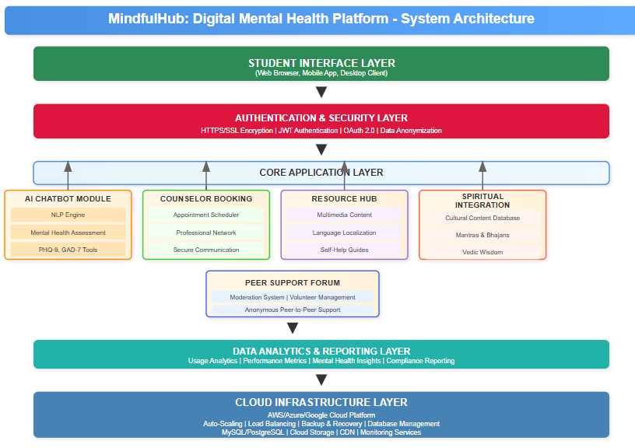
Fig.1. Flow Chart

3.2 Hardware/Software Designing
Software Requirements:
- Frontend: HTML5, CSS3, JavaScript, React.js/Angular
- Backend: Node.js, Python (Django/Flask), RESTful APIs
- Database: Mysql/PostgreSQL for data storage
- AI/ML: Natural Language Processing libraries, TensorFlow/PyTorch
- Authentication: JWT (JSON Web Tokens), OAuth 2.0
- Security: HTTPS, SSL encryption, data anonymization protocols
- Cloud Services: AWS/Azure/Google Cloud for hosting and scaling
Hardware Requirements:
- Client Side: Any device with internet connectivity (smartphones, tablets, laptops, desktops)
- Server Side: Cloud-based infrastructure with scalable computing resources
- Minimum bandwidth: 2 Mbps for optimal performance
- Storage: Cloud storage for multimedia content and user data
Security Infrastructure:
- Data encryption for sensitive mental health information
- GDPR/HIPAA compliant data handling procedures
- Regular security audits and penetration testing
- Backup and disaster recovery systems

4. APPLICATION
Educational Institutions:
- Universities and colleges seeking to enhance student mental health services
- Integration with existing campus counseling centers
- Support for academic stress management programs
Healthcare Sector:
- Mental health clinics looking for digital intervention tools
- Telemedicine platforms for psychological support
- Community health programs targeting young adults
Corporate Wellness:
- Employee assistance programs for young professionals
- Workplace stress management initiatives
- Mental health awareness campaigns
Government Initiatives:
- National mental health programs
- Digital India healthcare initiatives
- Student welfare schemes at state and central levels
Research and Development:
- Mental health research institutions
- Academic studies on digital therapeutic interventions
- Cultural psychology research programs
Social Impact:
- NGOs working in mental health awareness
- Community outreach programs
- Rural and semi-urban mental health support initiatives

REFERENCES

[1] Higher Ed Today. (2024). AI in Student Mental Health: AI tools help provide early support and connect students to mental health resources [Online]. Available: https://www.higheredtoday.org/
[2] J. Farrer, et al., "Digital mental health interventions can reduce anxiety and depression in university students," Psychiatry Res., vol. 279, pp. 315–322, 2019. [Online]. Available: https://www.jmir.org/2019/7/e12869/
[3] Ruderman Family Foundation. (2024). Guide: Effectiveness and Engagement of Digital Mental Health Interventions for Colleges [Online]. Available: https://rudermanfoundation.org/
[4] TalkCampus. Student Peer Support Works – Research Evidence [Online]. Available: https://www.talkcampus.com/student-peer-support-works
[5] TalkCampus. TalkCampus Platform – Moderated peer-to-peer support platform for students' mental well-being [Online]. Available: https://www.talkcampus.com/
[6] Wysa. Research Evidence – Digital Mental Health Effectiveness [Online]. Available: https://www.wysa.com/research

Guided By: Prof. Monika Choudhary Group Members:
Mahak Padlaya (0827IT221085)
Mayank Rathore (0827IT221094)
Prarthana Purohit (0827IT221109)
Sanskriti Chouksey (0827IT221131)

