Movie Theater Ticket Sales System Elaboration Report

Sala Chang, Samir Mahamed, Sam Schug

Metropolitan State University

**Movie Theater Ticket Sales System Elaboration Report**

Management of a small theatre has stated that they need a better system to understand their sales and be able to compare revenue. They would like a tool that gathers the data values of ticket sales. The tool should generate reports for reviewing and presenting in order to help the theatre achieve their revenue goals and to develop processes for a better performance.

The Movie Theatre Ticket Sales System (MTTSS) is created to help movie theatre management better understand their ticket sales and movie entertainment performance records. This information is important because by being able to view the amount of tickets sold per movie, genre, and/or timeframe, management can analyze specific data for understanding sales to improve sales and their performances.

# Vision

The purpose of this project is to provide a tool that will allow analytics of ticket sales for a small theatre to aid management in decision making regarding, marketing, promotions, and pricing.

**Scope: In Scope**

The intended audience of this project is the management of a small movie theatre. The intended use is for data analytics of ticket sales. The first criteria is based on timeframes of sales such as: year, season, month, day, week, or promotional period. The second criteria is the various movie genres offered in the Cinema.

**Scope: Out of Scope**

This project is not intended for businesses outside of theatres, or theatres with more than five screens. The reports are not meant for the public or employees not involved in the decision-making processes.

Additionally, other uses such as other revenue streams like concessions sales, or information about sales from other theatres are outside the scope of this project.

**Business Value**

With the ability to have on demand information about individual movies, management will better understand what is the hot new movie that is in demand that should have more screen time and may require more staffing. It will also help in making decisions regarding future promotions and marketing choices.

The compiled information will give management a sense of understanding within the market trends and have an ability to make predictions based on the information.

**Feasibility Studies**

The technical feasibility of the project indicates that creating a web page program is low risk. The project is a small project with little compatibility risk. This is its own system, not relying on any other major applications as it only uses the local database to retain movie inventory values.

Economically, the return on investment has a four-year proposal. The benefit of the end result is a better reporting tool that will continue to aid in increased revenue through better decision-making capabilities.

From an organizational standpoint, the management team intended for this project include those serving the roles of Chief Finance Officer / Finance team, Technology team, Marketing team, and operational managers.

This is a practical tool that can help the cinema organization gain data about the quality of their inventory and develop strategies to increase revenue.

The schedule feasibility timeline is as follows:

* + - 2 months – Planning and designing phase​
    - 3 months – Developing and Coding​
    - 2 month – Reviewing and testing​
    - 2 month – Continuous developing and testing​
    - 1 month – First product deployment​
    - Continuous maintenance

**Software Development Methodologies**

The Agile methodology will be used in creating this project. This was chosen because its iterative life cycle allows for more user involvement. The desired outcome is that with this user involvement, the tool will not only be easier to use and understand by those without technical knowledge, but also that the information generated is suitable for business purposes at that level.

**Architectural Representations**

Use Case Scenario 1.1: Manager System Interactions

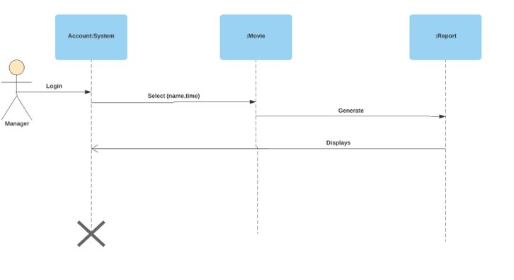

Figure 1.1

Use Case Scenario 1.2: Administrator System Interactions

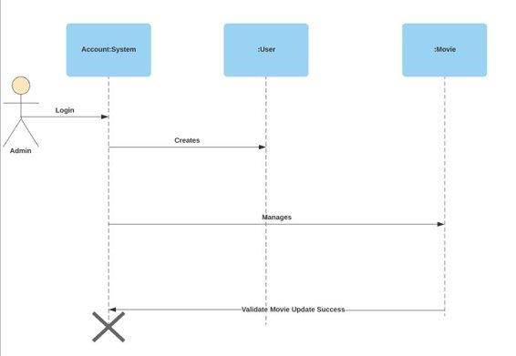

Figure 1.2

Use Case 1.3: Administrator creates a user

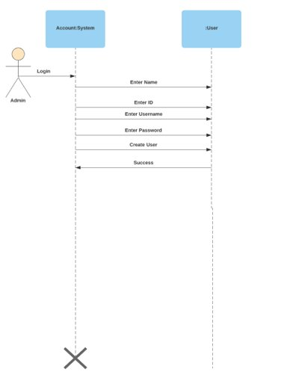

Figure 1.3

**Architectural Goals and Constraints**

The program will be able to handle several filters in order to provide the accurate and useful information to the user. ​

The second goal is in making sure all the information that is stored is updated and reliable. ​

It is also important that the service be online during business hours, making sure there are no inconveniences to the user.

**Logical View**

The Movie Theatre Ticket Sales System is split into two parts:

1. User Interface:
   1. This is where the user can enter and receive information by communicating with the interface to access data stored within.
2. Business Services:
   1. The information is able to be controlled as the information can be edited by an administrator, as well as the ability to control user permissions and creation of users. ​

**Process View**

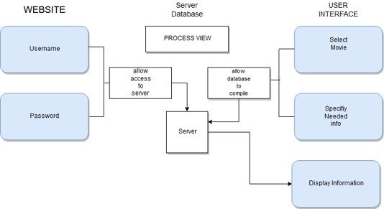

Figure 2.1

**Programming View**

HTML, CSS, and JavaScript will be the technologies that will be used to create the code for this software. Only approved employees can login and receive the information they need from a database. ​​

**Hardware Requirements**

The first hardware requirement is a storage server that is appropriately sized to store the required data for the last two years.

On the host end there will need to be a server that will meet the needs of the database.

On the user end, a standard computer with an internet connection that can access the database is required.

**Software Requirements**

This is a web application that is accessible to authorized users through the URL. It will utilize html, CSS, JavaScript, PHP, and MySQL to form a user interface that interacts with the database and user requests.