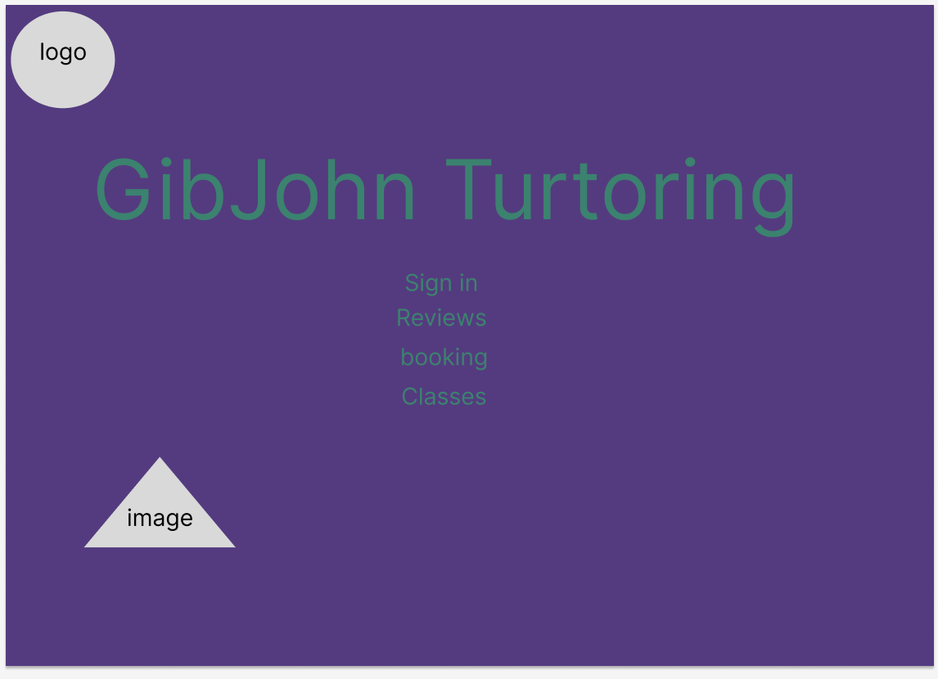
Here is the design of the home page for the website, you might notices that it is very bare bones since I’m complete new to the design software but it gives me an ideas where to improve, add or remove

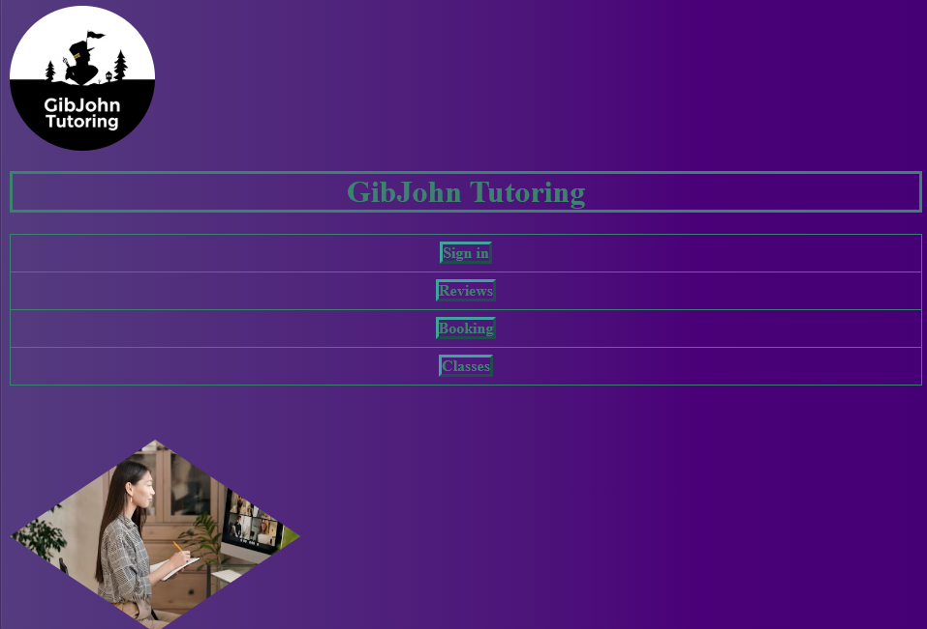
Now this is the finished home page which you might noticed that I have add a nice gradient to the background and add rows to make them pop out even more.

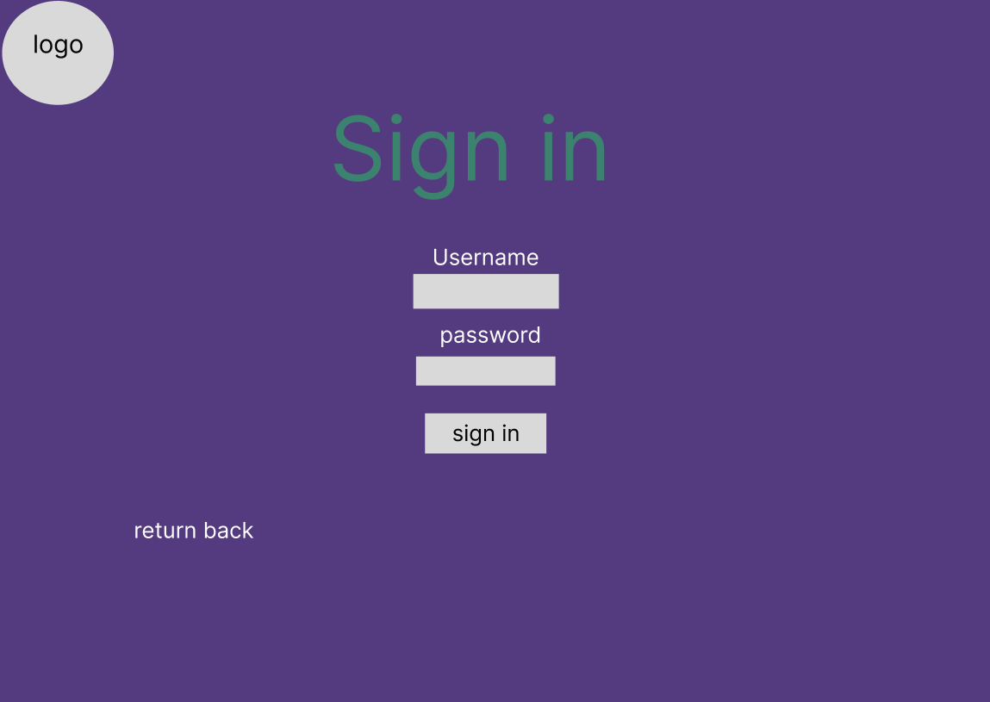
It is still all are bone’s it needs to be improved through more
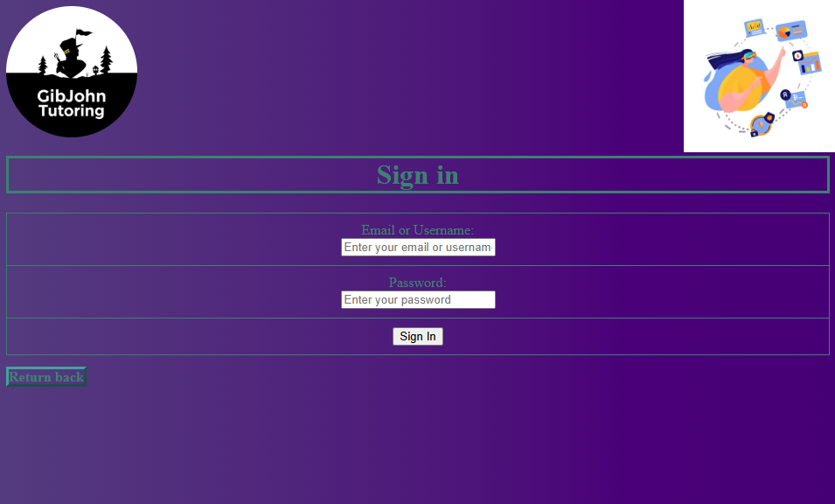
Now I add more stuff like another image on the top right corner and added content inside the boxes which will help out the user what to do.
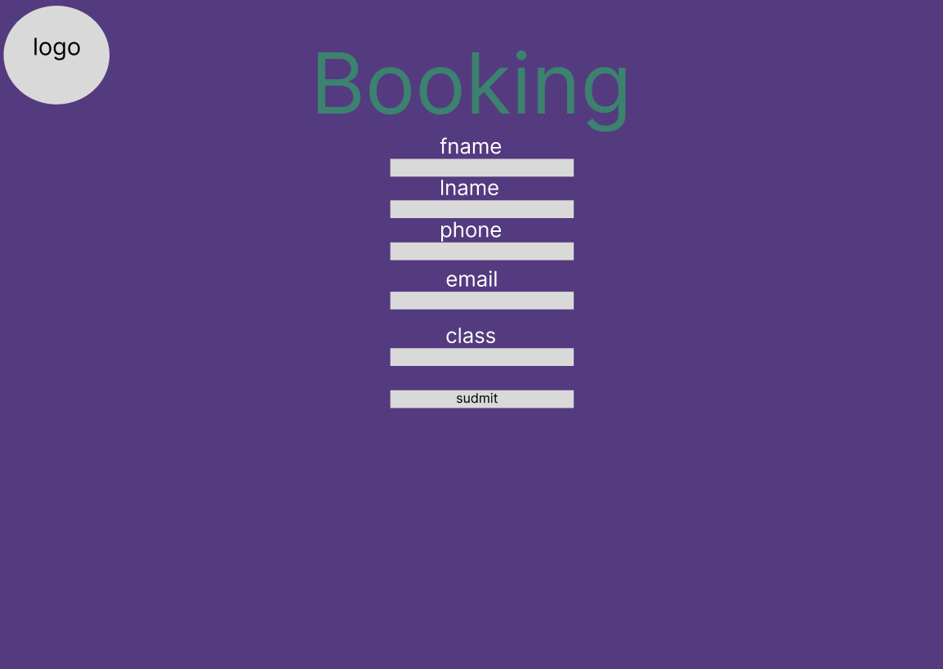
It is still all are bone’s it needs to be improved through more
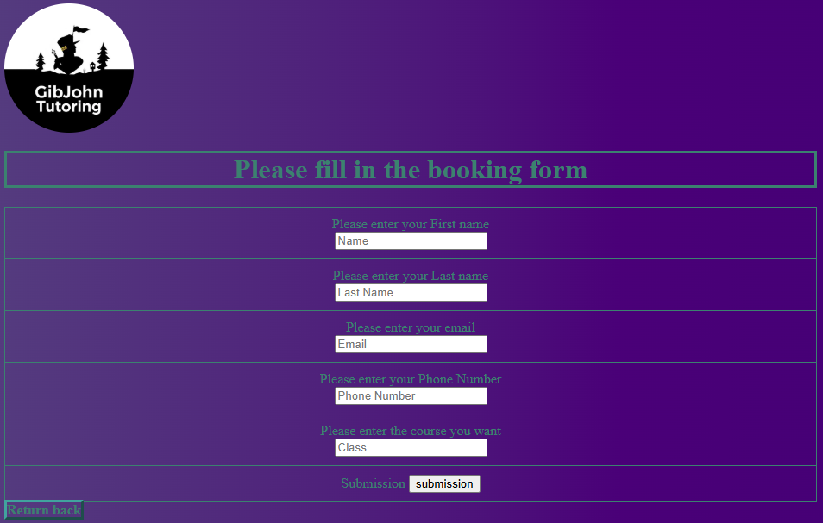
Now I add more stuff like another image on the top right corner and added content inside the boxes which will help out the user what to do as well as adding lines to separate the text from each other and make it clear from the background

