Penpot V1 – Initial Wireframes
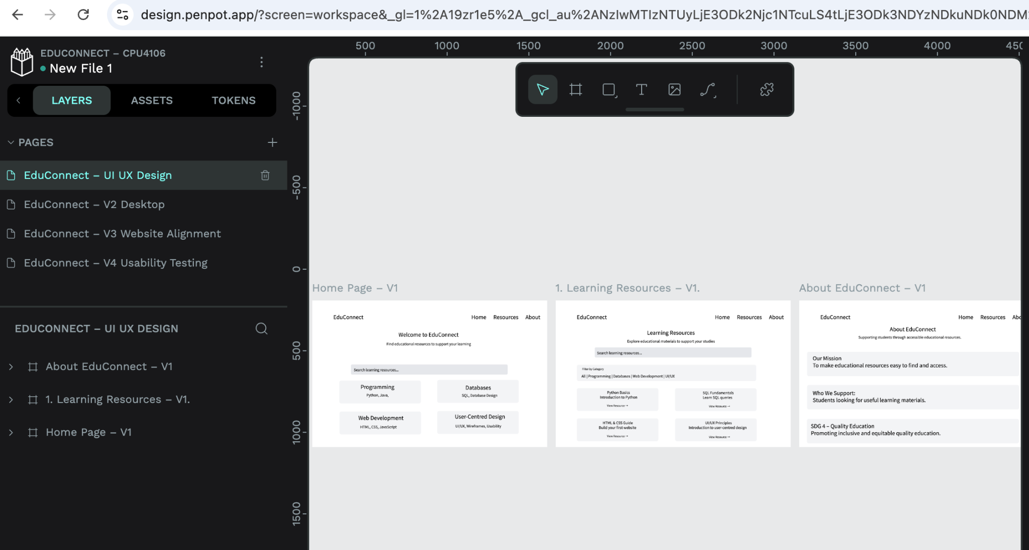

Penpot V2 – Visual Design
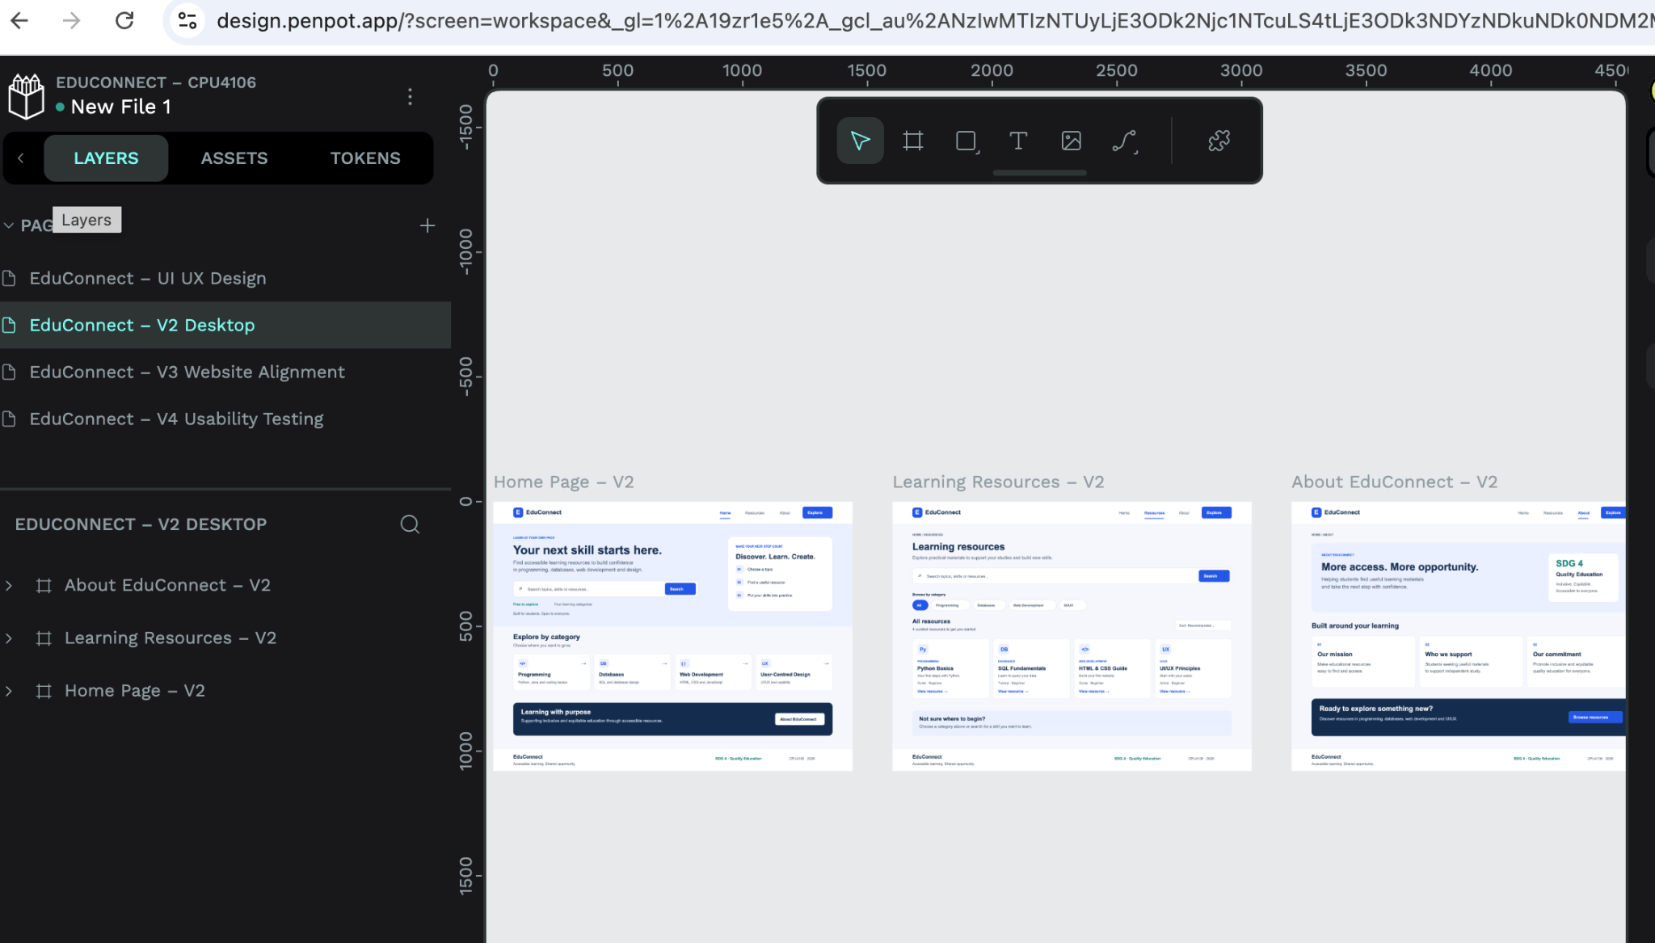

Penpot V3 – Website Alignment
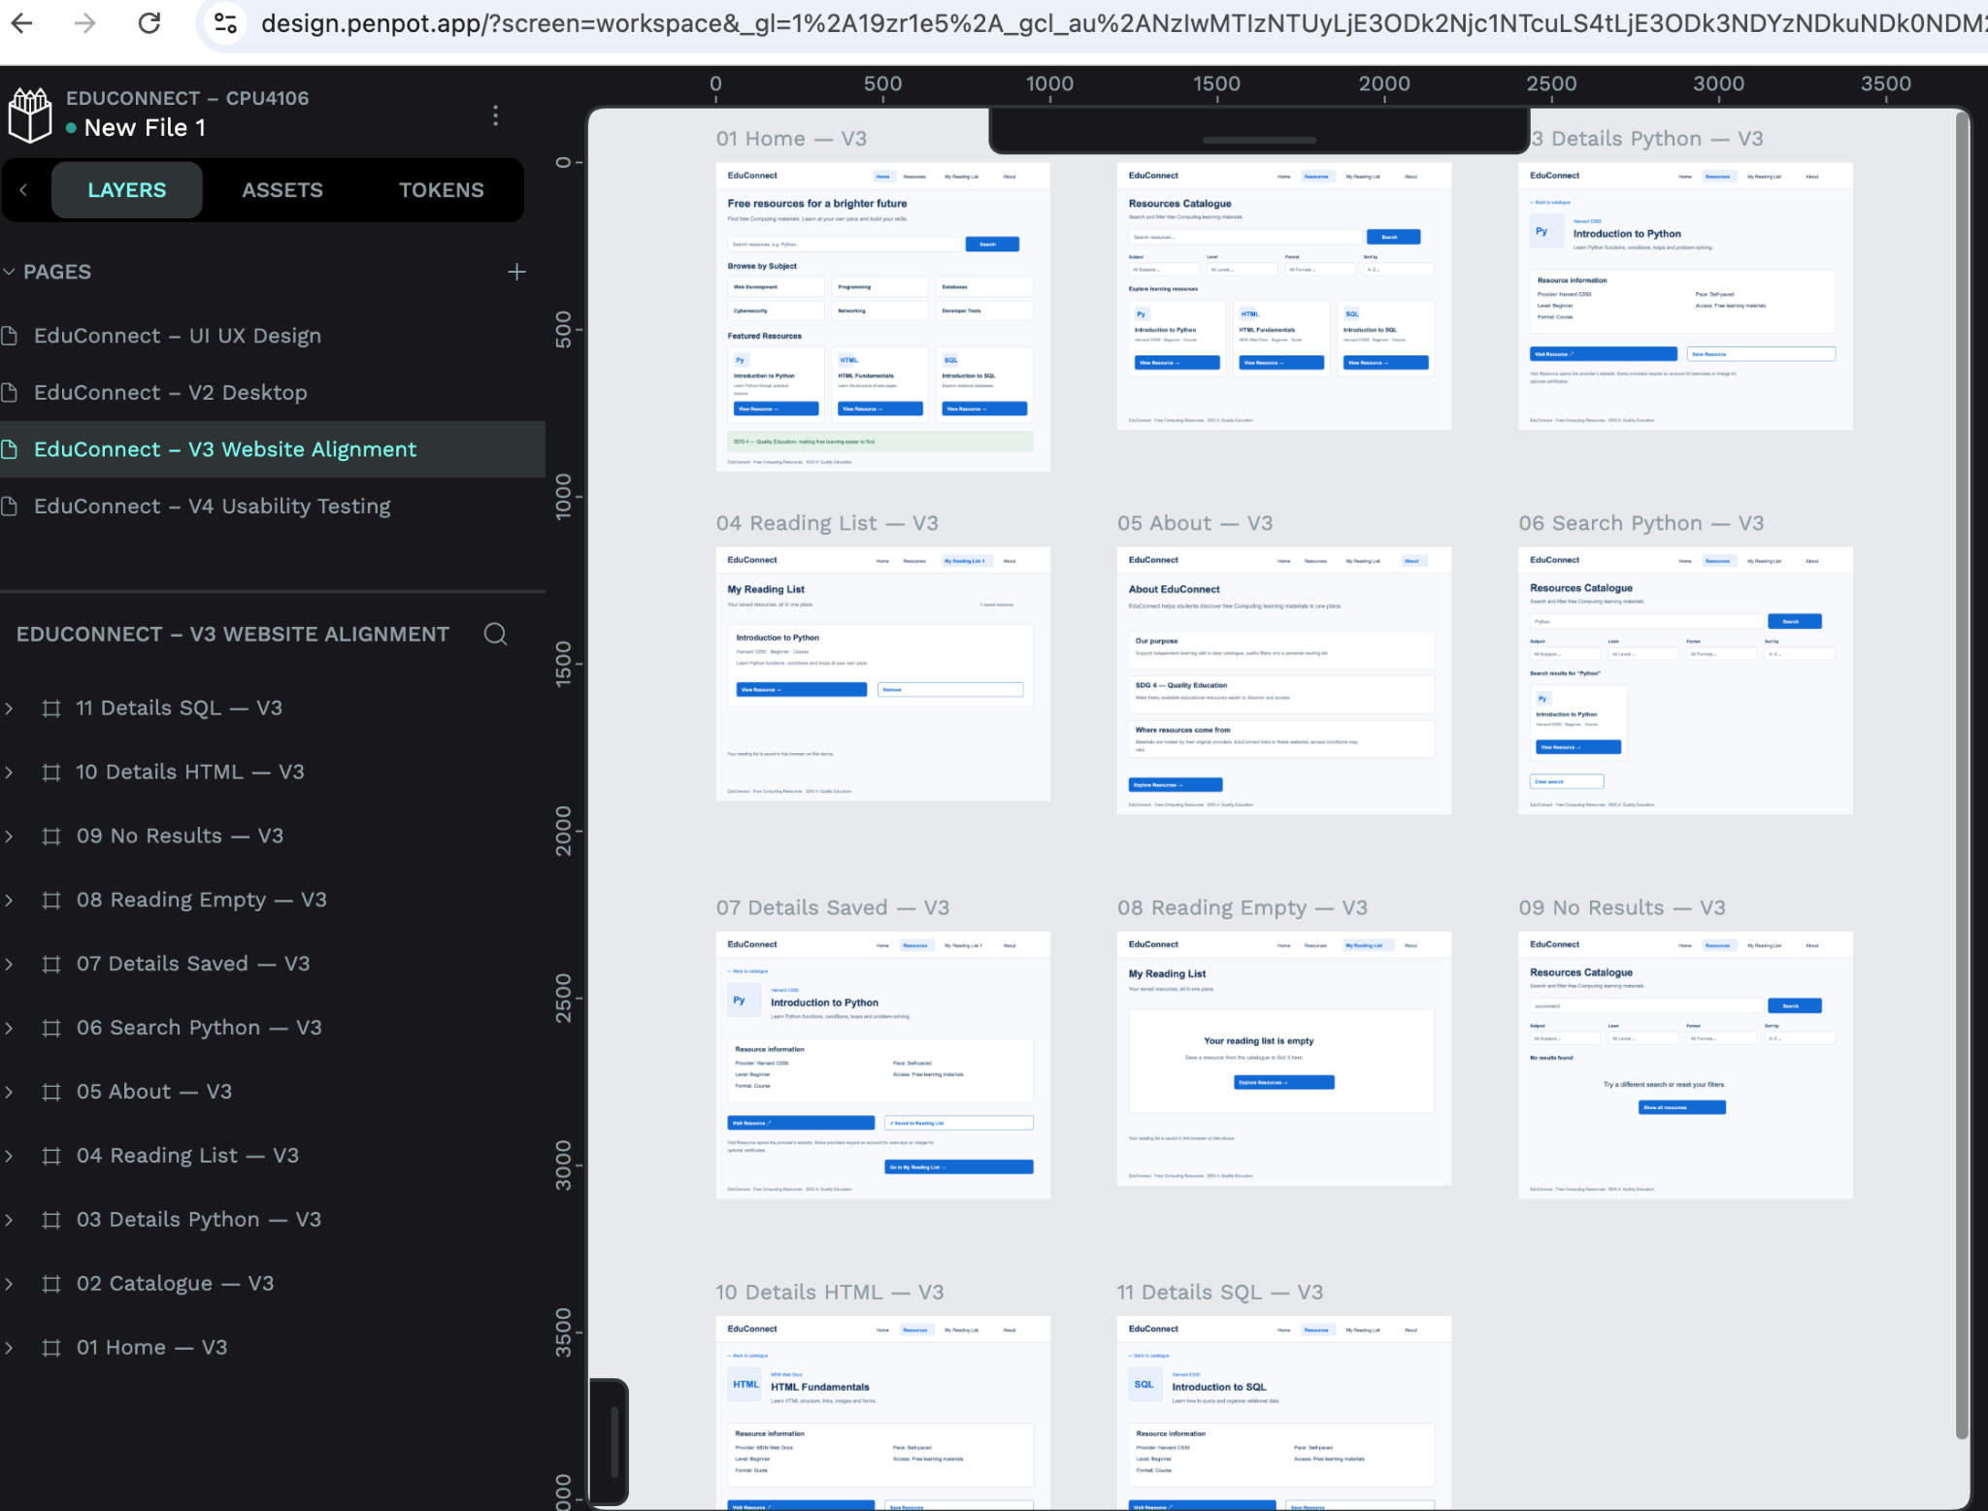

Penpot V4 – Usability Testing


