625 state Trials w/ complex terrain

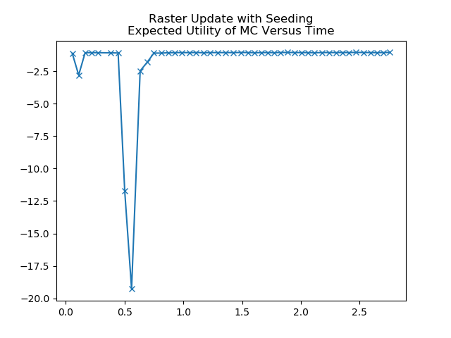
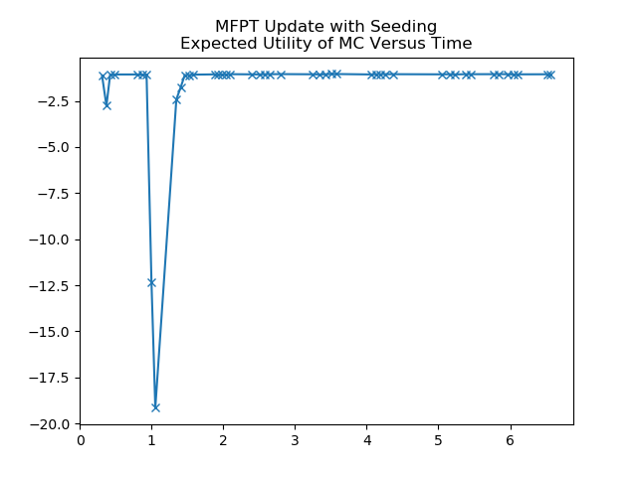
MFPT 2x as slow, but same performance curve. Going to try using mfpt values instead of VF

Timing of a MFPT refresh loop:
>>> mfpt init dt = -4.00543212890625e-05
>>> mfpt populate sparse mtrx dt = -0.007064104080200195
>>> mfpt mtrx inversion dt = -0.29118800163269043
test.py: deltaTime: 0.40451908111572266

Timing of a MFPT non-refresh loop.
test.py: deltaTime: 0.05239987373352051

Perhaps the timing funciton iteself is too expensive? Let’s try w/o timing fxns.

