ABOUT RONALDO

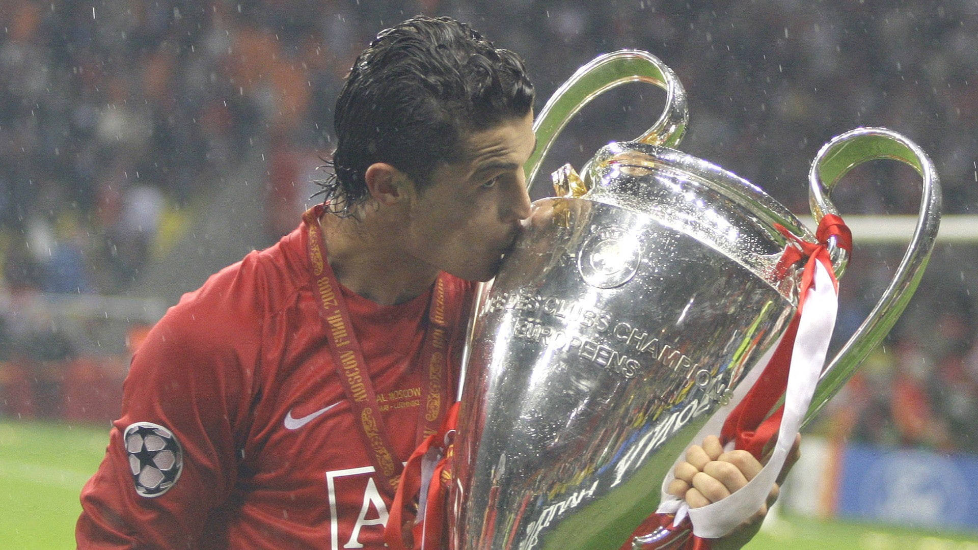

HI GUYS, I’M SHERPA LAMA AND I’M BIG FAN OF RONALDO THAT’S WHY TODAY I’M GOING TO TELL YOU ABOUT HIM.