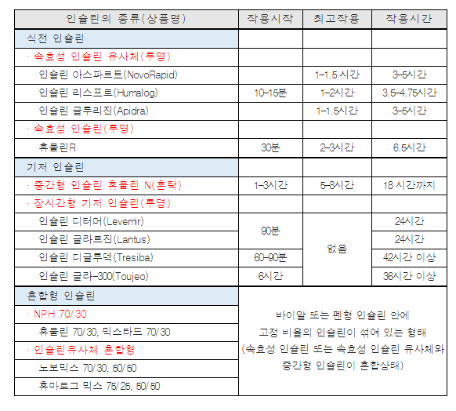
휴마로그에이치디퀵펜주100단위/mL Humalog HD Qucik Pen Inj. 100Unit/mL 670801211

