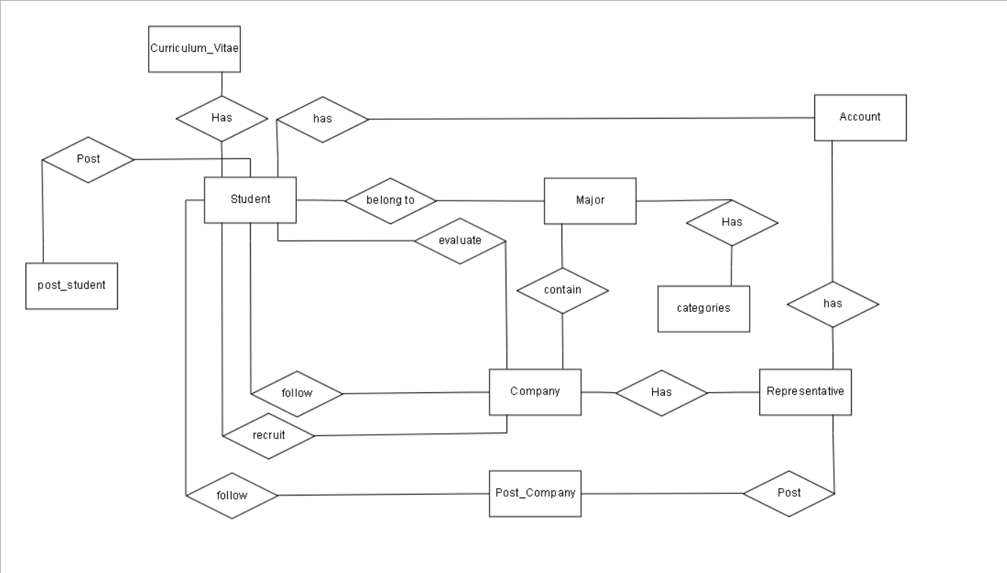

1

M

1

1

1

1

1

1

M

M

M

M

M

M

M

1

M

M

M

1

M

1

1

1

1

M