DOCUMENTATION

1. Before we begin

Thank you for choosing Aesthe as your theme for your Tebex store.

In this documentation, I will guide you through the process of installing Aesthe as well as some other details worth mentioning. I should also include that I am not planning to make this documentation to look beautiful so please don’t expect too much.

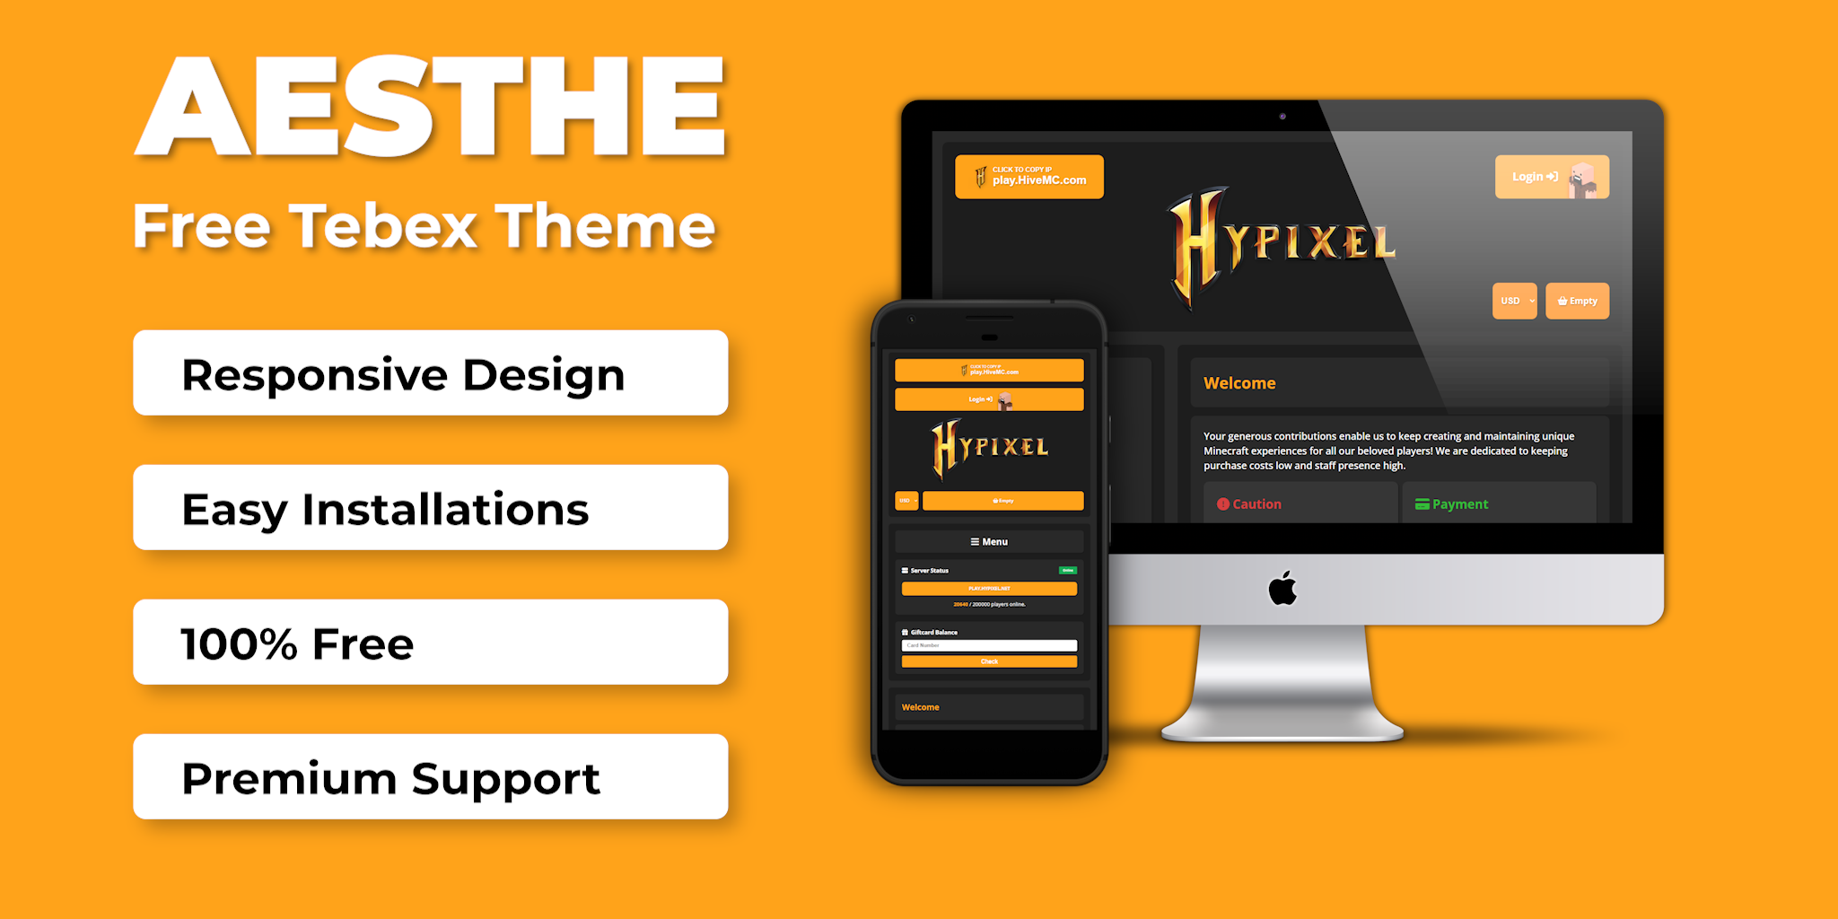

If you need any extra help, feel free to contact me on Discord, my Discord is **tjktak1002#8267**

2. How to install

- To install the theme, go to **Webstore>Appearance>Template>Change.**

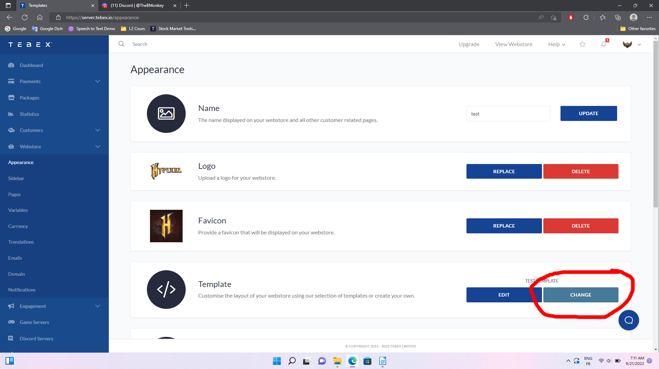

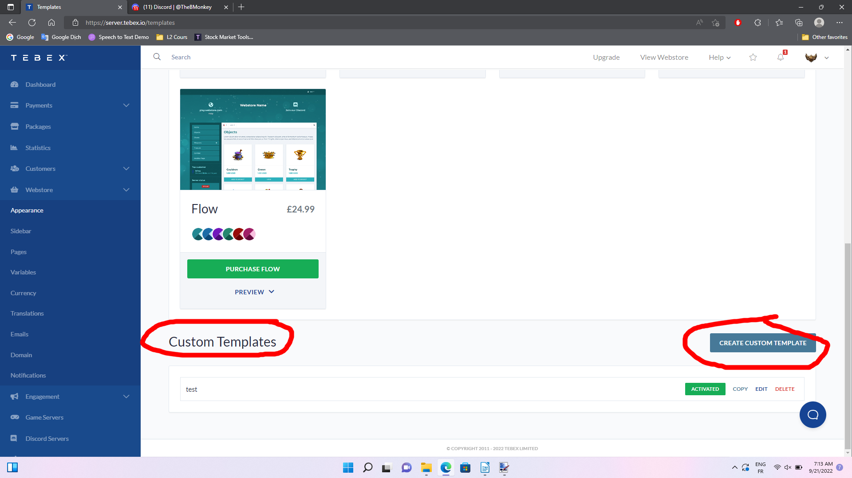- Go to **Custom Templates** and create a new one. Make sure to select **Abstract** theme and **not Flat** theme or else this template won’t work.

- Click on “Activate”.

- Then “Edit” to launch the theme editor.

- Replace all of the file in “Webstore” of the side bar section with its equivalence from the theme you downloaded. ( If you can’t find a file, it means than I don’t need to modify that file so I don’t include it in the theme ).

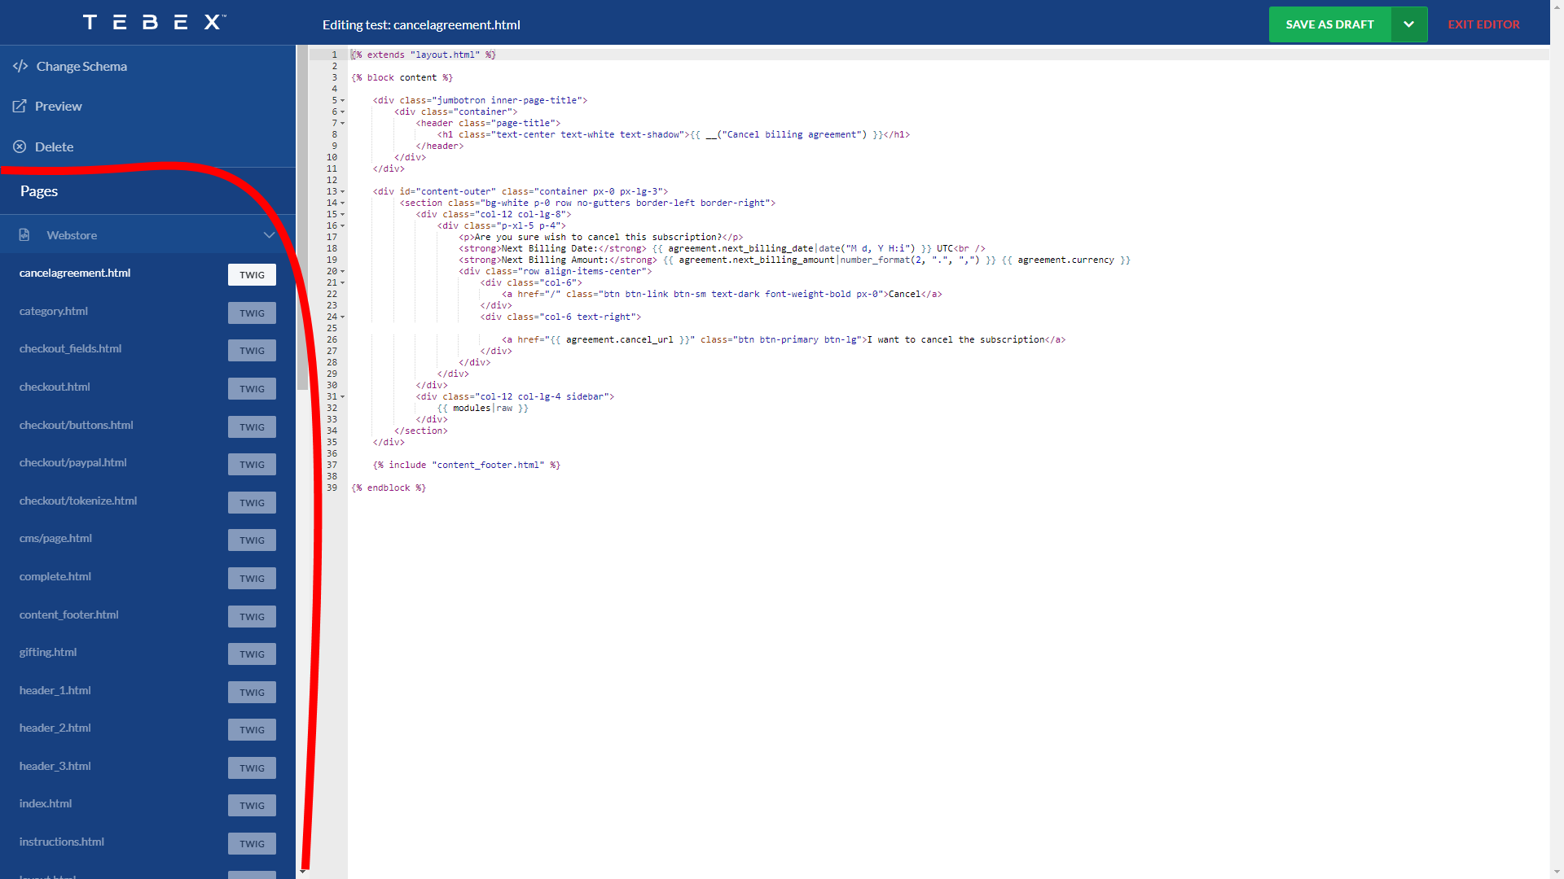

- Click on “Change Schema” and the go to the “schema” folder of the file you downloaded to change the page schema.

- “Save as draft” then “Publish” to apply all the updates.

- Now you should see an “Option” section after you have published your page.

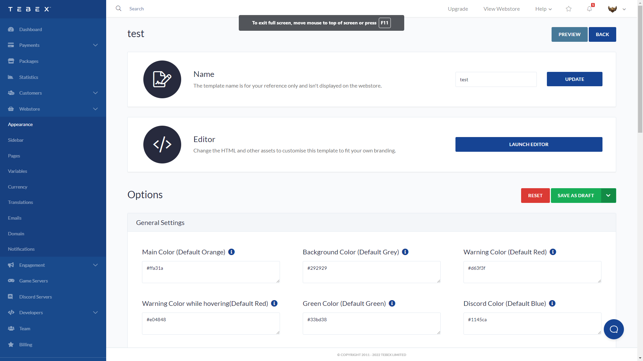

- Go to the next section for further reading.

3. Theme

Inside the folder “themes”, I have already included 4 color themes which you can use freely or make your own if you know some css. Pick one that you like.

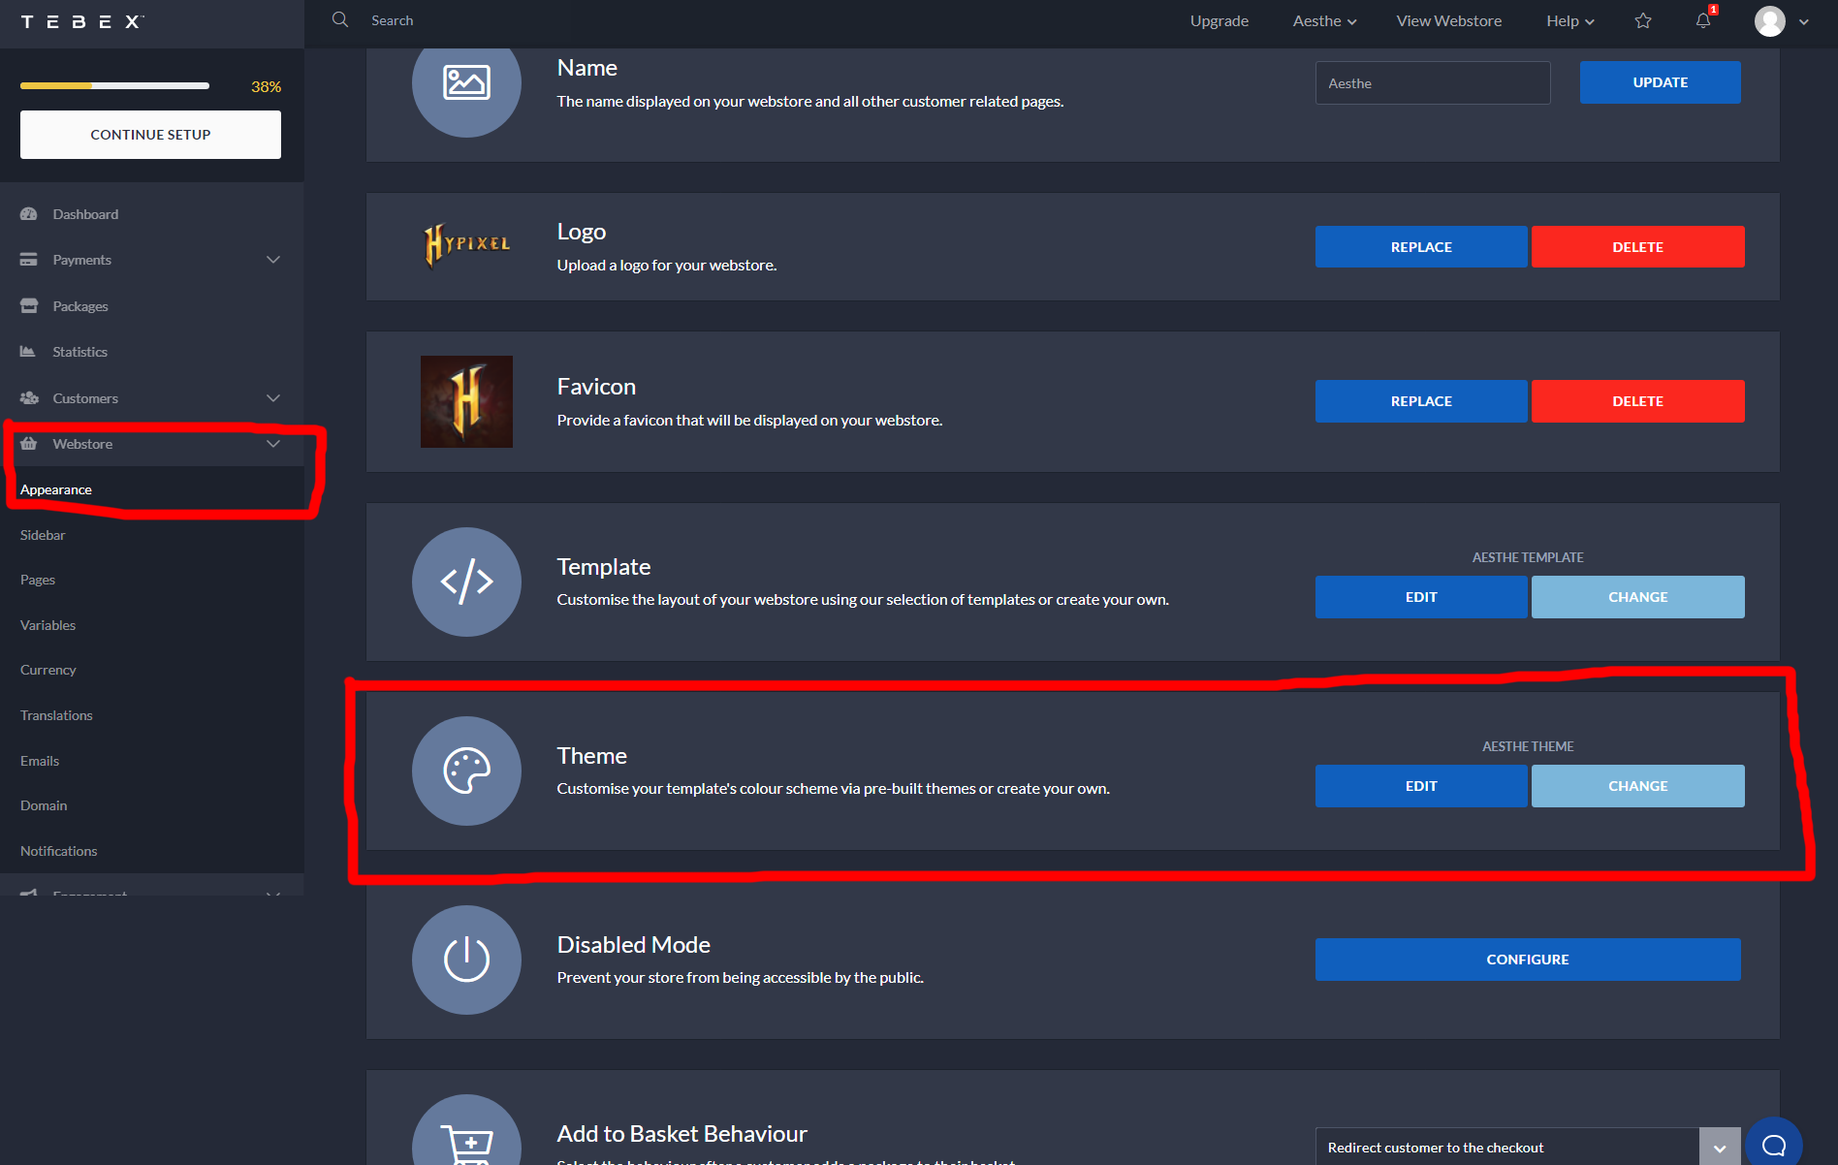Then go to **Webstore > Appearance > Theme > Choose a theme**, then “Create custom theme”. If you already have a theme, click on “change” instead.

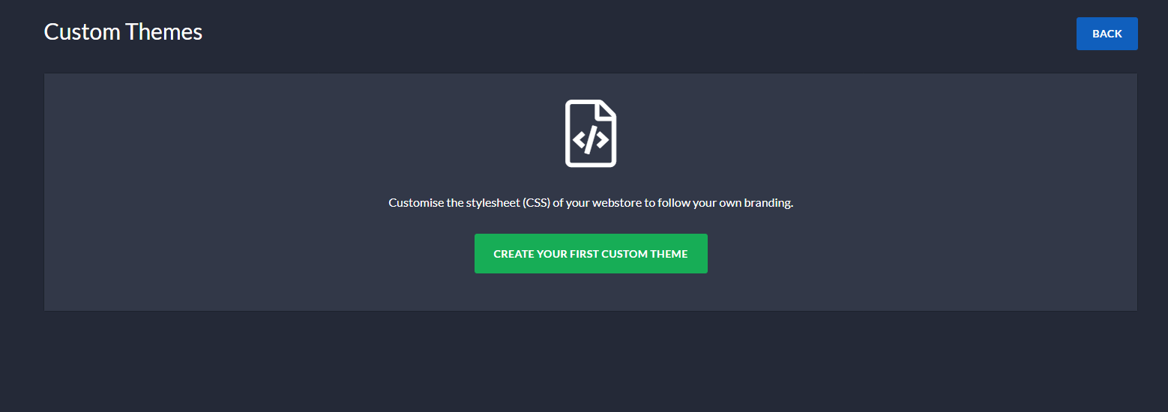 Then just copy and paste the theme you choose. Once done, hit update at the end of the page.

4. General settings

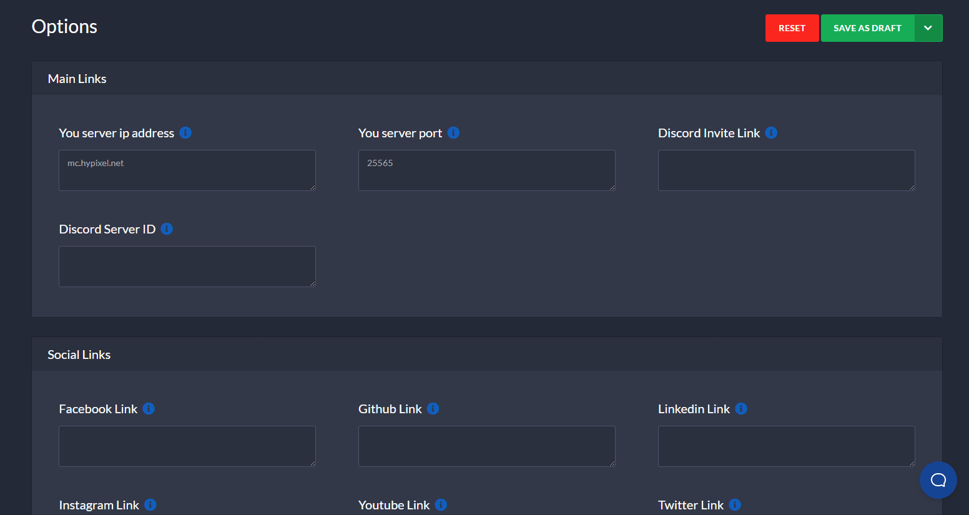

This section mostly concerns with the links for your server. If you don’t need something or don’t have something, just leave it blank.