DOCUMENTATION

1. Before we begin

Thank you for choosing Aesthe as your theme for your Tebex store.

In this documentation, I will guide you through the process of installing Aesthe as well as some other details worth mentioning. I should also include that I am not planning to make this documentation to look beautiful so please don’t expect too much.

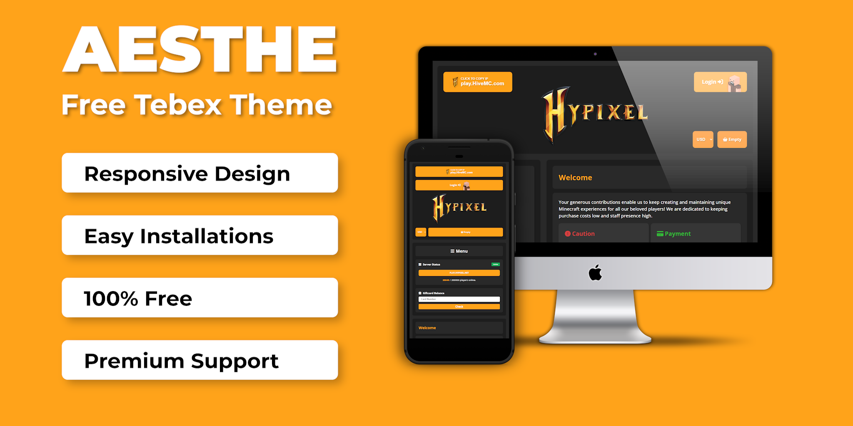

If you need any extra help, feel free to contact me on Discord, my Discord is **tjktak1002#8267**

2. How to install

- To install the theme, go to **Webstore>Appearance>Theme>Change.**

- Go to **Custom Templates** and create a new one (you can set it to whatever, it is not important).

- Click on “Activate”.

- Then “Edit” to launch the theme editor.

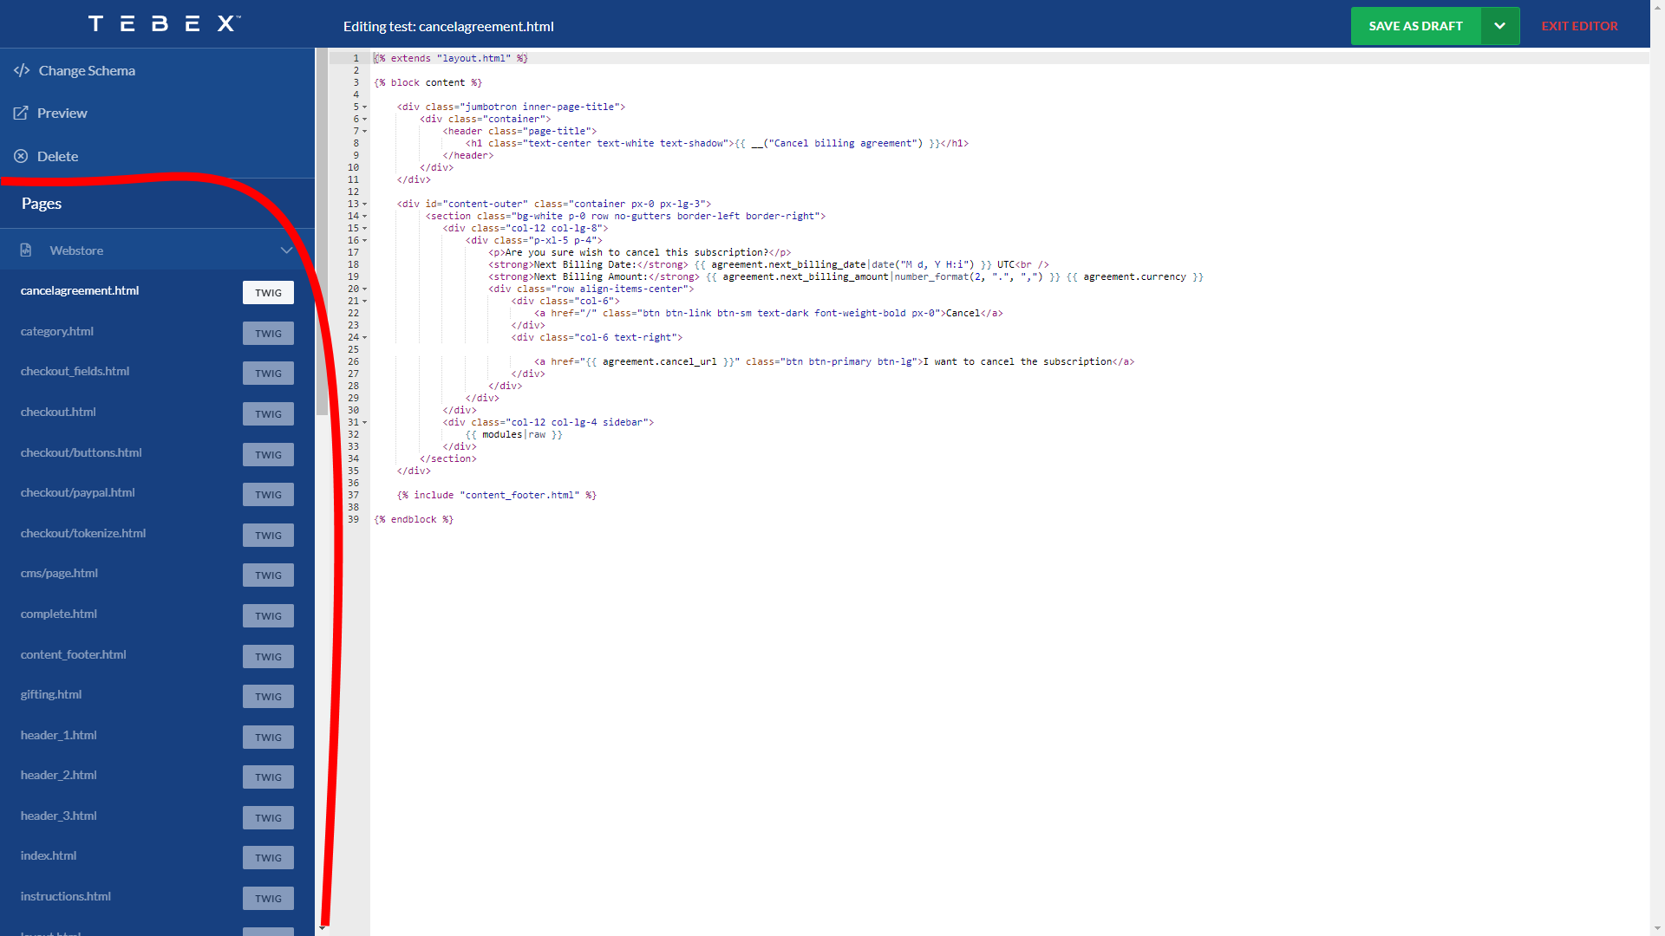

- Replace all of the file in “Webstore” of the side bar section with its equivalence from the theme you downloaded. ( If you can’t find a file, it means than I don’t need to modify that file so I don’t include it in the theme ).

- Click on “Change Schema” and the go to the “schema” folder of the file you downloaded to change the page schema.

- “Save as draft” then “Publish” to apply all the updates.

- Now you should see an “Option” section after you have published your page.

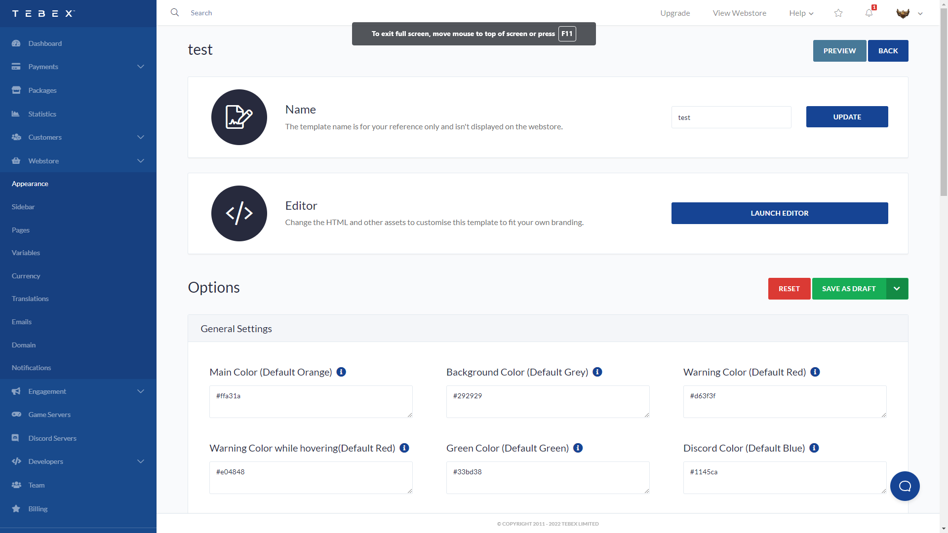

- Go to the next section for further reading.

3. General settings

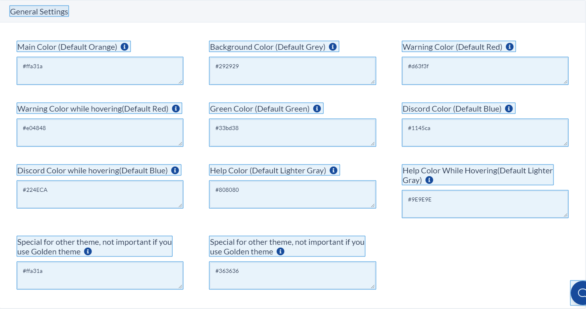

This section mostly concerns with the main color of the theme, you can find this option in **Webstore>Appearance>Template>Edit**. You can change it to however you want. I have also include 2 other themes in the “schema” folder if you want.

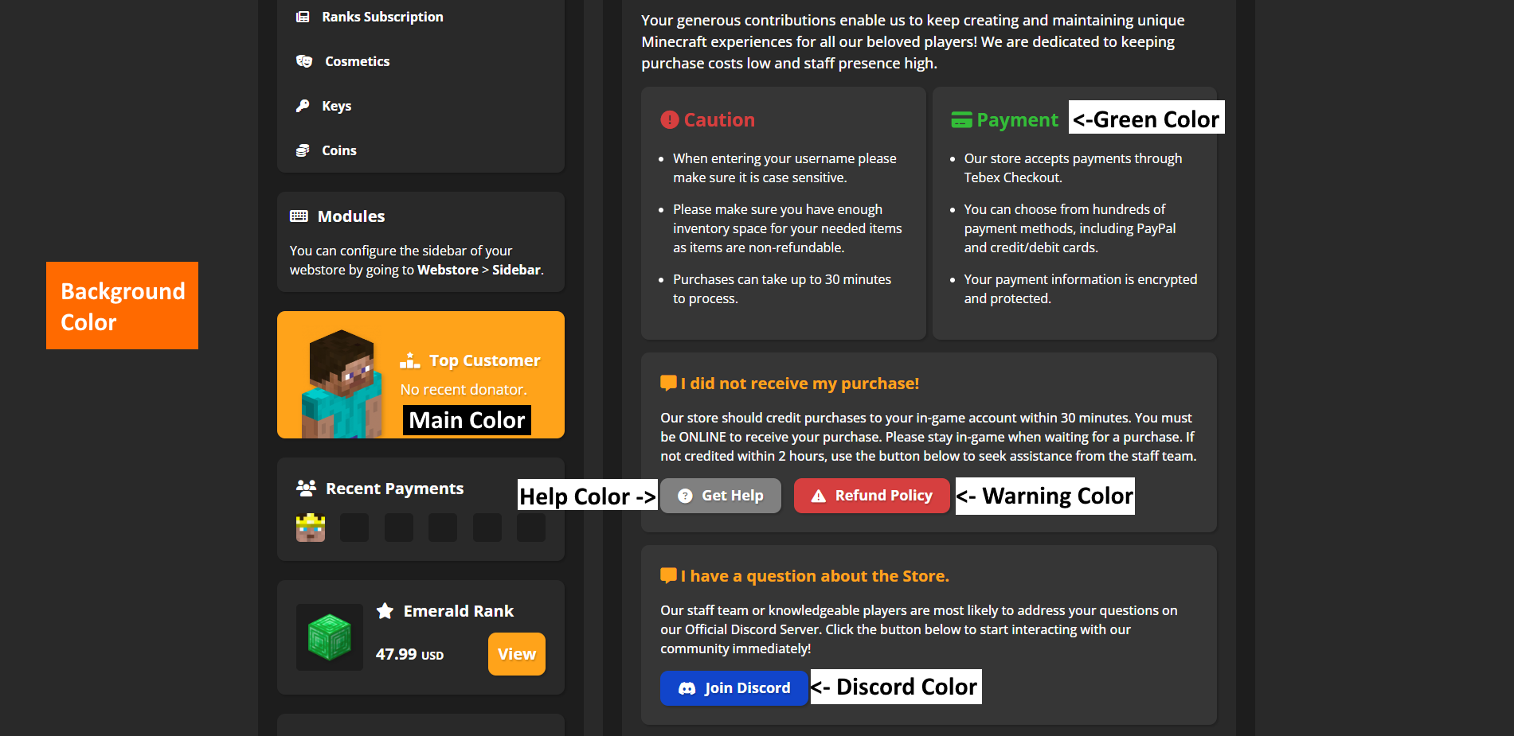

4. Background Layers Settings

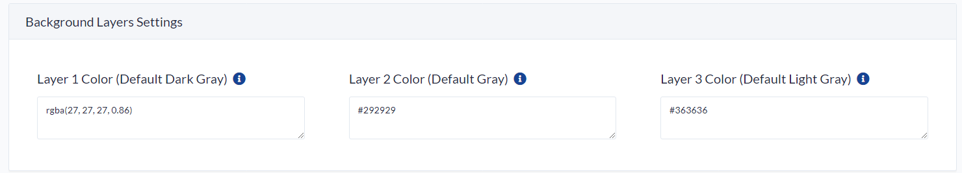

Mainly background color, gives the website a bit more depth

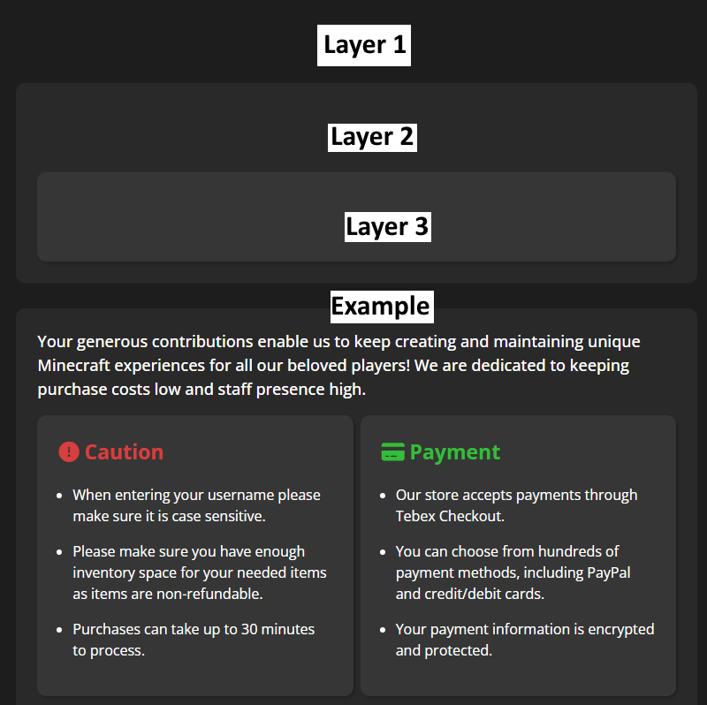

5. Footer settings

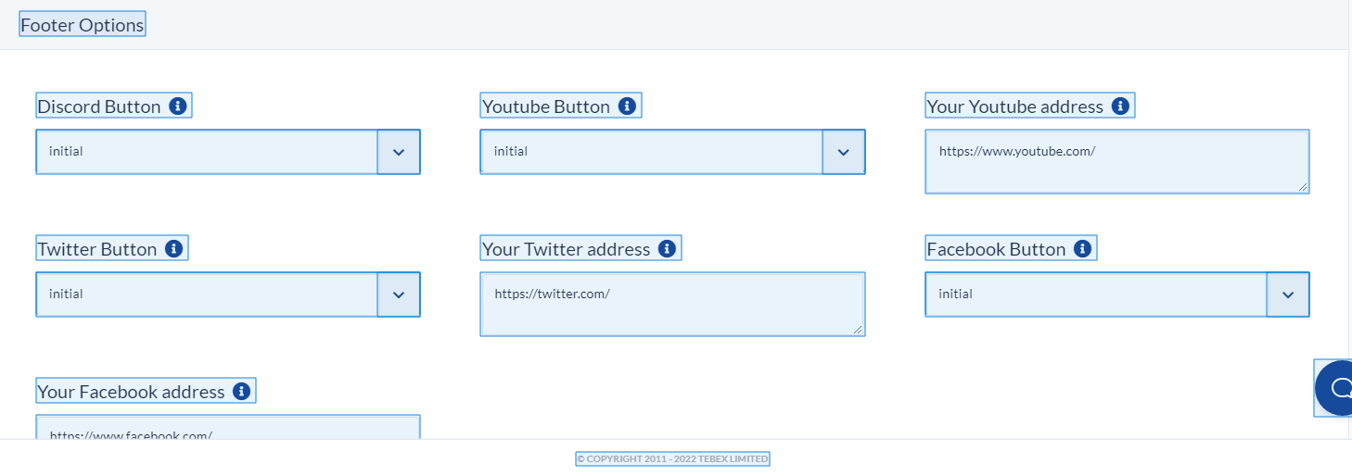

Each button has 2 mode: “initial” (enable), “none” (disable).