Motion Sickness In Virtual Reality



Liverpool Hope University

Luis Andrade 20207957

Supervised by: Dr Nicolas Garron

School of Mathematics, Computer Science and Engineering

Liverpool Hope University, UK

# Acknowledgements

I would like to voice my profound gratitude to my advisor, Dr Nicolas Garron, for his valuable guidance and support throughout my academic journey. I am also grateful for my university lecturers Dr Neil Buckley and Dr David Reed who without with this would not have been possible and I would like to thank them deeply for their shrewd advice as well as constructive criticism during the research and development. Additionally, I would like all my friends and family for their steadfast support and encouragement. Without all of the people talked about, this project would not have been possible so once again I would like to say thank you.

Contents

Acknowledgements 1

Contents 2

Introduction 3

Literature Review 4

Introduction 4

Problem 4

Why does it happen? 4

1.1 4

1.2 4

1.3 4

Symptoms 5

2.1 5

2.2 5

2.4 6

Surveys and Questionnaires 6

3.1 6

3.2 6

3.3 6

How can it be reduced? 7

4.1 7

4.2 7

Methodology 8

Results and Discussion 11

Conclusion 14

# Introduction

The virtual reality field has rapidly evolved in the last few years and is increasingly becoming a more important technology for uses such as gaming and education however, it does not end there, increasingly there is an increase in businesses using these for product design, global virtual meetings and more. Although this technology is becoming increasingly more mainstream it is not without its challenges. One significant challenge that has developed from this technology is motion sickness. Motion sickness is a discomfort that occurs when there is a discrepancy between the visual and vestibular (inner ear) sensory inputs which result in symptoms such as nausea, dizziness, fatigue, and sweating. Such symptoms can restrict the length of time as well as quality of using these VR headsets.

Recent years have shown the advances of virtual reality as a technology, but there has also been an increasing interest in the investigation for solutions that alleviates symptoms in VR related motion sickness. Numerous studies have been conducted which focus on various VR factors such as field of view (FOV), frame rate, latency, and the simulator sickness questionnaires (SSQ). Nonetheless, most of these studies have depended on subjective measures such as self-report questionnaires which is why in this experiment, the survey was administered by the researcher while participants were immersed in VR. This market is so important especially since the market has grown to around $26.89 billion by 2022 (Chattha et al., 2020)

This will directly improve people’s lives due to there currently being millions of people with VR headsets and although some people are heavy users of this technology in their daily life, many people who have one for reasons such as gaming, occasional office use, and even new users get put off as they’re getting affected by motion sickness rapidly especially if it’s a fast-paced moving game. Due to trying to find a way to reduce occurrence of motion sickness this could potentially help people that are interested in VR due to many reasons such as entertainment, gaming, medical professionals, and military personnel, and although, this research might not be in the frontline of innovation this could pave the way for further innovation in this industry. This also indirectly improves people’s lives by contributing to the research of this major VR issue which hopefully could be useful for any researchers and hopefully there are benefits which the academic and practical communities.

This dissertation is delving into what causes motion sickness in VR. The main goal for this research is to find causes of cybersickness so that solutions can be created and prevention of using techniques that cause cybersickness. The hypothesis is that jerky movement, certain colours and having too many models can contribute to motion sickness.

The chapters of this dissertation are the following:

* Literature review – Going through relevant research that has been conducted
* Methodology – This chapter goes through, what was done, how it was done and why
* Results – Exploring the results and viewing the results which the research produced
* Conclusion – Analysing the results and concluding research.

# Literature Review

## Introduction

The literature review for this research on Motion Sickness in Virtual Reality focuses on understanding why it occurs, what causes it, and how it can be reduced or prevented. Several experiments from different authors are analysed to understand the common conclusions reached in the field.

## Problem

Virtual reality induced motion sickness, also known as VR sickness or cybersickness, is a widespread problem experienced by some users of virtual reality technology. This phenomenon occurs when there is a mismatch between the visual information being displayed in the virtual environment and the user's vestibular system, which is responsible for our sense of balance and movement.

There are several factors that can contribute to this such as latency, frame rate, visual complexity, lack of control and poor field of view. To mitigate VR sickness, designers and developers of VR systems need to take into consideration these factors and design virtual environments that are optimized for comfort and reduce the risk of inducing VR sickness in users.

## Why does it happen?

### 1.1

Chattha, U.A., Janjua, U.I., Anwar, F., Madni, T.M., Cheema, M.F. and Janjua, S.I. (2020). Motion Sickness in Virtual Reality: An Empirical Evaluation. IEEE Access, [online] 8, pp.130486–130499. doi:https://doi.org/10.1109/access.2020.3007076.

This source is relevant to the topic as it is an evaluation to the benefits and limitations of VR such as the fields that already use it as fields that need it to become more innovative. This paper shows statistics of VR growth as well as the consequences. The main argument of the paper is about an experiment of forty-six participants and how they are affected, what gender is more susceptible to the consequences and the general findings of this experiment. The conclusion explains that this was a first attempt of these authors’ experiment, and their research was restricted to pleasant and horror genres of games. In the future they would explore dynamic 3D objects and different lighting.

### 1.2

Munafo, J., Diedrick, M. and Stoffregen, T.A. (2016). The virtual reality head-mounted display Oculus Rift induces motion sickness and is sexist in its effects. Experimental Brain Research, [online] 235(3), pp.889–901. doi:https://doi.org/10.1007/s00221-016-4846-7.

This paper is relevant due to an experiment using an oculus rift headset where participants tried a game. This paper also goes into the differences in sex and how the sex of the user is significant for motion sickness. The main argument of this paper is that sex can be a factor for motion sickness when evaluated in the experiment. When the participants were playing a game for 15 minutes the authors noticed body swaying. In conclusion the results of the experiment were that people using virtual reality headsets are at a significant risk of getting motion sickness and these effects may affect females more.

### 1.3

Kim, H., Kim, D.J., Chung, W.H., Park, K.-A., Kim, J.D.K., Kim, D., Kim, K. and Jeon, H.J. (2021). Clinical predictors of cybersickness in virtual reality (VR) among highly stressed people. Scientific Reports, [online] 11(1), p.12139. doi:https://doi.org/10.1038/s41598-021-91573-w.

This article is relevant as it discusses the clinical conjecturers and variations that the effect of cybersickness, which is a type of motion sickness that can occur during virtual reality exposure, in highly stressed people. The article aims to understand the factors that contribute to cybersickness and the effects of different VR experiences on motion sickness. The main focus of the study is to investigate the effect of motion sickness in VR, in people with high stress levels. The study recruited eighty-three healthy adult participants with high stress levels and conducted various evaluations such as psychiatric, ophthalmologic (the study of eyes and their diseases), and otologic (the study of the ear as well as their diseases) evaluations, and biological parameters. The study divided the participants into two groups and administered the Simulator Sickness Questionnaire (SSQ) and the Fast Motion sickness Scale (FMS) to investigate the effect of changes in the intensity of shaking in VR on cybersickness. The conclusion of this study is that changing the intensity of shaking in VR did not have an effect on cybersickness, but other factors such as age, smoking, and affect were found to be predictors of cybersickness during VR application in highly stressed people. The 40-59 years age group showed a greater increase in motion sickness compared to the 19-39 years age group also smoking was negatively associated with cybersickness.

## Symptoms

### 2.1

Chang, E., Kim, H.T. and Yoo, B. (2020). Virtual Reality Sickness: A Review of Causes and Measurements. International Journal of Human–Computer Interaction, 36(17), pp.1658–1682. doi:https://doi.org/10.1080/10447318.2020.1778351.

This article is relevant due to the article delving into what symptoms VR can cause and surveyed participants to try proving their hypothesis and to give future researchers a better understanding. The main focus of the article is breaking down the causes due to hardware, content, and human factors. To which the authors investigated them and created an experiment. In conclusion the authors found that there is not a single thing that causes discomfort but there are multiple factors to motion sickness from the device to the person using the device. It was found that having motion sickness effects differ depending on number of models in a scene, and that this is a feasible way to reduce effects.

### 2.2

Ohyama, S., Nishiike, S., Watanabe, H., Matsuoka, K., Akizuki, H., Takeda, N. and Harada, T. (2007). Autonomic responses during motion sickness induced by virtual reality. Auris Nasus Larynx, 34(3), pp.303–306. doi:https://doi.org/10.1016/j.anl.2007.01.002.

This article explains how ten healthy adults, nine male, one female which were all healthy and relatively young with a mean age on 29.7 years old were put into a VR game therefore this article is relevant to the symptoms that healthy individuals expressed. The main focus of this article is to observe symptoms progress as well as heart rate variability during virtual reality induced sickness. It also points out how motion sickness gradually worsened as they went on. The conclusion expressed that during the heart rate variability observation that it caused the activation of the sympathetic nervous system to the participants, or in other words the fight or flight response.

2.3

Fulvio, J.M., Ji, M. and Rokers, B. (2021). Variations in visual sensitivity predict motion sickness in virtual reality. Entertainment Computing, 38, p.100423. doi:https://doi.org/10.1016/j.entcom.2021.100423.

This article is relevant as it is an experiment about detecting symptoms and predicting when motion sickness will occur. The article also talks about sex and the differences that being male/female present. The main focus of the article is finding what causes motion sickness and to be able to find what makes VR users motion sick. They are following the cue conflict theory which occurs when a person’s senses send mixed signal which created confusion and leads to physical discomfort, an example of this is when moving in VR, the person is not moving in the real world so there is an inconsistency between the brain and vestibular system. In summary, some people are more sensitive to VR-induced motion sickness than others, but there are ways to make VR experiences more comfortable, such as using different modes with lessened head movement, gradually increasing the intensity of VR exposure, or making visual cues less dependable. These strategies can help reduce the discomfort caused by VR. There is also little evidence for sex based differenced as the authors claim poor personalisation of the VR displays.

### 2.4

Zhang, C. (2020). Investigation on Motion Sickness in Virtual Reality Environment from the Perspective of User Experience. [online] IEEE Xplore. doi:https://doi.org/10.1109/ICISCAE51034.2020.9236907.

This article is relevant due to investigation the side effects of VR games, as well as having frames per second (FPS), refresh rates and scene scenarios as variables. The main focus of this study is to investigate the side effects of virtual reality game experiences and their impact on the user experience. The study examines the impact of different FPS, refresh rates, and scene scenarios on the likelihood of players experiencing discomfort, headaches, upset stomach, nausea, sweating, tiredness, and disorientation. The results show that low FPS, low refresh rates, and realistic images increase the likelihood of discomfort, as well as playing fighting and shooting games. The study aims to provide insights into ways to improve VR devices from a user experience perspective.

## Surveys and Questionnaires

### 3.1

Kim, H.K., Park, J., Choi, Y. and Choe, M. (2018). Virtual reality sickness questionnaire (VRSQ): Motion sickness measurement index in a virtual reality environment. Applied Ergonomics, 69, pp.66–73. doi:https://doi.org/10.1016/j.apergo.2017.12.016.

This article is an experiment involving twenty-four participants, it is relevant as the authors have made a survey which they expect to measure motion sickness in VR. This was in 2017 when the VR market was still new, so this is an effective way to see if any changes have been made. The main purpose of this article is to measure motion sickness after each task the participants would fill out a survey which would indicate how they felt after each task. Due to this being in 2017 they were still discovering the side effects and what made them. In conclusion this article is about developing a virtual reality sickness questionnaire (VRSQ) which they modified the existing one to create a better one.

### 3.2

Chattha, U.A. and Shah, M.A. (2018). Survey on Causes of Motion Sickness in Virtual Reality. [online] IEEE Xplore. doi:https://doi.org/10.23919/IConAC.2018.8749071.

This article is relevant as the authors had participants playing ‘Escape’ on an oculus rift DK2 and had them complete a survey. Due to similarities, it is relevant although there are changes to the ‘game’ and the device. The article aims to determine how fatigue, nausea, and other side effects that VR displays on their participants and has them answer how they feel. By the end of the test many participants did not complete the simulation and suffered from motion sickness to the point that they could not continue.

### 3.3

Liao, C.-Y., Tai, S.-K., Chen, R.-C. and Hendry, H. (2020). Using EEG and Deep Learning to Predict Motion Sickness Under Wearing a Virtual Reality Device. IEEE Access, 8, pp.126784–126796. doi:https://doi.org/10.1109/access.2020.3008165.

This article is relevant due to it focusing on addressing the problem of motion sickness in VR. The study implements a deep learning model to train and predict motion sickness by using EEG (electroencephalogram, or a test to measure electrical brain activity) pattern, which is unlike the traditional method of measuring motion sickness through questionnaires, this method claims it can achieve 82.83% accuracy. The main focus of the paper is on the use of deep learning and EEG to predict motion sickness in VR experiences. The paper explains how the traditional method of using questionnaires to measure motion sickness is flawed because it only measures the symptoms after they occur. The paper proposes a deep learning model to predict motion sickness by learning the EEG pattern of the user when they begin to feel the symptoms. The model is trained using deep learning to detect patterns of sickness in the future. The results show that the model outperforms conventional models in accuracy and other system of measurements in predicting motion sickness during VR immersion. The study also found that a 5-minute period is a suitable configuration for predicting motion sickness.

## How can it be reduced?

### 4.1

Ranasinghe, N., Jain, P., Tolley, D., Karwita Tailan, S., Yen, C.C. and Do, E.Y.-L. (2020). Exploring the Use of Olfactory Stimuli Towards Reducing Visually Induced Motion Sickness in Virtual Reality. Symposium on Spatial User Interaction. doi:https://doi.org/10.1145/3385959.3418451.

This article is relevant due to it being an experiment to reduce motion sickness in virtual reality. In the article the experiment is based on adding smell to the vision and sound that VR already creates. The main focus of this article is to explore the use of coordinated olfactory stimuli in reducing symptoms associated with motion sickness in VR experiences. The study used a first person-view rollercoaster simulation in a VR headset to evaluate the effect of diverse olfactory stimuli on VIMS symptoms. The conclusion of the study is that the use of a peppermint aroma resulted in notable reductions in overall scores on both the simulator sickness questionnaire (SSQ) and the fast motion sickness scale (FMS), suggesting that providing a peppermint aroma can reduce the harshness of motion sickness symptoms experienced in VR. The study also highlights the need for added research and feedback on the use of controlled olfactory stimuli to minimize the occurrence of motion sickness symptoms in VR.

### 4.2

Cao, Z., Jerald, J. and Kopper, R. (2018). Visually-Induced Motion Sickness Reduction via Static and Dynamic Rest Frames. [online] IEEE Xplore. doi:https://doi.org/10.1109/VR.2018.8446210.

This article is relevant as it discusses the use of rest frames as a way to reduce motion sickness and presents the results of two studies that investigate the influence of static and dynamic rest frames on user comfort. The main focus of the article is to explore and evaluate the use of rest frames as a technique to reduce motion sickness in VR. The authors conduct two studies to investigate the influence of static rest frames with fixed opacity and dynamic rest frames (with changing opacity) on user comfort during VR immersion. The results of the studies show that the use of rest frames, both static and dynamic, can help users to use VR headset for longer period throughout the virtual environment before stopping due to discomfort compared to a virtual environment without a rest frame. The results also show that a virtual environment with a static rest frame results in more real-time reported comfort than a virtual environment without a rest frame.

# Methodology

To address the research questions, an application was created for testing what parameters can affect participants with cybersickness such as colours, sex , age, and movement. Age is a factor that is being test for since research indicated that sex can be a factor (Munafo, Diedrick and Stoffregen, 2016). After this application was completed, it needed to be assessed and calibrated to get the reliable results. Then it was time for user testing, where the participants put on the VR headsets and experience the application. The testing was done in a secluded and quiet room, away from distractions this is to ensure there are no unknown variables. Before the participants placed the headset on their head, they were asked some simple questions to which the participants would proceed to place the headset on and go through the simulation. While in the simulation the researcher would ask questions in order to gain the data for the research

The study was approved by the Liverpool Hope Research Ethics and adhered to the Research ethics policy for conducting research with human subjects Ethical considerations for this study were addressed by using participant ID’s in the questionnaire instead of having participants input their names, age is kept as an age range, data is kept online using Microsoft Forms which cannot be viewed without the researchers password and having participants in an empty room with no distractions as well as obtaining informed consent forms from participants and protecting their privacy and confidentiality.

To collect data for this study, the following tools were used: Meta Oculus Quest 2, Unity game engine, Microsoft Excel, and Microsoft Forms. Microsoft forms was used during data collection for the researcher to ask questions and for the participants to answer those said questions. This was a great tool as it allowed for quick and easy answering of questions as there are plenty of useful features such as branching, which allows different answers to lead to different questions. Most questions had the answers set to ‘next’ except for the “Phase ‘1-5’: Did it make you feel sick?” portion where if ‘yes’ was selected it would skip to the next relevant question. Another feature that makes Microsoft form a great tool is that it allows for easy extraction to excel where the data can be analysed. All of the equipment used in this study was calibrated and tested prior to data collection to ensure accuracy and precision, this included calibrating the oculus quest 2 to ensure when the participants put on the headset the application was loaded in, screen brightness on default brightness, and facing the correct orientation. Microsoft forms was also tested multiple times as well as changes were made before testing with participants. Data analysis for this study required the use of analysis tools and Microsoft Excel was used for this portion, all data from Microsoft Forms was exported onto Microsoft excel to create results. For the creation of the application that was used for the testing of the participants unity was used. This was a great platform to develop a 3D application as well as being one of the leading game engines for this purpose.

The participants in this study were selected randomly, while there are no inclusion criteria, participants from each sex should be as close as possible to even as well as gaining access to all age groups which are 18-24, 25-34, 35-45, and 55+. Ideally there would be 20-100 participants with 50% being male and 50% female as well as 25% for each age group. This will ensure enough data collection to conclude a verdict of how motion sickness can occur within users and how different points of simulation would affect these different demographics of users. "The independent variable in this study is the participants as everyone will react differently to the stimuli, while as the dependent variable is the application that has been created to measure the point that a participant becomes motion sick, and that was measured using a custom-made questionnaire. To ensure the validity and reliability of the data collected it was important to have the researcher ask questions during the participants time with the VR headset on, this makes sure all data is accurate and done in real time.

The questionnaire was created by the researcher and has thirteen questions, such as participant number, age, sex, and used VR. These questions were asked before the headset was placed on the participants. Participant numbers are important due to the participant having the right to withdraw their data, which they are entitled to, complying with data protection act 2018(DPA). Age and sex are basic questions needed to determine if there is a difference between male and female participants, and the fourth question is ‘has the participant has ever used VR before,’ this can be crucial information as recent users are more susceptible to getting motion sickness faster than an experienced user. The next five questions were “Phase ‘1-5’: Did it make you feel sick?” Each time a participant would get past each phase the researcher would ask a question to assess whether or not the participant was feeling well or not, as soon as the yes option to the question was pressed it would ask “What colour did you feel sick on” with the choices of red, blue, and green. This was significant as each phase has three rooms which are identical, apart from the wall and ceiling which are coloured to test whether or not being in an environment in those basic primary colours would affect the participants. The user would then remove the headset and be asked the final questions the first was asking about what they thought caused their motion sickness, there were pre-set options that the participants could choose from and a ‘other’ field if that had a different input. The final two questions were text fields, one for user feedback so anything they had to add and wanted on the record and the final question was for the researcher to put any notes on the participant such as anything participants said or did during the experiment.

The stages of the project were the following, planning, creating, debugging, testing, and analysis. For the planning, rough digital designs were created, a rollercoaster within rooms which would have different scenarios, but each scenario was repeated three times, each one in one of the primary colours. This was to address whether having any of these colours would contribute at all to participants motion sickness. The designs were not final, so some parts changed partly due of cost, ability, and time. While creating the application took months to develop, it was created as a quite simple and basic rollercoaster can would go in a straight line. This was clearly not enough so then peaks were created where the cart would go up the track and then back down, but this did not feel natural or correct. This was when code was added to make it so that if the cart were leaning back or fourth it would adjust speed accordingly. Another factor was jittery motion, most research already conducted has been by playing the game and measured in how long a participant could play it for or reach a certain achievement. Other researchers used games that have been created by major companies so there’s motion blur, there’s smooth graphics but for the research this was not what was wanted, jittery motion is a part of VR so needed to be tested. Originally, the motion was a bit too jittery so the code was change to ‘moveTowards’ so that instead of rotation to the new position it would move fluidly, and this actually helped the cart look more realistic and immersive. There were several bugs in the application such as parts not working, cart going underneath the track, unity game engine would crash, Oculus quest 2 could not handle the quantity of models so it would make a tiny screen appear in the headset and move with a lot of lag. Overall, these bugs were either fixed or had to have the features removed. Once the application was completed, debugged, and tested, it was time for the researcher to test the application on participants.

# Results and Discussion

Participants were asked for their sex before starting the experiment. Out of twenty participants thirteen were male and seven were female. Although, after efforts to keep male and female numbers even, there were more males willing to complete the experiment so 65% ended up being male. Please refer to figure 1.

Figure 1

From the data collected it is clear to see that on average the male participants felt motion sickness later than females although this does not speak for every female participant, this can be corroborated by an article on motion sickness (Jokerst et al., 2023) that female participants ages 18-26 had higher symptom scores compared to the male participants, this is also validated by a 2001 study (Dobie et al., 2001) where in the first study which revealed considerably higher motion sickness for female participants when compared to the male participants, although the results after the third study revealed no significant interactions between sex, so perhaps with more data the numbers even out.

The phase number that the majority of the female participants stopped at was phase 3 whereas for the male participants the majority was on phase 4. The female participants have two (28.57%) people feeling sick just after phase 2 whereas four (30.77%) male participants lasted until phase 3. Finally, there was one male participant who was a regular VR user and was completely fine throughout the experiment. Please refer to figure 2.

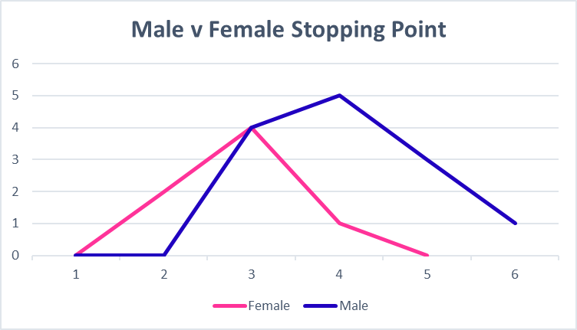

Figure 2

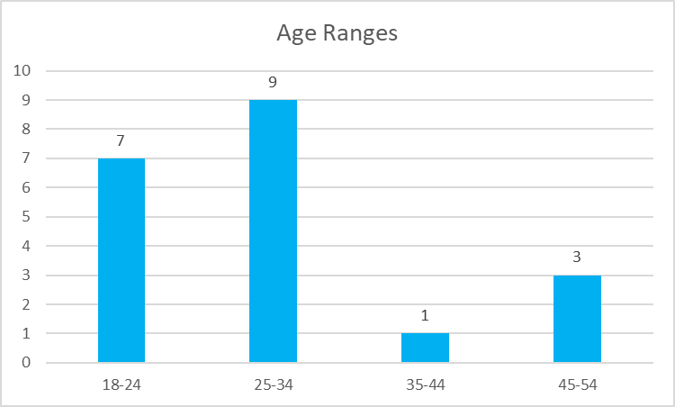There were five desired age ranges, 18-24, 25-34. 35-44, and 55+. Unfortunately, there was not the possibility of having the 55+ age range, although that should not be an issue for these results. While researcher attempted to get ever numbers of participants of each age range, that was not possible, looking at the graph it is clear to see that most of the testing was done with participants in the age range of 18-34. Please refer to figure 3.

Figure 3

Looking at figure 4, it is noticeable that the 25-34 age range has the lead with three participants feeling sick on the final phase. This is to be expected again the older age ranges as there is not enough data to compare it. However, if looking at the 18-24 range which has similar participant numbers that four people felt sick at phase 3 and one on phase 4. This data is shows that in this experiment that the 25-34 age range were less susceptible to cybersickness. This can be the case because of many reason. One reason could be that there are different amounts of males and females in each age group and as seen above females do seem to be affected more than the average male. In an article (Dobie et al., 2001) there was three studies and by the end on the research it was concluded that there not was a 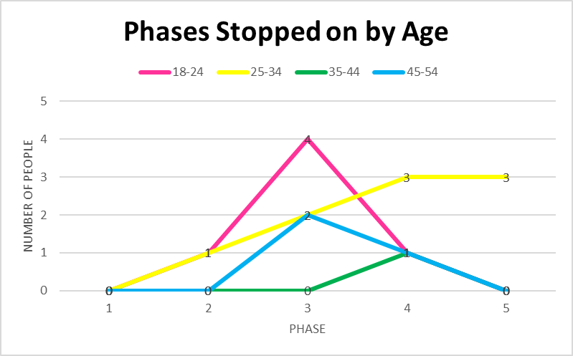significant difference between age.

Figure 4

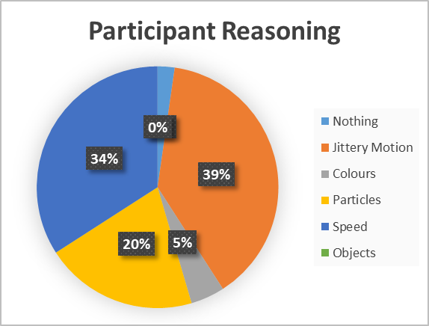The researcher instructed the participants to let them know when they were feeling motion sickness. Once the experiment had been stopped one of the questions asked was, what do you think contributed to becoming motion sick, there were multiple reasons listed by the researcher as well as a ‘other’ box that the participants could chose to write something else. Please refer to figure 5 to see what the participants had to say. The majority at 39% said jittery motion, seven participants found that jittery motion specifically going through zigzags caused them nausea whereas five people stated that it was either the going up and down the tracks as well as the loops made them feel nauseous. There were 20% of the participants that claimed particles had an effect on them, most complaints were about sore eyes or making them feel a bit dizzy. Particles were only on phase 2, and it is a flat track so two people stopped at this point, both were female.

Figure 5

Each room was one of three colours, red, blue, green. Upon doing research it was discovered that colours could have an impact but there are too many colours to test so the three primary colours were used. The data is in figure 6 and it shows that over half of the participants stopped on blue. Although there were two people who mentioned the bright colours contributing to their motion sickness it was not their main reasoning and no other participants noted a difference. Each phase has three identical rooms, and the blue room is the room in the middle so its not very shocking that blue was a popular colour to stop on.

Figure 6

# Conclusion

Overall, 90% of the participants ended the experiment with some sort of motion sickness, 10% did not, although one participant had to stop because of sore eyes, and another was a regular user so did not display motion sickness symptoms. Many participants stopped at phase 4 when they reached the zigzags, feedback from the participants said that if they moved their head while going through the zigzag portion then this caused them to feel significantly more motion sick. Eighty-five percent of participants stated that the jittery motion such as the zigzags was a contribution to making participants feel nauseous, followed by 75% also stating that the variable speed between high and low points was also a key factor. Interestingly, the difference between age groups 18-24 and 45-54 had comparable results apart from the latter having four less participants, and this needs to be researched further. Finally, as other literature suggests there seems to be a pattern on how fast females became nauseous before males, on average male participants lasted one phase longer than the female participants, this once again was not 100% dependable as not enough female participants to match the male participants.

The application that was created which had five phases which was possibly not enough, two of the phases were a flat track. This was done to get a baseline and it is difficult to assess how fast to make progress. In the future difficulty should be increased at bigger increments from the beginning to gain a better understand of how participants are getting motion sick as the average point for getting motion sick was between phase 3 and phase 4. Unfortunately, the three distinct colours did not really have an effect on the participants, when asked about, 10% of participants stated that the colour could be a contribution, but this was not supported by the majority, as in the overall reasoning chart it only claimed 5% of the total reasoning, this is perhaps because there were only three different colours, there needs more investigation as to which colours can cause motion sickness although the data from this research suggests that blue was stopped on 53% of the time.. Particles also made 15% of participants claim it was a factor and this accounts for 20% of participant reasoning, although some participants felt nausea after going through the particles, the majority stated that it caused their eyes to become sore.

## Future Research

After this research there is evidently more research that needs furthering if VR is going to be the technology of the future, motion sickness really is an issue in VR because no one wants to put on a device to then feel sick after 10-15 minutes.

A suggestion for future research is to break it down more, do individual research about what colours can trigger motion sickness or other symptoms, then move onto models, do certain models have characteristics that could cause motion sickness? Another interesting route to go down is olfactory, as other research suggests smell can assist to alleviate some of the symptoms. An interesting factor to this was seeing that jittery motion was such a big reason for motion sickness when games without jittery motion still cause motion sickness. Another route to investigate more into would be ages as this research did not find major differences between age ranges. Finally, audio could possibly be a factor, maybe research into headphones for VR which imitate the simulated environment and tricks the vestibular system into thinking its real, therefore solving the biggest part of motion sickness.

# References

Cao, Z., Jerald, J. and Kopper, R. (2018). *Visually-Induced Motion Sickness Reduction via Static and Dynamic Rest Frames*. [online] IEEE Xplore. doi:https://doi.org/10.1109/VR.2018.8446210.

Chang, E., Kim, H.T. and Yoo, B. (2020). Virtual Reality Sickness: A Review of Causes and Measurements. *International Journal of Human–Computer Interaction*, 36(17), pp.1658–1682. doi:https://doi.org/10.1080/10447318.2020.1778351.

Chattha, U.A., Janjua, U.I., Anwar, F., Madni, T.M., Cheema, M.F. and Janjua, S.I. (2020). Motion Sickness in Virtual Reality: An Empirical Evaluation. *IEEE Access*, [online] 8, pp.130486–130499. doi:https://doi.org/10.1109/access.2020.3007076.

Chattha, U.A. and Shah, M.A. (2018). *Survey on Causes of Motion Sickness in Virtual Reality*. [online] IEEE Xplore. doi:https://doi.org/10.23919/IConAC.2018.8749071.

Dobie, T., McBride, D., Dobie, T. and May, J. (2001). The effects of age and sex on susceptibility to motion sickness. *Aviation, space, and environmental medicine*, [online] 72(1), pp.13–20. Available at: https://europepmc.org/article/med/11194988 [Accessed 3 May 2023].

Fulvio, J.M., Ji, M. and Rokers, B. (2021). Variations in visual sensitivity predict motion sickness in virtual reality. *Entertainment Computing*, 38, p.100423. doi:https://doi.org/10.1016/j.entcom.2021.100423.

Jokerst, M., Gatto, M., Fazio, R., Gianaros, P.J., Stern, R.M. and Koch, K.L. (2023). *APA PsycNet*. [online] psycnet.apa.org. Available at: https://psycnet.apa.org/record/1999-01128-002 [Accessed 2 May 2023].

Kim, H., Kim, D.J., Chung, W.H., Park, K.-A., Kim, J.D.K., Kim, D., Kim, K. and Jeon, H.J. (2021). Clinical predictors of cybersickness in virtual reality (VR) among highly stressed people. *Scientific Reports*, [online] 11(1), p.12139. doi:https://doi.org/10.1038/s41598-021-91573-w.

Kim, H.K., Park, J., Choi, Y. and Choe, M. (2018). Virtual reality sickness questionnaire (VRSQ): Motion sickness measurement index in a virtual reality environment. *Applied Ergonomics*, 69, pp.66–73. doi:https://doi.org/10.1016/j.apergo.2017.12.016.

Liao, C.-Y., Tai, S.-K., Chen, R.-C. and Hendry, H. (2020). Using EEG and Deep Learning to Predict Motion Sickness Under Wearing a Virtual Reality Device. *IEEE Access*, 8, pp.126784–126796. doi:https://doi.org/10.1109/access.2020.3008165.

Munafo, J., Diedrick, M. and Stoffregen, T.A. (2016). The virtual reality head-mounted display Oculus Rift induces motion sickness and is sexist in its effects. *Experimental Brain Research*, [online] 235(3), pp.889–901. doi:https://doi.org/10.1007/s00221-016-4846-7.

Ohyama, S., Nishiike, S., Watanabe, H., Matsuoka, K., Akizuki, H., Takeda, N. and Harada, T. (2007). Autonomic responses during motion sickness induced by virtual reality. *Auris Nasus Larynx*, 34(3), pp.303–306. doi:https://doi.org/10.1016/j.anl.2007.01.002.

Ranasinghe, N., Jain, P., Tolley, D., Karwita Tailan, S., Yen, C.C. and Do, E.Y.-L. (2020). Exploring the Use of Olfactory Stimuli Towards Reducing Visually Induced Motion Sickness in Virtual Reality. *Symposium on Spatial User Interaction*. doi:https://doi.org/10.1145/3385959.3418451.

Zhang, C. (2020). *Investigation on Motion Sickness in Virtual Reality Environment from the Perspective of User Experience*. [online] IEEE Xplore. doi:https://doi.org/10.1109/ICISCAE51034.2020.9236907.