Kyntact: Real-time Braille Text Translation System
Kyntact: Sistema de tradução de texto para braile em tempo real
Kyntact: Sistema de traducción de texto a braille en tiempo real

Kauan dos Santos
kauan.santos102@etec.sp.gov.br

Miguel Yudi Baba¹
miguel.baba@etec.sp.gov.br

Nicolas Sinelli Pereira das Neves Hilário¹
nicolas.hilario@etec.sp.gov.br

Salomão Santana¹
salomao.nascimento@etec.sp.gov.br

Andreza Maria de Souza Rocha¹
andreza.rocha2@etec.sp.gov.br
Keywords:  Visual Impairment. Braille.  Accessibility.  Social Inclusion.  Internet of Things  Palavras-chave:  Deficiência Visual.  Braile.  Inclusão social.  Acessibilidade.  Internet das Coisas  Palabras clave:  Discapacidad Visual. Braille.  Inclusión Social.  Accesibilidad.  Internet de las Cosas.  Apresentado em:  03 dezembro, 2025  Evento:  8º EnGeTec  Local do evento:  Fatec Zona Leste  Avaliadores:  Avaliador 1  Avaliador 2   | Abstract:  The Kyntact project consists of a device that captures text with a camera, processes it on a mini-computer, and reproduces it in Braille via solenoids, allowing people with total visual impairment to understand written content through touch. The objective is to promote accessibility, autonomy, and social inclusion through a low-cost technological solution compared to others available on the market, especially given the limited number of similar options. The methodology adopted is qualitative, based on tests and observations conducted during prototype development. The issue addressed is the lack of accessible Braille resources in public spaces. The main conclusions are that the project demonstrated technical and functional feasibility, proving to be an efficient alternative for expanding access to information.  Resumo:  O projeto Kyntact consiste em um dispositivo capaz de capturar textos por meio de uma câmera, processá-los em um minicomputador e reproduzi-los em braile por meio de solenoides, permitindo que pessoas com deficiência visual total compreendam conteúdos escritos através do toque. O objetivo é promover acessibilidade, autonomia e inclusão social por meio de uma solução tecnológica de baixo custo se comparado as outras presents no mercado, além de existirem poucas opções semelhantes. A metodologia adotada é qualitativa, baseada em testes e observações realizadas durante o desenvolvimento do protótipo. A problemática centra-se na carência de recursos acessíveis para leitura em braile em espaços públicos. Como principais conclusões, o projeto demonstrou viabilidade técnica e funcional, mostrando-se uma alternativa eficiente para ampliar o acesso à informação.  Resumen:  El proyecto Kyntact consiste en un dispositivo capaz de capturar textos mediante una cámara, procesarlos en una minicomputadora y reproducirlos en braille a través de solenoides, permitiendo que las personas con discapacidad visual total comprendan contenidos escritos mediante el tacto. El objetivo es promover la accesibilidad, la autonomía y la inclusión social por medio de una solución tecnológica de bajo costo en comparación con otras disponibles en el mercado, además de que existen pocas opciones similares. La metodología adoptada es cualitativa, basada en pruebas y observaciones realizadas durante el desarrollo del prototipo. La problemática se centra en la falta de recursos accesibles para la lectura en braille en espacios públicos. Como principales conclusiones, el proyecto demostró viabilidad técnica y funcional, constituyéndose en una alternativa eficiente para ampliar el acceso a la información.

- Introduction
The project proposes the development of a tactile Braille reading device capable of capturing text through a camera, processing it on a mini-computer, and reproducing it using solenoids, letting individuals with total visual impairment to understand content through touch. This initiative, based on Internet of Things (IoT) technologies, aims to promote accessibility and social inclusion while addressing challenges such as the lack of adaptation in public spaces and the difficulty the project's target audience faces in understanding reading materials and information.
The main objective of the project is to assist people with total visual impairment in understanding texts present in their surroundings by using optical character recognition (OCR) and immediate transcription into the Braille system, ensuring autonomy and practicality. The specific objectives include: developing a raised-dot mechanism for Braille writing, implementing a text-capture and translation system via a camera, and making the device accessible and functional for the target audience.
Two hypotheses guide this study: the first is that the low presence of Braille text in public environments is associated with a lack of infrastructure and investment in accessibility, and the second is that the absence of accessible solutions contributes to exclusion and reduced autonomy for visually impaired individuals. In this context, the project seeks to promote social inclusion and independence for this group by enabling quick access to information, facilitating mobility, and expanding participation in social and professional environments.
The scope of this work encompasses the application and validation of the device in the eastern zone of São Paulo, where its functionality, efficiency, and usability will be assessed in real situations — such as the reading of signs, notices, and simple documents — while considering the particular conditions and challenges of this urban environment.
The methodology of the Project is qualitative, as it seeks to analyze the device's effectiveness and acceptance through observations, practical experience, and user perceptions collected during testing, without resorting to numerical data or statistical analysis.
Finally, this work is organized into five chapters, each fulfilling a specific role within the research. The first chapter presents the introduction, contextualizes the topic, outlines the objectives, and provides the project's justification. The second chapter brings together the theoretical and technological foundations that underpin the device's development. The third chapter describes the construction process, implementation, and operation of the proposed system. The fourth chapter presents the results obtained and the limitations identified. Lastly, the fifth chapter presents final considerations and potential future improvements.
With that in mind, is it possible to make tactile reading more accessible so that people with visual impairments can have the same level of autonomy as sighted individuals?
- Theoretical Foundation
For the development of Kyntact, concepts in Visual Impairment, Braille Language, the Internet of Things (IoT), and User Experience (UX), as well as technologies like Raspberry Pi, Python, OpenCV, EasyOCR, and ESP8266, were studied, all of which are essential for real-time image recognition and processing.
  - Visual Impairment
According to the Barsa Universal Encyclopedia (2009), visually impaired individuals are those who lack the sense of sight, that is, are unable to see.
There are two types of visual impairment: congenital and acquired. In accordance with Almeida and Araújo (2013), congenital blindness refers to a condition in which a person is born with it, while acquired blindness develops over the course of an individual's life.
The Brazilian Institute of Geography and Statistics (IBGE, 2010) reports that approximately 3.2% of Brazil’s population has significant difficulty seeing.
  - Difficulties Faced After Vision Loss
As reported by G1 (2019), visually impaired individuals face numerous challenges in their daily lives, such as walking on uneven pavement or boarding the correct bus, since they are unable to read its route or destination.
As stated by Aciem (2011), people with visual disabilities need autonomy in order to exercise their right to freedom effectively. To achieve this independence, the assistance of institutions and the use of assistive resources are essential.
  - Braille
As Borges (2009) explains, Braille is a tactile reading and writing system, simple and easy to reproduce, designed for visually impaired individuals. It was created by a Frenchman named Louis Braille in the 19th century.
This system is based on a set of six dots arranged in two equal columns, which represent various elements, such as letters or numbers, depending on the combination of raised dots, as claimed by Oliveira (2018).
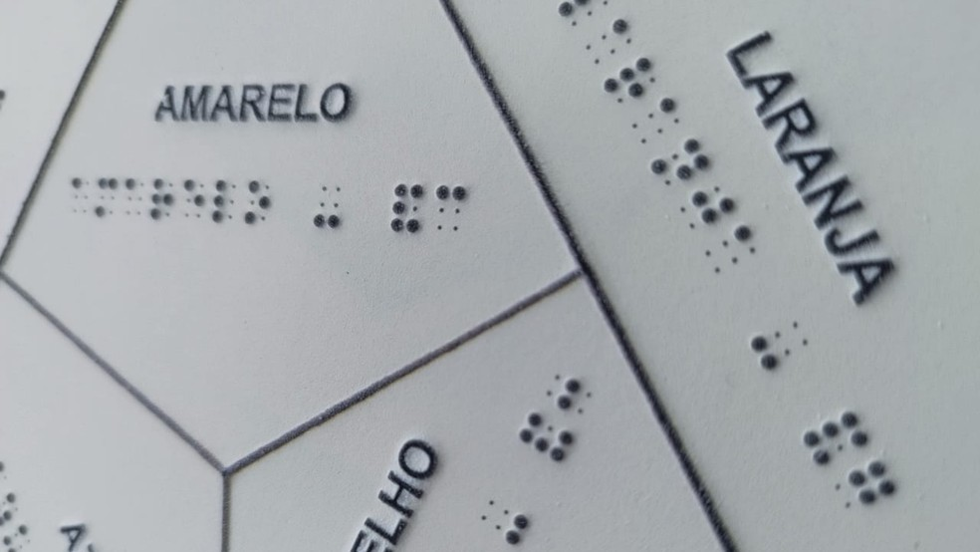
Figure 1 – Words written in Braille
Source: G1 (2025)
  - Python
As claimed by the Python Software Foundation (2025), Python is a programming language with intuitive features.
A syntax designed to optimize developer productivity, allowing the use of various reusable modules across different programs. Severance (2020) emphasizes that Python is a versatile language for sending and receiving instructions, allowing task automation through its commands and techniques.
  - Optical Character Recognition (OCR)
Optical Character Recognition (OCR) is a technology that converts images into text that can be digitally manipulated, playing a fundamental role in systems that must recognize text from images, as stated by Farias (2023).
As maintained by Antonio (2019), OCR performance can be improved when associated with image preprocessing techniques, which enhance data readability and, consequently, the accuracy of the digitized text.
  - Programming Language for Embedded Systems
During the project, the C++ language was used for embedded programming. In accordance with Bueno (2002), it was created by Bjarne Stroustrup to add object-oriented concepts—such as inheritance and classes—to the C language. Paraphrasing Schildt (2002), C++ aims to facilitate the management of complex programs and can be applied to a wide variety of projects.
  - Raspberry Pi
As stated by Silva (2019), Raspberry Pi was created by a foundation of the same name. It is a microcomputer that habilitates various technical activities on any scale and supports several Linux-based operating systems.
As Bertonha (2018) reminds us, an operating system (OS) consists of all the programs that manage and control hardware—that is, the set of pre-installed software that the user can freely use and manipulate.
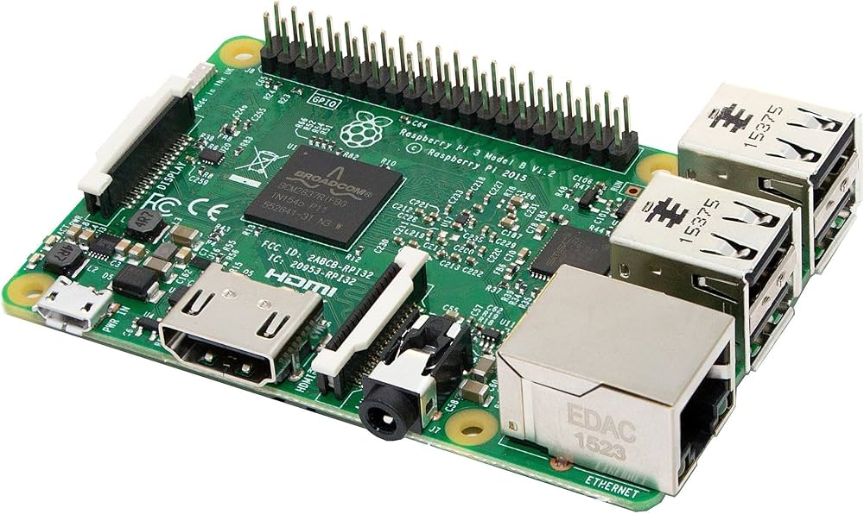
Figure 2 – Raspberry Pi 3.
Source: Raspberry Pi (2016)
  - ESP 8266
As claimed by Oliveira (2021), the ESP8266 is a microcontroller widely used in Internet of Things (IoT) projects. It supports the TCP/IP protocol, allowing direct network connection without the need for
Additional modules. Batrinu (2018) explains that it can be programmed using the official Espressif SDK or the Arduino IDE, through C or C++, simplifying the development and prototyping of connected systems.
  - Solenoid push-pull
As Koroishi (2013) explains, solenoids are formed by a long-coiled wire that generates a magnetic field when an electric current passes through it. Pires (2007) describes them as simple, affordable components that are easy to activate, available in various sizes, and capable of producing significant linear motion.
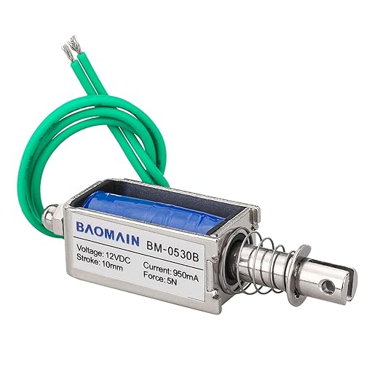
Figure 3 – Solenoid push-pull.
Source: Amazon (2023)
  - 3D Modeling and Printing
As maintained by the State Department of Education of Paraná (2018), 3D printing is a technology that permits the creation of physical objects from digital models and is widely used in educational contexts. As highlighted by Aguiar (2016), this technology can be applied in producing personalized teaching tools and materials adapted to students’ needs.
Botolotto (2014) explains that 3D modeling involves analyzing the surface of a three-dimensional object to generate its mathematical representation, a three-dimensional model, using specialized software. From Ferreira's perspective (2015, apud Bonato, 2006), these models are geometric structures composed of points, called vertices, interconnected to form the desired figure.
- Methodology
In accordance with Lakatos and Marconi (2010), qualitative methodology seeks to understand participants' perceptions, meanings, and experiences within a phenomenon. Unlike the quantitative method, this approach is not limited to numerical data; it values impressions, narratives, and observations that allow the studied reality to be interpreted in depth.
Thus, this project adopted a qualitative method to analyze user experience with Kyntact, given the importance of understanding how the device is perceived when converting text to Braille.
Qualitative research is particularly suitable for studies involving subjective aspects such as usability, accessibility, and social impact. Therefore, during Kyntact’s evaluation process, interviews and feedback sessions were conducted with users to identify their perceptions regarding system efficiency, ease of use, and contribution to autonomy in tactile reading.
Observing participants’ interactions with the device made it possible to analyze their emotions, difficulties, and suggestions for improvement.
- Results and Discussion
In summary, the development of Kyntact represents a significant advancement in technological accessibility. The project successfully achieved its primary goal of creating a functional, affordable solution for visually impaired individuals that automatically and immediately convert text to Braille.
By combining hardware and software into a compact and efficient system, it was possible to provide users with independent, practical, and inclusive reading experience.
Kyntact can be considered a tool for autonomy and social inclusion, demonstrating how technology can reduce barriers and expand opportunities for those facing visual limitations. The results highlight the potential of innovation applied to social causes, reinforcing the importance of initiatives that ensure equal access to information.
Figure 4 – 3D model of Kyntact.
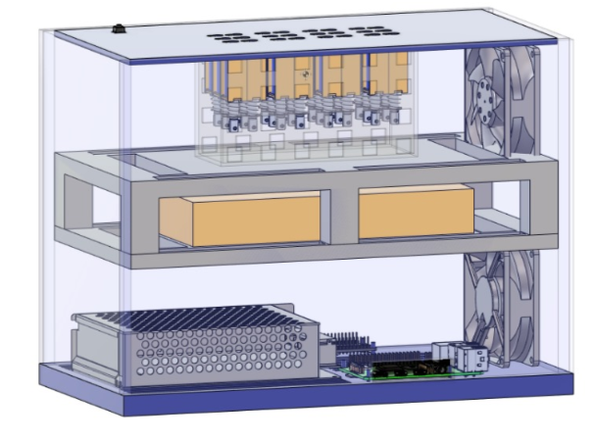
Source: Author’s Work (2025)
- Final Considerations
This work aims to promote social integration and accessibility for visually impaired people through Kyntact. Throughout its development, specific boundaries were defined to ensure the system remained focused on its primary function: assisting in the reading and interpretation of written texts.
Although Kyntact already meets its initial proposal, it shows great potential for further evolution, potentially becoming more portable and practical for everyday use. Even though it has not yet been applied on a large scale, the results obtained during its design and analysis are promising, demonstrating its ability to reduce barriers to reading access and to strengthen autonomy, inclusion, and equal opportunities for visually impaired individuals.
Based on this experience, it can be concluded that Kyntact has high potential for social impact, with the capacity to contribute significantly to the digital and communicative inclusion of this population. Furthermore, the project stands as both a reference and an inspiration for future technological initiatives focused on accessibility and social inclusion.
Referências
ACIEM, Tânia. Personal and social autonomy of visually impaired people after rehabilitation. 2011. Dissertation (Master's in Policies and Forms of Care in Developmental Disorders) – Mackenzie Presbyterian University, São Paulo, 2011.
AGUIAR, Leonardo de Conti Dias. A process for using 3D printing technology in the construction of didactic instruments for science teaching. 2016. Dissertation (Master's in Science Education) – São Paulo State University "Júlio de Mesquita Filho", Bauru, 2016.
ALMEIDA, T.; ARAÚJO, F. Experiential differences between people with congenital and acquired blindness: a brief appreciation. Interfaces Magazine: Health, Humanities and Technology, Ceará, June 2013.
ANTONIO, David Vitor. Implementation of a prototype based on OCR technology applied to label recognition for database searching. 2019. Undergraduate Thesis (Bachelor of Science in Computer Science) – University of Southern Santa Catarina, Criciúma, 2019.
BATRINU, Catalin. Home automation projects with ESP8266. São Paulo: Novatec, 2018.
BERTONHA, Arian Fernandes. Image description system with voice commands to assist visually impaired people. 2018. Undergraduate Thesis (Bachelor of Science in Electrical Engineering – Emphasis in Electronics) – University of São Paulo, School of Engineering of São Carlos, São Carlos, 2018.
BORGES, José. From Braille to Dosvox – Differences in the lives of blind people. 2009. Thesis (Doctorate in Education) – Federal University of Rio de Janeiro, Rio de Janeiro, 2009.
BOTOLLOTTO, André. 3D modeling and its application in technical education. 2014. Monograph (Production Engineering Course) – Federal Technological University of Paraná, Ponta Grossa, 2014.
BUENO, Francisco. Programming in C++ for embedded systems. São Paulo: Makron Books, 2002.
FARIAS, Lucas. Optical Character Recognition (OCR) and its applications in computer vision. 2023. Final Project (Computer Engineering) – State University of Campinas, Campinas, 2023.
IBGE. 2010 Demographic Census: general characteristics of the population, religion and people with disabilities. Rio de Janeiro: Brazilian Institute of Geography and Statistics, 2010.
KOROISHI, Evandro. Electromagnetism and industrial applications of solenoids. Curitiba: SENAI, 2013.
LAKATOS, Eva Maria; MARCONI, Marina de Andrade. Fundamentals of scientific methodology. 8th ed. São Paulo: Atlas, 2010.
OLIVEIRA, Bruno. Braille systems and inclusive education. 2018. Monograph (Bachelor's Degree in Pedagogy) – Federal University of Ceará, Fortaleza, 2018.
OLIVEIRA, Felipe. Internet of Things (IoT) and its applications in home automation. 2017. Journal of Technology and Innovation, v. 5, n. 2, p. 15–25, 2017.
OLIVEIRA, Matheus. ESP8266 and IoT applications. 2021. Electronic Journal of Embedded Systems, v. 9, n. 1, p. 33–41, 2021.
PIRES, Renato. Elements of machines and electromechanical actuators. 2nd ed. São Paulo: LTC, 2007.
PYTHON SOFTWARE FOUNDATION. Python 3.13 Documentation. Available at: https://www.python.org/doc/. Accessed in: 2025.
SECRETARIAT OF STATE FOR EDUCATION OF PARANÁ. 3D printing and inclusive education: pedagogical practices. Curitiba: SEED, 2018.
SEVERANCE, Charles. Python for Everybody: Exploring Data in Python 3. Ann Arbor: Charles Severance, 2020.
SILVA, André. Raspberry Pi: a practical guide to applications. São Paulo: Novatec, 2019.

"The content expressed in the work, as well as the copyright of figures and data, as well as its spelling and standardization, are the sole responsibility of the author(s)."
"The author(s) of the work declare(s) that during the preparation of the manuscript no Artificial Intelligence (AI) tool/service was used, and all the text produced is the responsibility of the authors."

Fatec da Zona Leste

