CAVITE STATE UNIVERSITY – CCAT CAMPUS
SYSTEM DOCUMENTATION
MCCAT
Submitted by:
Miguel Lumactod
Charlie Oras
Gervin Signo
Joshua Limpioso
Submitted to:
Vince Lorenz Dela Rea
June 13, 2026

Table of Contents
1. Executive Summary
2. System Overview
3. System Architecture and Design
4. Database Schema
5. Development Process
6. Installation and Deployment
7. User Guide
8. Testing and Quality Assurance
9. Conclusion
10. Appendices

EXECUTIVE SUMMARY:
The MCCAT (Mobile Cafeteria and Catering Application Tool) is a web-based food ordering system developed to simplify menu browsing, order placement, and sales monitoring. The system provides an interactive platform where customers can view available food items and submit orders online. It also includes administrative features for managing transactions and monitoring sales performance.
The upgraded version of MCCAT integrates both OLTP (Online Transaction Processing) and OLAP (Online Analytical Processing) functionalities. OLTP supports daily operational transactions such as customer orders, while OLAP provides analytical capabilities through summarized sales reports and performance dashboards.

The system was developed using PHP, HTML, CSS, JavaScript, and MySQL, with GitHub serving as the primary version control platform for collaborative development.

SYSTEM OVERVIEW:
The purpose of MCCAT is to provide an efficient and user-friendly platform for managing food ordering operations. The system allows customers to browse menu items, place orders, and interact with the service digitally while enabling administrators to monitor business performance.

Objectives:
• Automate food ordering transactions.
• Store customer and order information securely.
• Provide sales monitoring and reporting features.
• Improve efficiency in managing food services.
• Support data-driven decision making through analytics.

Scope:
The system covers customer registration, login, menu viewing, food ordering, transaction management, and sales analytics. Administrative users can access OLTP and OLAP modules for operational and analytical purposes.

SYSTEM ARCHITECTURE AND DESIGN:
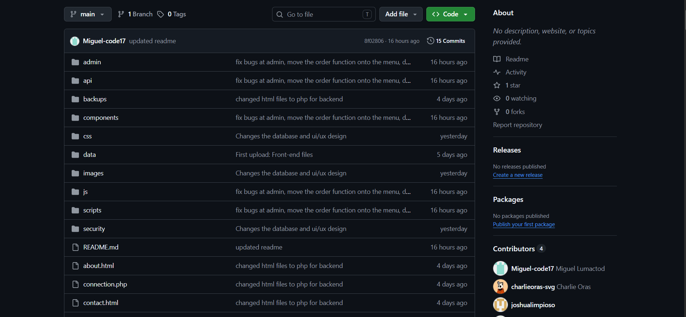
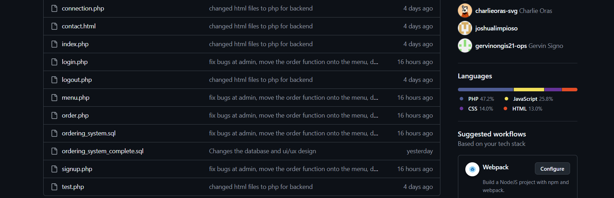

Architecture Diagram
User
↓
Web Browser
↓
PHP Application Layer
(index.php, login.php, menu.php, order.php)
↓
API Layer
(foods.php, place-order.php)
↓
MySQL Database
(ordering_system)
↓
OLAP Data Warehouse
(ordering_dw)

Architecture Description
The MCCAT system follows a multi-layer architecture. Users interact with the application through a web browser. The application layer processes requests using PHP pages, while API modules facilitate communication between the user interface and the database. Transactional data is stored in the OLTP database, and summarized information is transferred to the OLAP data warehouse for reporting and analytics.

DATABASE SCHEMA
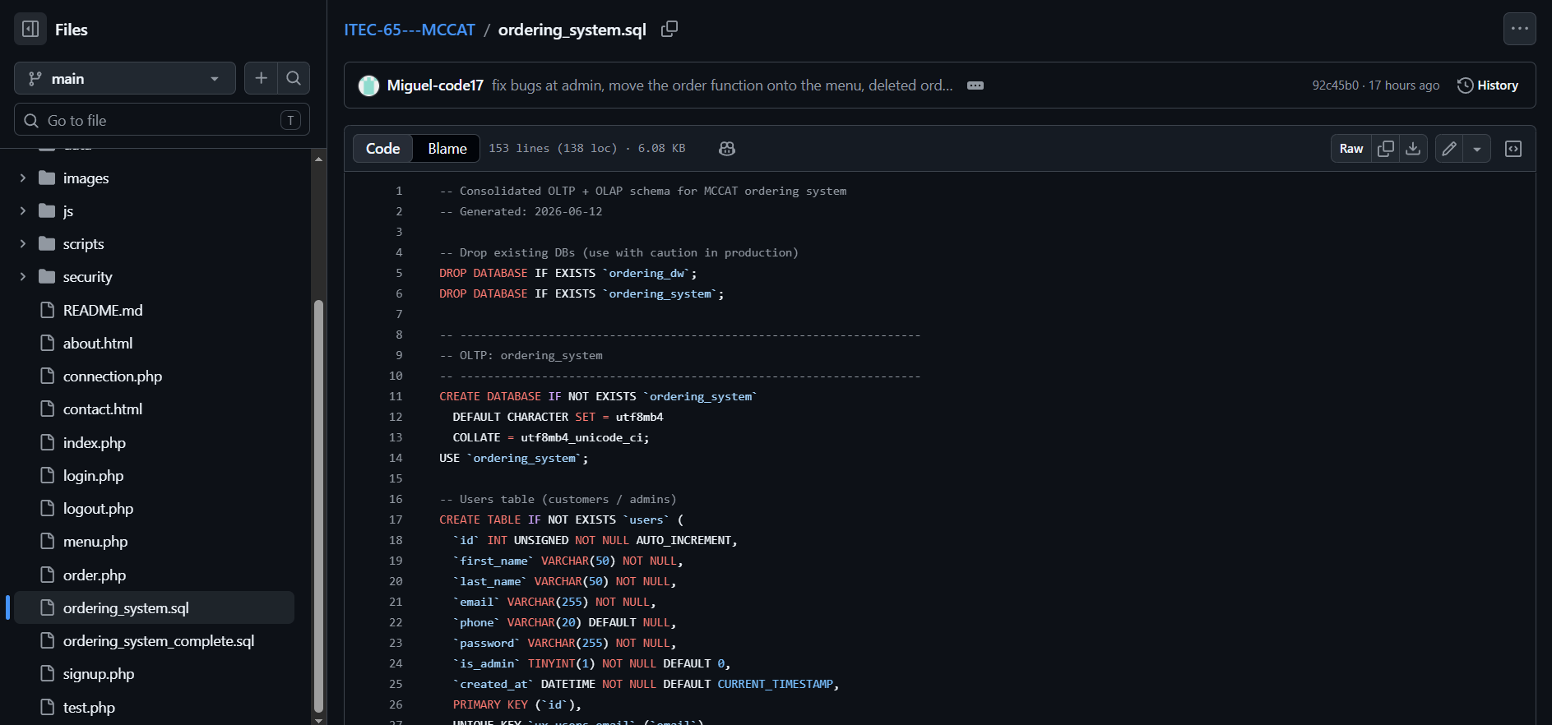

Main OLTP Tables
Table |  | Description
users | Stores customer and administrator accounts
foods | Stores menu information
orders | Stores customer transactions
order_items | Stores ordered products
audit_logs | Stores activity logs

OLAP Tables
Table | Description
daily_sales | Daily sales summary
product_daily_sales | Product performance reports
orders_by_hour | Hourly transaction analysis
category_performance | Category sales performance

ERD
Users
│
├── Orders
│
└── Order_Items
│
└── Foods

DEVELOPMENT PROCESS:
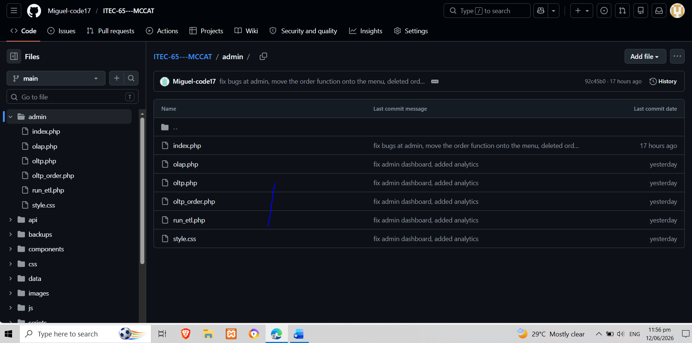

Modules Developed
Customer Module
• Registration
• Login
• Menu Viewing
• Order Placement
Administrative Module
• Dashboard
• OLTP Monitoring
• OLAP Analytics
• ETL Processing
API Module
• foods.php
• place-order.php

INSTALLATION AND DEPLOYMENT:
1. Install XAMPP.
2. Start Apache and MySQL.
3. Import ordering_system_complete.sql into MySQL.
4. Place the MCCAT project folder inside htdocs.
5. Open localhost/MCCAT in a web browser.
6. Access administrator functions through the admin module.

USER GUIDE:
Customer Workflow
1. Register an account.
2. Login to the system.
3. Browse available food items.
4. Select products.
5. Submit an order.
6. Receive order confirmation.

Administrator Workflow
1. Login as administrator.
2. Access dashboard.
3. Monitor transactions.
4. Generate reports.
5. Analyze sales performance.

TESTING AND QUALITY ASSURANCE:
The system underwent functionality testing to verify the correctness of user registration, login, ordering, and reporting features. Database connectivity and API communication were also tested to ensure proper operation. Issues identified during testing were resolved through debugging and iterative improvements.

CONCLUSION:
The MCCAT system successfully integrates transaction processing and analytical reporting within a single platform. Through the implementation of OLTP and OLAP technologies, the system supports both operational efficiency and business intelligence. The project demonstrates the practical application of database management, web development, and data analytics concepts in a real-world scenario.

