All related to mac SSD upgrade

**Thread #1**

**Link ->** [Macbook air 2017 SSD Compatibility with Samsung SSD | Page 14 | MacRumors Forums](https://forums.macrumors.com/threads/macbook-air-2017-ssd-compatibility-with-samsung-ssd.2099405/page-14)

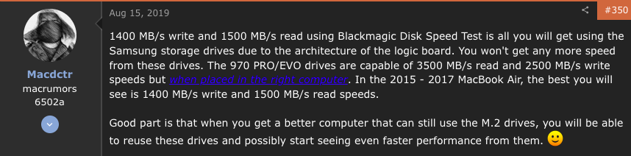

The next one I think is for computers below 2015, cause.i think my mac would not have recognized the SSD when I change it First.

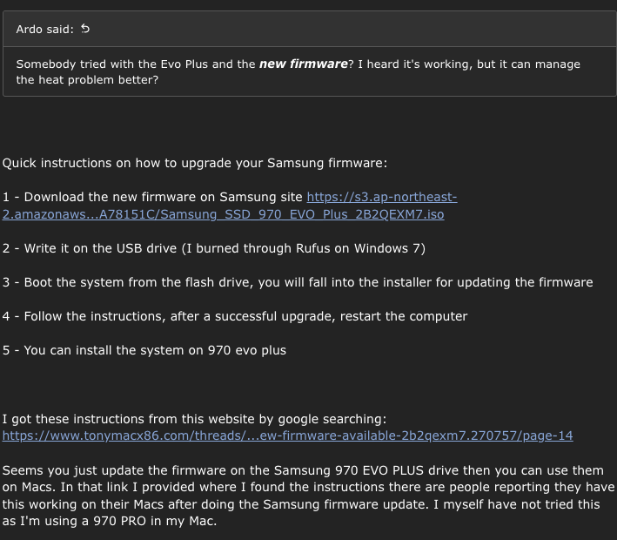

Link of how to update firmware -> <https://youtu.be/yBSDuX7e2c4>

**Thread #2**

**Link ->** [**https://discussions.apple.com/thread/251196277**](https://discussions.apple.com/thread/251196277) **,**[How to reset the SMC of your Mac - Apple Support](https://support.apple.com/en-us/HT201295)

This has been already done, it seems to work properly (increasing load). In this point, th battery issues stays on, but no as high as before of making these steps.