# RecipeTop: An Interactive Countertop and Recipe Preparation Assistant

Geraldine Versfeld, Jason Portillo, Edwin Santiago, and Miguel Ramirez

### Dept. of Electrical Engineering and Computer Science, University of Central Florida, Orlando, Florida, 32816-2450

### ***Abstract* —** RecipeTop is an interactive countertop and recipe preparation assistant, meant to be used as an addition to the evolving smart kitchen. RecipeTop’s ease of use allows it to integrate into and transform your everyday life in the kitchen. The major components of the system are the touch screen display, the recipe management application, and a Raspberry Pi for the central processing. Additionally, we wirelessly connected a scale to allow the users to easily and seamlessly weigh their ingredients.

### *Index Terms* — Interactive, Kitchen, Recipes, Scale, Smart, Touch-Screen, Wireless

### I. Introduction

Have you ever experienced the frustration of trying to read a recipe on your phone when your hands were covered in flour? Or realized once you began to smell the smoke of your burnt brownies that you never set a timer for the oven?

Imagine a kitchen counter that could keep you organized while you are cooking and baking. An interactive countertop that could wirelessly connect to other kitchen appliances to intuitively set timers and weigh your ingredients. This countertop could help you follow recipes and avoid making your phone or tablet a flour covered mess. RecipeTop keeps your recipes organized, helps you find new recipes, and walks you through the steps of a recipe to learn new cooking skills. Our interactive countertop could also help you reduce food waste by suggesting recipes for the ingredients that a user currently has on hand.

This project was inspired by a shared love of cooking. Cooking is an activity that can be enjoyable for some and a nuisance to others. Our goal was to create a product that makes cooking a pleasure for all users even for inexperienced chefs. RecipeTop provides users with the ability to search for recipes, store their favorite recipes, and learn new cooking techniques. The main project components consist of a touchscreen display connected to a single-board computer and a wireless scale.

RecipeTop will change the way that users interact with everyday kitchen appliances, making cooking a simpler task with instructions, cooking temperatures, and timers all organized in one centralized display. We hope to create a product that is both easy and fun to use, allowing users to get more out of their cooking experience.

### II. Overall System Design

RecipeTop is composed of two main subsystems: a multi-touch enabled display with a single board computer and a wireless scale. These two subsystems communicate over wifi using TCP/IP protocols. Connectivity of components and group member responsibilities for each major hardware component are summarized below in figure 1.

## 

Fig. 1. Overall system block diagram with each group member’s core hardware responsibility.

The first major subsystem, the touch screen and single board computer, are embedded inside of a kitchen cart, allowing users to seamlessly interact with RecipeTop while cooking. The counter surface is ¼” tempered glass. This material was chosen because it is durable, clear, non-porous and non-toxic. The wooden frame of the counter consists of a modified kitchen cart from Ikea. The countertop is made more portable for prototyping and demonstrations through the addition of a wheel. In this architecture all electronic components are safely stored underneath the counter surface where they are protected from water and other kitchen hazards. All of the electronic components fit in the top frame of the counter leaving two levels of storage area for kitchen equipment below. These design features are highlighted in figure 2.



Fig. 2. Illustration of System Architecture with Peripherals.

Underneath the tempered glass surface of the counter, there is a clear capacitive touch foil, which was adhered directly onto the glass. Separated by an air gap of 2-3 cm, is an LCD monitor. A custom wooden frame was built around the monitor to hold it in place. The single-board computer and power supply are also stored in the wooden frame. After developing a set of core marketing goals which included low cost, user friendliness, durability, and kitchen/food safety, our core engineering requirements were created with specificity and testability in mind. These engineering requirements are summarized in table 1.

TABLE 1

Engineering Requirement Specifications

|  |  |  |
| --- | --- | --- |
| # | Specification | Target |
| 1 | Diagonal Display Size |  |
| 2 | Touchscreen Multi-touch Capability | ≥ 2 touch points |
| 3 | Operating temperature | 60≤t≤140°F |
| 4 | Scale Accuracy | ≤ 5g |
| 5 | Power Consumption | ≤ 250W |
| 6 | Counter Height | ≥ 30 in |
| 7 | Countertop Diagonal | ≥ 35in |
| 8 | Total Prototype Cost | ≤ $2000 |

### III. System Components

Major system components included the capacitive touch foil, display, single board computer, counter surface, microprocessor, A/D converter, load cells, wifi module, and the portable power supply for the scale. The design choices and challenges faced with each component and it’s procurement are summarized in the following section.

*A. Touch Foil*

A multi-touch enabled touch screen with support for simple gestures like zooming and swiping serves as the primary user input channel for RecipeTop. The capacitive touch foil relies on a grid of small transparent wires and a small PCB control circuit to measure and process user touch events. When two wires in the foil cross, they create a capacitance. Signals from the user are read through capacitance changes as a result of the user’s capacitance being in parallel to the foil. [1]. The response time of the capacitive touch foil depends on the manufacturing quality and processing speed of the touch foil’s controller. Capacitive touch foils are commercially available at a reasonable price with response times between 10ms and 100ms, with up to 40 touch points, and support for a variety of OS drivers ranging from windows to linux [2].

Capacitive touch foils vary widely in cost. Most US vendors or resellers provide touch foils at a cost upwards of $2000. For this reason, alibaba.com was used to purchase a touch foil directly from the manufacturer at a much more affordable price. Our final vendor selection was Xiamen Greatouch Technology.

*B. Display*

The display is an essential component of RecipeTop as it serves as the primary visual interface with the user. A 32” inch diagonal TV was chosen to fit within the framework imposed by the kitchen cart while maximizing the active area. A Panasonic Class Viera TC-32LX24 was donated by one of our members to reduce cost. Because the frame of the TV was removed, it was necessary to create additional support within the frame to protect fragile TV components as well as cover internal electronics. Because the TV is quite old and prone to overheating it was also necessary to create ventilation slits within the frame enclosure. Future improvements upon RecipeTop might use a TV or monitor with a higher resolution for a better user experience.

*C. Single Board Computer*

A single board computer is the central control and data processing unit of our project. The raspberry pi 3b+ was chosen because it provides 802.11n Wifi, 4 usb 2.0 ports, an HDMI port, 1GB of RAM, and a quad core 64-bit ARM Cortex A53 clocked at 1.4Ghz [3]. An external SD Card with 32GB of memory was used for storage. Although the RAM and processing power of the PI are rather limited, this option was chosen because of its low cost, small footprint, and the abundance of open-source software and documentation. The native Raspberry Pi OS, Raspbian, is a linux variant which was suitable for our project because it was compatible with the applications, libraries, and software dependencies of our project. Towards the end of our software development process, it became clear that the processing power, or rather lack thereof, was a serious bottleneck to the performance of our web app. This was largely due to the rendering of pages with lots of data intensive visual content. The latency of the website could be improved by implementing partial loading that renders the page in stages or by switching to a single board computer with more processing power and RAM.

*D. Counter Surface*

Because our countertop will be used in a kitchen with the potential of raw ingredients and prepared foods being placed directly on the counter surface, it was important to design a countertop that has a smooth non-porous surface which could be easily cleaned and sanitized. Another safety concern is the risk of shock or fire associated with electrical components in a kitchen, this necessitated the choice of a waterproof material for the countertop.

*E. Microprocessor*

For the wireless scale, a simple embedded processor is used for control of wireless connectivity and digital signal processing, including calibration, taring, and unit conversion. Factors used to select a microprocessor for the scale included cost, size, and availability of documentation. After serious consideration between TI products and the Arduino product family, the Arduino platform was chosen because of its low cost and open-source software and hardware. The ATMEGA328p- AU was chosen as our microprocessor for the wireless scale because it was relatively inexpensive, well documented, and easy to prototype. The ATMEGA 328p-AU is a surface mount MCU with a clock speed of 16MHz and an 8-bit RISC architecture. For initial prototyping, an Arduino UNO R3 was used. After completing the initial stages of system design, the SMD version of the chip was incorporated into our PCB design.

*F. Load Cells*

Finding a suitable load cell for the wireless scale proved to a very challenging task as most manufacturers do not sell load cells at a reasonable cost without bulk purchases. High precision load cells are available from standard instrumentation and electronic supply companies however, these load cells are designed for extreme precision and large loads and therefore have costs ranging from hundreds to thousands of dollars [4,5].

Because the load cells chosen for our prototype were scavenged from an old kitchen scale, datasheets were not available for this component. As a result, significant additional testing had to be carried out to fully characterize the load cells. This characterization included measurements of the load cells impedance and output voltage as a function of applied mass.

*G. High Precision Analog to Digital Converter*

The analog to digital converter uses a comparator to record analog voltage values as digital values at a fixed sampling frequency. When finding and choosing an analog to digital converter important design features include the precision, accuracy, temperature-sensitivity and refresh rate. In order to read mass values over a range from 0-5kg with an accuracy and precision of at least 1 gram, an A/D converter with at least 14-bit precision was required. This exceeded the precision of the ATMEGA’s on-board A/D converter so an external module was required. The HX711 was chosen as our A/D converter because it has 24-bit precision with a sampling rate of 10Hz (modifiable up to 80Hz with reduced accuracy). The HX711 is specifically designed for use in weight scale applications, and as a result detailed reference materials were available to support the hardware design process.

*H. Power Supply for Wireless Scale*

A need for mobility was one of the most influential factors in the choice of power supply for the wireless scale; as a result battery power was the best fit for the project. AAA Alkaline batteries were chosen because of there low-cost, reliability, and general availability. Although alkaline batteries must be replaced after a single charge, they have a low up-front cost and are the most common choice in similar consumer products.

*I. Software Stack*

The LAMP stack with the addition of Django was chosen for this project, because it provides the benefit of a familiar open-source OS and an easy to use database, while replacing the Apache web server and the PHP server side scripting with the Python-based Django framework. Several of our team members are familiar with Python and it is an easy language to learn. Additionally, there is an add-on for the Django framework, called Django Channels, that allows us to create WebSockets. Django Channels is a project that extends Django’s HTTP abilities to be able to handle WebSockets, chat protocols, IoT protocols, and more [6]. It accomplishes this by adding a fully asynchronous layer underneath the existing core of Django. Django also includes many features out of the box such as user authentication and site maps that would otherwise have to be coded from scratch. The LAMP stack uses MySQL database which most of us have familiar with and it is very similar to other databases that the group has used before.

### IV. Hardware Design

The first subsystem, consists of an LCD display, touch-foil, and single-board computer. The LCD display will be a 32” TV which is powered by a wallwort and connected to the raspberry pi via HDMI cable. The raspberry pi will interface with the scale via wifi using wifi standard 802.11n. The second subsystem, a wireless scale, will consist of a custom designed and printed PCB connected to four load cells and powered by a 6V battery. The scale PCB will include a A/D converter, MCU, and wifi module as well as voltage regulation circuitry. The overall schematic of our hardware design is included below in figure 3.

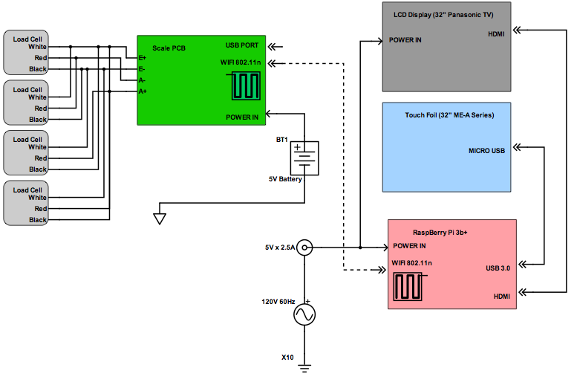

Fig. 3. Overall schematic of hardware components and connectivity.

*A. Subsystem 1: The Counter Top*

The first major subsystem consisted of the hardware components that create the interactive countertop display, which serves as the core of RecipeTop. These include a single board computer, 32” display, capacitive touch foil, the counter surface, and kitchen cart/wooden frame. The Raspberry Pi was powered using a standard wallwort which provides 2.5A at 5.1 Volts. The TV used as our display had its own built in power supply/voltage regulation circuitry. The touch foil was powered over mini-USB from the Raspberry Pi. An HDMI cable was used to connect the display to the PI and the touch foil transmitted data over USB. The Raspberry Pi has built in wifi which was used to communicate with the second major subsystem using TCP/IP protocols.

*B. Subsystem 2: Wireless Scale*

After initial breadboard testing and comparison of different prototypes using both arduino and TI products, the final design choices were made for the wireless scale. The final design consisted of an ATMEGA 328p as our MCU, the HX711 as our A/D converter, and the ESP-01 as our wifi module. This design was largely chosen for its simplicity and the availability of reference materials and examples online. The HX711 displayed a high degree of both accuracy and precision during initial breadboard testing so it was an obvious choice for the final design. The arduino had excellent built in libraries including serial read/write for peripherals. The load cells chosen were largely chosen for economic reasons although proper documentation was lacking. The wifi module was chosen for its compatibility with the arduino. During breadboard testing of the final design, the arduino was powered via USB connected to a laptop.

*C. PCB Design*

After significant breadboard testing and the development of a vector-board composed of individual through hole components, EAGLE was used to create the final schematic and lay the board for our PCB. The footprints of individual components were found either directly from manufacturers or from free hardware design libraries lika SnapEDA or EasyEDA. Some footprints were not available and had to be manually created using EAGLE based on datasheet specifications.

When selecting type and operating specification of the voltage regulators, the current and power requirements for the major components including the ATMEGA MCU, the ESP-01 wifi module and the HX711 were calculated using the nominal values provided in each component’s data sheet.

The major sections of the PCB design included the voltage regulators, the HX711, the ATMEGA328p, and the wifi module. Two different LDO Voltage regulators were used to supply the required 5V for the ATMEGA nd HX711 chip and 3.3V for the ESP-01 wifi module. Included in the voltage regulator circuitry were several capacitors for increased voltage stability and noise rejection. Two LEDs were added to indicate the proper function of the two voltage regulators. The voltage regulation circuitry is shown below in figure 4.

The ATMEGA328p has an external 16MHz crystal oscillator and decoupling capacitors were included on all supply pins, additionally a reset button was included for ease of operation. The schematic for the ATMEGA is shown below in figure 5.

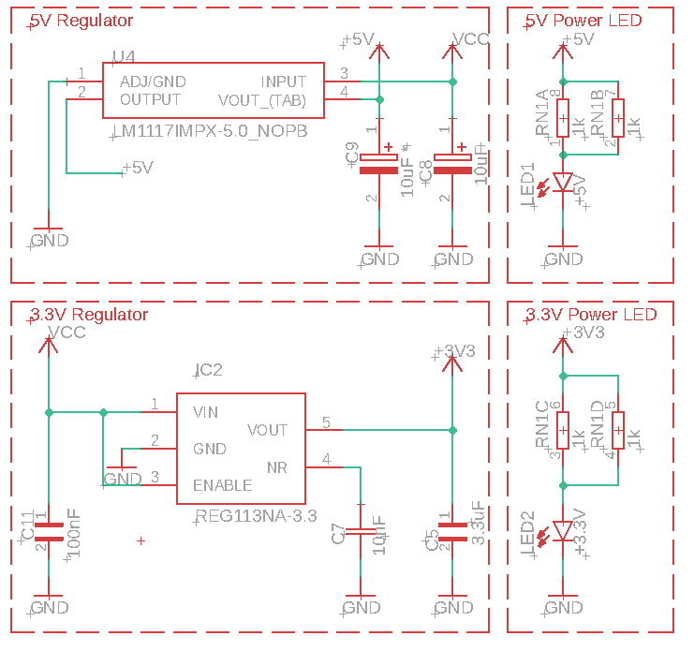

Fig. 4. Schematic of voltage regulation circuitry for the wireless scale PCB.

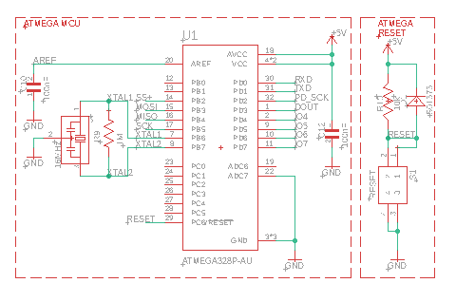

Fig. 5. Schematic of MCU circuitry for the wireless scale PCB.

The HX711 was supported by a large number of passive components which provided filtering on analog pins and decoupling on digital pins. A BJT was used to create an amplification circuit for the analog input to the HX711. The HX711 communicates data over serial to the ATMEGA chip over the DOUT and PD_SCK lines on pins 2 and 3. The schematic for the A/D converter is included below in figure 6.

The ESP-01 wifi module was added as-is in its through-hole packaging. Two pull up resistors were used to ensure the module was in the correct operating state. The wifi-module is controlled by the ATMEGA through serial communication on pins 6 and 7. A baud rate of 9600 was used to ensure reliability.

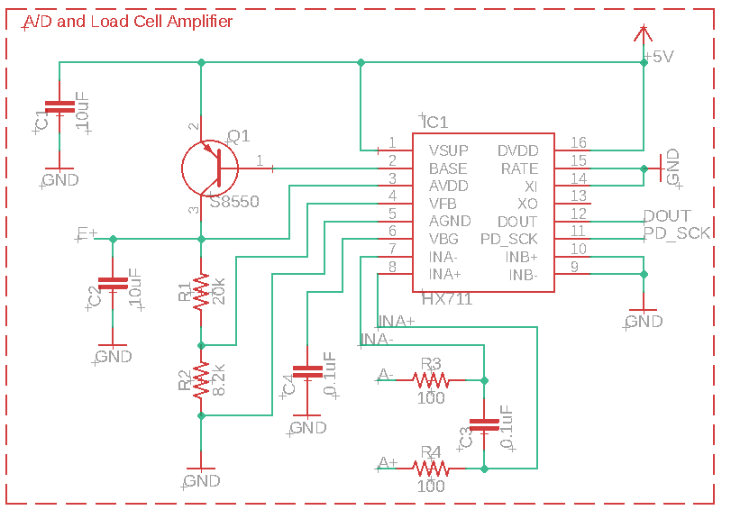

Fig. 6. Schematic of A/D Converter circuitry for the wireless scale PCB.

Two revisions of the PCB were created. The board layout for the final PCB is shown below in figure 7.

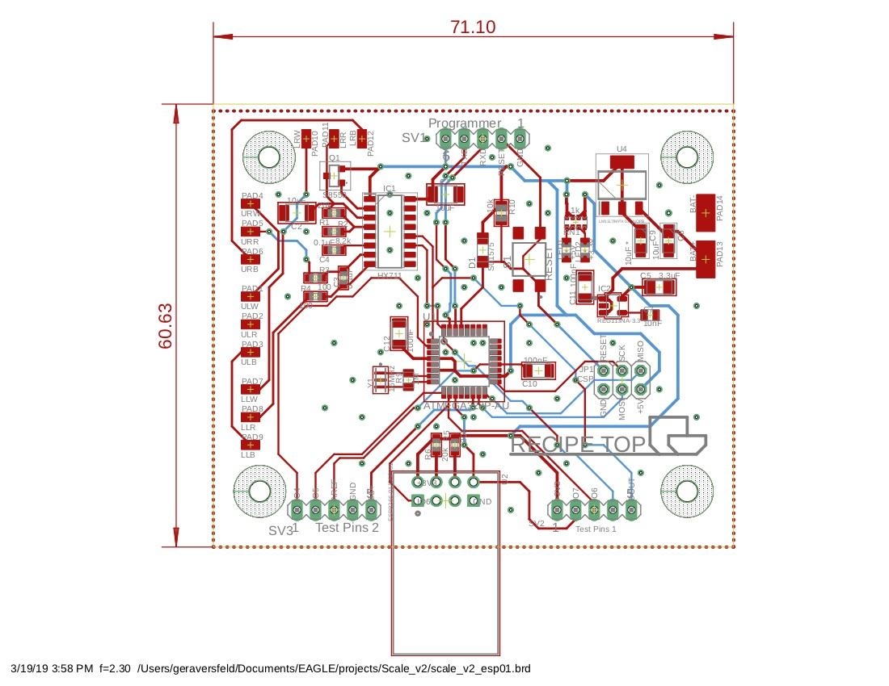

Fig. 7. Final PCB board layout.

### V. Software Design

Our approach to UX design, as well as core aspects of the database, and API design are summarized in the following section. The interaction between these core software components is illustrated below in figure 8.



Fig. 8. Block diagram illustrating major software components and flow of information through system.

*A. UX Design*

When the user logs in to their user account, the dashboard is displayed. From this page the user sees a collection of suggested recipes, and a navigation menu. The home page was left intentionally sparse to maximize the amount of counter space available for cooking tasks. The recipes will be displayed in a modal box, including the recipe’s name, whether or not it was favorited, difficulty rating, kitchen tools and ingredients used, and tags. From this modal, a user has the option to heart, edit, or begin following a recipe. When the user begins following a recipe, they are prompted to gather their ingredients then the method is presented along with access to an onscreen wireless scale and two timers. After completing a recipe users are asked to rate their experience and it’s difficulty.

*B. Database Design*

In order to create a good user experience, it is very important for the database to be fully optimized for the needs of the system as shown in figure 9.

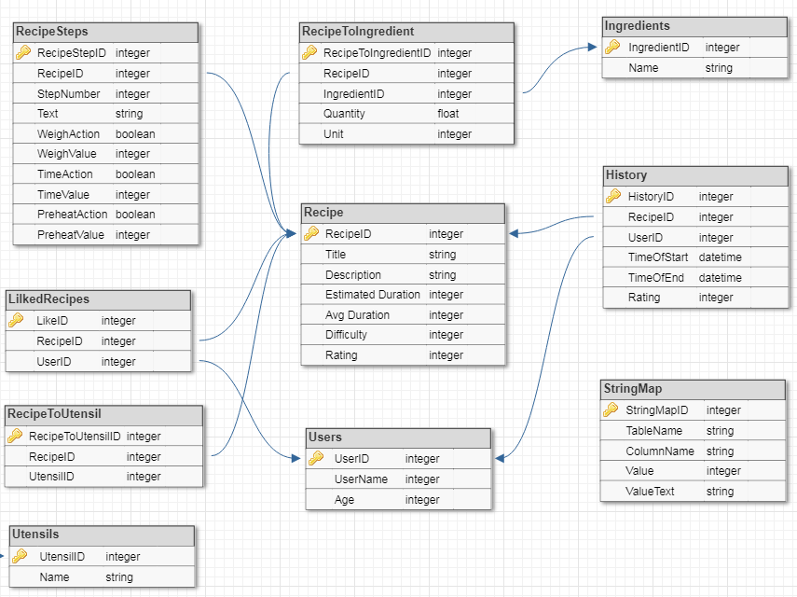

Fig. 9. Summary of Database Design.

As the full stack application will be running on a single board computer, one of the most important restrictions will be the memory, both RAM and hard disk. Queries need to be optimized in order to minimize the RAM usage. This can be achieved by limiting CTE (Common Table Expressions) usage. Additionally, the tables of the database need to be optimized in order to reduce space on the hard disk. More specifically, the database will be designed to minimize repetition of all data, but most importantly strings.

There are two primary ways to optimize the database tables in order to save space. The first way is to split up lists of objects into two smaller tables. The first table is a mapping table, and the second table is the literal table. This ensures that the space grows linearly as more lists are added, instead of multiplicatively. The second primary method to optimize database tables is to create a String Map table. The cost of storing strings is very high, so reducing this whenever possible is important for space optimization. The StringMap is a table that can be used as a single location for strings to be stored.

*C. API Design*

The API provides the application the ability to store and retrieve data from the database. It is important for the API to be well designed to be able to support the functionality of the application, the demand of the application, and the load of the application. The first important design choice that needs to be made is the method of sending data. As JSON (JavaScript Object Notation) is one of the most efficient and easy to use, it will be our primary format for sending and receiving data to and from the API. Another benefit for using JSON is the for the application’s front-end development. As the front-end functionality code is primarily JavaScript, which stores all of its object in the JSON format, it is very easy for the front-end to pass data to the API.

Considering RecipeTop will revolve around storing and executing recipes, a data structure must be defined for the recipes. See Figure 38 for the data structure. This structure will be used by the API in two ways. The first way will be when the application’s front-end has to send recipe data to the API. The front-end will Stringify the object into a JSON string and POST the string to an API endpoint. The second use for the recipe data structure is when the API has to return recipe data. First, the API must gather all of the recipe data from the database. Then, the rows have to be converted into classes, lists of classes, and fields following the same structure as the recipe data structure. Finally, the structure is serialized into a JSON string and returned from the API function as the response to the POST command.

*D. Software WIFI Connection to Wireless Scale*

In order to seamlessly integrate the communication between the scale and the application, there are several steps that need to occur. The first step is the communication between the scale and the single board computer. For this communication we will use the wireless communication technology Wi-Fi. Both the single board computer and the scale will be connected to the same network. Then, the single board computer will be running a process, separate to the application and the web server, that will host a server socket on a specific port. Once the socket is open, the scale will be able to open it’s own socket connecting to the server and allowing for TCP/IP packets to be sent between the two machines.The communication will consist of the scale periodically sending the current weight data to the single board computer.

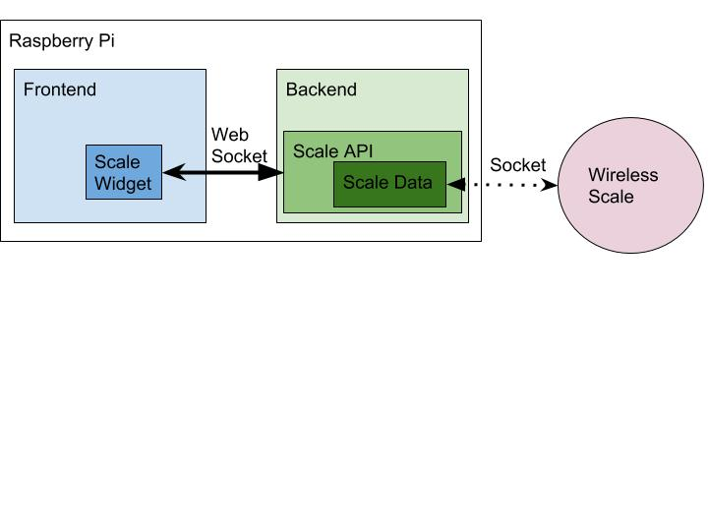

Fig. 10. Wireless communication between scale and front end of the web app.

The second step of seamless communication between the scale and the application is the communication between the new process described above and the front-end. This communication will be achieved using WebSockets. WebSockets are a communication protocol that extends HTTP and enables full-duplex communication over a single TCP connection [7]. Full-duplex communication allows for bi-directional communication that can happen simultaneously. WebSockets allow communication between the client and the webserver with low overhead enabling real time communication. Additionally, they allow for data to be transmitted to the client without the prerequisite of a prompt from the client. Finally, WebSockets extends TCP to allow for streams of messages instead of only streams of packets.

We integrated the scale process with the web server framework as shown above in figure 10. The largest benefit this will provide is the ability to completely bypass the back end of the application. With the use of WebSockets we will be able to both send commands to the scale and receive a stream of data from the scale. Another benefit to the WebSockets is their ability to be persistent. Therefore, we only have to make the server socket for the scale once. The only drawbacks of WebSockets are the small overhead of additional memory and the need for memory management. However, Python already has garbage collector and, the drawback of extra memory is worth the speed improvement.

V. Testing and System Functionality

Significant testing was performed on both individual components and subsystems as well as the system as a whole to ensure proper functionality and the best possible user experience. Whenever possible, the original engineering requirements were revisited and measures were taken to ensure they had been met.The wireless scale was thoroughly tested and calibrated to ensure its accuracy and precision. The wireless scale was able to transmit data to the countertop with an accuracy below the specified error tolerance of 5 grams with a latency of about 1-2 seconds. It was important to understand how linearities in the system might affect the performance. One concern was the small slippage in voltage that occurred if the masses were left on the scale for prolonged periods of time. Readings were taken over a period of 12 minutes, and it was determined that the overall scale performance would not be significantly affected by the slippage as illustrated below in figure 11.

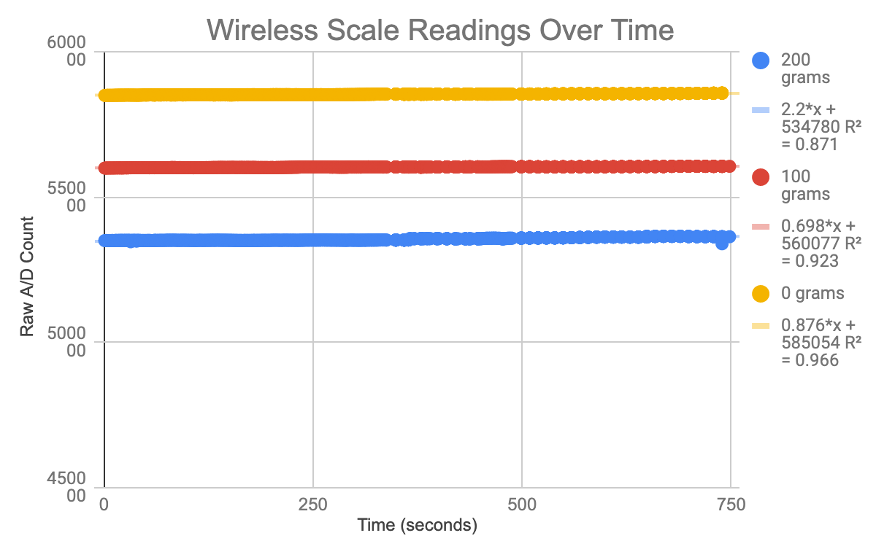

Fig. 11. Scale Readings over time

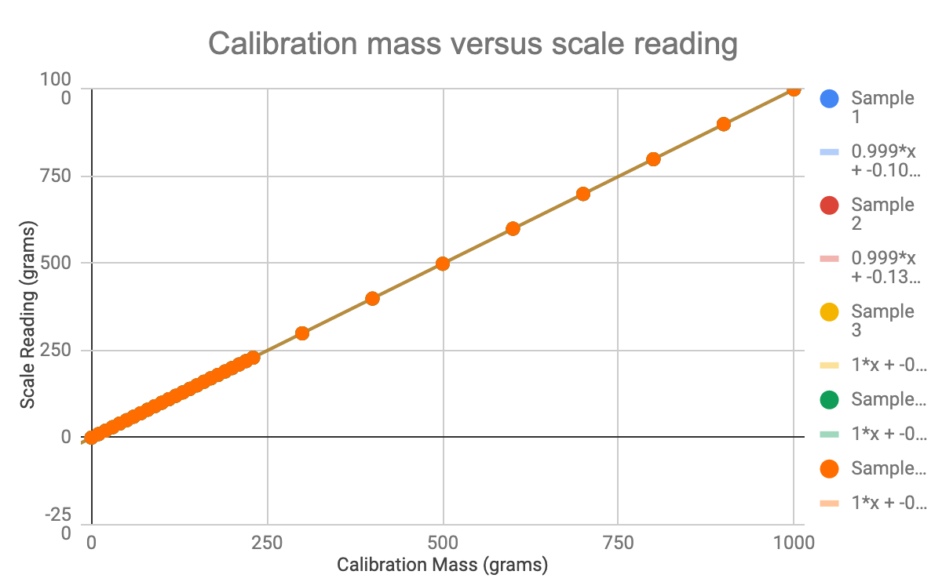

Fig. 12. Scale Readings compared to Calibration Masses

After calibration, readings from a scale were compared to a set of calibration masses to ensure the scale’s accuracy, and it was confirmed that the scale operated linearly over the range from 0-1 kg with a mean squared error of 0.39 grams. This is shown above in figure 12.

The touch enabled display was also tested to ensure the UI was intuitive and responsive. Additionally further testing ensured proper integration of the scale from arduino code through its front end display. Samples of the UI and are included below in figures 13-15.

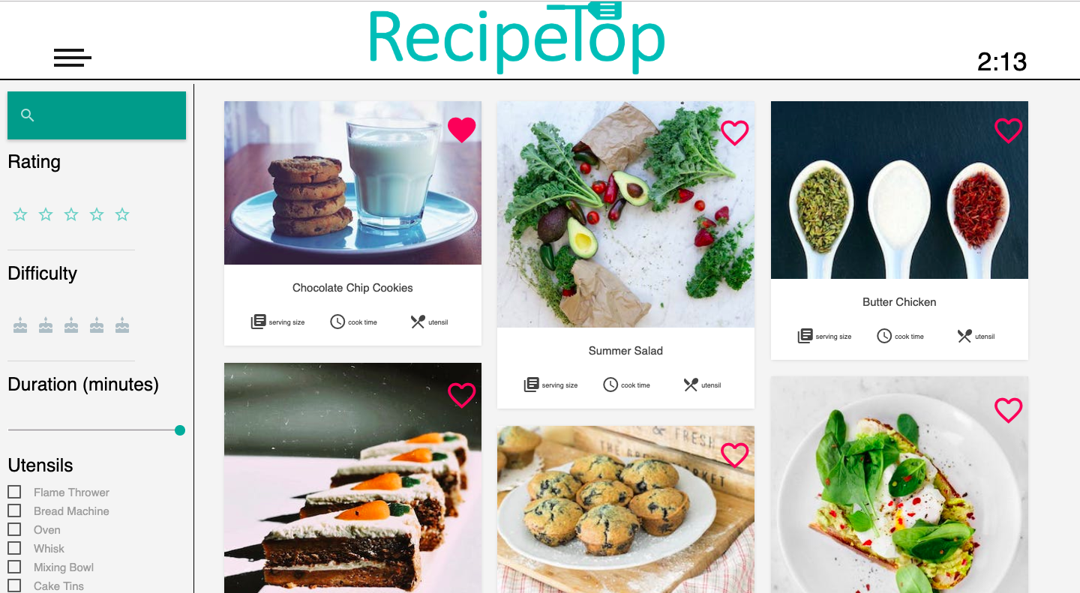

Fig. 13. Recipe Search Page, filter recipes by text, rating, difficulty, duration, utensils, and ingredients.

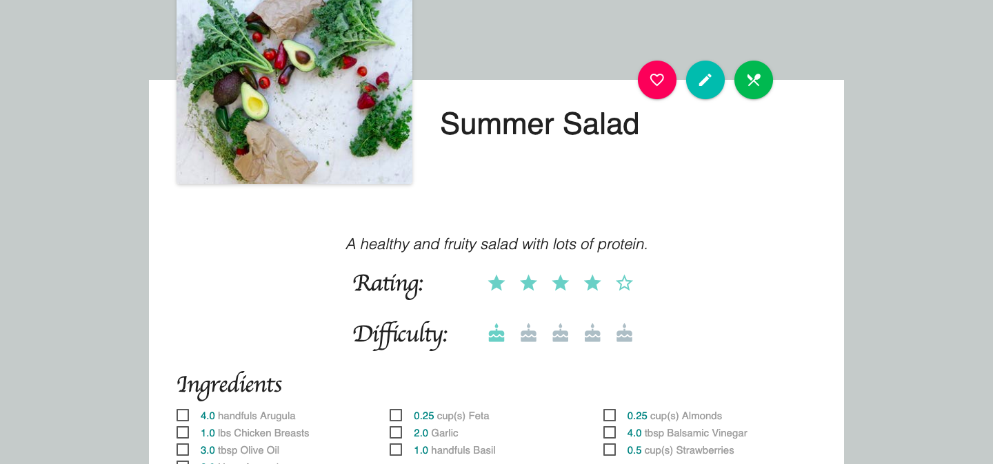

Fig. 14. Recipe Card

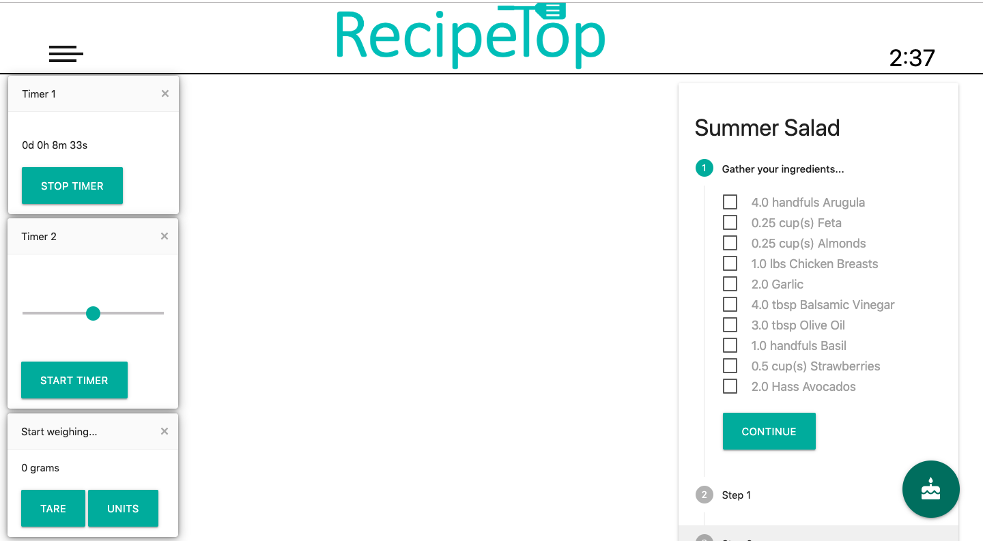

Fig. 15. Recipe Execution Page, with capability to intuitively set centralized timers and integrate with the wireless scale.

VII. Conclusion

RecipeTop is an interactive countertop and recipe preparation assistant, designed to make cooking a more enjoyable experience. The major components of the system are the touch screen display, the recipe management application, and a Raspberry Pi for the central processing. Additionally, we wirelessly integrate a scale to allow the users to seamlessly weigh ingredients.

### Acknowledgement

The authors wish to acknowledge the assistance of the TI Innovation Lab and the Senior Design Lab and its staff.

### References

[1] Barrett, G. and Omote, R. (2010). Projected Capacitive Touch Technology. 3rd ed. [ebook] Information Display, pp.16-21. [Accessed 1 Nov. 2018].

[2] Chen, C. (2018). Alibaba Manufacturer Directory [online] Message.alibaba.com. [Accessed 1 Nov. 2018].

[3] “Data Journey,” 17-Jul-2018. [Online]. datenreise.de [Accessed: 12-Nov-2018].

[4]"0.75" Diameter Stainless Steel Compression Load Cell, 0-25 to 0-1,000lb Capacities", Omega.com, 2018. [Online]. [Accessed: 14- Nov- 2018]

[5]"Alibaba Manufacturer Directory", alibaba.com, 2018. [Online]. [Accessed: 14- Nov- 2018]

[6] "Django Channels - Channels 2.1.5 documentation", Channels.read thedocs.io, 2018. [Online]. [Accessed: 01- Dec- 2018].

[7] Fette, I. and Melnikov, A. (2011). The WebSocket Protocol. Internet Engineering Task Force.

### Biography

**Geraldine Versfeld** is an Electrical Engineer graduating in Spring 2019. She is a former UCF Programming Team member and has research experience in Computer Vision. 

**Jason Portillo** is a Computer Engineer graduating in Spring 2019. He is a previous UCF Programming Team member and is doing research in Hardware Security. Jason will begin working at Google in May 2019.



**Edwin Santiago** is an Electrical Engineer graduating in Spring 2019. He currently works for Interplan LLC where he strives for a full-time position upon graduation.



**Miguel Ramirez** is a CPE student graduating in spring 2019. He currently works for Parsound and will look for other jobs in the web development field upon graduation.