  Checkpoint IV | Checkpoint IV: Second Prototype
 | Group: | G43
 | Date: | 2025/10/01

Prototype Architecture
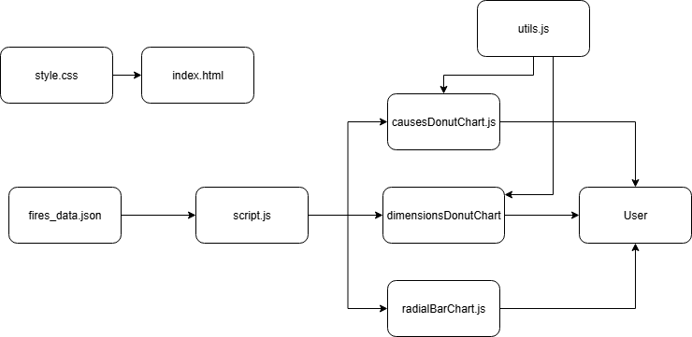
- causesDonutChart.js - implements the createCausesDonutChart() function. Contains the logic for data aggregation, scales, rendering arcs and labels, and user interactivity (hover highlights and displaying segment information in a tooltip near the cursor). It builds the Donut Chart that visualizes the distribution of fire causes.
- dimensionsDonutChart.js - it is similar to causesDonutChart.js but this one builds the Donut Chart that visualizes the distribution of fire dimensions.
- util.js - defines the color palette used in both Donut Charts and provides the switchChart() function, which contains the logic to determine which Donut Chart is displayed on the user’s dashboard.
- radialBarChart.js – performs the same functions as in the previous checkpoint, with the addition of an animation where the bars grow whenever a new region is selected.

All other files perform the same functions as described in the previous checkpoint, with updates to support the two newly implemented charts.

Dashboard Layout
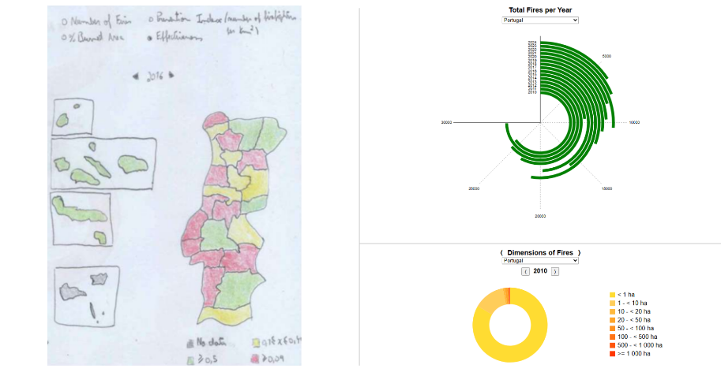

Right now, our dashboard is divided into 3. On the left side we have Choropleth Chart (not implemented) of NUTS-III regions of Portugal that allows comparison across four indicators for the selected year (2010-2024): number of fires, percentage of burned area, efficiency index (firefighters per fire), and prevention index (firefighters per km²). A year selector with arrows lets users browse yearly snapshots, while a filter panel enables them to switch between metrics. The map uses a color scale from teal (good, not green because) to yellow (moderate) to red (bad) for intuitive comparison. Teal was chosen instead of green to improve accessibility for color-blind users, as teal offers stronger contrast against red and yellow in most common types of color vision deficiency. On the right side, the Radial Chart is displayed, now enhanced with an animation where the bars grow whenever a new region is selected. We placed it above the Donut Charts because it conveys more information and we want users to view it first. Below it, a Donut Chart is shown, including an arrow control that allows the user to switch between the two Donut Charts (already implemented).

Data Processing
The data preprocessing required for this checkpoint remains unchanged from the previous phase. No additional transformations were necessary, as the dataset was already structured in a way that could be directly integrated into the visual idioms.

Chart Interaction
The donut charts are interactive. When the user hovers over a slice, it highlights and a tooltip appears, displaying the exact number of fires for that cause/dimension. The dropdown menu functions the same way as in the radial bar chart, allowing the user to select the sub-region and automatically updating the chart accordingly. In addition, two arrow buttons are available to switch between the “Dimensions” and “Causes” views and to change the year analyzed, ensuring smooth navigation between the different perspectives of the data. Whenever the region or year is changed, the slices animate by growing or shrinking to reflect the updated values, making the transition clearer and more engaging for the user.
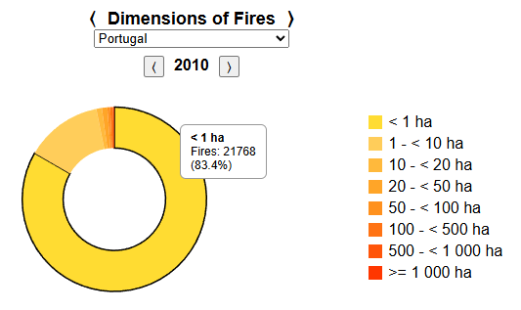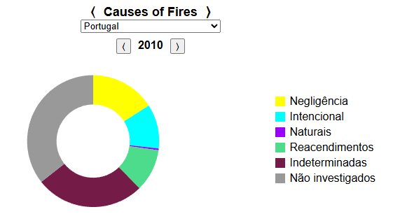

Chart Integration
No additional integration steps were required in this phase. The modular architecture designed in the previous checkpoint, where each chart is implemented as an independent function with its own container and update logic, continues to ensure smooth integration. This setup makes it straightforward to add new charts, and the separation of views is preserved both visually and functionally.

