  Checkpoint II | Checkpoint II: Visualization Sketch
 | Group: | G43
 | Date: | 2025/09/18

Dashboard Overview
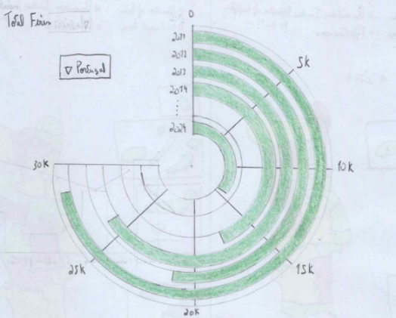
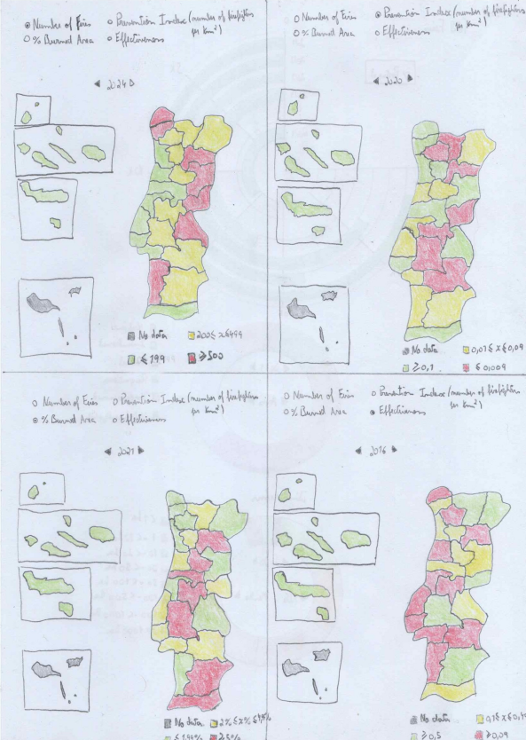
The dashboard combines temporal and spatial perspectives to explore fire activity and prevention in Portugal (2010–2024). At the top, a radial bar chart with a dropdown menu shows the annual number of fires, either for Portugal as a whole or by NUTS-III regions (NUTS-2024), giving users a quick view of long-term trends.
Beneath it, a choropleth map of NUTS-III regions allows comparison across four indicators for the selected year: number of fires, percentage of burned area, efficiency index (firefighters per fire), and prevention index (firefighters per km²). A year selector with arrows lets users browse yearly snapshots, while a filter panel enables switching between metrics.
The map uses a color scale from teal (good) to yellow (moderate) to red (bad) for intuitive comparison. Together, the bar chart and map support both overview (national trends) and drill-down (regional differences) tasks, giving users a clear, interactive understanding of fire evolution and prevention efforts.

Charts
The project will use four visualization idioms: a radial bar chart showing the number of fires per year for Portugal or by NUTS-III regions (NUTS-2024); a choropleth map of NUTS-III regions displaying fires, burned area percentage, efficiency index, or prevention index depending on the selected filter; and two donut charts showing fire causes and fire size distribution for a chosen region and year.

Chart #1
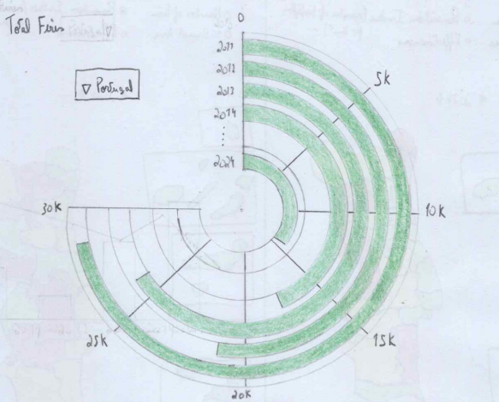

Marks and Channels
The radial bar chart uses circular bars, one for each year in the dataset. The main visual channel is bar length, represented by the radial distance from the center, which encodes the number of fires (a quantitative variable). Years are arranged chronologically around the circle, with angular position encoding time, while a uniform green fill ensures consistency and avoids distracting from length comparisons. Reference values such as 5k or 10k are provided through axis ticks and labels, helping users interpret bar lengths precisely.

Rationale
The radial bar chart was chosen instead of a standard bar chart to emphasize the cyclical nature of yearly data and to provide a compact visualization that integrates smoothly into the dashboard layout. Length is an effective channel for quantitative comparison, and arranging years radially helps highlight variations over time while maintaining visual appeal.

Interaction
A drop-down menu allows users to switch between Portugal as a whole or a specific NUTS-III region (NUTS-2024), updating the chart accordingly. Hovering over a bar highlights it for better visibility, and clicking a bar reveals a pop-up with the exact number of fires for that year, supporting more precise analysis beyond visual estimation.

Chart #2

Marks and Channels
The choropleth map represents Portugal’s NUTS-III regions (NUTS-2024) as polygons, with fill color encoding the selected indicator: number of fires, percentage of burned area, efficiency index, or prevention index. The chosen color scale follows a hue progression from teal to yellow to red, which communicates performance in an intuitive way—teal reflects good outcomes, yellow indicates moderate, and red highlights poor results. Neutral-colored borders preserve the visibility of geographic boundaries, while the position of each polygon matches its real geographic location to ensure accurate spatial comparisons.

Rationale
The choropleth map provides an intuitive way to compare regions spatially, as geographic boundaries are directly tied to the data of interest. Color is an effective channel for representing ratio and magnitude variables across areas, enabling quick identification of high- and low-performing regions. The chosen color scale leverages intuitive associations with “good” (teal) and “bad” (red), which supports interpretation at a glance. The inclusion of multiple filters increases flexibility, allowing users to analyze not only fire occurrence but also efficiency and prevention efforts.

Interaction
Users can interact with the map through several mechanisms. A year selector with arrows allows them to move through time between 2010 and 2024, updating the visualization. Filters let them switch between indicators by clicking on the desired option. Hovering over a region highlights it for clarity, and clicking on it reveals detailed information for that year, including two donut charts of fire causes and fire dimensions as well as accompanying text on the number of firefighters and the percentage of burned area.

Chart #3
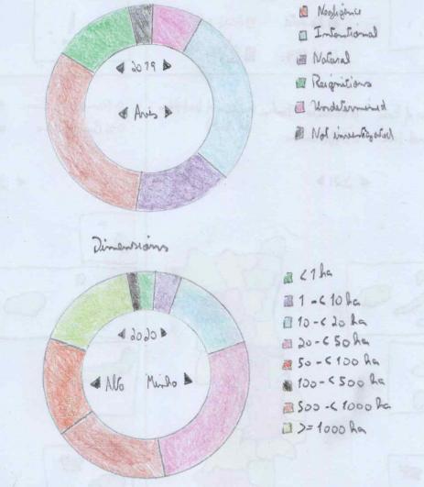

Marks and Channels
The donut chart displays fire causes as arcs arranged in a circular ring, with each arc corresponding to one category such as negligence or intentional origin. Arc length and angle encode the proportion of fires attributed to each cause, while distinct colors differentiate between categories and ensure they are easily distinguishable. The sequential arrangement of arcs around the circle allows all categories to be visible simultaneously.

Rationale
The donut chart was chosen to represent the distribution of categorical data (fire causes) in a visually intuitive way. Arc length/angle is an effective channel for comparing proportions, and distinct colors help differentiate between categories.

Interaction
Interaction is straightforward: when the user hovers over an arc, the corresponding segment is highlighted to improve visibility and focus. Clicking on an arc displays a pop-up with the exact number of fires for that cause, offering precise information beyond visual estimation.

Chart #4

Marks and Channels
The second donut chart represents fire size distribution, with arcs arranged in a circular ring where each arc corresponds to a fire size class, such as less than 1 ha or 1–10 ha. The proportion of fires in each class is encoded through arc length and angle, while distinct colors differentiate the categories. Their sequential arrangement ensures that all classes are visible at once, and the hole at the center is reserved for labels or totals, improving readability while conserving dashboard space.

Rationale
The donut chart effectively communicates categorical proportions, making it well suited for showing the distribution of fire sizes across defined classes. Angle/arc length is a perceptually strong channel for relative comparison, while the use of distinct colors ensures categories are easily distinguishable. The donut format was chosen over a full pie chart to allow for integration of contextual labels (e.g., total fires) in the center and to maintain visual consistency with the fire causes chart.

Interaction
Interaction follows the same principles as Chart #3. When hovering over an arc, the corresponding segment is highlighted, drawing attention to that class. Clicking on a segment displays a pop-up with the exact number of fires in the selected size class, giving precise values in addition to the visual comparison.

Chart Integration
The main interaction occurs between the choropleth map and the donut charts. After selecting a year, the user can click on a specific NUTS-III region in the map. This action updates the dashboard with detailed information for that region and year: two donut charts display the distribution of fire causes and fire dimensions, while accompanying text provides the number of firefighters and the percentage of burned area. In this way, the choropleth offers a comparative overview across regions, and the linked donut charts and textual indicators allow users to drill down into regional details.

Answering the Questions
- Question 1: How has the total number of fires in Alentejo Central evolved over the past fourteen years?
  - To answer this, the user opens the bar chart dropdown menu, selects Alentejo Central, and observes the yearly progression of fire occurrences from 2010 to 2024.
- Question 2: Which regions have the highest number of fires in 2024, and how does this compare with the number of firefighters in each region?
  - The user navigates to 2024 on the choropleth map, applies the Prevention Index filter, and compares regional values. Regions shaded teal have more firefighters relative to fire occurrences, while yellow and red regions have weaker ratios, highlighting areas under more strain.
- Question 3: What is the distribution of fire causes within Algarve in 2024, and does it relate with the number of firefighters available?
  - The user selects the year 2024 on the choropleth map and clicks the Algarve region. The dashboard updates to show a donut chart with the distribution of fire causes for that year alongside the number of firefighters, allowing comparison between resources and fire origins.
- Question 4: How do fire causes and dimensions relate with the number of firefighters in Alto Minho in 2023?
  - The user selects 2023 on the choropleth map and clicks Alto Minho. The dashboard reveals two donut charts: one with fire causes and another with fire size distribution, as well as the number of firefighters available that year. Together, these visualizations highlight possible relationships between resources, fire origins, and fire scale.
- Question 5: Which regions have the most or fewest firefighters relative to the number of fires, and does this reveal patterns of high fire risk?
  - The user applies the Efficiency Index filter on the choropleth map. Teal regions indicate more firefighters per fire, while yellow and red highlight regions with higher fire risk due to limited resources relative to occurrences.
- Question 6: Is there a relationship between the number of fires and the number of firefighters in each region in 2020?
  - The user selects the year 2020 and activates the Efficiency Index filter on the choropleth map. The color-coded regions display the balance between fire occurrences and firefighter allocation, making it possible to spot potential mismatches.
- Question 7: How does the amount of burned area per firefighter vary across regions, and what does this suggest about prevention and response capacity?
  - The user selects the Prevention Index filter on the choropleth map. Teal regions show higher firefighter coverage per km², while yellow and red reveal weaker prevention and response capacity relative to burned area.

Storyboards
Frame 1: The choropleth map is set to 2024, showing regional values. The user clicks on Algarve.
Frame 2: The dashboard updates, zooming into Algarve’s details. A donut chart appears showing the breakdown of fire causes for 2024.
Frame 3: Alongside the donut chart, the dashboard displays the number of available firefighters for Algarve, enabling the user to compare whether the distribution of causes aligns with the allocated resources.

