  Checkpoint III | Checkpoint III: First Prototype
 | Group: | G43
 | Date: | 2025/09/26

Prototype Architecture

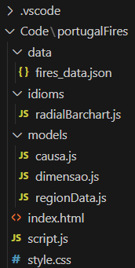

- fires_data.json - contains all our data.
- radialBarchart.js - implements the createRadialBarchart() function. Contains the logic for data aggregation, scales, rendering arcs and labels, and user interactivity (hover highlights, click pop-ups).
- causa.js - data model for a fire cause (cause name + number of occurrences).
- dimensao.js - data model for a fire dimension (dimension label + number of occurrences).
- regionData.js - data model for a single region in a given year, storing attributes like burned area, percentage, number of sapadores, efficiency/prevention indexes, total fires, causes, and dimensions.
- index.html - provides the basic structure of the web application. Loads D3 and all project scripts, defines the container for the charts, and runs init() when the page loads.
- script.js - acts as the entry point. Fetches and restructures the dataset (fires_data.json), creates RegionData objects, and initializes the visualizations (currently only the radial bar chart).
- style.css - defines the styling and layout of the application. Uses CSS Grid to organize the chart container, applies a clean font, and styles the chart controls (centered dropdown and label).

Dashboard Layout

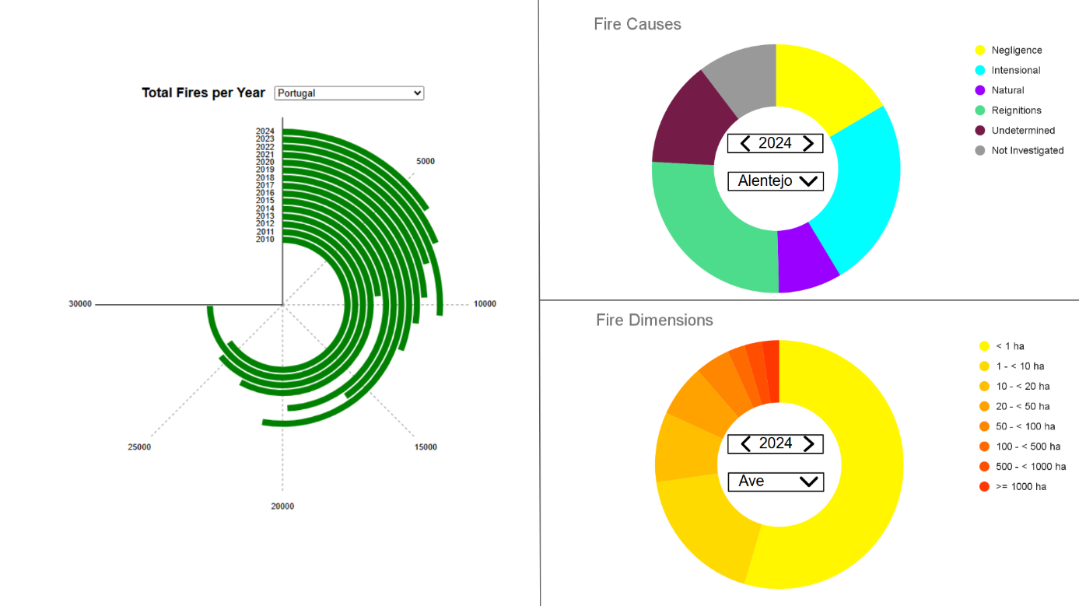

Our dashboard includes a radial bar chart (the one that is implemented) that displays the total number of fires per year, either for a selected Portuguese sub-region or for the entire country. The user can choose the desired sub-region, or Portugal as a whole, through the dropdown menu located above the chart.
It includes also two donut charts (not implemented yet). One of them displays the Fire Causes with bright different colors, because they represent nominal data, the other one displays the dimension of the fires with a continuous color gradient transitioning smoothly from yellow to red, because we are dealing with quantitative data. The user can choose the desired sub-region and year for each chart, through the dropdown menu located in the middle of the charts.
We also included two lines intentionally to separate the three charts, so that users understand they are independent — changing the filters on one chart only affects that chart.

Data Processing

Chart Interaction

The radial chart is also interactive: when the user hovers over a bar, its color changes to highlight the selection. By clicking on a bar, a pop-up layer appears, showing the exact number of fires represented and providing a button to close the pop-up. Changing the sub-region automatically updates the scale according to the number of fires, keeping the data clear and visible for the user.

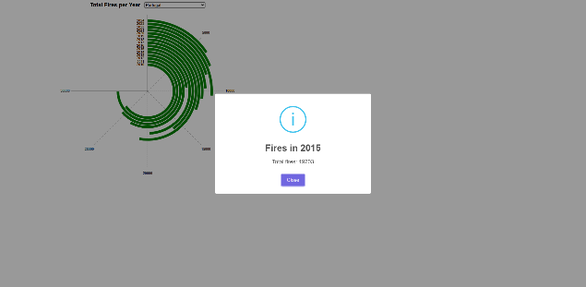
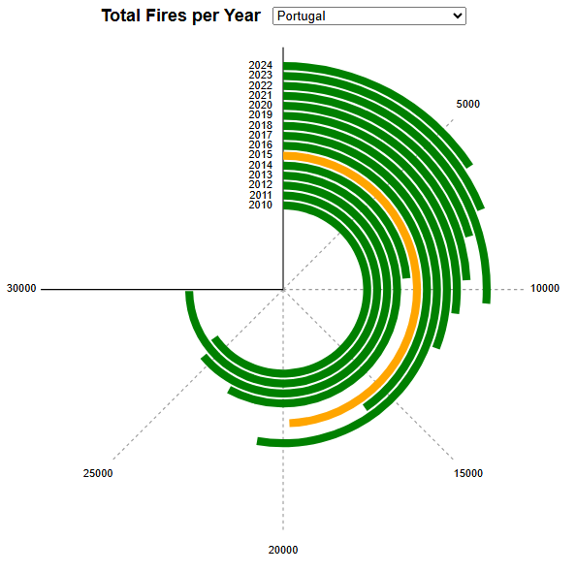

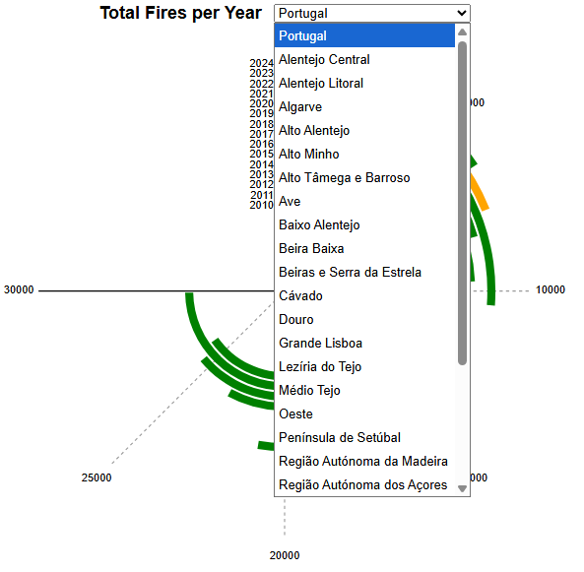
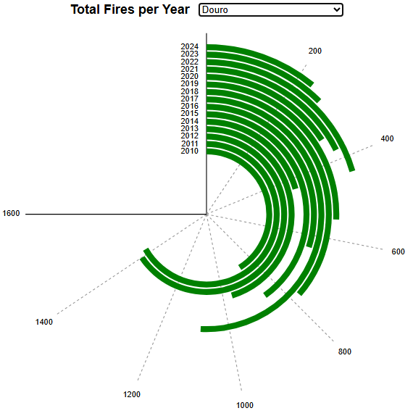

Chart Integration

Chart Integration

