  Checkpoint V | Checkpoint V: Third Prototype
 | Group: | G43
 | Date: | 2025/10/09

Prototype Architecture
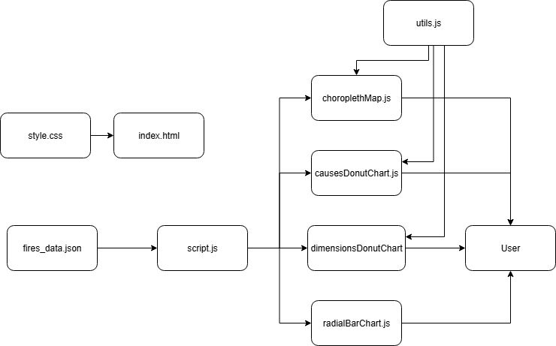

- causesDonutChart.js, dimensionsDonutChart.js, radialBarChart.js – perform the same functions as in the previous checkpoint
- utils.js – performs the same functions as in the previous, and now, defines the color palette for the choropleth map and has the functions to handle the legend, color selection and data used in the map
- choroplethMap.js - implements the createChoroplethMap() function. Contains the logic for scales, rendering arcs and labels, and user interactivity (hover highlights and displaying segment information in a tooltip near the cursor). It builds the Choropleth Map that visualizes the distribution of fire causes, prevention index (number of firefighters per km²), efficiency index (number of firefighters per fire) and percentage of burned area based on the filter selected.

Dashboard Layout
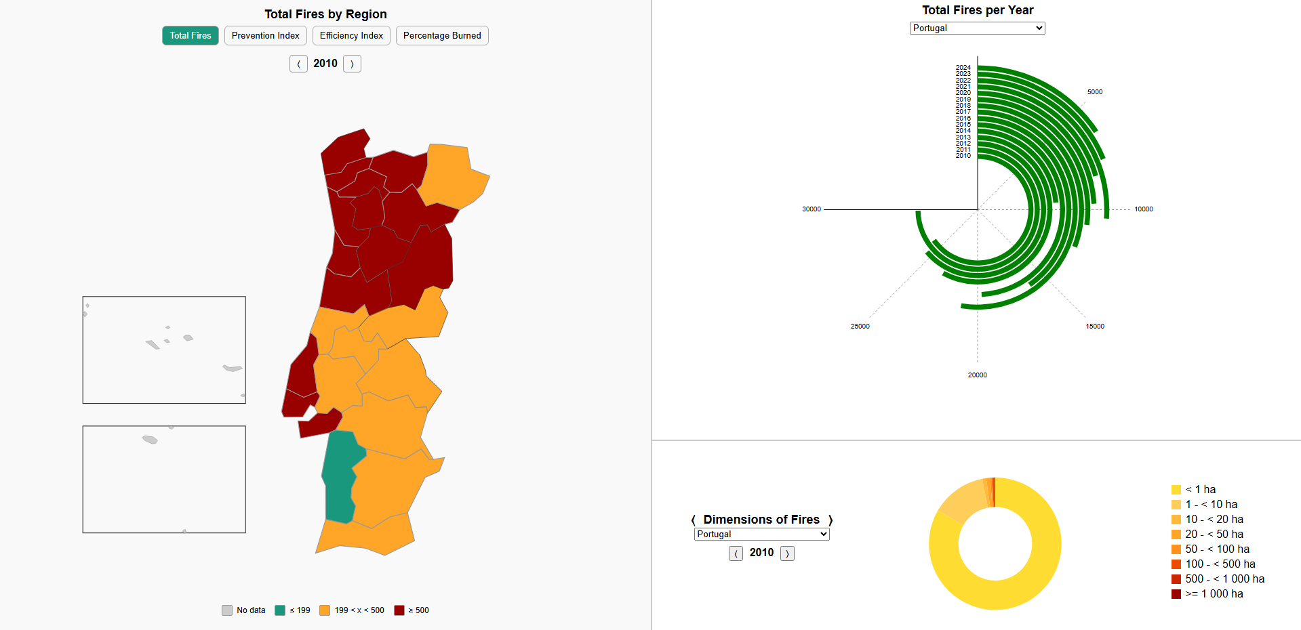
In this checkpoint the choropleth map was implemented without any change to the previously implemented charts. The dashboard maintains the same three-part structure established in the previous checkpoint. On the left side, the Choropleth Chart of NUTS-III regions of Portugal is now fully implemented. It allows comparison across four indicators for the selected year (2010–2024): Total Fires, Percentage of Burned Area, Efficiency Index (firefighters per fire), and Prevention Index (firefighters per km²). A year selector with arrow buttons enables users to browse yearly snapshots, while a set of four filter buttons allows switching between the different metrics. The map uses a color scale from teal (good) to yellow (moderate) to red (bad), maintaining accessibility for color-blind users by ensuring strong contrast across color categories. On the right side, the Radial Chart remains positioned above the Donut Charts. The radial chart features an animation where the bars grow whenever a new region is selected, emphasizing change and aiding user perception. Below it, the donut chart section includes arrow controls that allow switching between the “Dimensions” and “Causes” views. The spatial organization remains unchanged to ensure visual consistency and intuitive data exploration, while the implementation of the choropleth chart completes the left-side view of the dashboard.

Data Processing
The data preprocessing required for this checkpoint remains unchanged from the previous phase. No additional transformations were necessary, as the dataset was already structured in a way that could be directly integrated into the visual idioms.

Chart Interaction
The choropleth map is fully interactive and consistent with the interface and interaction logic established in previous charts. When the user hovers over a region, it highlights and displays a tooltip with the exact value for the currently selected metric, providing immediate feedback and aiding comparison across regions. The same arrow buttons used in previous charts allow changing the analyzed year, triggering smooth color transitions that animate the updated data values. In addition, four filter buttons are available to switch between different metrics: Total Fires (total number of fires by region), Prevention Index (number of firefighters per km² by region), Efficiency Index (number of firefighters per fire by region), and Percentage Burned (percentage of burned area by region). Whenever the selected filter or year changes, the color scale dynamically adjusts, and the map animates the color transition to clearly convey the data update and maintain user engagement. These interactive elements ensure an intuitive exploration of regional fire dynamics, aligning with the visual and interactive consistency of the dashboard’s other idioms.
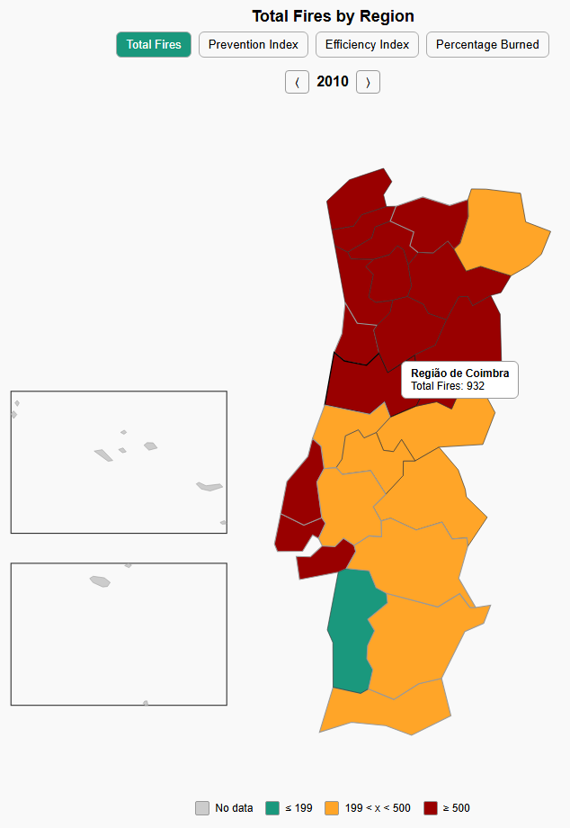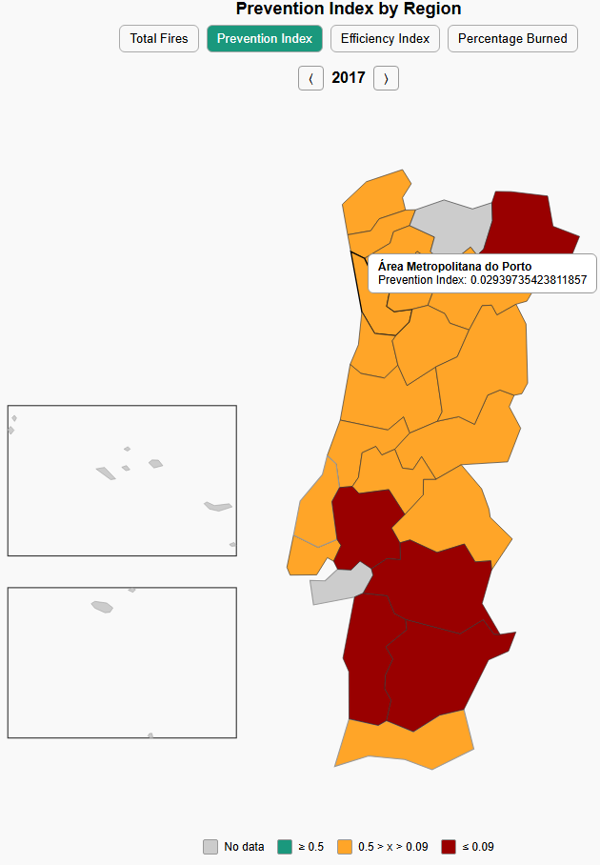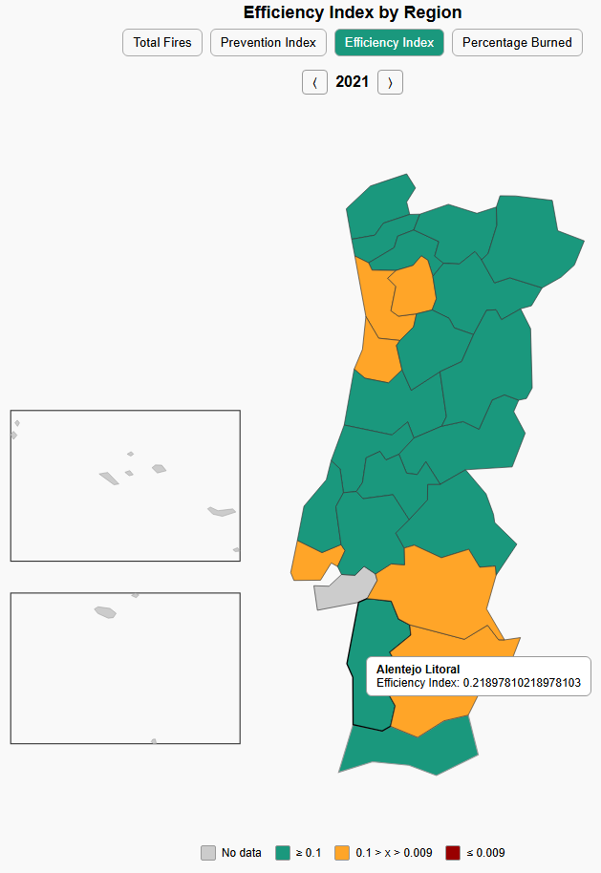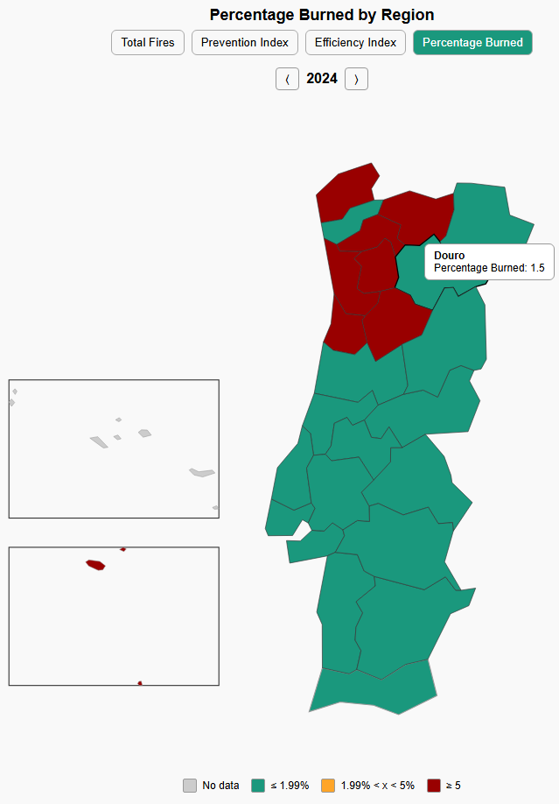

Chart Integration
No additional integration steps were required in this phase. The modular architecture designed in the previous checkpoint, where each chart is implemented as an independent function with its own container and update logic, continues to ensure smooth integration. This setup makes it straightforward to add new charts, and the separation of views is preserved both visually and functionally.

