Activity 1. The numerical square

|  |  |  |  |
| --- | --- | --- | --- |
| ***Test case*** | ***Number of solutions*** | ***Time for all solutions*** | ***Time for first solution*** |
| Test00 | 1 | 3 | 3 |
| Test01 | 2 | 105 | 22 |
| Test02 | Unknown | Oot | 46689 |

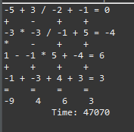

It takes a lot for the second test so I cannot determine how many solution it takes for all solutions.