**Exam.**

Normalize in first, second and third normal form. Make your outline, on any platform you want. Perform the 4 CRUD operations from java using a maven project.

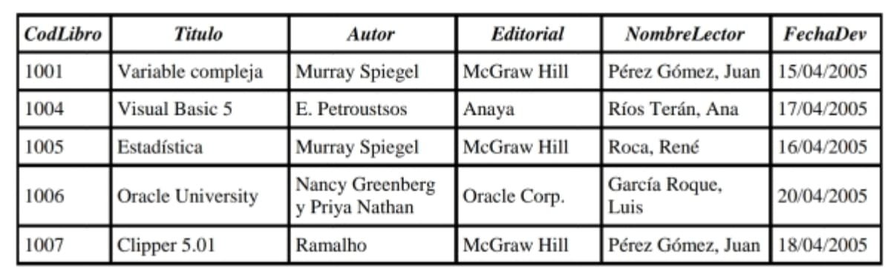

1FN

### **Tabla en 1FN**

|  |  |  |  |  |  |
| --- | --- | --- | --- | --- | --- |
| **CodLibro** | **Título** | **Autor** | **Editorial** | **NombreLector** | **FechaDev** |
| 1001 | Variable Compleja | Murray Spiegel | McGraw Hill | Pérez Gómez | 15/04/2005 |
| 1001 | Variable Compleja | Murray Spiegel | McGraw Hill | Juan | 15/04/2005 |
| 1004 | Visual Basic 5 | E. Petrouststos | Anaya | Ríos Terán | 17/04/2005 |
| 1004 | Visual Basic 5 | E. Petrouststos | Anaya | Ana | 17/04/2005 |
| 1005 | Estadística | Murray Spiegel | McGraw Hill | Roca | 16/04/2005 |
| 1005 | Estadística | Murray Spiegel | McGraw Hill | René | 16/04/2005 |
| 1006 | Oracle University | Nancy Greenberg | Oracle Corp. | García Roque | 20/04/2005 |
| 1006 | Oracle University | Nancy Greenberg | Oracle Corp. | Luis | 20/04/2005 |
| 1006 | Oracle University | Priya Nathan | Oracle Corp. | García Roque | 20/04/2005 |
| 1006 | Oracle University | Priya Nathan | Oracle Corp. | Luis | 20/04/2005 |
| 1007 | Clipper 5.01 | Ramalho | McGraw Hill | Pérez Gómez | 18/04/2005 |
| 1007 | Clipper 5.01 | Ramalho | McGraw Hill | Juan | 18/04/2005 |

División en 2FN

**Tabla de Libros**

|  |  |  |  |
| --- | --- | --- | --- |
| **CodLibro** | **Título** | **Autor** | **Editorial** |
| 1001 | Variable Compleja | Murray Spiegel | McGraw Hill |
| 1004 | Visual Basic 5 | E. Petrouststos | Anaya |
| 1005 | Estadística | Murray Spiegel | McGraw Hill |
| 1006 | Oracle University | Nancy Greenberg | Oracle Corp. |
| 1006 | Oracle University | Priya Nathan | Oracle Corp. |
| 1007 | Clipper 5.01 | Ramalho | McGraw Hill |

Tabla de Préstamos

|  |  |  |
| --- | --- | --- |
| **CodLibro** | **NombreLector** | **FechaDev** |
| 1001 | Pérez Gómez, Juan | 15/04/2005 |
| 1004 | Ríos Terán, Ana | 17/04/2005 |
| 1005 | Roca, René | 16/04/2005 |
| 1006 | García Roque, Luis | 20/04/2005 |
| 1007 | Pérez Gómez, Juan | 18/04/2005 |

3FN se mantiene la división anterior lo que significa que no tienen dependencias transitivas, y todos los atributos no clave dependen completamente de la clave primaria.

### **Tabla 1: Libros**

Esta tabla almacena información sobre los libros.

|  |  |  |  |
| --- | --- | --- | --- |
| **CodLibro** | **Título** | **Autor** | **Editorial** |
| 1001 | Variable Compleja | Murray Spiegel | McGraw Hill |
| 1004 | Visual Basic 5 | E. Petrouststos | Anaya |
| 1005 | Estadística | Murray Spiegel | McGraw Hill |
| 1006 | Oracle University | Nancy Greenberg | Oracle Corp. |
| 1006 | Oracle University | Priya Nathan | Oracle Corp. |
| 1007 | Clipper 5.01 | Ramalho | McGraw Hill |

### **Tabla 2: Prestamos**

Esta tabla almacena la información sobre los préstamos de los libros.

|  |  |  |
| --- | --- | --- |
| **CodLibro** | **NombreLector** | **FechaDev** |
| 1001 | Pérez Gómez, Juan | 15/04/2005 |
| 1004 | Ríos Terán, Ana | 17/04/2005 |
| 1005 | Roca, René | 16/04/2005 |
| 1006 | García Roque, Luis | 20/04/2005 |
| 1007 | Pérez Gómez, Juan | 18/04/2005 |

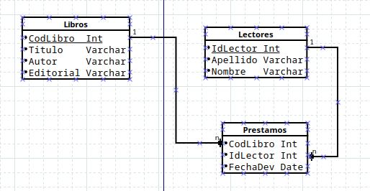

Operaciones CRUD

