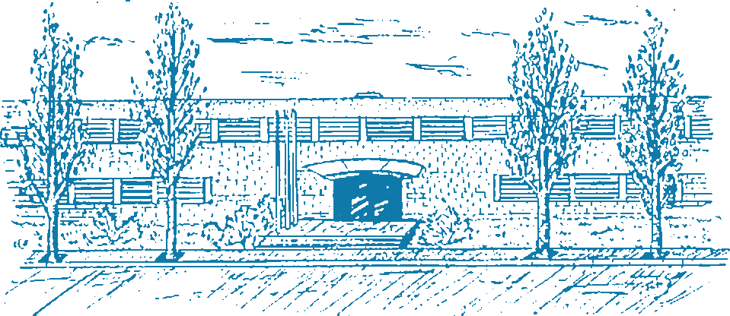

UNIVERSITAT POLITÈCNICA DE CATALUNYA - BarcelonaTech (UPC)
FME - FACULTAT DE MATEMÀTIQUES I ESTADÍSTICA

MASTER'S DEGREE IN STATISTICS AND OPERATIONS RESEARCH (MESIO UPC-UB)
MASTER’S THESIS

TRAFFIC SIMULATION WITH IRRATIONAL DRIVERS

Author: Miguel Ángel Donado Fernández
Director: Manuel Molano Mazón
Codirector: María Paz Linares Herreros
Department: Mathematics
Barcelona, May 27, 2026




