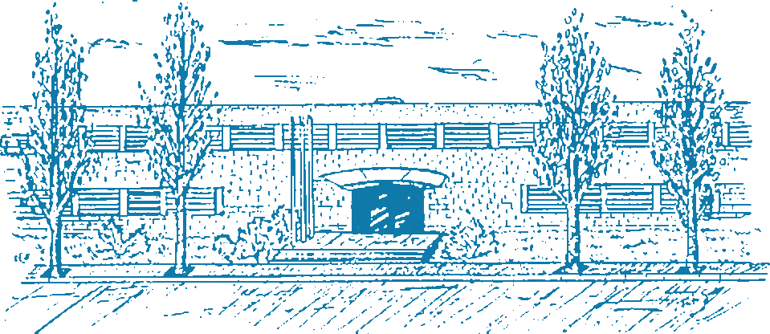

UNIVERSITAT POLITÈCNICA DE CATALUNYA - BarcelonaTech (UPC)
FME - FACULTAT DE MATEMÀTIQUES I ESTADÍSTICA

MASTER'S DEGREE IN STATISTICS AND OPERATIONS RESEARCH (MESIO UPC-UB)
MASTER’S THESIS

TRAFFIC SIMULATION WITH IRRATIONAL DRIVERS

Author: Miguel Ángel Donado Fernández
Director: Dr. Manuel Molano Mazón
Codirector: Dr. María Paz Linares Herreros
Departments: Department of Mathematics
Department of Statistics and Operations Research
Barcelona, Sep 20, 2026



