UNIVERSIDAD AUTÓNOMA DE MADRID
MÁSTER UNIVERSITARIO EN INGENIERÍA INFORMÁTICA
Procesamiento y Gestión de Datos Masivos (Curso 2024/25)
Laboratory 1: PROFILERS AND OPENMP
Zhijie Qian y Miguel

Indice
1. Perf (I)
2. Perf (II)
3. GPROF

1. PERF (I)

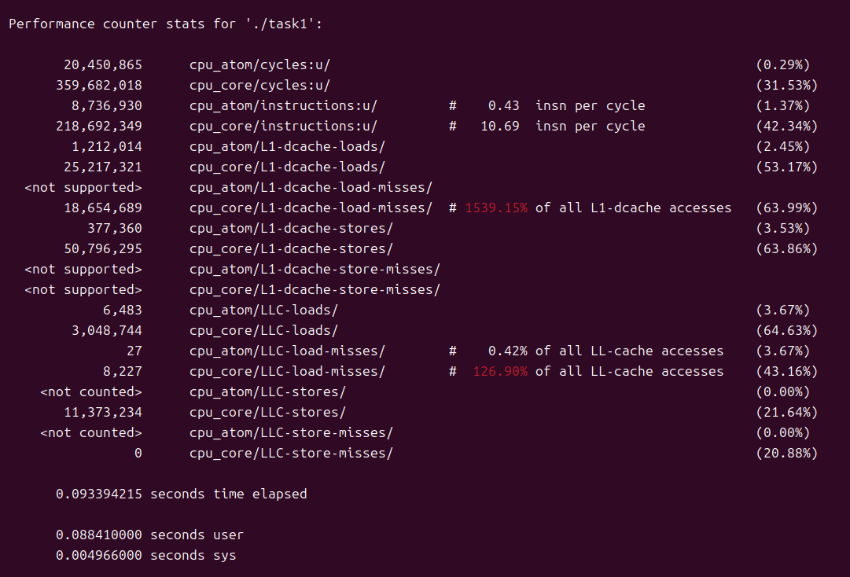
CPU Cycles
20,450,865 cycles on cpu_atom(efficiency core)
359,682,018 cycles on cpu_core(performance core)

Instructions
8,736,930 instructions executed in cpu_atom → 0.43 IPC
218,692,349 instructions executed in cpu_core → 10.69 IPC
Lower IPC means less efficient use of CPU cycles.

L1 Data Cache Loads
1,212,014 load operations on the cpu_atom
25,217,321 load operations on the cpu_core

L1 Data Cache Load Misses
cpu_atom did not provide data on L1 cache load misses.
18,654,689 load operations misses on the cpu_core.
1539.15% of all L1-dcache accesses on the cpu_core missed, which likely means a lot of L1 cache accesses went to higher cache levels, such as L2 or LLC.
- Modern CPUs use techniques like prefetching and speculative execution to speed up access to memory. Prefetching fetches data into the cache before it's actually requested by the program.
- If these speculatively fetched or prefetched data are missed and reloaded multiple times, this can result in multiple L1 cache load misses for a single load operation. CPU might speculatively fetch data, but later discover that it fetched the wrong data and discard it. It will then reload the correct data.
- In some multi-core systems, cache might lead to situations where cache lines are invalidated and reloaded multiple times, especially if different cores access the same data in quick succession. This can lead to extra cache misses being counted.
- The 1539.15% value is likely not a simple ratio of load misses to total loads. Instead, it's reflecting how many more cycles are spent handling the cache misses relative to normal cache accesses.

L1 Data Cache Stores
377,360 store operation on the cpu_atom
50,796,295 store operation on the cpu_core

L1 Data Cache Store Misses
The cpu_atom did not provide data on L1 cache store misses.
No data on L1 cache store misses was recorded for the cpu_core.

Last-Level Cache (LLC) Loads
6,483 load operation on the cpu_atom
3,048,744 load operation on the cpu_core

Last-Level Cache (LLC) Load Misses
27 load misses on the cpu_atom
8,227 load misses on the cpu_core

Last-Level Cache (LLC) Stores
No data was recorded for LLC stores by the cpu_atom.
11,373,234 store operation on the cpu_core

Last-Level Cache (LLC) Store Misses
No data for LLC store misses was recorded by the cpu_atom.
No LLC store misses were recorded by the cpu_core.

0.093394215 seconds: This is the total time elapsed for the task.
0.088410000 seconds user: This is the time spent by the task in user mode.
0.004966000 seconds sys: This is the time spent by the task in kernel mode.

Change array[j][i] ➔ array[i][j]

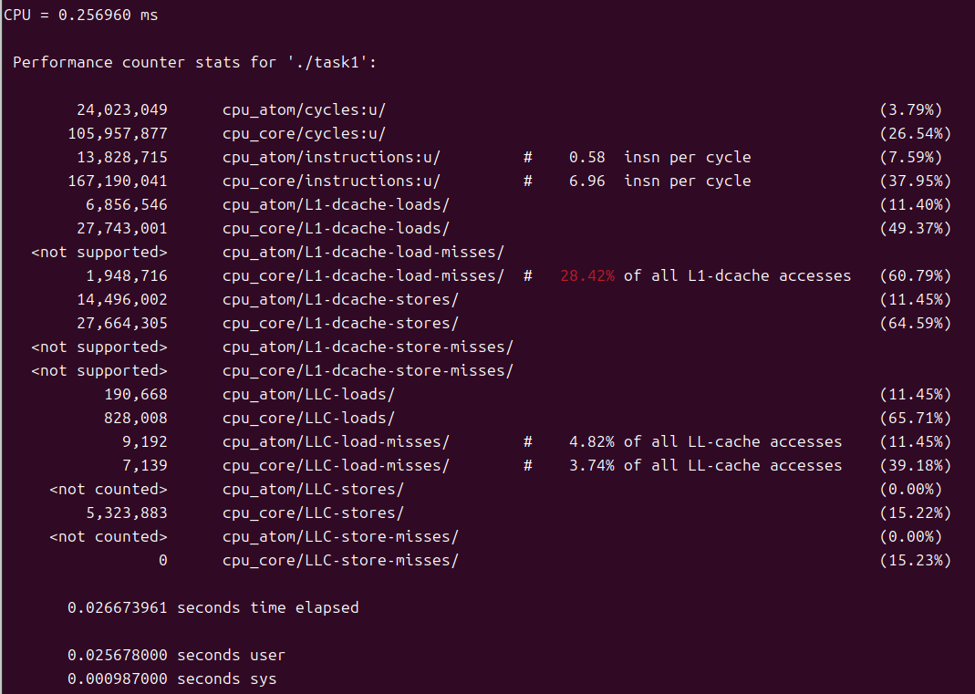
CPU Cycles
24,023,049 cycles on cpu_atom(efficiency core)
185,957,877 cycles on cpu_core(performance core)

Instructions
13,828,715 instructions executed in cpu_atom → 0.58 IPC
167,190,041 instructions executed in cpu_core → 6.96 IPC

L1 Data Cache Loads
6,856,546 load operations on the cpu_atom
27,743,001 load operations on the cpu_core

L1 Data Cache Load Misses
cpu_atom did not provide data on L1 cache load misses.
1,948,716 load operations misses on the cpu_core. Only 28.42% of L1 Data Cache Load

L1 Data Cache Stores
14,496,002 store operation on the cpu_atom
27,664,305 store operation on the cpu_core

L1 Data Cache Store Misses
The cpu_atom did not provide data on L1 cache store misses.
No data on L1 cache store misses was recorded for the cpu_core.

Last-Level Cache (LLC) Loads
6,483 load operation on the cpu_atom
3,048,744 load operation on the cpu_core

Last-Level Cache (LLC) Load Misses
9,192 load misses on the cpu_atom
7,139 load misses on the cpu_core

Last-Level Cache (LLC) Stores
No data was recorded for LLC stores by the cpu_atom.
5,323,883 store operation on the cpu_core

Last-Level Cache (LLC) Store Misses
No data for LLC store misses was recorded by the cpu_atom.
No LLC store misses were recorded by the cpu_core.

0.026673961 seconds: This is the total time elapsed for the task.
0.025678000 seconds user: This is the time spent by the task in user mode.
0.000987000 seconds sys: This is the time spent by the task in kernel mode.

Va mas rapido porque la mayoría de Load Misses desaparece, ya que las lecturas va en secuencial y no va por columnas, por lo tanto, la mayoría de los datos se encuentra en el cache y se puede acceder a él sin problema. Mientras que si vamos por columnas, es muy posible de que tras leer/escribir cierto dato, se tendrá que leer/escribir información de siguiente columna, de lo cual, tiene alta probabilidad de que no haya espacio suficiente en el cache y tendrá que solicitar espacio en el siguiente nivel de cache. Sobre todo, esto se puede notar en el último nivel de cache, donde segunda imagen produce menos lecturas.

i5-12450H

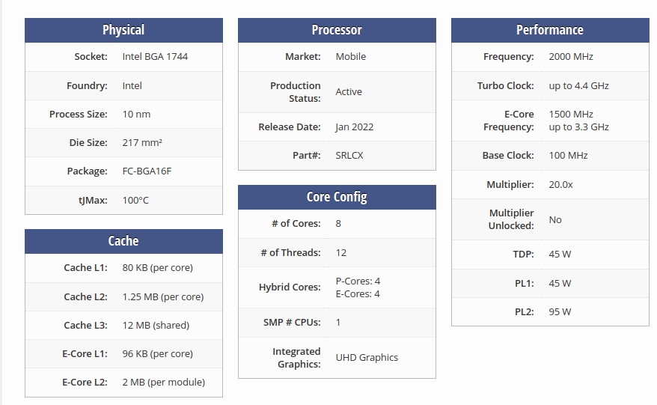

-O1: With -O, the compiler tries to reduce code size and execution time, without performing any optimizations that take a great deal of compilation time.
-O is the recommended optimization level for large machine-generated code as a sensible balance between time taken to compile and memory use: higher optimization levels perform optimizations with greater algorithmic complexity than at -O.
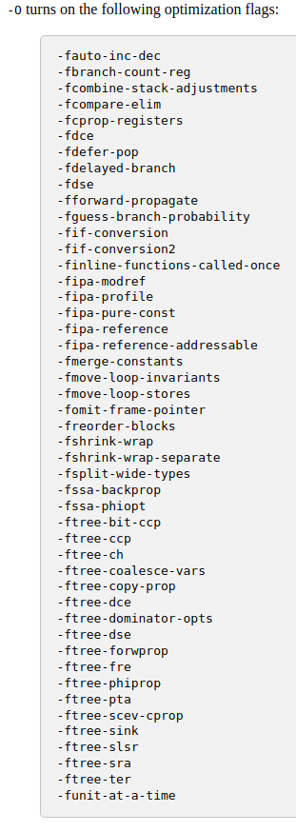

-O2: Optimize even more. GCC performs nearly all supported optimizations that do not involve a space-speed tradeoff. As compared to -O, this option increases both compilation time and the performance of the generated code.
-O2 turns on all optimization flags specified by -O1.
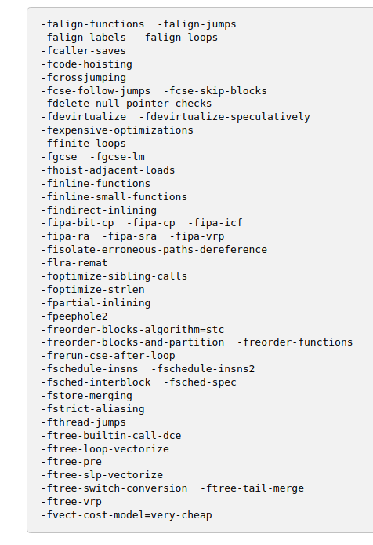

-O3: Optimize yet more. -O3 turns on all optimizations specified by -O2 and also turns on the following optimization flags:
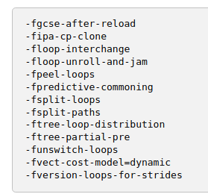
a
Gprof

OpenMP

Task1
- CPU Name: 12th Gen Intel(R) Core(TM) i5-12450H
- Number CPU: 12
- Number Core: 8
- Siblings: 12
- processor: 0
- physical id: 0
- core id: 0
- Number of core and Threads: 8 Cores + 12 Threads

Mpstat Num Thread 1
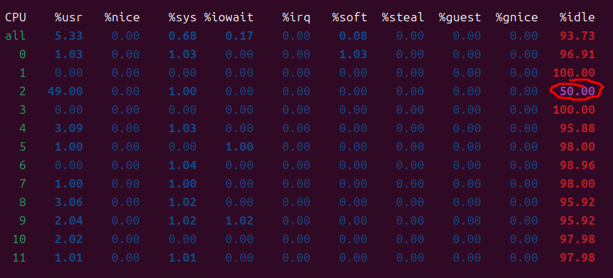
CPU time = 914 ms
Wall time = 457 ms

Mpstat Num Thread 2
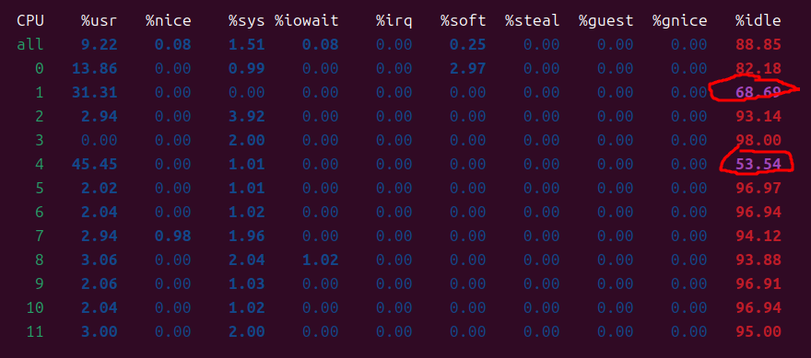
CPU time = 914 ms
Wall time = 457 ms
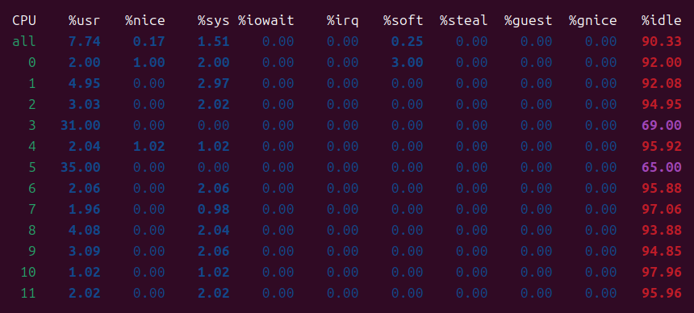
CPU time = 914 ms
Wall time = 457 ms
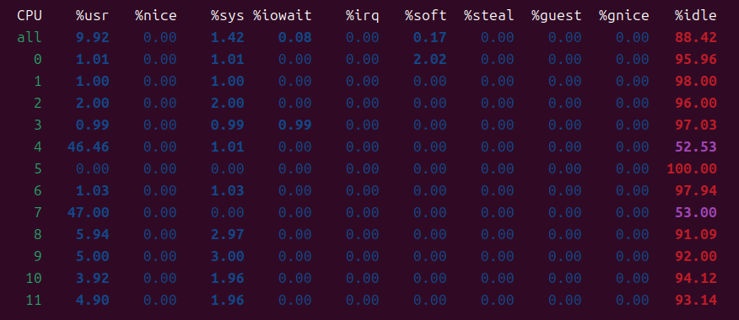
CPU time = 914 ms
Wall time = 457 ms

Speed Up:
Efficiency:

export GOMP_CPU_AFFINITY="2 3"
CPU time = 914 ms
Wall time = 457 ms
Speed Up:
Efficiency:

CPU time = 914 ms
Wall time = 457 ms
Speed Up:
Efficiency:

CPU time = 914 ms
Wall time = 457 ms
Speed Up:
Efficiency:

Mpstat Num Thread 4
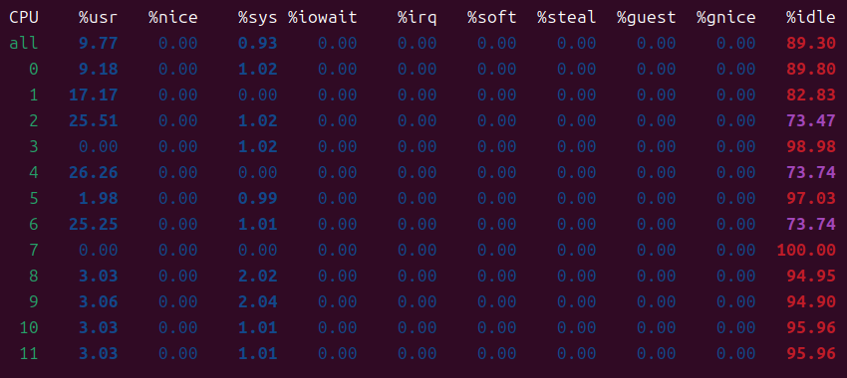
CPU time = 914 ms
Wall time = 457 ms
Speed Up:
Efficiency:

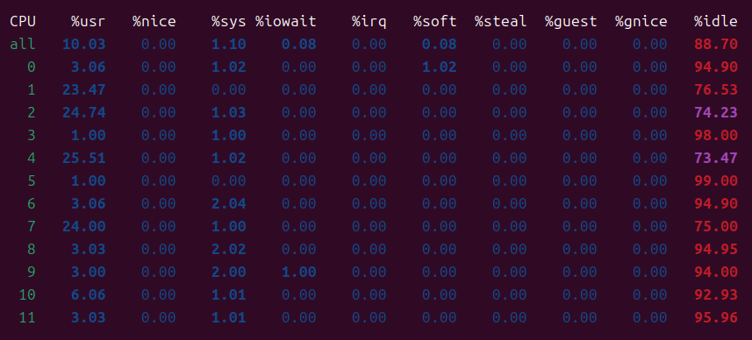
CPU time = 914 ms
Wall time = 457 ms
Speed Up:
Efficiency:

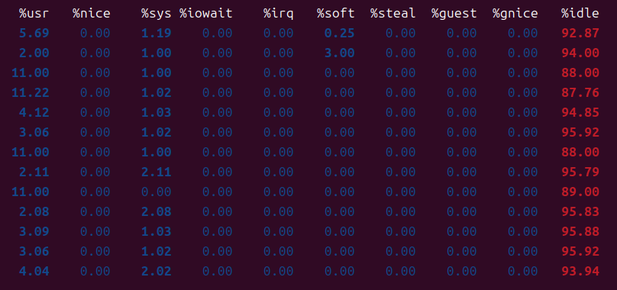
CPU time = 914 ms
Wall time = 457 ms
Speed Up:
Efficiency:

Task2
Pid Shared
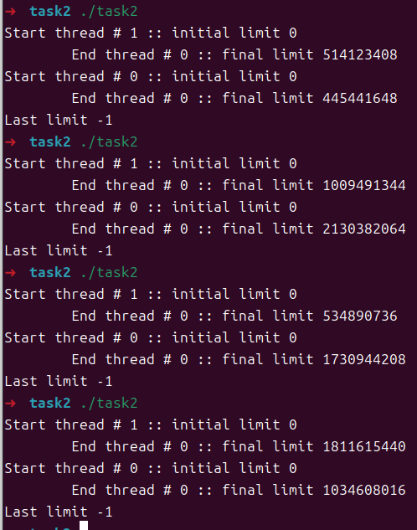
Pid private
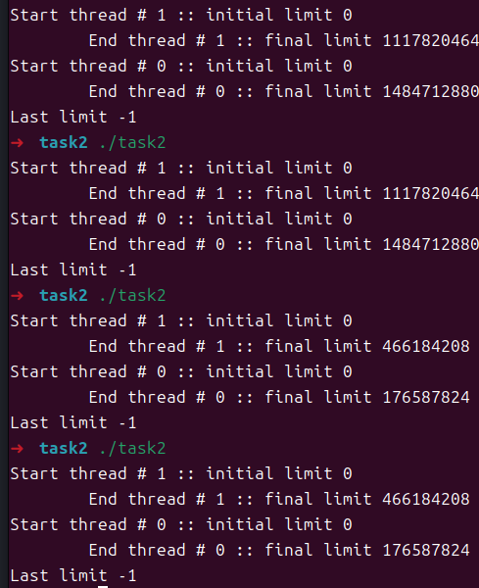
private(limit)

firstprivate(...)

Task3

