**Requirements:**

* If you’re using Windows, install Cygwin and then install Node.js version 4+
* If you’re using Linux or OSX just install Node.js 4+

## **OOP +** Modules **+** N**odejs**:

* Define the *times* method for the String objects, which receives a number and returns the string repeated that number of times:
  + i.e: “*”.times(5) ///prints “*****”
* Implement the following architecture in JS, with the following restrictions:
  + Each class should be a separate module.
  + Students can only enroll on a course if they have the required average grade
  + When a teacher grades a student, the student’s avg_grade attribute is recalculated (implement this using an observer pattern, feel free to re-work the uml if you need to)

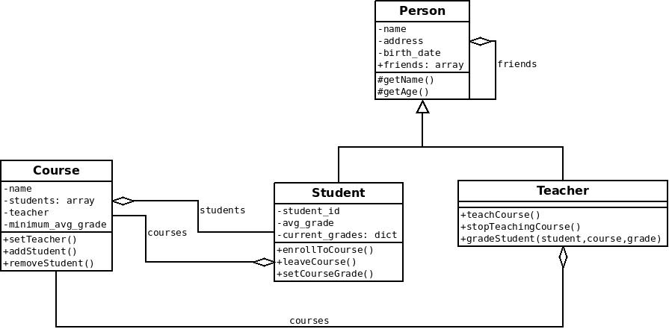

* Write a command line program that does the following:
  + Presents a menu with the following options:

1- Create a new student

2- Create a new teacher

3- Enroll student to a course

4- Get teacher to teach a course

5- Exit

Pick one> __

1. Option #1 will ask for the basic attributes of a student and then return to the main menu
2. Option #2 will ask for the basic attributes of a teacher and return to the main menu
3. Option #3 will list all students, all courses and will ask the user to choose which student to enroll to which course:

i,e:

Students:

* (12314) John Doe
* (12523) Jane Doe
* (12389) Christian Doe

Courses

* (8823) Maths with chop sticks
* (2195) Advanced computer programming in Brain F*ck
* (9283) How to build your own genetically modified killer puppy

Your input (student id, course id)>

4) Option #4 will list all teachers and all courses and ask the user to pick one of each (see option #3)

# Hoisting

* What is the output of each piece of code below and why?

(function () {  
 test = 5;  
  
 if (false) {  
 var test;  
 } else {  
 console.log(test + 2);  
 }  
}());

(function () {  
 test = 5;  
  
 if (false) {  
 var test = 3;  
 } else {  
 console.log(one(test));  
 }  
  
 function one(value) {  
 return value + 1;  
 }  
}());

(function () {  
 var test = 5,  
 one = (function one(value) {  
 if (value > 2) {  
 return one(value - 1);  
 }  
 return value - 1;  
 }(test));  
  
 console.log(one);  
}());

(function () {  
 console.log(one(3));  
  
 var test = 5,  
 one = (function one(value) {  
 if (value > 2) {  
 return one(value - 1);  
 }  
 return value - 1;  
 });  
  
 console.log(one(test));  
  
 var identity = (x => x)(4);  
}());