**Exercise 3: Installing Ubuntu**

1. **Creating the virtual machine**

In this first step I’m assigning the 2GB RAM, the 30GB of HDD capacity and creating the VDI dinamically allocated on a external storage unit that I have.

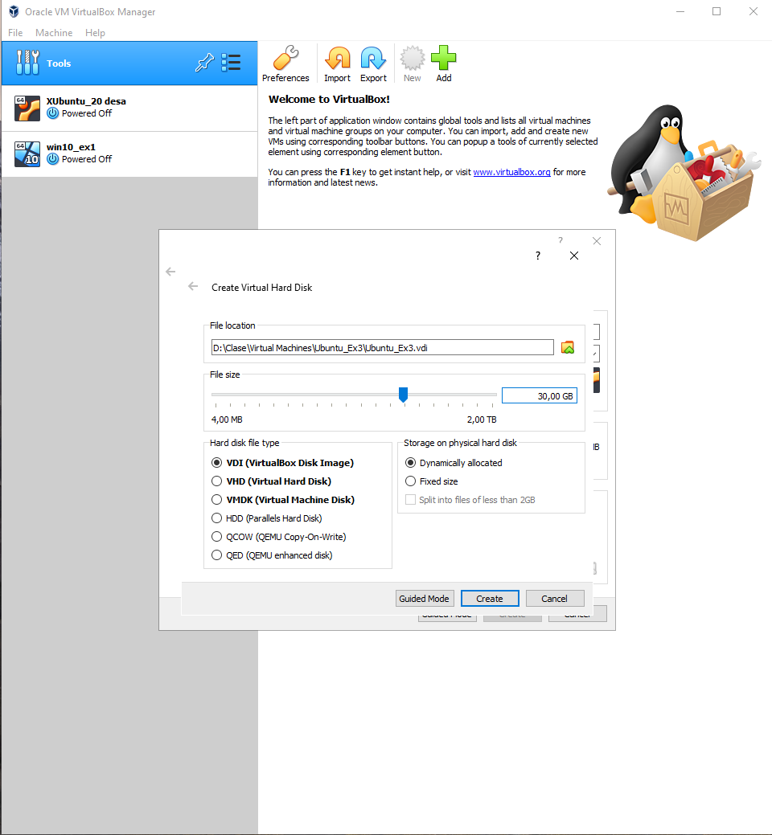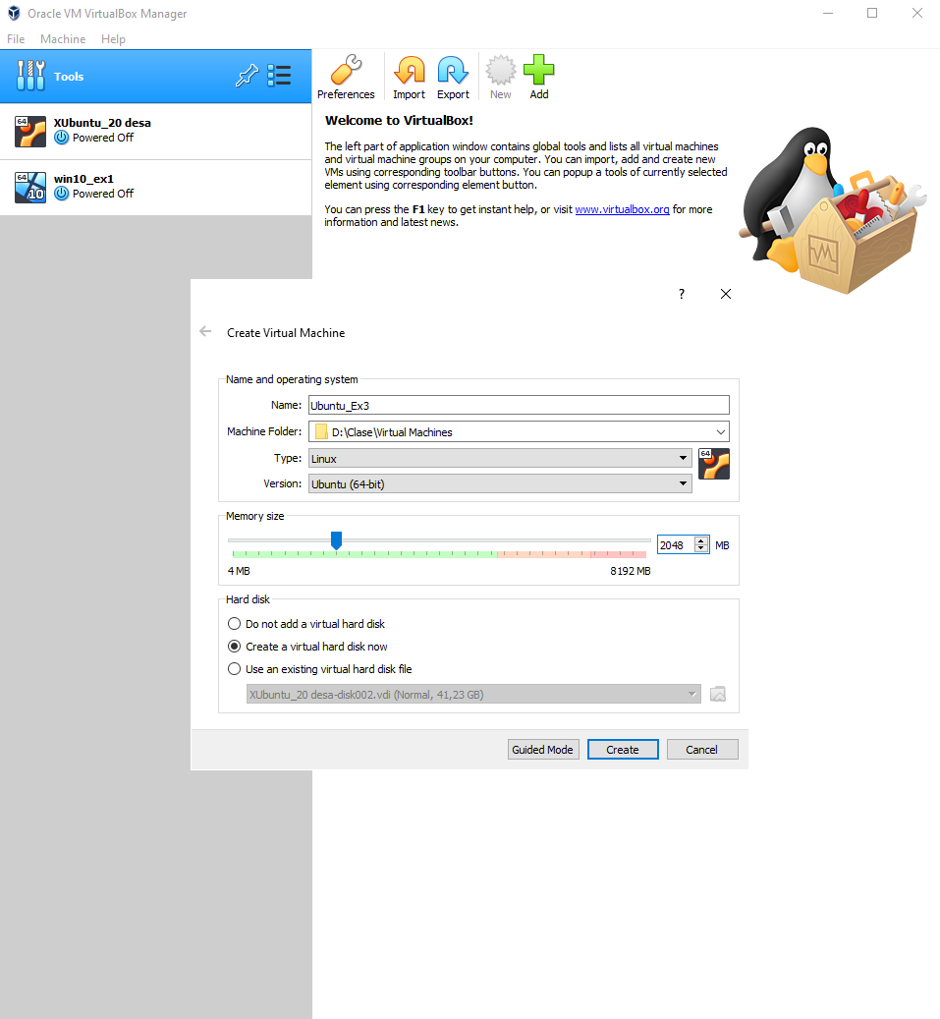

1. **Selecting startup disk and beginning the O.S. installation**

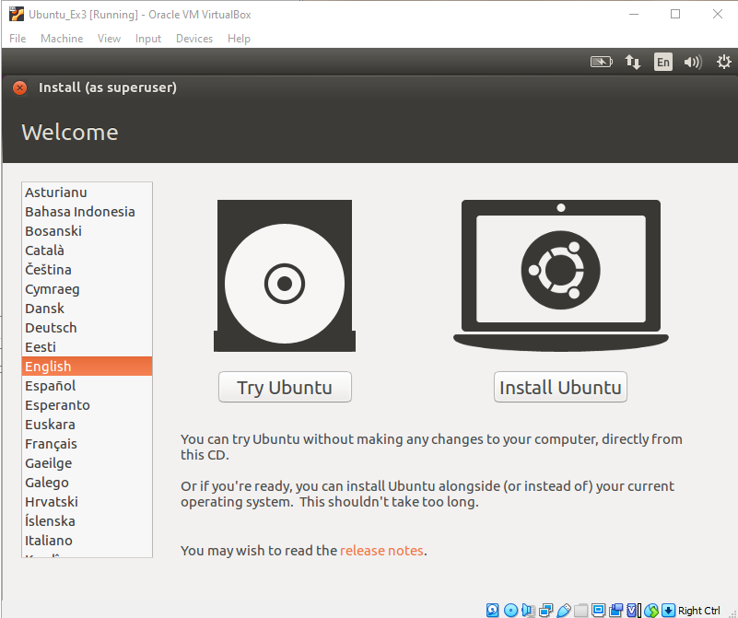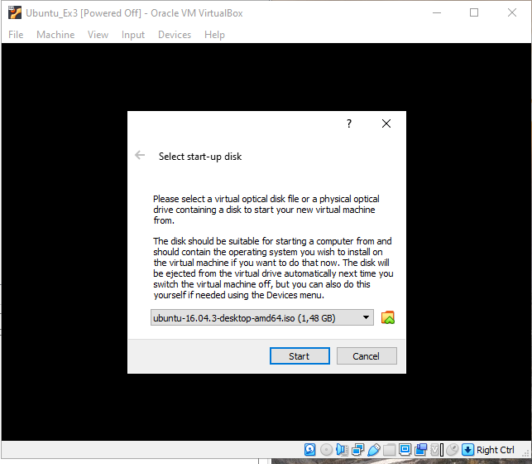At this point I choose the Ubuntu iso file, then the installation guide start, I choose the English language and click on the install Ubuntu button.

1. **Creating the O.S. partitions**

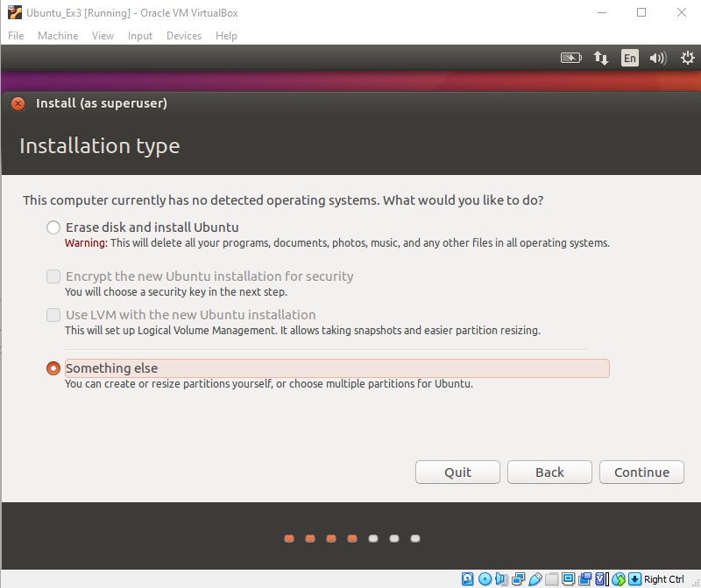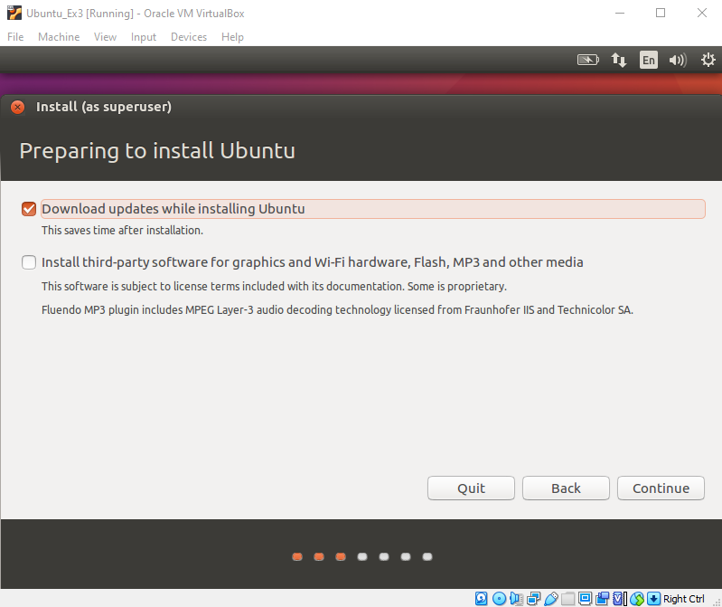In this step I follow the recomendations of the "Installation and configuration of Ubuntu 19.04" file and the Ubuntu partition guide documentation.

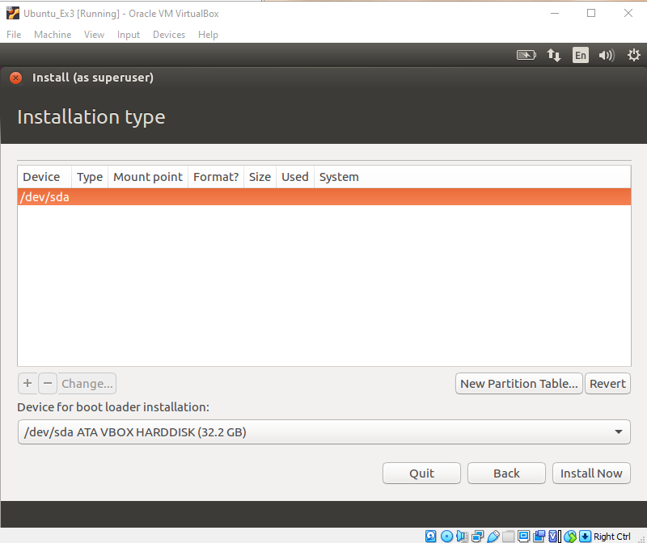

Here I click on the New Partition table button and I made the boot, swap, root and home partitions according to the 30GB space and de documentation.

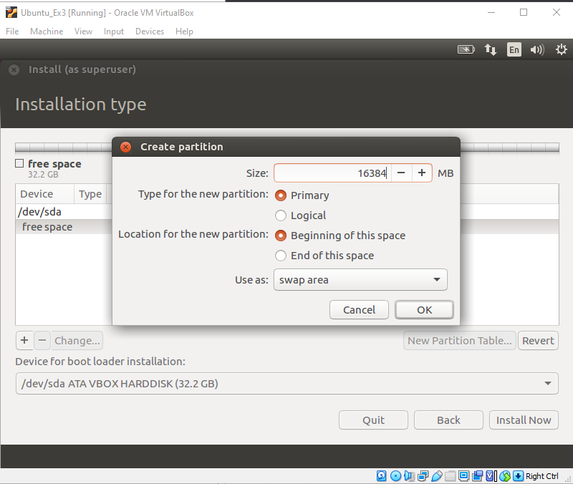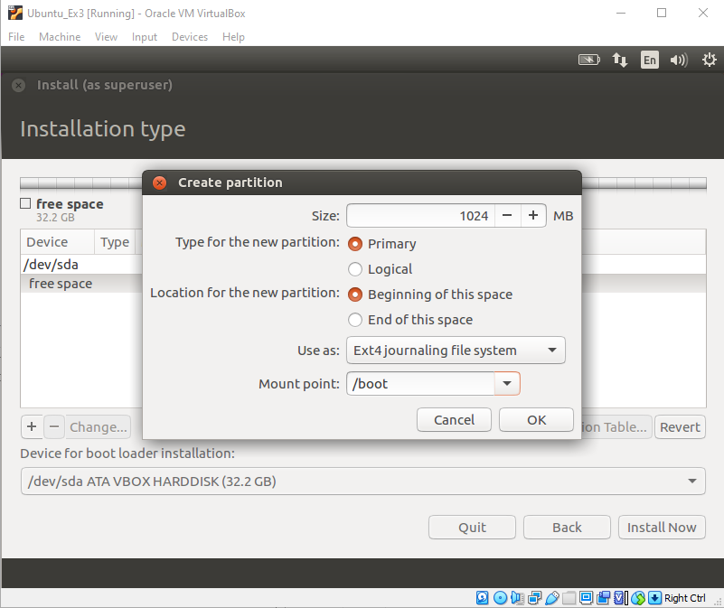Here we can see the two most important partition boot and swap and the file format assigment.

**/swap**

**/boot**

Final result of the partitions configuration.

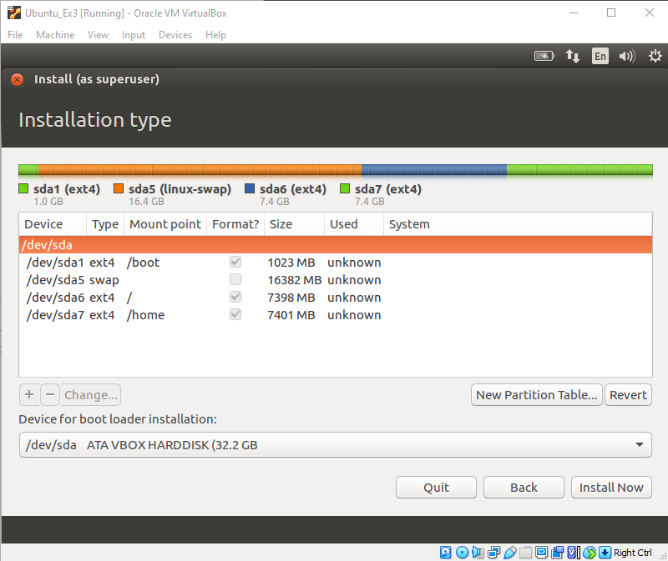

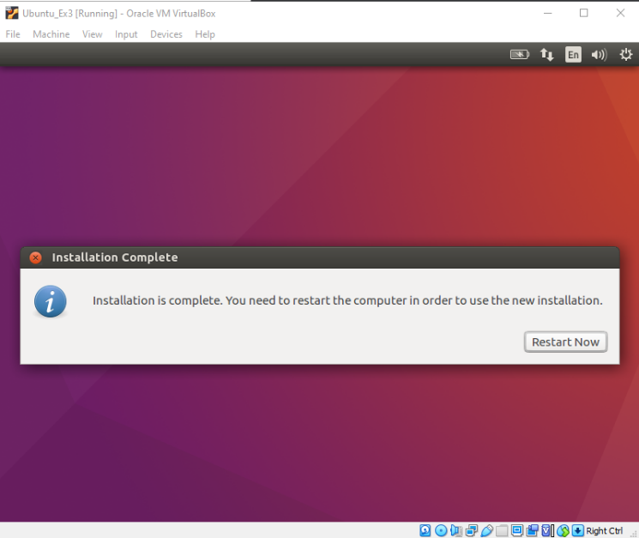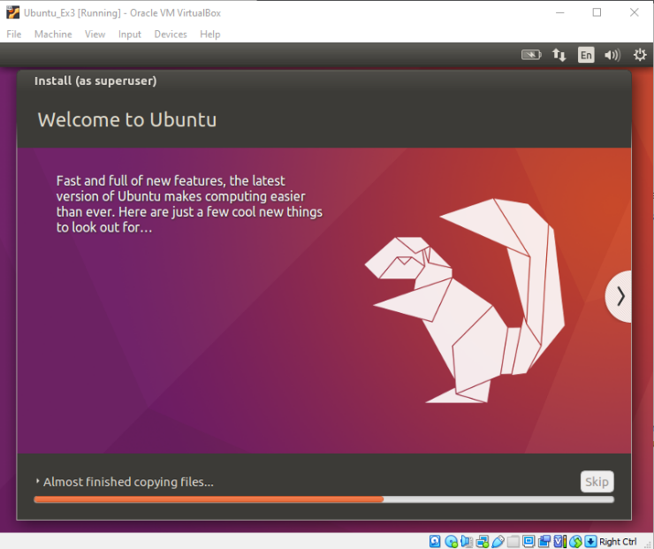

1. **Finishing with the installation of the O.S.**

Once the partitions are written on to the HDD the installer complete with the installation.

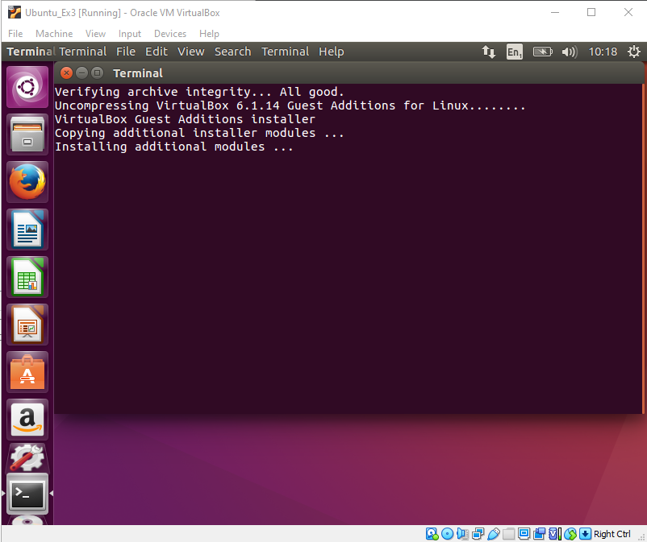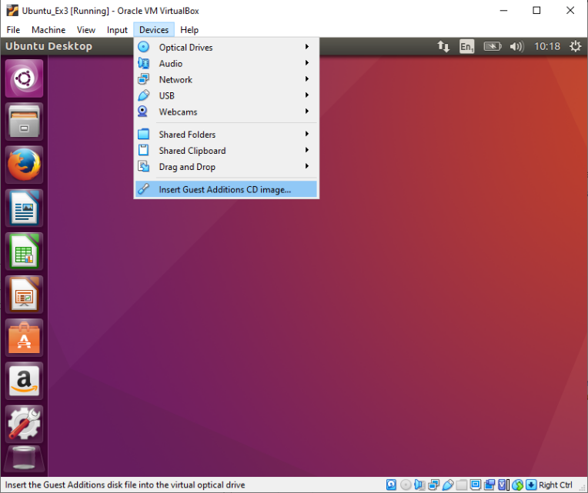When the VM reboot I proceed to install the guest additions modules to be able to share folders.

1. **Making the last settings for the Ubuntu VM**

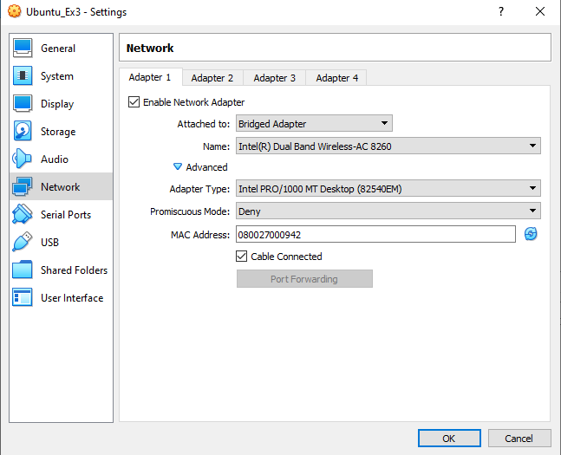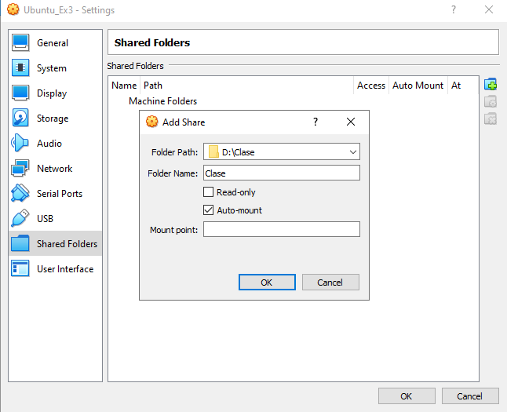Adding the shared folder and configuring the bridged network adapter for Ubuntu VM to have internet access.

1. **Final step: adding permissions**

Adding the user permissions to access the shared folder via command line.

